Date: 2023.07.25

Aircraft Firmware: v01.04.0000

Goggles Firmware: v01.03.0000 (DJI Goggles Integra) V01.07.0000 (DJI Goggles 2) V01.07.0000 (DJI FPV Goggles V2)

Remote Control Device Firmware: v02.00.0900 (DJI FPV Remote Controller 2)

v02.00.0700 (DJI Motion Controller)

DJI Fly App iOS: v1.11.0

DJI Fly App Android: v1.11.0

What’s New?

* Added support for the aircraft to use with DJI Goggles Integra and DJI Goggles 2.
* Added support for Remote ID requirements in the United States.

Notes:

* Restart the aircraft, remote controller, and goggles after the update is complete.
* Note that the update may reset various flight parameters such as the RTH altitude and the maximum flight distance. Before updating, take note of your preferred settings and readjust them after the update.
* If the update fails, restart aircraft, remote controller, goggles, and DJI Fly or DJI Assistant 2 (DJI Consumer Drones Series), and retry.

|  |  |
| --- | --- |
| Date: | 2022.09.08 |
| Aircraft Firmware: | v01.03.0000 |
| Goggles Firmware: | v01.03.0000 |
| Remote Controller firmware: | v02.00.0200 |
| Motion Controller Firmware: | v02.00.0400 |
| DJI Fly App iOS: | v1.7.4 |
| DJI Fly App Android: | v1.7.4 |

What’s New?

* Added support for Japanese RID requirements.

Notes:

* Restart the aircraft, remote controller, and goggles after the update is complete.
* Note that the update may reset various flight parameters such as the RTH altitude and the maximum flight distance. Before updating, take note of your preferred settings and readjust them after the update.
* If the update fails, restart aircraft, remote controller, goggles, and DJI Fly or DJI Assistant 2 (DJI FPV series), and retry.

|  |  |
| --- | --- |
| Date: | 2022.08.25 |
| Aircraft Firmware: | v01.02.0015 |
| Goggles Firmware: | v01.03.0000 |
| Remote Controller firmware: | v02.00.0200 |
| Motion Controller Firmware: | v02.00.0400 |
| DJI Fly App iOS: | v1.7.0 |
| DJI Fly App Android: | v1.7.0 |

What’s New?

* DJI FPV Goggles V2 added support for DJI Avata.
* DJI FPV Remote Controller 2 added support for DJI Avata.
* DJI Motion Controller added support for DJI Avata.

Notes:

* Restart the aircraft, remote controller, and goggles after the update is complete.
* Note that the update may reset various flight parameters such as the RTH altitude and the maximum flight distance. Before updating, take note of your preferred settings and readjust them after the update.
* If the update fails, restart aircraft, remote controller, goggles, and DJI Fly or DJI Assistant 2 (DJI FPV series), and retry.

Date: 2021.08.30

Aircraft Firmware: v01.02.0020

Goggles Firmware: v01.02.0020 Remote Controller firmware: v01.02.0000 DJI Fly App iOS: v1.4.8

DJI Fly App Android: v1.4.8

What’s New?

* Optimized flight safety.

Notes:

* Restart the aircraft, remote controller, and goggles after the update is complete.
* Note that the update may reset various flight parameters such as the RTH altitude and the maximum flight distance. Before updating, take note of your preferred settings and readjust them after the update.
* If the update fails, restart aircraft, remote controller, goggles, and DJI Fly or DJI Assistant 2 (DJI FPV series), and retry.

Date: 2021.07.15

Aircraft Firmware: v01.02.0000

Goggles Firmware: v01.02.0001 Remote Controller firmware: v01.02.0000 DJI Fly App iOS: v1.4.8

DJI Fly App Android: v1.4.8

What’s New?

* Fixed rare issue: goggles restarted automatically when in DJI Digital FPV System mode.

Notes:

* Restart the aircraft, remote controller, and goggles after the update is complete.
* Note that the update may reset various flight parameters such as the RTH altitude and the maximum flight distance. Before updating, take note of your preferred settings and readjust them after the update.
* If the update fails, restart aircraft, remote controller, goggles, and DJI Fly or DJI Assistant 2 (DJI FPV series), and retry.

Date: 2021.06.15

Aircraft Firmware: v01.02.0000

Goggles Firmware: v01.02.0000 Remote Controller firmware: v01.02.0000 DJI Fly App iOS: v1.4.3

DJI Fly App Android: v1.4.3

What’s New?

* Added ability to enable or disable video subtitles under camera settings in goggles.
* Added ability to trigger Find My Drone by pressing Mode button and Brake button simultaneously on the motion controller.
* Added flashing auxiliary bottom light when Find My Drone is triggered.
* Added ability to start or stop motors in Manual mode when customizing C2 switch under control settings in goggles.
* Added ability to view HDMI live broadcast by connecting the goggles to the DJI Smart Controller (v01.00.07.00 or above required). By connecting the goggles to the DJI Smart Controller using USB-C cable, users can see the camera view of the aircraft on the screen of the Smart Controller and can transmit the live view from the Smart Controller to other display devices through an HDMI cable.
* Optimized hints on goggles for updates, Manual mode limitations, and motion controller critical low battery warnings.
* Optimized flight safety.
* Optimized flight experience when using Manual mode.
* Optimized flight experience when using motion controller.

Notes:

* Restart the aircraft, remote controller, and goggles after the update is complete.
* Note that the update may reset various flight parameters such as the RTH altitude and the maximum flight distance. Before updating, take note of your preferred settings and readjust them after the update.
* If the update fails, restart aircraft, remote controller, goggles, and DJI Fly or DJI Assistant 2 (DJI FPV series), and retry.

Date: 2021.03.02

Aircraft Firmware: v01.01.0000

Goggles Firmware: v01.01.0000 Remote Controller firmware: v01.01.0000 DJI Fly App iOS: v1.3.0

DJI Fly App Android: v1.3.0

What’s New?

* Added support for DJI Motion Controller.
* Added ability to take off or land by pressing lock button on motion controller.
* Added tutorial videos for motion controller in goggles.
* Added calibration for motion controller.
* Added ability to switch goggles to DJI Digital FPV System.
* Added Turtle mode.
* Added Coordinated Turn to Sport mode when using remote controller.
* Added Find My Drone under safety settings in goggles.
* Added ability to set camera exposure value manually.
* Optimized flight performance in all flight modes.
* Improved transmission stability between air unit and ground unit.

Notes:

* Restart the aircraft, remote controller, and goggles after the update is complete.
* Note that the update may reset various flight parameters such as the RTH altitude and the maximum flight distance. Before updating, take note of your preferred settings and readjust them after the update.
* If the update fails, restart aircraft, remote controller, goggles, and DJI Fly or DJI Assistant 2 (DJI FPV series), and retry.

|  |  |
| --- | --- |
| Date: | 2024.11.06 |
| DJI Avata 2 Firmware: | V01.00.0400 |
| DJI Goggles 3 Firmware: | V01.00.0600 |
| DJI RC Motion 3 Firmware: | V01.00.0200 |
| DJI FPV Remote Controller 3 Firmware: | V01.00.0300 |
| DJI Goggles 2 Firmware： | V01.10.0000 |
| DJI Goggles N3 Firmware： | V01.00.0200 |
| DJI Goggles Integra Firmware： | V01.06.0000 |
| DJI RC Motion 2 Firmware： | V01.08.0000 |
| DJI FPV Remote Controller 2 Firmware： | V02.00.1000 |
| DJI Fly App iOS: | V1.15.4 |
| DJI Fly App Android: | V1.15.4 |

What’s New

* Added Power Loop in Easy ACRO mode when used with DJI Goggles N3/DJI Goggles 3 and DJI RC Motion 3.
* Added support for use with DJI Goggles N3.
* Added Landing Protection when used with DJI Goggles N3/DJI Goggles 3 and DJI RC Motion 3.
* Fixed some known issues.

Notes:

* Restart the aircraft, remote control device, and goggles after the firmware update is complete.
* Note that the firmware update may reset various flight parameters such as RTH Altitude and Maximum Flight Distance. Before updating, take note of your preferred settings and readjust them after the firmware update is complete.
* If the update fails, restart the aircraft, remote control device, goggles, and the DJI Fly app or DJI Assistant 2 (Consumer Drone Series), and try again.
* Always perform Power Loop in Easy ACRO mode in an open area to ensure flight safety.
* Take extra caution when flying close to the ground with Landing Protection disabled.

|  |  |
| --- | --- |
| Date: | 2024.05.28 |
| DJI Avata 2 Firmware: | V01.00.0300 |
| DJI Goggles 3 Firmware: | V01.00.0200 |
| DJI RC Motion 3 Firmware: | V01.00.0100 |
| DJI FPV Remote Controller 3 Firmware: | V01.00.0100 |
| DJI Goggles 2 Firmware： | V01.10.0000 |
| DJI Goggles Integra Firmware： | V01.06.0000 |
| DJI RC Motion 2 Firmware： | V01.08.0000 |
| DJI FPV Remote Controller 2 Firmware： | V02.00.1000 |
| DJI Fly App iOS: | V1.13.4 |
| DJI Fly App Android: | V1.13.4 |

What’s New

* Added support for use with DJI Goggles Integra.
* Added support for use with DJI Goggles 2.
* Added support for use with DJI RC Motion 2 and DJI FPV Remote Controller 2 when used with DJI Goggles Integra and DJI Goggles 2.
* Added support for recording 4K/100 videos.
* Added support for RID in some regions.
* Fixed some known issues.

Notes:

* Restart the aircraft, remote control device, and goggles after the firmware update is complete.
* Note that the firmware update may reset various flight parameters such as RTH Altitude and Maximum Flight Distance. Before updating, take note of your preferred settings and readjust them after the firmware update is complete.
* If the update fails, restart the aircraft, remote control device, goggles, and the DJI Fly app or DJI Assistant 2 (Consumer Drone Series), and try again.

|  |  |
| --- | --- |
| Date: | 2024.04.11 |
| DJI Avata 2 Firmware: | V01.00.0200 |
| DJI Goggles 3 Firmware: | V01.00.0100 |
| DJI RC Motion 3 Firmware: | V01.00.0100 |
| DJI FPV Remote Controller 3 Firmware: | V01.00.0100 |
| DJI Fly App iOS: | V1.13.0 |
| DJI Fly App Android: | V1.13.0 |

What’s New

* Added Easy ACRO for use with DJI Goggles 3 and DJI RC Motion 3.
* Added Beginner mode for the aircraft when used with DJI Goggles 3 and DJI RC Motion 3.
* Added support for Manual Mode when used with DJI FPV Remote Controller 3.

Notes:

* Restart the aircraft, remote control device, and goggles after the firmware update is complete.
* Note that the firmware update may reset various flight parameters such as RTH Altitude and Maximum Flight Distance. Before updating, take note of your preferred settings and readjust them after the firmware update is complete.
* If the update fails, restart the aircraft, remote control device, goggles, and the DJI Fly app or DJI Assistant 2 (Consumer Drone Series), and try again.

### Drone

User Guide

使用说明

使用說明

ユーザーガイド 사용자 가이드 Bedienungsanleitung

Guía de usuario Guide de l'utilisateur Guida dell'utente Gebruiksaanwijzing Manual do utilizador Guia do usuário

Руководство пользователя

2021.03



v1.2

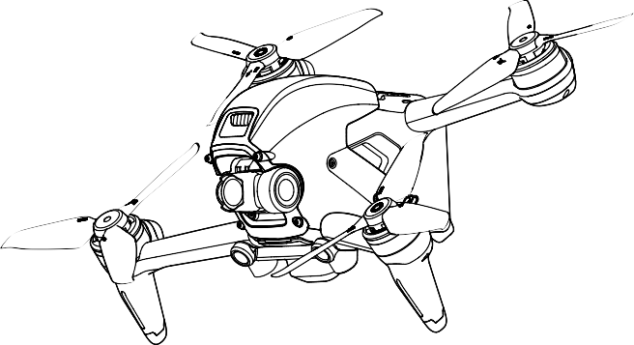



[www.dji.com/dji-fpv/**video**](http://www.dji.com/dji-fpv/video)

## 2

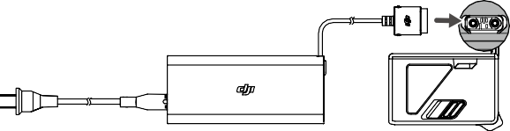

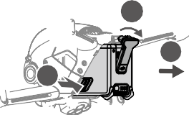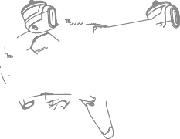

1

3

2

1

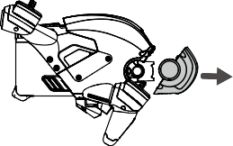

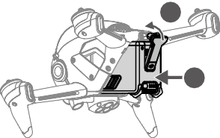

2

1

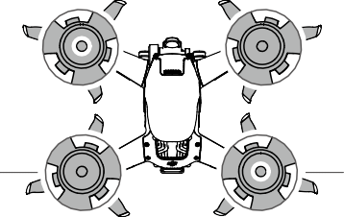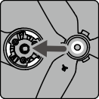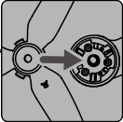A B



|  |  |  |  |  |  |
| --- | --- | --- | --- | --- | --- |
|  | B |  |  | A |  |
| Unmarked |  |  |  |  | Marked |
| 无标记  無標記 |  |  |  |  | 红色标记紅色標記 |
| マークなし |  |  |  |  | マークあり |
| 표시 없음 |  |  |  |  | 표시 있음 |
| Nicht markiert |  |  | 1 |  | Markiert |
| Sin marcas |  |  |  |  | Con marcas |
| Sans repères |  |  |  |  | Avec repères |
| Senza contrassegno  Ongemarkeerd |  | 2 |  |  | Con contrassegno  Gemarkeerd |
| Não marcado |  |  |  |  | Marcado |
| Sin marcas |  |  |  |  | Con marcas |
| Без меток |  |  |  |  | С метками |

2

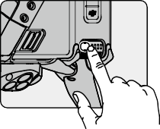

EN Check battery level: press once.

Power on/off: press then press and hold.

CHS 检查电量：短按一次。

开机 / 关机：短按一次，再长按 2 秒。

CHT 檢查電量：短按一次。

開機 / 關機：短按一次，再長按 2 秒。

JP バッテリー残量確認：1 回押す。

電源をオン／オフ：1 回押して、長押し。

KR 배터리 잔량 확인 : 한 번 누르기

전원 켜기 / 끄기 : 한번 누르고 다시 길게 누르기

DE Einmal drücken: Akkustand überprüfen.

Ein-/auszuschalten: Kurz drücken, dann nochmals drücken und gedrückt halten.

ES Comprobar nivel de batería: presione una vez.

Encender/apagar: pulse, vuelva a pulsar y mantenga pulsado.

FR Vérification du niveau de batterie : appuyer une fois

Allumer/Éteindre : appuyez une fois, puis appuyez et maintenez le bouton enfoncé pour allumer/éteindre.

IT Verificare il livello della batteria: premere una volta.

Accendere/spegnere: premere, quindi premere e tenere premuto.

NL Controle batterijniveau: één keer drukken.

Aan- en uitzetten: Indrukken en vasthouden.

PT Verificar o nível da bateria: prima uma vez.

Ligar/desligar: prima, e em seguida prima de forma contínua.

PT-BR Verificar o nível da bateria: pressione uma vez.

Ligar/desligar: pressione uma vez, então pressione novamente e segure.

RU Проверить заряд аккумулятора: нажмите один раз.

Включение/выключение: нажмите, затем нажмите еще раз и удерживайте кнопку.

3

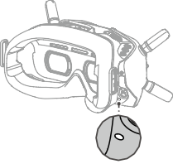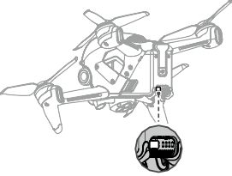a.



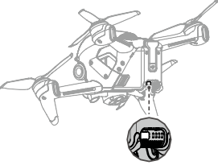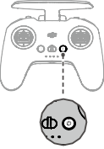**b.**



**Linking**

Ensure that all devices are powered on.

1. Aircraft + Goggles
   1. Press the link button on the goggles. The goggles will beep continually.
   2. Press and hold the power button of the aircraft until the battery level indicator blinks in sequence.
   3. The battery level indicator of the aircraft turns solid and displays the battery level. The goggles stop beeping when they are successfully linked and the video display is normal.
2. Aircraft + Remote Controller
   1. Press and hold the power button of the aircraft until the battery level indicator blinks in sequence.
   2. Press and hold the power button of the remote controller until it beeps continually and the battery level indicator blinks in sequence.
   3. The remote controller stops beeping when successfully linked and both the battery level indicators turn solid and display the battery level.

 The aircraft must be linked with the goggles before the remote controller.

4

对 频

对频前请确保所有设备均已开启。

1. 飞行器 + 飞行眼镜
   1. 按下飞行眼镜的对频按键直至响起嘀 - 嘀…的提示音。
   2. 长按飞行器的电源按键，电池电量指示灯将循环闪烁。
   3. 对频成功后，飞行器的电池电量指示灯常亮显示电量，飞行眼镜提示音停止并显示图传。
2. 飞行器 + 遥控器
   1. 长按飞行器的电源按键，电池电量指示灯将循环闪烁。
   2. 长按遥控器的电源按键直至响起嘀 - 嘀…的提示音，且电池电量指示灯循环闪烁。
   3. 对频成功后，飞行器及遥控器的电池电量指示灯均常亮显示电量，遥控器提示音停止。

 飞行器需先完成与飞行眼镜的对频，再进行和遥控器的对频。

配 對

配對前請確保所有裝置均已開啟。

1. 航拍機 + 飛行眼鏡
   1. 按下飛行眼鏡的配對按鍵直至響起嘀 - 嘀…的提示音。
   2. 長按航拍機的電源按鍵，電池電量指示燈將循環閃爍。
   3. 配對成功後，航拍機的電池電量指示燈恆亮顯示電量，飛行眼鏡提示音停止並顯示影像傳輸。
2. 航拍機 + 遙控器
   1. 長按航拍機的電源按鍵，電池電量指示燈將循環閃爍。
   2. 長按遙控器的電源按鍵直至響起嘀 - 嘀…的提示音，且電池電量指示燈循環閃爍。
   3. 配對成功後，航拍機及遙控器的電池電量指示燈均恆亮顯示電量，遙控器提示音停止。

 航拍機需先完成與飛行眼鏡的配對，再進行和遙控器的配對。

***リンク***

すべての機器の電源が入っていることを確認します。

1. ***機体* + *ゴーグル***
   1. ゴーグルのリンクボタンを押します。ゴーグルからビープ音が連続して鳴ります。
   2. バッテリー残量インジケーターが順に点滅するまで機体の電源ボタンを長押しします。
   3. 機体のバッテリー残量インジケーターが点灯し、電池残量を表示します。正常にリンクされ、動画ディスプレイが正常になると、ゴーグルのビープ音が止まります。
2. ***機体* + *送信機***
   1. バッテリー残量インジケーターが順に点滅するまで機体の電源ボタンを長押しします。
   2. ビープ音が連続して鳴り、バッテリー残量インジケーターが順に点滅するまで、送信機の電源ボタンを長押しします。
   3. リンク作業が正常に終了し、両方のバッテリー残量インジケーターが点灯してバッテリー残量を表示されると、送信機のビープ音は止まります。

機体は送信機より前にゴーグルとリンクしておく必要があります。

5

**연동**

모든 기기의 전원이 켜졌는지 확인합니다 .

1. **기체 + 고글**
   1. 고글의 연동 버튼을 누릅니다 . 고글은 계속 신호음 소리를 냅니다 .
   2. 배터리 잔량 표시기가 순차적으로 깜박일 때까지 기체의 전원 버튼을 길게 누릅니다 .
   3. 기체의 배터리 잔량 표시기가 켜진 상태로 배터리 잔량을 표시합니다 . 성공적으로 연동되고 동영상 디스플레이가 정상이면 , 고글 신호음이 멈춥니다 .
2. **기체 + 조종기**
   1. 배터리 잔량 표시기가 순차적으로 깜박일 때까지 기체의 전원 버튼을 길게 누릅니다 .
   2. 조종기가 계속해서 신호음을 내고 배터리 잔량 표시기가 순차적으로 깜박일 때까지 조종기의 전원 버튼을 길게 누릅니다 .
   3. 성공적으로 연동되면 조종기가 깜박임을 중단하고 두 배터리 잔량 표시기가 모두 켜지며 배터리 잔 량을 표시합니다 .

 기체를 고글과 먼저 연동한 후 조종기와 연동해야 합니다 .

**Koppeln**

Stell sicher, dass alle Geräte eingeschaltet sind.

1. Fluggerät + Goggles
   1. Drück die Kopplungstaste auf den Goggles. Die Goggles piepsen kontinuierlich.
   2. Halt den Einschaltknopf des Fluggeräts gedrückt, bis die Akkustandanzeige blinkt.
   3. Die Akkustandsanzeige auf dem Fluggerät leuchtet ständig und zeigt den Akkustand an. Die Goggles hören auf zu piepen, sobald sie erfolgreich gekoppelt wurden und die Videowiedergabe normal angezeigt wird.
2. Fluggerät + Fernsteuerung
   1. Halt den Einschaltknopf des Fluggeräts gedrückt, bis die Akkustandanzeige blinkt.
   2. Halt den Einschaltknopf der Fernsteuerung gedrückt, bis diese kontinuierlich piepst und die Akkustandsanzeige blinkt.
   3. Die Fernbedienung hört auf zu piepsen, wenn die Verbindung erfolgreich hergestellt wurde und die beiden Akkustandsanzeigen leuchten ständig und zeigen den Akkustand an.

 Das Fluggerät muss mit den Goggles vor der Fernsteuerung verbunden werden.

**Vinculación**

Asegúrese de que todos los dispositivos estén encendidos.

1. Aeronave + Gafas
   1. Presione el botón de enlace en las gafas. Las gafas emitirán un pitido continuo.
   2. Mantenga presionado el botón de encendido de la aeronave hasta que el indicador del nivel de batería parpadee en secuencia.
   3. El indicador del nivel de batería de la aeronave se vuelve fijo y muestra el nivel de batería. Las gafas dejarán de pitar cuando se enlacen correctamente y la visualización del vídeo sea normal.

6

1. Aeronave + Control remoto
   1. Mantenga presionado el botón de encendido de la aeronave hasta que el indicador del nivel de batería parpadee en secuencia.
   2. Mantenga presionado el botón de encendido del control remoto hasta que emita un pitido continuo y el indicador del nivel de batería parpadee en secuencia.
   3. El control remoto deja de pitar cuando se conecta correctamente y ambos indicadores del nivel de batería se vuelven fijos y muestran el nivel de batería.

 La aeronave debe vincularse a las gafas antes que el control remoto.

**Appairage**

Assurez-vous que tous les dispositifs sont sous tension.

1. Appareil + Casque
   1. Appuyez sur le bouton d’appairage du casque. Le casque émet alors un bip continu.
   2. Maintenez le bouton d'alimentation de l’appareil enfoncé jusqu’à ce que l’indicateur de niveau de batterie clignote en séquence.
   3. L’indicateur de niveau de batterie de l’appareil brille de façon continue et affiche le niveau de batterie. Le casque cessent de biper lorsqu'il est appairé et l'affichage vidéo est normal.
2. Appareil + Radiocommande
   1. Maintenez le bouton d'alimentation de l’appareil enfoncé jusqu’à ce que l’indicateur de niveau de batterie clignote en séquence.
   2. Maintenez le bouton d'alimentation de la radiocommande enfoncé jusqu’à ce qu’elle émette un bip continu et que l’indicateur de niveau de batterie clignote en séquence.
   3. La radiocommande arrête de biper quand elle est correctement appairée et que l’indicateur du niveau de batterie passe au fixe et affiche le niveau de batterie.

 L’appareil doit être appairé au casque avant la radiocommande.

**Collegamento**

Accertarsi che tutti i dispositivi siano accesi.

1. Aeromobile + visore
   1. Premere il pulsante di collegamento sul visore. Il visore emetterà un bip continuo.
   2. Premere e tenere premuto il pulsante di accensione dell’aeromobile fino a quando l’indicatore del livello della batteria lampeggia in sequenza.
   3. L’indicatore del livello della batteria dell’aeromobile si illumina di luce fissa e visualizza il livello della batteria. Gli occhiali smetteranno di lampeggiare quando collegati correttamente e la visualizzazione delle immagini si stabilizza.
2. Aeromobile + radiocomando
   1. Premere e tenere premuto il pulsante di accensione dell’aeromobile fino a quando l’indicatore del livello della batteria lampeggia in sequenza.
   2. Premere e tenere premuto il pulsante di accensione sul radiocomando fino a quando emette un bip continuo e l’indicatore del livello della batteria lampeggia in sequenza.

7

* 1. Il radiocomando smette di emettere il bip una volta eseguito il collegamento ed entrambi gli indicatori del livello della batteria si illuminano di luce fissa e visualizzano il livello della batteria.

 È necessario collegare l’aeromobile al visore prima del radiocomando.

**Koppelen**

Zorg ervoor dat alle apparaten zijn ingeschakeld.

1. Drone + bril
   1. Druk op de verbindingsknop op de bril. De bril piept continu.
   2. Druk en houd de aan-/uitknop van de drone ingedrukt totdat de indicator van de accu in volgorde knippert.
   3. De indicator voor het accuniveau van de drone brandt constant en geeft het accuniveau weer. De bril stopt met piepen wanneer deze met succes is gekoppeld en het videoscherm normaal is.
2. Drone + afstandsbediening
   1. Druk en houd de aan-/uitknop van de drone ingedrukt totdat de indicator van de accu in volgorde knippert.
   2. Druk en houd de aan-/uitknop van de afstandsbediening ingedrukt totdat deze continu piept en de indicator voor het accuniveau op volgorde knippert.
   3. De afstandsbediening stopt met piepen wanneer deze met succes is gekoppeld. Beide indicatoren voor het accuniveau worden constant en geven het accuniveau weer.

 De drone moet vóór de afstandsbediening met de bril worden gekoppeld.

**Ligação**

Assegure-se de que todos os dispositivos estão ligados.

1. Aeronave + Goggles
   1. Prima o botão de ligação nos goggles. Os goggles emitirão um sinal sonoro contínuo.
   2. Prima e mantenha premido o botão de alimentação da aeronave até que o indicador de nível de bateria pisque sequencialmente.
   3. O indicador de nível da bateria da aeronave fica sólido e mostra o nível da bateria. Os óculos param de emitir sinais sonoros quando ligados com êxito e o visor de vídeo é normal.
2. Aeronave + Telecomando
   1. Prima e mantenha premido o botão de alimentação da aeronave até que o indicador de nível de bateria pisque sequencialmente.
   2. Prima e mantenha premido o botão do telecomando até emitir um sinal sonoro contínuo e o indicador do nível da bateria piscar em sequência.
   3. O telecomando deixa de emitir um sinal sonoro quando for ligado com êxito e ambos os indicadores do nível de bateria ficarem sólidos e mostrarem o nível da bateria.

 A aeronave tem de ser ligada aos goggles antes do telecomando.

8

**Vinculação**

Verifique se todos os dispositivos estão ligados.

1. Aeronave + óculos
   1. Pressione o botão de vinculação nos óculos. Os óculos emitirão um sinal sonoro contínuo.
   2. Mantenha pressionado o botão liga/desliga da aeronave até que o indicador de nível da bateria pisque em sequência.
   3. O indicador de nível da bateria da aeronave ficará aceso e exibirá o nível da bateria. Os óculos de proteção param de emitir sinal sonoro quando forem vinculados com êxito e a exibição do vídeo for normal.
2. Aeronave + controle remoto
   1. Mantenha pressionado o botão liga/desliga da aeronave até que o indicador de nível da bateria pisque em sequência.
   2. Mantenha pressionado o botão liga/desliga do controle remoto até ouvir um bipe contínuo e o indicador de nível da bateria piscar em sequência.
   3. O controle remoto vai parar de emitir sinal sonoro quando vinculado com êxito e os dois indicadores de nível da bateria ficarem acesos e exibirem o nível da bateria.

 A aeronave deve ser vinculada aos óculos antes do controle remoto.

**Сопряжение**

Убедитесь, что все устройства включены.

а. Дрон + очки

1. Нажмите кнопку сопряжения на очках. Устройство начнет издавать непрерывный звуковой сигнал.
2. Нажмите и удерживайте кнопку питания дрона до тех пор, пока индикатор уровня заряда аккумулятора не начнет последовательно мигать.
3. Индикатор уровня заряда аккумулятора дрона начнет светиться и отобразит его оставшийся заряд. Очки перестанут издавать звуковой сигнал при успешном сопряжении, а изображение на экране нормализуется.

б. Дрон + пульт управления

1. Нажмите и удерживайте кнопку питания дрона, пока индикатор уровня заряда не начнет последовательно мигать.
2. Нажмите и удерживайте кнопку питания пульта управления, пока устройство не начнет издавать непрерывный звуковой сигнал, а индикатор уровня заряда аккумулятора – последовательно мигать.
3. Звуковой сигнал пульта управления прекратится после успешного сопряжения, индикатор уровня заряда аккумулятора начнет светиться и отобразит оставшийся заряд.

 Дрон сначала должен быть сопряжен сначала с очками, а затем с пультом управления.

9

## 6

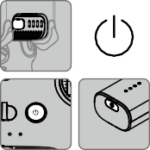

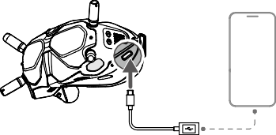

**DJI Fly App**

Connect the USB-C port of the goggles to the mobile device, run DJI Fly, and follow the prompt to activate.

连接飞行眼镜的 USB-C 接口至手机，运行 DJI Fly App 并根据 App 提示激活设备。

連接飛行眼鏡的 USB-C 接口至手機，執行 DJI Fly 應用程式並根據應用程式提示啟動裝置。

ゴーグルの USB-C ポートとモバイル端末を接続し、DJI Fly を起動し、プロンプトに従ってアクティベーションを行います。

고글의 USB-C 포트를 모바일 기기에 연결하고 , DJI Fly 를 실행한 다음 메시지에 따라 활성화합니다 .

Verbinde den USB-C-Anschluss der Goggles mit dem Mobilgerät, starte die DJI Fly App, und folg den Anweisungen zur Aktivierung.

Conecte el puerto USB-C de las gafas al dispositivo móvil, ejecute DJI Fly y siga las instrucciones para la activación.

Connectez le casque à l’appareil mobile à l’aide du câble USB-C, lancez DJI Fly et suivez les instructions à l’écran.

Collegare la porta USB-C del visore al dispositivo mobile, avviare DJI Fly e seguire il prompt per effettuare l’attivazione.

Verbind de USB-C-poort van de bril met het mobiele apparaat, start DJI Fly en volg het bericht om te activeren.

Ligue a porta USB-C dos goggles ao dispositivo móvel, inicie a DJI Fly e siga a mensagem para ativar.

Conecte a entrada USB-C dos óculos ao dispositivo móvel, execute o DJI Fly e siga as instruções para ativar.

Подключите порт USB-C на очках к мобильному устройству, откройте приложение DJI Fly и следуйте инструкциям по активации.

10

EN

**Disclaimer and Warning**

Please read this entire document and all safe and lawful practices DJITM provided carefully before use. Failure to read and follow instructions and warnings may result in serious injury to yourself or others, damage to your DJI product, or damage to other objects in the vicinity. By using this product, you hereby signify that you have read this disclaimer and warning carefully and that you understand and agree to abide by the terms and conditions herein. You agree that you are solely responsible for your own conduct while using this product, and for any consequences thereof. DJI accepts no liability for damage, injury or any legal responsibility incurred directly or indirectly from the use of this product.

DJI is a trademark of SZ DJI TECHNOLOGY CO., LTD. (abbreviated as “DJI”) and its affiliated companies. Names of products, brands, etc., appearing in this document are trademarks or registered trademarks of their respective owner companies. This product and document are copyrighted by DJI with all rights reserved. No part of this product or document shall be reproduced in any form without the prior written consent or authorization of DJI.

This document and all other collateral documents are subject to change at the sole discretion of DJI. For up to date product information, visit [http://www.dji.com](http://www.dji.com/) and click on the product page for this product.

This disclaimer is available in various languages. In the event of divergence among different versions, the English version shall prevail.

**Usage**

Visit <http://www.dji.com/dji-fpv> (User Manual) to learn more about how to use this product.

**Specifications**

Aircraft (Model: FD1W4K)

Takeoff Weight Approx. 795 g

Max Flight Time Approx. 20 mins (0 wind while flying at a consistent 24.9 mph (40 kph))

Operating Temperature -10° to 40° C (14° to 104° F)

Operating Frequency 2.400-2.4835 GHz; 5.725-5.850 GHz

Transmitter Power (EIRP) 2.4 GHz: ≤31.5 dBm (FCC), ≤20 dBm (CE/SRRC/MIC)

5.8 GHz: ≤31.5 dBm (FCC), ≤25.5 dBm (SRRC), ≤14 dBm (CE)

Camera

Sensor 1/2.3” CMOS, Effective Pixels: 12M

Lens

FOV: 150°

35 mm format equivalent: 14.66 mm Aperture: f/2.8

Focus range: 0.6 m to ∞

ISO Range 100-12800

Electronic Shutter Speed 1/50-1/8000 s

11

Max Image Size 3840×2160

Video Resolution

4K: 3840×2160 50/60 p

FHD: 1920×1080 50/60/100/120 p

Video Format MP4/MOV (MPEG-4 AVC/H.264, HEVC/H.265)

Intelligent Flight Battery

Capacity 2000 mAh

Voltage 22.2 V (standard)

Type LiPo 6S

Energy 44.4 [Wh@0.5C](mailto:Wh@0.5C)

Charging Temperature 5° to 40° C (40° to 104° F)

Max Charging Power 90 W

Please refer to <http://www.dji.com/service> for after-sales service for your product where applicable.

DJI shall mean SZ DJI TECHNOLOGY CO., LTD. and/or its affiliated companies where applicable.

CHS

免责声明和警告

使用本产品之前，请仔细阅读并遵循本文及大疆 TM 创新（DJITM）提供的所有安全指引，否则可能会给您和周围的人带来伤害，损坏本产品或其它周围物品。一旦使用本产品，即视为您已经仔细阅读本文档，理解、认可和接受本声明全部条款和内容。您承诺对使用本产品以及可能带来的后果负全部责任。大疆创新（DJI）对于直接或间接使用本产品而造成的损坏、伤害以及任何法律责任不予负责。

DJI 是深圳市大疆创新科技有限公司及其关联公司的商标。本文出现的产品名称、品牌等，均为其所属公司的商标。本产品及手册为大疆创新版权所有。未经许可，不得以任何形式复制翻印。

本文档及本产品所有相关的文档最终解释权归大疆创新（DJI）所有。如有更新，恕不另行通知。请访问 [www.dji.com](http://www.dji.com/) 官方网站以获取最新的产品信息。

使 用

访问 <http://www.dji.com/dji-fpv>（用户手册）获取详细的产品使用方法。

规格参数

飞行器（型号：FD1W4K）

起飞重量 约 795 g

最长飞行时间 约 20 分钟（无风环境 40 km/h 匀速飞行）

工作环境温度 -10℃至 40℃

工作频率 2.400-2.4835 GHz; 5.725-5.850 GHz

EIRP 2.4 GHz: ≤31.5 dBm (FCC), ≤20 dBm (CE/SRRC/MIC)

5.8 GHz: ≤31.5 dBm (FCC), ≤25.5 dBm (SRRC), ≤14 dBm (CE)

发射功率（ ）

12

镜头

视场角：150°

等效焦距：14.66 mm

光圈：f/2.8

焦点范围：0.6 m 至无穷远

录像分辨率

4K: 3840×2160 50/60 p

FHD: 1920×1080 50/60/100/120 p

影像传感器

1/2.3 英寸 CMOS，有效像素 12M

ISO 范围

100-12800

最大照片尺寸

3840×2160

视频格式

MP4/MOV (MPEG-4 AVC/H.264, HEVC/H.265)

容量

2000 mAh

类型

LiPo 6S

充电环境温度

5℃至 40℃

最大充电功率 90 W

能量 44.4 [Wh@0.5C](mailto:Wh@0.5C)

电压 22.2 V（标称电压）

智能飞行电池

电子快门速度 1/50-1/8000 s

相机

浏览 <http://www.dji.com/service> 以获取产品的售后信息。 “DJI”表示深圳市大疆创新科技有限公司及其关联公司。

CHT

免責聲明和警告

使用本産品之前，請仔細閱讀並遵循本文及大疆 TM 創新（DJITM）提供的所有安全指南，否則可能會給您和周圍的人帶來傷害，損壞本産品或其它周圍物品。一旦使用本產品，即視為您已經仔細閱讀本文件，理解、認可和接受本聲明全部條款和內容。您承諾對使用本產品以及可能帶來的後果負全部責任。大疆創新（DJI）對於直接或間接使用本產品而造成的損壞、傷害及任何法律責任概不負責。

DJI 是深圳市大疆創新科技有限公司及其附屬公司的商標。本文出現的産品名稱、品牌等，均為其所屬公司的商標。本產品及手冊之版權為大疆創新所有。未經許可，不得以任何形式複製翻印。

本文件及本產品所有相關文件的最終解釋權歸大疆創新（DJI）所有。如有更新，恕不另行通知。請前往 [www.dji.com](http://www.dji.com/) 官方網站以取得最新的產品資訊。

使 用

請參閱 <http://www.dji.com/dji-fpv> （使用者手冊）以取得詳細的產品使用方法。

13

規格參數

航拍機（型號：FD1W4K）

起飛重量 约 795 g

最長飛行時間 约 20 分鐘（無風環境 40 km/h 等速飛行）

操作環境溫度 -10℃ 至 40℃

運作頻率 2.400-2.4835 GHz; 5.725-5.850 GHz

EIRP 2.4 GHz: ≤31.5 dBm (FCC), ≤20 dBm (CE/SRRC/MIC)

5.8 GHz: ≤31.5 dBm (FCC), ≤25.5 dBm (SRRC), ≤14 dBm (CE)

相機

發射功率（ ）

影像感應器 1/2.3 英寸 CMOS，有效像素 1200 萬

鏡頭

視角：150°

等效焦距：14.66 mm

光圈：f/2.8

焦點範圍：0.6 m 至無窮遠

ISO 範圍 100-12800

電子快門速度 1/50-1/8000 秒

最大照片尺寸 3840×2160

錄影解析度

4K: 3840×2160 50/60 p

FHD: 1920×1080 50/60/100/120 p

影片格式 MP4/MOV (MPEG-4 AVC/H.264, HEVC/H.265)

智能飛行電池

容量 2000 mAh

電壓 22.2 V ( 標準電壓 )

類型 LiPo 6S

能量 44.4 [Wh@0.5C](mailto:Wh@0.5C)

充電環境溫度 5℃ 至 40℃

最大充電功率 90 W

瀏覽 <http://www.dji.com/service> 以取得產品的售後資訊。

「DJI」代表深圳市大疆創新科技有限公司及其附屬公司。

JP

免責事項および警告

ご使用前に、この文書全体に目を通し、DJITM が提供する安全で合法的慣行についての説明を注意深くお読みください。指示と警告に従わなかった場合、ご自身や他の人に重傷を負わせたり、またはお客様の DJI 製品および周辺の他の物の破損につながる恐れがあります。本製品を使用することにより、本書の免責事項および警告をよく読み、記載されている利用規約を理解し、順守することに同意したとみなされます。本製品の使用中の行動とこれに伴う結果には、ユーザーが全面的に責任を負うことに同意するものとします。本製品の使用により直接または間接的に発生する損害、傷害、およびその他法的責任に対して、DJI は一切責

14

任を負いません。

DJI はSZ DJI TECHNOLOGY CO., LTD.（以下「DJI」と省略）およびその関連会社の商標です。本書に記載されている製品、ブランドなどの名称は、その所有者である各社の商標または登録商標です。本製品および本書は、不許複製・禁無断転載を原則とするDJI の著作物のため、 DJI から書面による事前承認または許諾を得ることなく、本製品または文書のいかなる部分も、いかなる方法によっても複製することは固く禁じられています。

本書およびその他すべての付属書は、DJI 独自の裁量で変更されることがあります。最新の製品情報については、[http://www.dji.com](http://www.dji.com/) にアクセスして、本製品に対応する製品ページをクリックしてご覧ください。

この免責条項は複数の言語で提供されています。言語版によって相違がある場合には、英語版が優先されます。

使用方法

本製品の使用方法について詳しく[は、http://www.dji.com/dji-fpv](http://www.dji.com/dji-fpv) ( ユーザーマニュアル ) をご覧ください。

仕様

機体（モデル：FD1W4K）

離陸重量 約 795 g

最大飛行時間 約 20 分（無風、定速 40 km/h の状態）

動作環境温度 -10℃～ 40℃

動作周波数

2.400 ～ 2.4835 GHz、

5.725 ～ 5.850 GH（z 日本国内は2.400 ～ 2.4835GHz のみ利用可）

伝送電力（EIRP） 2.4 GHz: ≤ 31.5 dBm (FCC)、≤ 20 dBm（CE/SRRC/MIC（日本））

5.8 GHz: ≤ 31.5 dBm (FCC)、≤ 25.5 dBm (SRRC)、≤ 14 dBm (CE)

カメラ

センサー 1/2.3 インチ CMOS、有効画素数：12M

レンズ

FOV：150°

35 mm 判換算：14.66 mm

絞り：F2.8

フォーカス範囲：0.6 m ～ ∞

ISO 感度 100 ～ 12800

電子シャッター速度 1/50 ～ 1/8000 秒

最大静止画サイズ 3840 × 2160

動画解像度

4K: 3840 × 2160 50/60 p

FHD: 1920 × 1080 50/60/100/120 p

動画フォーマット MP4/MOV (MPEG-4 AVC/H.264、HEVC/H.265)

インテリジェント フライトバッテリー

容量 2000 mAh

電圧 22.2 V（標準）

15

タイプ

LiPo 6S

充電温度

5℃～ 40℃

最大充電電力 90 W

電力量 44.4 [Wh@0.5C](mailto:Wh@0.5C)

お客様の製品に該当するアフターセールスサービスにつきましては、<http://www.dji.com/> service を参照してください。

DJI は、SZ DJI TECHNOLOGY CO., LTD. および／または該当する場合はその関連会社を表し。

KR

**고지 사항 및 경고**

DJITM 에서 제공해드리는 본 문서 전문과 안전하고 적법한 사용 방법 관련된 모든 내용을 사용 전에 주의 깊 게 읽어 주십시오 . 지침 및 경고 사항을 읽고 따르지 않을 경우 사용자 또는 다른 사람이 심각하게 다치거나 DJI 제품 또는 근처에 있는 다른 물체가 손상될 수 있습니다 . 제품을 사용하는 것은 본 고지 사항 및 경고를 주의 깊게 읽었으며 명시된 약관을 이해하고 준수하기로 동의한 것으로 간주합니다 . 본 제품 사용 시 사용 자의 행위와 그에 따른 결과에 대한 책임은 전적으로 본인에게 있다는 것에 동의합니다 . DJI 는 본 제품의 사용으로 인해 직접 또는 간접적으로 발생한 피해 , 부상 또는 모든 법적 책임에 대해 어떠한 책임도 지지 않 습니다 .

DJI 는 SZ DJI TECHNOLOGY CO., LTD.( 약어로 “DJI”) 및 해당 자회사의 상표입니다 . 본 문서에 표시된 제품명 , 브랜드 등은 해당 소유 회사의 상표 또는 등록 상표입니다 . DJI 는 본 제품 및 문서의 저작권과 함 께 모든 권리를 보유합니다 . 본 제품 또는 문서의 어떠한 부분도 DJI 의 서면 허가 또는 동의 없이 어떠한 형식으로 재생산할 수 없습니다 .

이 문서 및 기타 모든 부수적인 문서는 DJI 의 단독 재량에 따라 변경될 수 있습니다 . 최신 제품 정보를 확 인하려면 [http://www.dji.com](http://www.dji.com/) 을 방문하여 본 제품에 대한 제품 페이지를 클릭하십시오 .

이 고지 사항은 다양한 언어로 제공됩니다 . 각 언어 버전 간에 차이가 있을 경우 , 영어 버전이 우선합니다 .

**사용**

이 제품의 사용 방법에 관한 자세한 내용은 <http://www.dji.com/dji-fpv> ( 사용 설명 서 ) 에서 확인하십 시오 .

**사양**

기체 ( 모델명 : FD1W4K)

이륙 무게 약 795 g

최대 비행시간 약 20 분 ( 지속적인 40 km/h 비행 , 무풍 환경 )

작동 온도 -10~40 ° C

작동 주파수 2.400~2.4835 GHz, 5.725~5.850 GHz

(EIRP) 2.4 GHz: ≤ 31.5 dBm (FCC), ≤ 20 dBm (CE/SRRC/MIC)

송신기 출력

5.8 GHz: ≤ 31.5 dBm (FCC), ≤ 25.5 dBm (SRRC), ≤ 14 dBm (CE)

카메라

센서 1/2.3" CMOS, 유효 픽셀 : 12M

16

렌즈

FOV: 150°

35 mm 환산 : 14.66 mm

조리개 : f/2.8

포커스 : 0.6 m ~ ∞

ISO 범위 100 ~ 12800

전자 셔터 속도 1/50 ~ 1/8000 초

최대 이미지 크기 3840 × 2160

동영상 해상도

4K: 3840 × 2160 50/60 p

FHD: 1920 × 1080 50/60/100/120 p

동영상 파일 형식 MP4/MOV (MPEG-4 AVC/H.264, HEVC/H.265)

인텔리전트 플라이트 배터리

용량 2000 mAh

전압 22.2 V ( 표준 )

유형 LiPo 6S

에너지 44.4 [Wh@0.5C](mailto:Wh@0.5C)

충전 온도 5~40 ° C

최대 충전 전력 90 W

해당 제품의 적용 가능한 A/S 서비스는 <http://www.dji.com/service> 를 참조하십시오 . DJI 는 SZ DJI TECHNOLOGY CO., LTD. 및 / 또는 해당 자회사를 의미합니다 .

DE

**Haftungsausschluss und Warnhinweis**

Bitte lesen Sie vor der Verwendung dieses gesamte Dokument und alle von DJITM zur Verfügung gestellten sicheren und rechtmäßigen Praktiken sorgfältig durch. Die Nichtbeachtung der Anweisungen und Warnungen kann zu schweren Verletzungen für Sie oder andere Personen bzw. zu Schäden an Ihrem DJI-Produkt oder anderen Objekten in der näheren Umgebung führen. Mit dem Gebrauch des Produkts bestätigen Sie, dass Sie diesen Haftungsausschluss inkl. Warnungen aufmerksam gelesen und den Inhalt verstanden haben und mit den allgemeinen Geschäftsbedingungen hierin einverstanden sind. Sie stimmen zu, dass Sie beim Gebrauch des Produkts die alleinige Verantwortung für Ihre Handlungen und alle daraus entstehenden Folgen tragen. DJI übernimmt keine Haftung für Sachschäden oder Personenschäden sowie keine juristische Verantwortung für Schäden, die direkt oder indirekt mit dem Gebrauch des Produkts in Zusammenhang stehen.

DJI ist eine Marke von SZ DJI Technology Co., Ltd. (kurz: „DJI“) und seiner verbundenen Unternehmen. Namen von Produkten, Marken usw., die in diesem Dokument enthalten sind, sind Warenzeichen oder eingetragene Warenzeichen der jeweiligen Besitzer (Eigentümergesellschaften). Dieses Produkt und dieses Dokument sind urheberrechtlich geschütztes Eigentum von DJI und alle Rechte sind vorbehalten. Kein Teil dieses Produkts oder dieses Dokuments darf in irgendeiner Form ohne vorherige schriftliche Zustimmung oder Genehmigung von DJI reproduziert werden.

17

Dieses Dokument und alle zugehörigen Dokumente können nach eigenem Ermessen von DJI jederzeit geändert werden. Aktuelle Produktinformationen finden Sie auf der Produktseite für dieses Produkt unter [http://www.dji.com.](http://www.dji.com/)

Dieser Haftungsausschluss ist in verschiedenen Sprachen verfügbar. Bei Abweichungen zwischen den verschiedenen Fassungen ist die englische Fassung maßgebend.

**Verwendung**

Weitere Informationen zur Verwendung dieses Produkts finden Sie im Internet unter http:// [www.dji.com/dji-fpv](http://www.dji.com/dji-fpv) (Bedienungsanleitung).

**Technische Daten**

Max. Flugzeit

Ca. 20 Minuten (ohne Wind, bei einer konstanten Fluggeschwindigkeit

von 40 km/h)

Objektiv

Sichtfeld (FOV): 150°

Entspricht im 35 mm Format: 14,66 mm Blende: f/2,8

Fokusbereich: 0,6 m bis ∞

Videoauflösung

4K: 3840×2160 50/60 p

Full HD: 1920×1080 50/60/100/120 p

Startgewicht

Ca. 795 g

Betriebstemperaturbereich

-10 °C bis 40 °C

Strahlungsleistung (EIRP)

2,4 GHz: ≤31,5 dBm (CE/SRRC/MIC), ≤20 dBm (FCC)

5,8 GHz: ≤31,5 dBm (FCC), ≤25,5 dBm (SRRC), ≤14 dBm (CE)

Sensor

1/2,3 Zoll CMOS; Effektive Pixel: 12 MP

ISO-Bereich

100 – 12800

Maximale Auflösung

3840×2160

Videoformat

MP4/MOV (MPEG-4 AVC/H.264, HEVC/H.265)

Speicherkapazität

2.000 mAh

Typ

LiPo 6S

Ladetemperatur

5 °C bis 40 °C

Max. Ladeleistung 90 W

Energie 44,4 Wh bei 0,5 C

Spannung 22,2 V (Standard)

Intelligent Flight Battery

Elektronischer Verschluss 1/50 – 1/8000 s

Kamera

Betriebsfrequenz 2,400–2,4835 GHz; 5,725–5,850 GHz

Fluggerät (Modell: FD1W4K)

Die entsprechenden Informationen zum Kundenservice entnehmen Sie <http://www.dji.com/> service.

DJI bedeutet SZ DJI TECHNOLOGY CO., LTD. und/oder ihre verbundenen Unternehmen.

18

ES

**Renuncia de responsabilidad y advertencia**

Lea detenidamente este documento al completo y todas las prácticas de seguridad y legales que DJITM ha facilitado antes de su uso. Si no lee ni sigue correctamente las instrucciones y advertencias, podría sufrir lesiones importantes o provocarlas a otras personas. Asimismo, podría causar daños en su producto DJI u otros objetos en las proximidades. Al usar este producto, manifiesta que ha leído detenidamente esta renuncia de responsabilidad y advertencia, así como que entiende y acepta cumplir los términos y condiciones establecidos en este documento. Acepta que usted es el único responsable de su propia conducta durante el uso de este producto y de cualquier consecuencia derivada de dicho uso. DJI no acepta responsabilidad alguna por daños o lesiones, ni ningún tipo de responsabilidad legal derivada directa o indirectamente del uso de este producto.

DJI es una marca comercial de SZ DJI TECHNOLOGY CO., LTD. (abreviado como “DJI”) y sus filiales. Los nombres de productos, marcas, etc., que aparecen en este documento son marcas comerciales o marcas comerciales registradas de sus respectivas empresas propietarias. Este producto y el documento están protegidos por los derechos de autor de DJI con todos los derechos reservados. No se permite la reproducción total ni parcial de este documento o producto en forma alguna sin el consentimiento previo por escrito o la autorización de DJI.

Este documento y el resto de documentos colaterales están sujetos a cambios a entera discreción de DJI. Para obtener información actualizada sobre el producto, visite [http://www.dji.com](http://www.dji.com/) y haga clic en la página de este producto.

Esta renuncia está disponible en diversos idiomas. En caso de divergencia entre las diferentes versiones, prevalecerá la versión en inglés.

**Uso**

Visite <http://www.dji.com/dji-fpv> (Manual del usuario) para obtener más información sobre el uso de este producto.

**Especificaciones**

Aeronave (Modelo: FD1W4K)

Peso de despegue Aprox. 795 g

Tiempo máx. de vuelo Aprox. 20 minutos (sin viento a 24.9 mph [40 kph] sostenidos)

Temperatura de funcionamiento De −10 a 40 °C (de 14 a 104 °F)

Frecuencia de funcionamiento 2.400-2.4835 GHz; 5.725-5.850 GHz

Transmisor de potencia (PIRE) 2.4 GHz: ≤31.5 dBm (FCC), ≤20 dBm (CE/SRRC/MIC)

5.8 GHz: ≤31.5 dBm (FCC), ≤25.5 dBm (SRRC), ≤14 dBm (CE)

19

Campo de visión (FOV): 150°

Objetivo

Formato equivalente a 35 mm: 14.66 mm

Apertura: f/2.8

Rango de enfoque: desde 0.6 m hasta ∞

Resolución de vídeo

4K: 3840×2160 50/60 p

FHD: 1920×1080 50/60/100/120 p

Sensor

CMOS de 1/2.3’’, Píxeles efectivos: 12 MP

Rango ISO

100-12800

Tamaño de imagen máx.

3840×2160

Formato de vídeo

MP4/MOV (MPEG-4 AVC/H.264, HEVC/H.265)

Capacidad

2000 mAh

Tipo

LiPo 6S

Temperatura de carga

De 5 a 40 °C (de 40 a 104 °F)

Potencia de carga máx. 90 W

Energía 44.4 Wh a 0.5C

Voltaje 22.2 V (estándar)

Batería de Vuelo Inteligente

Velocidad del obturador electrónico 1/50-1/8000 s

Cámara

Visite <http://www.dji.com/service> para recibir servicio postventa para su producto según corresponda.

Por DJI se entiende SZ DJI TECHNOLOGY CO., LTD. y sus filiales, según corresponda.

FR

**Clause d’exclusion de responsabilité et mise en garde**

Veuillez lire attentivement ce document dans son intégralité, ainsi que toutes les pratiques sécuritaires et légales fournies par DJITM avant l’utilisation du produit DJI associé. Si vous ne lisez pas et ne respectez pas les instructions et les mises en garde, vous exposez les autres et vous-même à des blessures graves et risquez d’endommager votre produit DJI ou d’autres objets placés à proximité. En utilisant ce produit, vous confirmez que vous avez lu attentivement la clause d’exclusion de responsabilité et la mise en garde, que vous comprenez les conditions générales qui y sont énoncées, et que vous acceptez de les respecter. Vous déclarez assumer l’entière responsabilité de votre comportement lors de l’utilisation du produit ainsi que toutes les conséquences qui en découlent. DJI décline toute responsabilité quant aux dégâts, aux blessures ou aux problèmes découlant directement ou indirectement de l’utilisation de ce produit.

DJI est une marque commerciale de SZ DJI TECHNOLOGY CO., LTD. (« DJI » en abrégé) et de ses sociétés affiliées. Les noms de produits, de marques, etc., apparaissant dans le présent document sont des marques commerciales ou des marques déposées de leurs détenteurs respectifs. Ce produit et le présent document sont la propriété de DJI, tous droits réservés. Aucune partie de ce produit ou du présent document ne peut être reproduite sous

20

quelque forme que ce soit sans l’autorisation ou le consentement écrit préalable de DJI.

DJI se réserve le droit de modifier, à sa seule discrétion, le présent document et tous les autres documents connexes. Pour connaître les dernières informations sur le produit, rendez-vous sur le site [http://www.dji.com](http://www.dji.com/) et cliquez sur la page produit.

Cette clause de non-responsabilité est disponible en plusieurs langues. En cas de divergence entre les différentes versions, la version en langue anglaise prévaudra.

**Utilisation**

Rendez-vous sur le site <http://www.dji.com/dji-fpv> (Manuel de l'utilisateur) pour en savoir plus sur l'utilisation de ce produit.

**Caractéristiques techniques**

Temps de vol max.

Env. 20 min (sans vent à une vitesse constante de 40 km/h (24,9 mph))

Objectif

FOV : 150°

Équivalent 35 mm : 14,66 mm Ouverture : f/2,8

Plage de mise au point : de 0,6 m à ∞

Résolution vidéo

4K : 3840 × 2160 50/60 p

FHD : 1920 × 1080 50/60/100/120 p

Poids au décollage

Env. 795 g

Température de fonctionnement -10 à 40 °C

Puissance de l’émetteur (EIRP)

2,4 GHz : ≤31,5 dBm (FCC), ≤20 dBm (CE/SRRC/MIC)

5,8 GHz : ≤31,5 dBm (FCC), ≤25,5 dBm (SRRC), ≤14 dBm (CE)

Capteur

CMOS 1/2,3", Pixels effectifs : 12 M

Gamme ISO

100 - 12 800

Taille d’image maximale

3840 × 2160

Format de vidéo

MP4/MOV (MPEG-4 AVC/H.264, HEVC/H.265)

Capacité

2 000 mAh

Type

LiPo 6S

Température de charge

5 à 40 °C

Puissance de charge max. 90 W

Énergie 44,4 Wh@0,5C

Tension 22,2 V (standard)

Batterie de vol intelligente

Vitesse d’obturation électronique 1/50-1/8000 s

Caméra

Fréquence de fonctionnement 2,400 à 2,4835 GHz ; 5,725 à 5,850 GHz

Appareil (Modèle : FD1W4K)

Consultez la page <http://www.dji.com/service> pour bénéficier du service après-vente pour votre produit, le cas échéant.

DJI signifie SZ DJI TECHNOLOGY CO., LTD. et/ou ses sociétés affiliées le cas échéant.

21

IT

**Limitazioni di responsabilità e avvertenze**

Si prega di leggere con attenzione l’intero documento e tutte le pratiche sicure e legali DJITM fornite prima dell’uso. La mancata lettura e l’inosservanza delle istruzioni e delle avvertenze ivi riportate potrebbero determinare lesioni gravi all’utente o ad altre persone, nonché danni al prodotto DJI o ad altri oggetti che si trovano nelle vicinanze. Utilizzando il prodotto, l’utente dichiara di aver letto e compreso le limitazioni di responsabilità e le avvertenze e di accettare i termini e le condizioni ivi specificati. L’utente riconosce di essere l’unico responsabile della propria condotta durante l’utilizzo del prodotto e di eventuali relative conseguenze. DJI declina ogni responsabilità per danni, infortuni o altre responsabilità legali direttamente o indirettamente imputabili all’utilizzo del presente prodotto.

DJI è un marchio registrato di SZ DJI TECHNOLOGY CO., LTD. (abbreviato come “DJI”) e delle sue società affiliate. I nomi di prodotti, i marchi e altre informazioni simili menzionati nel presente documento sono marchi o marchi registrati delle rispettive società proprietarie. Il presente prodotto e la relativa documentazione sono protetti da copyright di DJI e tutti i diritti sono riservati. Nessuna parte di questo prodotto o della relativa documentazione potrà essere riprodotta in qualsiasi forma senza previo consenso o autorizzazione scritti da parte di DJI.

Il presente documento e tutti i documenti complementari sono soggetti a modifiche a esclusiva discrezione di DJI. Per informazioni aggiornate su questo prodotto, visitare [http://www.dji.com](http://www.dji.com/) e accedere alla pagina corrispondente.

Le presenti limitazioni di responsabilità sono disponibili in varie lingue. In caso di divergenza tra le diverse versioni, prevarrà la versione in lingua inglese.

**Uso**

Per ulteriori informazioni sull'uso di questo prodotto, visitare il sito Web <http://www.dji.com/> dji-fpv (Manuale utente).

**Specifiche**

Autonomia di volo

Circa. 20 minuti (in assenza di vento, a 40 km/h [24,9 miglia/h]

costanti)

Peso al decollo

Circa. 795 g

Temperatura operativa

-10 °C – 40 °C (14 °F – 104 °F)

Potenza del trasmettitore

(EIRP)

2,4 GHz: ≤31,5 dBm (FCC), ≤20 dBm (CE/SRRC/MIC)

5,8 GHz: ≤31,5 dBm (FCC), ≤25,5 dBm (SRRC), ≤14 dBm (CE)

Sensore

1/2,3” CMOS; pixel effettivi: 12M

Fotocamera

Frequenza operativa 2,400 – 2,4835 GHz, 5,725 – 5,850 GHz

Aeromobile (modello: FD1W4K)

22

Obiettivo

FOV: 150°

Formato equivalente 35 mm: 14,66 mm Apertura: f/2,8

Intervallo di messa a fuoco: da 0,6 m a ∞

Intervallo ISO 100 – 12800

Velocità dell’otturatore

elettronico

1/50 – 1/8000 s

Dimensioni massime dell’immagine

3840×2160

Risoluzione video

4K: 3840×2160 50/60 p

Full HD: 1920×1080 50/60/100/120 p

Formato video MP4/MOV (MPEG-4 AVC/H.264, HEVC/H.265)

Batteria di volo intelligente

Capacità 2000 mAh

Tensione 22,2 V (standard)

Tipo LiPo 6S

Energia 44,4 Wh@0,5C

Temperatura di ricarica 5 °C – 40 °C (40 °F – 104 °F)

Potenza massima di ricarica 90 W

Fare riferimento al sito Web <http://www.dji.com/service> per assistenza post-vendita per il prodotto acquistato, dove applicabile.

DJI si riferisce a SZ DJI TECHNOLOGY CO., LTD. e/o sue società affiliate, dove applicabile.

NL

**Disclaimer en waarschuwing**

Lees dit hele document, evenals alle veilige en wettelijke praktijken die DJITM heeft verstrekt, vóór gebruik zorgvuldig door. Het niet lezen en opvolgen van de instructies en waarschuwingen kan leiden tot ernstig letsel bij uzelf of anderen, schade aan het DJI-product of schade aan andere voorwerpen in de omgeving. Door het gebruik van dit product geeft u te kennen dat u deze disclaimer en waarschuwing zorgvuldig hebt gelezen en dat u begrijpt en ermee akkoord gaat dat u zich dient te houden aan de hierin gestelde algemene voorwaarden. U gaat ermee akkoord dat u tijdens het gebruik van dit product verantwoordelijk bent voor uw eigen gedrag, en voor de mogelijke gevolgen daarvan. DJI aanvaardt geen aansprakelijkheid voor schade, letsel of enige wettelijke verantwoordelijkheid die direct of indirect voortvloeit uit het gebruik van dit product.

DJI is een handelsmerk van SZ DJI TECHNOLOGY CO., LTD. (afgekort als ‘DJI’) en hieraan gelieerde bedrijven. Namen van producten, merken enz. in dit document zijn handelsmerken of gedeponeerde handelsmerken van hun respectieve eigenaren. Het copyright voor dit product en dit document rust bij DJI met alle rechten voorbehouden. Geen enkel onderdeel van dit product of document mag worden gereproduceerd in welke vorm dan ook zonder voorafgaande schriftelijke toestemming van DJI.

23

Dit document en alle overige documentatie kunnen naar eigen inzicht van DJI gewijzigd worden. Ga voor actuele productinformatie naar [http://www.dji.com](http://www.dji.com/) en klik op de productpagina van dit product.

Deze disclaimer is in verschillende talen beschikbaar. In geval van verschillen tussen verschillende versies, geldt de Engelse versie.

**Gebruik**

Bezoek <http://www.dji.com/dji-fpv> (Gebruikershandleiding) voor meer informatie over het gebruik van dit product.

**Technische gegevens**

Max. vliegtijd

Circa 20 minuten (0 wind tijdens het vliegen op een constante

snelheid van 40 km/u)

Lens

Gezichtsveld: 150°

35 mm-equivalent: 14,66 mm Diafragma: f/2,8 Focusbereik: 0,6 m tot ∞

Videoresolutie

4 K: 3840×2160 50/60 p

FHD: 1920×1080 50/60/100/120 p

Drone (Model: FD1W4K)

Startgewicht Circa 795 g

Bedrijfstemperatuur -10° tot 40°C (14° tot 104°F)

Bedieningsfrequentie 2,400 - 2,4835 GHz; 5,725 - 5,850 GHz

Zendervermogen (EIRP) 2,4 GHz: ≤31,5 dBm (FCC), ≤20 dBm (CE/SRRC/MIC)

5,8 GHz: ≤31,5 dBm (FCC), ≤25,5 dBm (SRRC), ≤14 dBm (CE)

Camera

Sensor 1/2,3-inch CMOS, effectieve pixels: 12 M

ISO-bereik 100 - 12800

Elektronische sluitertijd 1/50 - 1/8000 s

Maximale beeldgrootte 3840×2160

Bestandsindeling video MP4/MOV (MPEG-4 AVC/H.264, HEVC/H.265)

Intelligent Flight Battery

Capaciteit 2000 mAh

Spanning 22,2 V (standaard)

Type LiPo 6S

Vermogen 44,4 Wh bij 0,5C

Laadtemperatuur 5° tot 40°C (41° tot 104°F)

Max. laadvermogen 90 W

Raadpleeg indien van toepassing <http://www.dji.com/service> voor after-sales-service voor uw product.

24

DJI staat voor SZ DJI TECHNOLOGY CO., LTD. en/of haar dochterondernemingen, indien van toepassing.

PT

**Declaração de exoneração de responsabilidade e aviso**

Leia cuidadosamente este documento na íntegra e todas as práticas de segurança e legais DJITM fornecidas antes da utilização. A não leitura e o incumprimento das instruções e avisos podem resultar em ferimentos graves para si ou terceiros, em danos ao seu produto da DJI ou em danos noutros objetos que se encontrem nas proximidades. A utilização deste produto significa que o utilizador leu cuidadosamente esta declaração de exoneração de responsabilidade e o aviso e que compreende e aceita cumprir os termos e condições aqui expostos. O utilizador concorda que é o único responsável pela sua conduta durante a utilização deste produto e pelas possíveis consequências daí resultantes. A DJI não assume qualquer responsabilidade pelos danos ou ferimentos ou quaisquer responsabilidades legais decorrentes direta ou indiretamente da utilização deste produto.

A DJI é uma marca comercial da SZ DJI TECHNOLOGY CO., LTD. (abreviada como "DJI") e das respetivas empresas afiliadas. Todos os nomes de produtos, marcas, etc., incluídos no presente documento são marcas comerciais ou marcas comerciais registadas das respetivas empresas detentoras. Este produto e este documento estão protegidos por direitos de autor pela DJI, com todos os direitos reservados. Nenhuma parte deste produto ou documento deverá ser reproduzida, seja de que forma for, sem o consentimento ou autorização prévios, por escrito, da DJI.

Este e todos os outros documentos de garantia estão sujeitos a alteração ao critério exclusivo da DJI. Para obter informações atualizadas sobre o produto, visite http://www.dji. com e clique na página de produto relativa a este produto.

Esta exoneração de responsabilidade está disponível em diversos idiomas. Em caso de divergência entre as diferentes versões, a versão em Inglês deverá prevalecer.

**Utilização**

Para obter informações adicionais sobre como utilizar este produto, visite http://www.dji. com/dji-fpv (Manual do utilizador).

**Especificações**

Tempo máximo de voo

Aprox. 20 minutos (sem vento, a voar a uma velocidade

constante de 40 km/h [24,9 mi/h])

Peso de descolagem

Aprox. 795 g

Temperatura de funcionamento

-10 °C a 40 °C (14 °F a 104 °F)

Frequência de funcionamento 2,400-2,4835 GHz; 5,725-5,850 GHz

Aeronave (Modelo: FD1W4K)

25

Alimentação do transmissor (EIRP) 2,4 GHz: ≤31,5 dBm (FCC), ≤20 dBm (CE/SRRC/MIC)

5,8 GHz: ≤31,5 dBm (FCC), ≤25,5 dBm (SRRC), ≤14 dBm (CE)

Câmara

Sensor CMOS de 1/2,3", píxeis reais: 12M

Lente

FOV: 150°

Equivalente ao formato de 35 mm: 14,66 mm Abertura: f/2.8

Intervalo de foco: 0,6 m a ∞

Gama de ISO 100-12800

Velocidade do obturador eletrónico 1/50-1/8000 s

Tamanho máximo da imagem 3840×2160

Resolução de vídeo

4K: 3840×2160 50/60 p

FHD: 1920×1080 50/60/100/120 p

Formato de vídeo MP4/MOV (MPEG-4 AVC/H.264, HEVC/H.265)

Bateria de voo inteligente

Capacidade 2000 mAh

Tensão 22,2 V (padrão)

Tipo LiPo 6S

Energia 44,4 Wh@0,5C

Temperatura de carregamento 5 °C a 40 °C (40 °F a 104 °F)

Potência máx. de carregamento 90 W

Consulte <http://www.dji.com/service> para obter assistência pós-venda para o seu produto, conforme aplicável.

DJI significa SZ DJI TECHNOLOGY CO., LTD. e/ou as suas empresas afiliadas, conforme aplicável.

PT-BR

**Isenção de Responsabilidade e Advertência**

Leia este documento por inteiro e todas as práticas legais e seguras que a DJITM forneceu cuidadosamente antes de usar seu dispositivo. A não leitura e o não cumprimento das instruções e advertências podem resultar em lesões graves para si ou terceiros, em danos ao produto da DJI ou a outros objetos que se encontrem nas proximidades. O uso deste produto confirma que o usuário leu cuidadosamente a presente Isenção de Responsabilidade e Advertência, e que compreende e aceita obedecer aos termos e as condições aqui expostos. O usuário concorda que é o único responsável por sua conduta ao utilizar este produto e pelas possíveis consequências dele resultantes. A DJI não assume qualquer responsabilidade por danos, ferimentos ou quaisquer responsabilidades legais decorrentes direta ou indiretamente da utilização deste produto.

DJI é uma marca comercial da SZ DJI TECHNOLOGY CO., LTD. (abreviada como “DJI”)

26

e de suas empresas afiliadas. Nomes de produtos, marcas, etc. que aparecem neste documento são marcas comerciais ou marcas registradas de suas respectivas empresas proprietárias. Este produto e documento são protegidos pela DJI com todos os direitos reservados. Nenhuma parte deste produto ou documento deve ser reproduzida de qualquer forma sem o consentimento prévio por escrito ou autorização da DJI.

Este e todos os outros documentos de garantia estão sujeitos à alteração, a critério exclusivo da DJI. Para obter informações atualizadas sobre o produto, acesse [http://www.](http://www/) dji.com e clique na página relacionada a este produto.

Esta Isenção de responsabilidade está disponível em vários idiomas. Em caso de divergência entre versões diferentes, a versão em inglês prevalecerá.

**Uso**

Acesse <http://www.dji.com/dji-fpv> (Manual do usuário) para mais informações sobre como utilizar este produto.

**Especificações**

Duração máx. de voo

Aprox. 20 minutos (vento zero a uma consistência de 40 km/h

[24,9 mph])

Lente

FOV: 150°

Formato equivalente a 35 mm: 14,66 mm Abertura: f/2.8

Alcance do foco: 0,6 m a ∞

Velocidade do obturador

eletrônico

1/50 a 1/8000 s

Resolução de vídeo

4K: 3840×2160 50/60 p

FHD: 1920×1080 50/60/100/120 p

Peso de decolagem

Aprox. 795 g

Temperatura de funcionamento -10° a 40 °C (14° a 104 °F)

Potência do transmissor (EIRP) 2,4 GHz: ≤ 31,5 dBm (FCC), ≤ 20 dBm (CE/SRRC/MIC)

5,8 GHz: ≤ 31,5 dBm (FCC), ≤ 25,5 dBm (SRRC), ≤ 14 dBm (CE)

Sensor

CMOS de 1/2,3 pol.; píxeis efetivos: 12M

Alcance ISO

100 a 12800

Dimensões máximas da imagem 3840×2160

Formato de vídeo

MP4/MOV (MPEG-4 AVC/H.264, HEVC/H.265)

Capacidade

2000 mAh

Tipo

LiPo 6S

Tensão 22,2 V (padrão)

Bateria de voo inteligente

Câmera

Frequência de funcionamento 2,400 a 2,4835 GHz; 5,725 a 5,850 GHz

Aeronave (Modelo: FD1W4K)

27

Temperatura de carregamento 5° a 40 °C (40° a 104 °F)

Potência máx. de carregamento 90 W

Energia 44,4 Wh@0,5C

Consulte <http://www.dji.com/service> para informações de atendimento pós-venda de seu produto onde aplicável.

DJI significa SZ DJI TECHNOLOGY CO., LTD. E/ou suas empresas afiliadas onde aplicável.

RU

**Отказ от ответственности и предупреждение**

Внимательно ознакомьтесь с данным документом и правилами техники безопасности DJITM перед использованием продукта. Пренебрежение содержимым данного документа и несоблюдение мер безопасности может привести к серьезным травмам, повреждению устройства DJI или другого имущества, находящегося поблизости. Используя данный продукт, вы подтверждаете, что внимательно ознакомились с заявлением об отказе от ответственности и предупреждением и соглашаетесь выполнять содержащееся в данном документе пользовательское соглашение. Вы несете полную ответственность за эксплуатацию данного продукта и все возможные последствия его использования. DJI не несет ответственность за повреждения, травмы или любую юридическую ответственность, прямо или косвенно вызванную использованием данного продукта.

DJI – это товарный знак компании SZ DJI TECHNOLOGY CO., LTD. (сокращенно «DJI») и ее дочерних компаний. Названия продуктов, торговых марок и т. д., содержащиеся в данном документе, являются товарными знаками или зарегистрированными товарными знаками соответствующих компаний. Этот продукт и документ DJI охраняются авторским правом. Все права защищены. Никакая часть данного продукта или документа не может быть воспроизведена в какой-либо форме без предварительного письменного согласия или разрешения DJI.

Компания DJI вправе единолично вносить изменения в содержание данного и всех сопутствующих документов. Для получения обновленной информации о продукте посетите сайт [http://www.dji.com](http://www.dji.com/) и выберите страницу, соответствующую данному продукту.

Этот отказ от ответственности доступен на нескольких языках. В случае расхождения между различными версиями, версия на английском языке имеет преимущественную силу.

**Использование**

Посетите сайт <http://www.dji.com/dji-fpv> (Руководство пользователя) для получения более подробной информации по применению данного продукта.

28

**Технические характеристики**

Макс. время полета

Около 20 мин (при отсутствии ветра и постоянной скорости

40 км/ч)

Объектив

Угол обзора: 150°

Эквивалент формата 35 мм: 14,66 мм Диафрагма: f/2.8

Диапазон фокуса: от 0,6 м до ∞

Разрешение видео

4K: 3840×2160 50/60 p

FHD: 1920×1080 50/60/100/120 p

Взлетная масса

Около 795 г

Диапазон рабочих температур

-10°...+40°C

Мощность передатчика (ЭИИМ)

≤31,5 дБм (FCC), ≤ 20 дБм (CE/SRRC/MIC)

Матрица

CMOS 1/2,3”, число эффективных пикселей: 12 млн

Диапазон ISO

100–12800

Макс. размер изображения

3840×2160

Видеоформат

MP4/MOV (MPEG-4 AVC/H.264, HEVC/H.265)

Емкость

2000 мАч

Тип

Литий-полимерный 6S

Диапазон температур зарядки

+5°...+40°C

Макс. мощность зарядки 90 Вт

Энергия 44,4 Вт·ч при 0,5C

Напряжение 22,2 В (стандартное)

Аккумулятор Intelligent Flight Battery

Диапазон выдержки 1/50–1/8000 с

Камера

Диапазон рабочих частот 2,400-2,4835 ГГц

Дрон (модель: FD1W4K)

Посетите страницу <http://www.dji.com/service> для получения информации о послепродажном обслуживании продукта.

Аббревиатура DJI означает SZ DJI TECHNOLOGY CO., LTD. и/или ее дочерние компании.

29

**Compliance Information**

**FCC Compliance Notice**

This device complies with Part 15 of the FCC Rules. Operation is subject to the following two conditions: (1) This device may not cause harmful interference, and (2) This device must accept any interference received, including interference that may cause undesired operation.

Any changes or modifications not expressly approved by the party responsible for compliance could void the user’s authority to operate the equipment.

This equipment has been tested and found to comply with the limits for a Class B digital device, pursuant to part 15 of the FCC Rules. These limits are designed to provide reasonable protection against harmful interference in a residential installation. This equipment generates, uses and can radiate radio frequency energy and, if not installed and used in accordance with the instructions, may cause harmful interference to radio communications. However, there is no guarantee that interference will not occur in a particular installation. If this equipment does cause harmful interference to radio or television reception, which can be determined by turning the equipment off and on, the user is encouraged to try to correct the interference by one or more of the following measures:

—Reorient or relocate the receiving antenna.

—Increase the separation between the equipment and receiver.

—Connect the equipment into an outlet on a circuit different from that to which the receiver is connected.

—Consult the dealer or an experienced radio/TV technician for help.

The aircraft complies with FCC radiation exposure limits set forth for an uncontrolled environment. In order to avoid the possibility of exceeding the FCC radio frequency exposure limits, human proximity to the antenna shall not be less than 20cm during normal operation. This transmitter must not be co-located or operating in conjunction with any other antenna or transmitter.

This equipment complies with FCC radiation exposure limits set forth for an uncontrolled environment. End user must follow the specific operating instructions for satisfying RF exposure compliance. This transmitter must not be co-located or operating in conjunction with any other antenna or transmitter.

ISED Compliance Notice

This device contains licence-exempt transmitter(s)/receiver(s) that comply with Innovation, Science and Economic Development Canada’s licence-exempt RSS(s). Operation is subject to the following two conditions: (1)This device may not cause interference.(2)This device must accept any interference, including interference that may cause undesired operation of the device.

L’émetteur/récepteur exempt de licence contenu dans le présent appareil est conforme aux CNR d’Innovation, Sciences et Développement économique Canada applicables aux appareils radio exempts de licence. L’exploitation est autorisée aux deux conditions suivantes :(1)L’appareil ne doit pas produire de brouillage; (2)L’appareil doit accepter tout brouillage radioélectrique subi, même si le brouillage est susceptible d’en compromettre le fonctionnement.

This equipment complies with RSS‐102 radiation exposure limits set forth for an uncontrolled environment. This equipment should be installed and operated with minimum distance 20cm between the radiator and your body. This transmitter must not be co-located or operating in conjunction with any other antenna or transmitter.

Cet équipement est conforme aux limites d'exposition aux radiations CNR‐102 établies pour un environnement non contrôlé. Cet équipement doit être installé et utilisé avec une distance minimale de 20 cm entre le radiateur et votre corps.

This equipment complies with ISED radiation exposure limits set forth for an uncontrolled environment. End user must follow the specific operating instructions for satisfying RF exposure compliance. This transmitter must not be co-located or operating in conjunction with any other antenna or transmitter.The portable device is designed to meet the requirements for exposure to radio waves established by the ISED.

Cet équipement est conforme aux limites d’exposition aux rayonnements ISED établies pour un environnement non contrôlé. L’utilisateur final doit suivre les instructions spécifiques pour satisfaire les normes. Cet émetteur ne doit pas être co-implanté ou fonctionner en conjonction avec toute autre antenne ou transmetteur. Le dispositif portatif est conçu pour répondre aux exigences d’exposition aux ondes radio établie par le développement énergétique DURABLE.

|  |  |  |  |  |  |  |
| --- | --- | --- | --- | --- | --- | --- |
| 部件名称 | 有害物质 | | | | | |
| 铅  (Pb) | 汞  (Hg) | 镉  (Cd) | 六价铬  (Cr+6) | 多溴联苯  (PBB) | 多溴二苯醚  (PBDE) |
| 线路板 | × | ○ | ○ | ○ | ○ | ○ |
| 外壳 | × | ○ | ○ | ○ | ○ | ○ |
| 金属部件（铜合金） | × | ○ | ○ | ○ | ○ | ○ |
| 内部线材 | × | ○ | ○ | ○ | ○ | ○ |
| 其他配件 | × | ○ | ○ | ○ | ○ | ○ |
| 本表格依据 SJ/T 11364 的规定编制。  ○：表示该有害物质在该部件所有均质材料中的含量均在 GB/T 26572  规定的限量要求以下。  ×：表示该有害物质至少在该部件的某一均质材料中的含量超出 GB/T  26572 规定的限量要求。（产品符合欧盟 ROHS 指令环保要求） | | | | | | |

30



KCC Compliance Notice “해당무선설비는 운용 중 전파혼신 가능성이 있으므로 인명안전과 관련된 서비스는 할 수 없습니다 .”

“해당 무선설비는 운용 중 전파혼신 가능성이 있음”

NCC Compliance Notice

取得審驗證明之低功率射頻器材，非經核准，公司、商號或使用者均不得擅自變更頻率、加大功率或變更原設計之特性及功能。低功率射頻器材之使用不得影響飛航安全及干擾合法通信；經發現有干擾現象時，應立即停用，並改善至無干擾時方得繼續使用。前述合法通信，指依電信管理法規定作業之無線電通信。低功率射頻器材須忍受合法通信或工業、科學及

醫療用電波輻射性電機設備之干擾。注意：

應避免影響附近雷達系統之操作。

高增益指向性天線只得應用於固定式點對點系統。

供遙控無人機類似器材遙控器之使用，應符合目的的事業主管機關有關遙控無人機之管理規定。

|  |  |  |  |  |  |  |
| --- | --- | --- | --- | --- | --- | --- |
| 設備名稱：DJI FPV Drone，型號（型式）：FD1W4K | | | | | | |
| 單元  Unit | 限用物質及其化學符號 | | | | | |
| 鉛 Lead (Pb) | 汞 Mercury (Hg) | 鎘 Cadmium (Cd) | 六價鉻 Hexavalent chromium (Cr+6) | 多溴聯苯 Polybrominated biphenyls (PBB) | 多溴二苯醚 Polybrominated diphenyl ethers (PBDE) |
| 線路板 | － | ○ | ○ | ○ | ○ | ○ |
| 外殼 | ○ | ○ | ○ | ○ | ○ | ○ |
| 排針 | ○ | ○ | ○ | ○ | ○ | ○ |
| 其他 | － | ○ | ○ | ○ | ○ | ○ |
| 備考 1.〝超出 0.1 wt %〞及〝超出 0.01 wt %〞係指限用物質之百分比含量超出百分比含量基準值。  備考 2.〝○〞係指該項限用物質之百分比含量未超出百分比含量基準值。  備考 3.〝－〞係指該項限用物質為排除項目。 | | | | | | |



EU Compliance Statement: SZ DJI TECHNOLOGY CO., LTD. hereby declares that this device is in compliance with the essential requirements and other relevant provisions of the Directive 2014/53/EU.

A copy of the EU Declaration of Conformity is available online at [www.dji.com/](http://www.dji.com/) euro-compliance

EU contact address: DJI GmbH, Industriestrasse 12, 97618, Niederlauer, Germany

GB Compliance Statement: SZ DJI TECHNOLOGY CO., LTD. hereby declares that this device is in compliance with the essential requirements and other relevant provisions of Radio Equipment Regulations 2017.

A copy of the GB Declaration of Conformity is available online at www.dji. com/euro-compliance

Declaración de cumplimiento UE: SZ DJI TECHNOLOGY CO., LTD. por la presente declara que este dispositivo cumple los requisitos básicos y el resto de provisiones relevantes de la Directiva 2014/53/EU.

Hay disponible online una copia de la Declaración de conformidad UE en [www.dji.com/euro-compliance](http://www.dji.com/euro-compliance)

Dirección de contacto de la UE: DJI GmbH, Industriestrasse 12, 97618, Niederlauer, Germany

EU-verklaring van overeenstemming: SZ DJI TECHNOLOGY CO., LTD. verklaart hierbij dat dit apparaat voldoet aan de essentiële vereisten en andere relevante bepalingen van Richtlijn 2014/53/EU.

De EU-verklaring van overeenstemming is online beschikbaar op www.dji. com/euro-compliance

Contactadres EU: DJI GmbH, Industriestrasse 12, 97618, Niederlauer, Germany

Declaração de conformidade da UE: A SZ DJI TECHNOLOGY CO., LTD. declara, através deste documento, que este dispositivo está em conformidade com os requisitos essenciais e outras disposições relevantes da Diretiva 2014/53/EU.

Existe uma cópia da Declaração de conformidade da UE disponível online em [www.dji.com/euro-compliance](http://www.dji.com/euro-compliance)

Endereço de contacto na UE: DJI GmbH, Industriestrasse 12, 97618, Niederlauer, Germany

Dichiarazione di conformità UE: SZ DJI TECHNOLOGY CO., LTD. dichiara che il presente dispositivo è conforme ai requisiti essenziali e alle altre disposizioni rilevanti della direttiva 2014/53/EU.

Una copia della dichiarazione di conformità UE è disponibile online all'indirizzo Web [www.dji.com/euro-compliance](http://www.dji.com/euro-compliance)

Indirizzo di contatto UE: DJI GmbH, Industriestrasse 12, 97618, Niederlauer, Germany

Déclaration de conformité UE : Par la présente, SZ DJI TECHNOLOGY CO., LTD déclare que cet appareil est conforme aux principales exigences et autres clauses pertinentes de la directive européenne 2014/53/EU.

Une copie de la déclaration de conformité UE est disponible sur le site [www.](http://www/) dji.com/euro-compliance

Adresse de contact pour l'UE : DJI GmbH, Industriestrasse 12, 97618, Niederlauer, Germany

EU-Compliance: Hiermit erklärt SZ DJI TECHNOLOGY CO., LTD., dass dieses Gerät den wesentlichen Anforderungen und anderen einschlägigen Bestimmungen der EU-Richtlinie 2014/53/EU entspricht.

Eine Kopie der EU-Konformitätserklärung finden Sie online auf [www.dji.com/](http://www.dji.com/) euro-compliance.

Kontaktadresse innerhalb der EU: DJI GmbH, Industriestrasse 12, 97618, Niederlauer, Germany

Декларация за съответствие на ЕС: SZ DJI Technology Co., Ltd. декларира, че това устройство отговаря на основните изисквания и другите приложими разпоредби на Директива 2014/53/ЕС.

Копие от Декларацията за съответствие на ЕС ще намерите онлайн на адрес [www.dji.com/euro-compliance](http://www.dji.com/euro-compliance)

Адрес за контакт за ЕС: DJI GmbH, Industriestrasse 12, 97618, Niederlauer, Германия

Prohlášení o shodě pro EU: Společnost SZ DJI Technology Co., Ltd. tímto prohlašuje, že tohle zařízení vyhovuje základním požadavkům a dalším příslušným ustanovením směrnice 2014/53/EU.

Kopie prohlášení o shodě pro EU je k dispozici on-line na webu [www.dji.com/](http://www.dji.com/) euro-compliance

Kontaktní adresa v EU: DJI GmbH, Industriestrasse 12, 97618, Niederlauer, Německo

EU-overensstemmelseserklæring: SZ DJI Technology Co., Ltd. erklærer hermed, at denne enhed er i overensstemmelse med de væsentlige krav og andre relevante bestemmelser i direktiv 2014/53/EU.

Der er en kopi af EU-overensstemmelseserklæringen tilgængelig online på [www.dji.com/euro-compliance](http://www.dji.com/euro-compliance)

EU-kontaktadresse: DJI GmbH, Industriestrasse 12, 97618, Niederlauer, Tyskland

Δήλωση Συμμόρφωσης ΕΕ: Η SZ DJI Technology Co., Ltd. δια του παρόντος δηλώνει ότι η συσκευή αυτή συμμορφώνεται με τις βασικές απαιτήσεις και άλλες σχετικές διατάξεις της Οδηγίας 2014/53/EΕ.

Αντίγραφο της Δήλωσης Συμμόρφωσης ΕΕ διατίθεται ηλεκτρονικά στη διεύθυνση [www.dji.com/euro-compliance](http://www.dji.com/euro-compliance)

Διεύθυνση επικοινωνίας στην ΕΕ: DJI GmbH, Industriestrasse 12, 97618, Niederlauer, Γερμανία

ELi vastavuskinnitus Käesolevaga teatab SZ DJI Technology Co., Ltd., et see seade on kooskõlas direktiivi 2014/53/EL oluliste nõuete ja muude asjakohaste sätetega.

ELi vastavusdeklaratsiooni koopia on kättesaadav veebis aadressil www.dji. com/euro-compliance

Kontaktaadress ELis: DJI GmbH, Industriestrasse 12, 97618, Niederlauer, Saksamaa

Pranešimas dėl atitikties ES reikalavimams Bendrovė „SZ DJI Technology Co., Ltd.“ tvirtina, kad šis prietaisas atitinka pagrindinius 2014/53/ES direktyvos reikalavimus ir kitas susijusias nuostatas.

ES atitikties deklaracijos kopiją galite rasti adresu [www.dji.com/euro-](http://www.dji.com/euro-) compliance

ES kontaktinis adresas: „DJI GmbH“, Industriestrasse 12, 97618, Niederlauer, Germany (Vokietija)

ES atbilstības paziņojums: SZ DJI Technology Co., Ltd ar šo apliecina, ka šī ierīce atbilst direktīvas 2014/53/ES pamatprasībām un pārējiem būtiskiem nosacījumiem.

ES atbilstības deklarācijas kopija pieejama tiešsaistē vietnē [www.dji.com/euro-](http://www.dji.com/euro-) compliance

ES kontaktadrese: DJI GmbH, Industriestrasse 12, 97618, Niederlauer, Vācija

EU:n vaatimustenmukaisuusvakuutus: SZ DJI Technology Co., Ltd. ilmoittaa täten, että tämä laite on direktiivin 2014/53/EU olennaisten vaatimusten ja sen muiden asiaankuuluvien ehtojen mukainen.

Kopio EU:n vaatimustenmukaisuusvakuutuksesta on saatavana verkossa osoitteessa [www.dji.com/euro-compliance](http://www.dji.com/euro-compliance)

Yhteystiedot EU:ssa: DJI GmbH, Industriestrasse 12, 97618, Niederlauer, Germany

RÁITEAS Comhlíonta an AE: Dearbhaíonn SZ DJI Technology Co., Ltd. leis seo go bhfuil an gléas seo de réir na gceanglas riachtanach agus na bhforálacha ábhartha eile sa Treoir 2014/53/AE.

Tá coip de Dhearbhú Comhréireachta an AE ar fáil ar líne ag [www.dji.com/](http://www.dji.com/) euro-compliance

Seoladh teagmhála san AE: DJI GmbH, Industriestrasse 12, 97618, Niederlauer, Germany

Dikjarazzjoni ta’ Konformità tal-UE: SZ DJI Technology Co., Ltd. hawnhekk tiddikjara li dan l-apparat huwa konformi mar-rekwiżiti essenzjali u ma’ dispożizzjonijiet relevanti oħra tad-Direttiva 2014/53/UE.

Kopja tad-Dikjarazzjoni ta’ Konformità tal-UE hija disponibbli onlajn fis-sit [www.dji.com/euro-compliance](http://www.dji.com/euro-compliance)

Indirizz ta’ kuntatt tal-UE: DJI GmbH, Industriestrasse 12, 97618, Niederlauer, il-Ġermanja

Declarația UE de conformitate: Prin prezenta, SZ DJI Technology Co., Ltd. declară faptul că acest dispozitiv este conform cu cerințele esențiale și celelalte prevederi relevante ale Directivei 2014/53/UE.

Un exemplar al Declarației UE de conformitate este disponibil online, la adresa [www.dji.com/euro-compliance](http://www.dji.com/euro-compliance)

Adresa de contact pentru UE: DJI GmbH, Industriestrasse 12, 97618, Niederlauer, Germania

Izjava EU o skladnosti: Družba SZ DJI Technology Co., Ltd. izjavlja, da ta naprava ustreza osnovnim zahtevam in drugim ustreznim določbam Direktive 2014/53/EU.

Kopija izjave EU o skladnosti je na voljo na spletu [nawww.dji.com/euro-](http://www.dji.com/euro-) compliance

Kontaktni naslov EU: DJI GmbH, Industriestrasse 12, 97618, Niederlauer, Nemčija

EU Izjava o sukladnosti: Tvrtka SZ DJI Technology Co. Ltd. izjavljuje da je ovaj uređaj izrađen u skladu s osnovnim zahtjevima i ostalim relevantnim odredbama Direktive 2014/53/EU.

Kopija EU Izjave o sukladnosti dostupna je na mrežnoj stranici [www.dji.com/](http://www.dji.com/) euro-compliance

Adresa EU kontakta: DJI GmbH, Industriestrasse 12 97618, Niederlauer, Njemačka

Vyhlásenie o zhode EÚ: SZ DJI Technology Co., Ltd. týmto vyhlasuje, že toto zariadenie je v zhode so základnými požiadavkami a ďalšími relevantnými ustanoveniami smernice 2014/53/EÚ.

Kópia tohto Vyhlásenia o zhode EÚ je k dispozícii online na [www.dji.com/](http://www.dji.com/) euro-compliance

Kontaktná adresa v EÚ: DJI GmbH, Industriestrasse 12, 97618, Niederlauer, Nemecko

Deklaracja zgodności UE: Firma SZ DJI Technology Co., Ltd. niniejszym oświadcza, że przedmiotowe urządzenie jest zgodne z zasadniczymi wymogami i innymi stosownymi postanowieniami dyrektywy 2014/53/UE. Kopię deklaracji zgodności UE można znaleźć w Internecie na stronie [www.](http://www/) dji.com/euro-compliance

Adres do kontaktu w UE: DJI GmbH, Industriestrasse 12, 97618, Niederlauer, Niemcy

EU megfelelőségi nyilatkozat: A DJI Technology Co., Ltd. ezúton megerősíti, hogy ez az eszköz megfelel a 2014/53/EU Irányelv alapvető követelményeinek és más vonatkozó rendelkezéseinek.

Az EU megfelelőségi nyilatkozat másolata elérhető a [www.dji.com/euro-](http://www.dji.com/euro-) compliance oldalon

EU kapcsolati cím: DJI GmbH, Industriestrasse 12, 97618, Niederlauer, Németország

EU-försäkran om efterlevnad: SZ DJI Technology Co., Ltd. härmed förklarar att denna enhet uppfyller de väsentliga kraven och andra relevanta bestämmelser i direktivet 2014/53/EU.

En kopia av EU-försäkran om efterlevnad finns att tillgå online på adressen [www.dji.com/euro-compliance](http://www.dji.com/euro-compliance)

Kontaktadress EU: DJI GmbH, Industriestrasse 12, 97618, Niederlauer, Tyskland

Yfirlýsing um fylgni við reglur ESB: SZ DJI Technology Co., Ltd. lýsir hér með yfir að þetta tæki hlíti mikilvægum kröfum og öðrum viðeigandi ákvæðum tilskipunar 2014/53/ESB.

Nálgast má eintak af ESB-samræmisyfirlýsingunni á netinu á [www.dji.com/](http://www.dji.com/) euro-compliance

Heimilisfang ESB-tengiliðar: DJI GmbH, Industriestrasse 12, 97618, Niederlauer, Germany

AB Uygunluk Beyanı: SZ DJI Technology Co., Ltd. bu belge ile bu cihazın temel gerekliliklere ve 2014/53/EU sayılı Direktifin diğer ilgili hükümlerine uygun olduğunu beyan eder.

AB Uygunluk Beyanının bir kopyasına [www.dji.com/euro-compliance](http://www.dji.com/euro-compliance) adresinden çevrim içi olarak ulaşılabilir

AB için iletişim adresi: DJI GmbH, Industriestrasse 12, 97618, Niederlauer, Almanya

CAUTION: RISK OF EXPLOSION IF BATTERY IS REPLACED BY AN INCORRECT TYPE. DISPOSE OF USED BATTERIES ACCORDING TO THE INSTRUCTIONS

Environmentally friendly disposal

Old electrical appliances must not be disposed of together with the residual waste, but have to be disposed of separately. The disposal at the communal collecting point via private persons is for free. The owner of old appliances is responsible to bring the appliances to these collecting points or to similar collection points. With this little

31

personal effort, you contribute to recycle valuable raw materials and the treatment of toxic substances.

Umweltfreundliche Entsorgung

Elektro-Altgeräte dürfen nicht mit gewöhnlichem Abfall entsorgt werden und müssen separat entsorgt werden. Die Entsorgung an kommunalen Sammelstellen ist für Privatpersonen kostenlos. Die Eigentümer der Altgeräte sind für den Transport zu den Sammelstellen verantwortlich. Durch diesen geringen Aufwand können Sie zur Wiederverwertung von wertvollen Rohmaterialien beitragen und dafür sorgen, dass umweltschädliche und giftige Substanzen ordnungsgemäß unschädlich gemacht werden.

Tratamiento de residuos responsable con el medio ambiente

Los aparatos eléctricos viejos no pueden desecharse junto con los residuos orgánicos, sino que deben ser desechados por separado. Existen puntos limpios donde los ciudadanos pueden dejar estos aparatos gratis. El propietario de los aparatos viejos es responsable de llevarlos a estos puntos limpios o similares puntos de recogida. Con este pequeño esfuerzo estás contribuyendo a reciclar valiosas materias primas y al tratamiento de residuos tóxicos.

Mise au rebut écologique

Les appareils électriques usagés ne doivent pas être éliminés avec les déchets résiduels. Ils doivent être éliminés séparément. La mise au rebut au point de collecte municipal par l'intermédiaire de particuliers est gratuite. Il incombe au propriétaire des appareils usagés de les apporter à ces points de collecte ou à des points de collecte similaires. Avec ce petit effort personnel, vous contribuez au recyclage de matières premières précieuses et au traitement des substances toxiques.

Smaltimento ecologico

I vecchi dispositivi elettrici non devono essere smaltiti insieme ai rifiuti residui, ma devono essere smaltiti separatamente. Lo smaltimento da parte di soggetti privati presso i punti di raccolta pubblici è gratis. È responsabilità del proprietario dei vecchi dispositivi portarli presso tali punti di raccolta o punti di raccolta analoghi. Grazie a questo piccolo impegno personale contribuirete al riciclo di materie prime preziose e al corretto trattamento di sostanze tossiche.

Milieuvriendelijk afvoeren

Oude elektrische apparaten mogen niet worden weggegooid samen met het restafval, maar moeten afzonderlijk worden afgevoerd. Afvoeren via het gemeentelijke inzamelpunt is gratis voor particulieren. De eigenaar van oude toestellen is verantwoordelijk voor het inleveren van de apparaten op deze of vergelijkbare inzamelpunten. Met deze kleine persoonlijke inspanning lever je een bijdrage aan de recycling van waardevolle grondstoffen en de verwerking van giftige stoffen.

Eliminação ecológica

Os aparelhos elétricos antigos não podem ser eliminados juntamente com os materiais residuais. Têm de ser eliminados separadamente. A eliminação no ponto de recolha público através de entidades particulares é gratuita. É da responsabilidade do proprietário de aparelhos antigos levá-los a estes pontos de recolha ou a pontos de recolha semelhantes. Com este pequeno esforço pessoal, contribui para a reciclagem de matérias-primas úteis e para o tratamento de substâncias tóxicas.

Изхвърляне с оглед опазване на околната среда

Старите електрически уреди не трябва да се изхвърлят заедно с битовите отпадъци, а отделно. Изхвърлянето в общинския пункт за събиране на отпадъци от частни лица е безплатно. Собственикът на старите уреди е отговорен за пренасянето на уредите до тези или до подобни събирателни пунктове. С това малко собствено усилие допринасяте за рециклирането на ценни суровини и за обработката на токсични вещества.

Ekologicky šetrná likvidace

Stará elektrická zařízení nesmějí být likvidována spolu se zbytkovým odpadem, ale musí být likvidována samostatně. Likvidace na komunálních sběrných místech prostřednictvím soukromých osob je bezplatná. Vlastník starých zařízení odpovídá za to, že je donese do těchto sběrných míst nebo na obdobná sběrná místa. Tímto můžete přispět k recyklaci hodnotných surovin a zpracování toxických látek.

Miljøvenlig bortskaffelse

Gamle elektriske apparater må ikke bortskaffes sammen med restaffald, men skal bortskaffes separat. Bortskaffelse på et fælles indsamlingssted er gratis for privatpersoner. Ejere af gamle apparater er ansvarlige for at bringe apparater hen til disse indsamlingssteder eller til lignende indsamlingssteder. Med denne lille personlige indsats bidrager du til genanvendelse af værdifulde råvarer og behandlingen af giftige stoffer.

Απόρριψη φιλική προς το περιβάλλον

Οι παλιές ηλεκτρικές συσκευές δεν πρέπει να απορρίπτονται μαζί με τα υπολειμματικά απόβλητα, αλλά ξεχωριστά. Η απόρριψη στο δημοτικό σημείο συλλογής μέσω ιδιωτών γίνεται χωρίς χρέωση. Ο κάτοχος παλιών συσκευών είναι υπεύθυνος για τη μεταφορά των συσκευών σε αυτά ή παρόμοια σημεία συλλογής. Μέσω της ατομικής σας προσπάθειας, συμβάλλετε στην

ανακύκλωση πολύτιμων πρώτων υλών και την επεξεργασία των τοξικών ουσιών.

Keskkonnasäästlik kasutuselt kõrvaldamine

Vanu elektriseadmeid ei tohi ära visata koos olmejäätmetega, vaid tuleb koguda ja kasutuselt kõrvaldada eraldi. Kohaliku omavalitsuse elektroonikaromude kogumispunktis on äraandmine eraisikutele tasuta. Vanade seadmete sellistesse või sarnastesse kogumispunktidesse toimetamise eest vastutavad seadmete omanikud. Selle väikese isikliku panusega aitate kaasa väärtusliku toorme ringlussevõtule ja mürgiste ainete töötlemisele.

Utilizavimas nekenkiant aplinkai

Senų elektrinių prietaisų negalima išmesti kartu su buitinėmis atliekomis; juos būtina utilizuoti atskirai. Tokių prietaisų utilizavimas per komunalinius atliekų surinkimo punktus yra nemokamas. Elektrinių prietaisų savininkai utilizuojamus prietaisus privalo priduoti į atitinkamus arba analogiškus atliekų surinkimo punktus. Tokiu būdu, įdėdami nedaug pastangų, prisidėsite prie vertingų medžiagų perdirbimo ir aplinkos apsaugojimo nuo toksinių medžiagų.

Videi draudzīga atkritumu likvidēšana

Vecas elektriskās ierīces nedrīkst likvidēt kopā ar pārējiem atkritumiem, bet tās jālikvidē atsevišķi. Privātpersonām atkritumu likvidēšana komunālajā savākšanas punktā ir bez maksas. Veco ierīču īpašnieks ir atbildīgs par ierīču nogādāšanu šajos savākšanas punktos vai līdzīgos savākšanas punktos. Ar šīm nelielām personiskajām pūlēm jūs veicināt vērtīgu izejmateriālu pārstrādi un toksisko vielu apstrādi.

Hävittäminen ympäristöystävällisesti

Vanhoja sähkölaitteita ei saa hävittää kaatopaikkajätteen mukana, vaan ne on hävitettävä erikseen. Kunnalliseen keräyspisteeseen vieminen on yksityishenkilölle ilmaista. Vanhojen laitteiden omistaja vastaa laitteiden toimittamisesta kyseisiin keräyspisteisiin tai vastaaviin. Tällä vähäisellä henkilökohtaisella vaivalla edistät omalta osaltasi arvokkaiden raaka-aineiden kierrätystä ja myrkyllisten aineiden käsittelyä.

Diúscairt neamhdhíobhálach don chomhshaol

Níor cheart seanghléasanna leictreacha a dhiúscairt leis an dramhaíl iarmharach, ach caithfear iad a chur de láimh astu féin. Tá an diúscairt ag an ionad bailiúcháin pobail ag daoine príobháideacha saor in aisce. Tá freagracht ar úinéir seanghléasanna na gléasanna a thabhairt chuig na hionaid bhailiúcháin sin nó chuig ionaid bhailiúcháin den chineál céanna. Le hiarracht bheag phearsanta mar sin, cuidíonn tú le hamhábhair luachmhara a athchúrsáil agus le substaintí tocsaineacha a chóireáil

Rimi li jirrispetta l-ambjent

L-apparat elettriku qadim ma għandux jintrema flimkien ma’ skart residwu, iżda għandu jintrema b’mod separat. Ir-rimi fil-post tal-ġbir komunali minn persuni privati huwa b’xejn. Is-sit ta’ apparat qadim huwa responsabbli biex iġib l-apparat f’dawn il-postijiet tal-ġbir jew f’postijiet tal-ġbir simili. B’dan l-isforz personali żgħir, inti tikkontribwixxi għar-riċiklaġġ ta’ materja prima prezzjuża u għat-trattament ta’ sustanzi tossiċi.

Eliminarea ecologică

Aparatele electrice vechi nu trebuie aruncate odată cu deșeurile reziduale, ci trebuie eliminate separat. Eliminarea în cadrul punctului de colectare local de către persoane fizice este gratuită. Proprietarii de aparate vechi sunt responsabili pentru transportul acestora la respectivele puncte de colectare sau la alte puncte de colectare similare. Prin acest efort personal nesemnificativ, puteți contribui la reciclarea materiilor prime valoroase și la tratarea substanțelor toxice.

Okolju prijazno odlaganje

Starih električnih aparatov ne smete odvreči skupaj z ostanki odpadkov, temveč ločeno. Odlaganje na komunalnem zbirnem mestu je za fizične osebe brezplačno. Lastnik starih naprav je odgovoren, da jih pripelje do teh ali podobnih zbirnih mest. S tako malo osebnega truda prispevate k recikliranju dragocenih surovin in obdelavi strupenih snovi.

Ekološko odlaganje

Stari električni uređaji ne smiju se odlagati zajedno s kućnim otpadom, već ih treba odlagati odvojeno. Odlaganje na komunalnom sabirnom mjestu od strane privatnih osoba je besplatno. Vlasnik starih uređaja dužan je donijeti uređaje do tih sabirnih mjesta ili sličnih sabirnih mjesta. Ovim malim osobnim naporom doprinosite recikliranju vrijednih sirovina i pravilnoj obradi otrovnih tvari.

Ekologická likvidácia

Staré elektrospotrebiče sa nesmú likvidovať spolu so zvyškovým odpadom, ale musia sa zlikvidovať samostatne. Likvidácia v komunálnom zbernom mieste prostredníctvom súkromných osôb je bezplatná. Majiteľ starých spotrebičov je zodpovedný za prinesenie spotrebičov na tieto zberné miesta alebo na podobné zberné miesta. Týmto malým osobným úsilím prispievate k recyklovaniu cenných surovín a spracovaniu toxických látok

Utylizacja przyjazna dla środowiska

Nie można usuwać starych urządzeń elektrycznych wraz z pozostałymi

32

odpadami. Wymagają one oddzielnej utylizacji. Utylizacja przez osoby prywatne w punkcie zbiórki odpadów komunalnych jest darmowa. Właściciel starych urządzeń jest odpowiedzialny za dostarczenie ich do takich lub podobnych punktów zbiórki. Zadając sobie tak niewielki trud, przyczyniasz się do recyklingu cennych surowców i odpowiedniego postępowania z substancjami toksycznymi.

Környezetbarát hulladékkezelés

A régi elektromos készülékeket nem szabad a nem szelektíven gyűjtött hulladékkal együtt kidobni, hanem a hulladékkezelésüket elkülönítve kell végezni A közösségi gyűjtőpontokon a magánszemélyek ingyenesen leadhatják ezeket. A régi készülékek tulajdonosai felelnek azért, hogy e készülékeket ezekre a gyűjtőpontokra, vagy más gyűjtőpontokra elhozzák. Ezzel a kis személyes erőfeszítéssel Ön is hozzájárul az értékes nyersanyagok újrahasznosításához és a mérgező anyagok kezeléséhez.

Miljövänlig hantering av avfall

Gamla elektriska apparater får inte kasseras tillsammans med restavfallet utan måste kasseras separat. Kassering på den lokala insamlingsplatsen för privatpersoner är gratis. Ägaren av gamla apparater ansvarar för att ta apparaterna till dessa insamlingsplatser eller till liknande insamlingsplatser. Med denna lilla personliga insats bidrar du till återvinning av värdefulla råvaror och hantering av giftiga ämnen.

Umhverfisvæn förgun

Ekki má farga gömlum raftækjum með úrgangsleifum, heldur þarf að farga þeim sérstaklega. Förgun á almennum söfnunarstöðum er ókeypis fyrir einstaklinga. Eigandi gamalla tækja ber ábyrgð á að koma með tækin á þessa söfnunarstaði eða á svipaða söfnunarstaði. Með þessu litla persónulega átaki stuðlar þú að endurvinnslu verðmætra hráefna og meðferð eitrurefna.

Çevre dostu bertaraf

Eski elektrikli cihazlar, diğer atıklarla birlikte bertaraf edilmemeli, ayrıca atılmalıdır. Özel kişiler aracılığıyla genel toplama noktasına bertaraf işlemi ücretsiz olarak yapılmaktadır. Eski cihazların sahibi, cihazları bu toplama noktalarına veya benzer toplama noktalarına getirmekten sorumludur. Bu az miktardaki kişisel çabayla, değerli ham maddelerin geri dönüştürülmesine ve toksik maddelerin işleme alınmasına katkıda bulunmuş olursunuz.

Thailand Warning message

เครื่องโทรคมนาคมและอุปกรณ์นี้ มีความสอดคล้องตามข้อกำาหนดของ กทช.

Mexico Warning message

“La operación de este equipo está sujeta a las siguientes dos condiciones: (1) es posible que este equipo o dispositivo no cause interferencia perjudicial y (2) este equipo o dispositivo debe aceptar cualquier interferencia, incluyendo la que pueda causar su operación no deseada.”



33

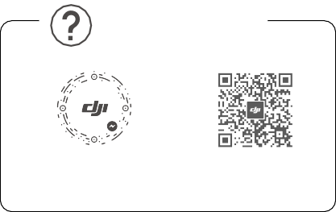

WE ARE HERE FOR YOU

在线技术支持

Contact DJI SUPPORT

via Facebook Messenger

微信扫一扫

获取技术支持

SUBSCRIBE FOR MORE INFORMATION

关注 DJI 大疆创新及时获取最新资讯

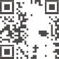





[**www.dji.com/dji-fpv/downloads**](http://www.dji.com/dji-fpv/downloads)

DJI is a trademark of DJI.

Copyright © 2021 DJI All Rights Reserved.

Printed in China.



37QDDJAC03TY

# User Manual

2021.06

v1.2

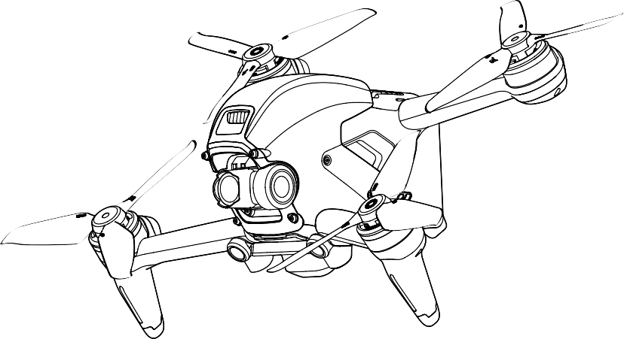



**Searching for Keywords**

Search for keywords such as “battery” and “install” to find a topic. If you are using Adobe Acrobat Reader to read this document, press Ctrl+F on Windows or Command+F on Mac to begin a search.

**Navigating to a Topic**

View a complete list of topics in the table of contents. Click on a topic to navigate to that section.

**Printing this Document**

This document supports high resolution printing.

Revision Log

|  |  |  |
| --- | --- | --- |
| Version | Date | Revisions |
| v1.2 | 2021.06 | 1. Added information for Intelligent Flight Battery maintenance. (P28) 2. Added information for goggles operation. (P32) 3. Modified information of some parameters and RTH when the aircraft is |

in a GEO zone. (P19, P61, P63)

##### Using this Manual

Legend

Warning Important Hints and Tips Reference

Read Before the First Flight

Read the following documents before using DJITM FPV.

1. User Manual
2. Quick Start Guide
3. Disclaimer and Safety Guidelines

It is recommended to watch all tutorial videos on the official DJI website and read the disclaimer and safety guidelines before using for the first time. Prepare for your first flight by reviewing the quick start guide and refer to this user manual for more information.

Video Tutorials

Visit the address below or scan the QR code to watch the DJI FPV tutorial videos, which demonstrate how to use DJI FPV safely:

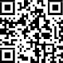[https://www.dji.com/dji-fpv/video](http://www.dji.com/dji-fpv/video)

Download the DJI Fly App

Scan the QR code on the right to download DJI Fly.

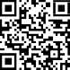The Android version of DJI Fly is compatible with Android v6.0 and later. The iOS version of DJI Fly is compatible with iOS v11.0 and later.

* For increased safety, flight is restricted to a height of 98.4 ft (30 m) and a range of 164 ft (50 m) when not connected or logged into the app during flight. This applies to DJI Fly and all apps compatible with DJI aircraft.

Download the DJI Virtual Flight App

Scan the QR code on the right to download DJI Virtual Flight.

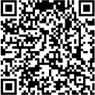The iOS version of DJI Virtual Flight is compatible with iOS v11.0 and later.

Download DJI Assistant 2 (DJI FPV series)

Download DJI ASSISTANTTM 2 (DJI FPV Series) at [https://www.dji.com/dji-fpv/downloads.](http://www.dji.com/dji-fpv/downloads)

 The operating temperature of this product is -10° to 40° C. It does not meet the standard operating temperature for military grade application (-55° to 125° C), which is required to endure greater environmental variability. Operate the product appropriately and only for applications that it meets the operating temperature range requirements of that grade.

##### Contents

**Using this Manual 3**

Legend 3

Read Before the First Flight 3

Video Tutorials 3

Download the DJI Fly App 3

Download the DJI Virtual Flight App 3

Download DJI Assistant 2 (DJI FPV series) 3

**Product Profile** **6**

Introduction 6

Preparing the Aircraft 7

Preparing the Goggles 8

Preparing the Remote Controller 10

Diagram 10

Linking 14

Activation 15

**Aircraft** **16**

Flight Modes 16

Aircraft Status Indicator 17

Return to Home 18

Vision Systems and Infrared Sensing System 20

Flight Recorder 23

Propellers 23

Intelligent Flight Battery 25

Gimbal and Camera 29

**Goggles 31**

Power Supply 31

Operation 32

Home Screen 32

Menu Bar 34

**Remote Controller 39**

Operation 39

Optimal Transmission Zone 43

Stick Adjustment 44

**DJI Fly App 45**

**DJI FPV** User Manual

**Flight 47**

Flight Environment Requirements 47

Flight Limits and GEO Zones 47

Pre-Flight Checklist 48

Starting/Stopping the Motors 49

Flight Test 50

**Maintenance 51**

Goggles 51

Aircraft 52

**Appendix** **61**

Specifications 61

Calibrating the Compass 65

Updating Firmware 66

After-Sales Information 66

**Product Profile**

Introduction

DJI FPV consists of an aircraft, goggles, and remote controller, which all feature DJI’s O3 technology that provides video transmission with a maximum transmission range of 6 mi (10 km), bit rate of up to 50 Mbps, and minimum end-to-end latency within 28 ms. DJI FPV works at both 2.4 and 5.8 GHz and is capable of selecting the best transmission channel automatically. The enhanced anti-interference ability greatly improves the smoothness and stability of the video transmission, providing an integrated and immersive flight experience.

Featuring a Forward and Downward Vision System and Infrared Sensing System, the aircraft can hover and fly indoors as well as outdoors and automatically initiate Return to Home (RTH). With a gimbal and 1/2.3” sensor camera, the aircraft stably shoots 4K 60fps ultra-HD video and 4K photos. The aircraft has a maximum flight speed of 87 mph (140 kph) and a maximum flight time of approximately 20 minutes.

The DJI FPV Goggles V2 are equipped with a high-performance display and support 810p 120fps HD display and real-time audio transmission. By receiving the video signal from the aircraft, users can enjoy a first-person view of their aerial experience in real time. The goggles have a maximum runtime of approximately 1 hour and 50 minutes when used with DJI FPV Goggles Battery and where the ambient temperature is 25° C and the screen brightness is set to 6.

The DJI FPV Remote Controller 2 is equipped with a range of function buttons, which can be used to control the aircraft and operate the camera. The maximum runtime of the remote controller is approximately 9 hours.

 The remote controller reaches its maximum transmission distance (FCC) in a wide-open area with no electromagnetic interference when the aircraft is at an altitude of approximately 400 ft (120 m). The maximum transmission distance refers to the maximum distance that the aircraft can still send and receive transmissions. It does not refer to the maximum distance the aircraft can fly in a single flight.

The end-to-end latency is the total time from camera sensor input to screen display. The DJI FPV can reach its minimum latency in Low Latency mode (810p 120fps) in a wide open area with no electromagnetic interference.

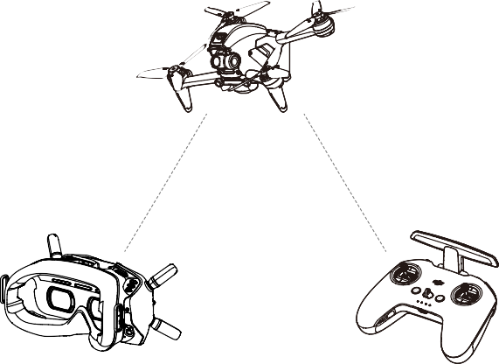

Aircraft

Goggles

Remote Controller

Maximum flight time was tested in an environment with no wind while flying at a consistent 24.9 mph (40 kph) and the maximum flight speed was tested in Manual mode at sea level altitude with no wind. These values are for reference only. The maximum flight speed of the aircraft varies depending on national and regional regulations.

5.8 GHz is not supported in some regions. This frequency band will automatically be disabled when the aircraft is activated or connected to DJI Fly in these regions. Observe local laws and regulations.

Using the goggles does not satisfy the requirement of visual line of sight (VLOS). Some countries or regions require a visual observer to assist by observing the flight. Make sure to comply with local regulations when using the goggles.

Preparing the Aircraft

1. Remove the gimbal protector from the camera.

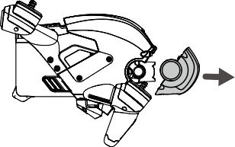

1. Attach the propellers.

Propellers with and without marks indicate different directions of rotation. Attach the propellers with marks to the motors with marks and the unmarked propellers to the motors without marks. Hold the motor, press the propeller down, and rotate in the direction marked on the propeller until it pops up and locks in place.

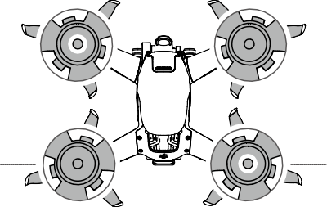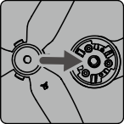A B



B A 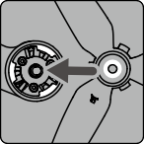

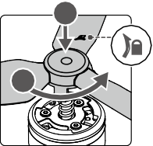

1

2



1. All Intelligent Flight Batteries are in hibernation mode before shipping to ensure safety. Remove the Intelligent Flight Battery and use the provided charger to charge and activate the Intelligent Flight Batteries for the first time. It takes approximately 50 minutes to fully charge an Intelligent Flight Battery.

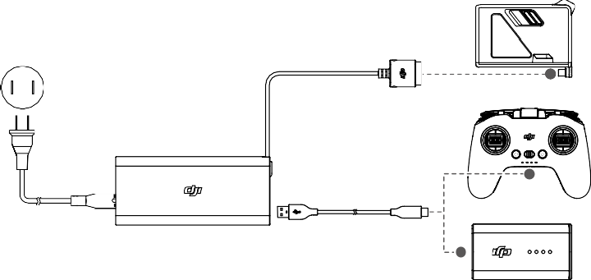

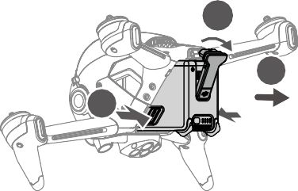

1

3

2

It is recommended to attach a gimbal protector to protect the gimbal when the aircraft is not in use.



 Make sure the gimbal protector is removed before powering on the aircraft. Otherwise, it may affect the aircraft self-diagnostics.



Preparing the Goggles

1. Install the four antennas to the mounting holes on the front of the goggles. Make sure that the antennas are installed securely.

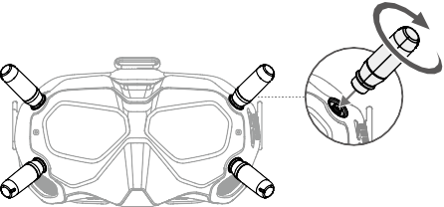

1. Attach the strap to the headband attachment on the top and sides of the goggles.

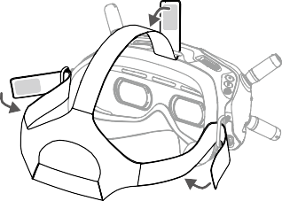

1. Use the included power cable to connect the power port of the goggles to the goggles battery.

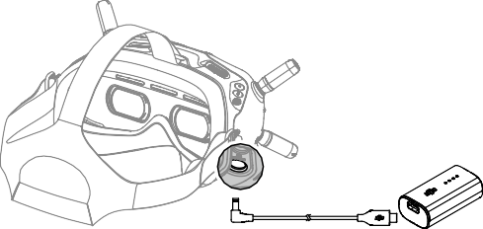

1. Align the lenses over your eyes and pull the headband down. Adjust the headband size until the goggles fit securely and comfortably on your face and head.

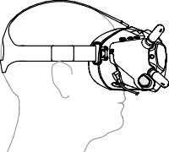

1. Turn the Interpupillary Distance (IPD) slider to adjust the distance between the lenses until the images are

properly aligned.

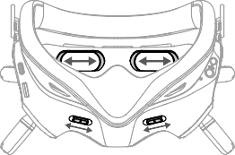

58 – 70 mm

 The goggles can be worn over glasses.

DO NOT use the goggles battery to power other mobile devices.

Preparing the Remote Controller

1. Remove the control sticks from the storage slots on the remote controller and screw them into place.
2. Unfold the antennas.

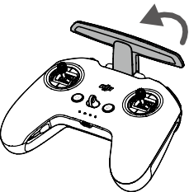

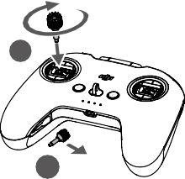

2

1

Diagram

Aircraft

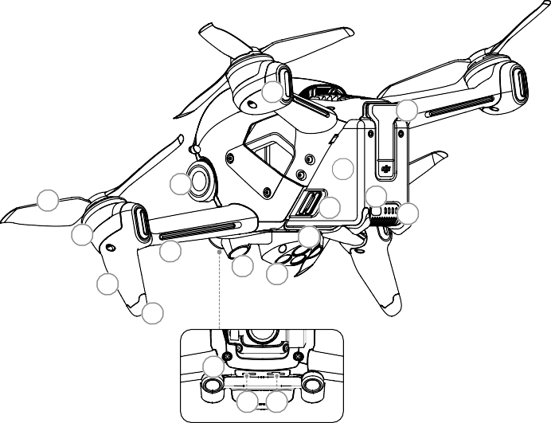

7

15

11

6

1

12

13

14

2

10

5

8

3

9

4

16

17 18

1. Propellers
2. Motors
3. Front LED
4. Landing Gears (Built-in antennas)
5. Frame Arms LED
6. Gimbal and Camera
7. Aircraft Status Indicator
8. Downward Vision System
9. Infrared Sensing System
10. Auxiliary Bottom Light
11. Intelligent Flight Battery
12. Battery Buckles
13. Power Button
14. Battery Level LEDs
15. Power Port
16. Forward Vision System
17. USB-C Port
18. microSD Card Slot

Goggles

* 1. Antennas

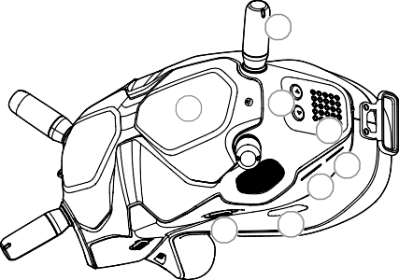

1

2

3

4

5

6

8

7

* 1. Front Cover
  2. Channel Adjustment Buttons
  3. Channel Display
  4. USB-C Port
  5. microSD Card Slot
  6. Air Intake
  7. IPD Slider

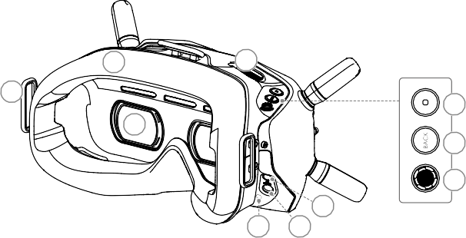

10

12

9

13

11

14

15

16

18 17

* 1. Headband Attachment
  2. Foam Padding
  3. Lens
  4. Air Vent
  5. Shutter/Record Button

Press once to take photos or start or stop recording. Press and hold to switch between photo and video

mode.

* 1. Back Button

Press to return to the previous menu or exit the current mode.

* 1. 5D Button

Toggle the button to scroll through the menu. Press the button to confirm.

On the main screen, toggle left or right to adjust the screen brightness and toggle up or down to adjust the volume. Press the button to enter the menu.

* 1. Audio/AV-IN Port
  2. Power Port (DC5.5×2.1)
  3. Link Button

Remote Controller

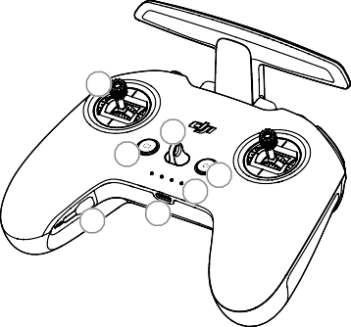

5

3

4

1

2

7

6

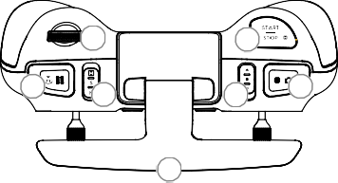

9

12

8

10

11

13

14

1. Power Button

Press once to check the current battery level. Press once, then again, and hold to power the remote controller on or off.

1. Battery Level LEDs

Displays the current battery level of the remote controller.

1. Lanyard Attachment
2. C1 Button (Customizable)

The function of this button can be adjusted in the goggles. By default, press once to adjust or disable Coordinated Turn (S Mode). Press twice to enable or disable ESC Beeping.

1. Control Sticks

Used to control the movements of the aircraft. The control sticks mode can be set in the goggles. The control sticks are removable and easy to store.

1. USB-C Port

For charging and connecting the remote controller to the computer.

1. Control Sticks Storage Slot

For storing the control sticks.

1. Flight Pause/RTH Button

Press once to make the aircraft brake and hover in place (only when GPS or Downward Vision System are available). Press and hold the button to initiate RTH. The aircraft returns to the last recorded Home Point. Press again to cancel RTH.

1. Gimbal Dial

Controls the tilt of the camera.

1. Flight Mode Switch

Switch between Normal, Sport, and Manual mode. Manual mode is disabled by default and must be enabled

in the goggles.

1. C2 Switch (Customizable)

The function of this switch can be adjusted in the goggles. By default, toggle the switch to recenter the gimbal and adjust up and down.

1. Start/Stop Button

When using Sport mode, press once to enable or disable cruise control. When using Manual mode, press twice to start or stop the motor.

When using Normal or Sport mode, press once to cancel Low Battery RTH when the countdown appears in

the goggles.

1. Shutter/Record Button

Press once to take photos or start or stop recording. Press and hold to switch between photo and video

mode.

1. Antennas

Relays aircraft control wireless signals.

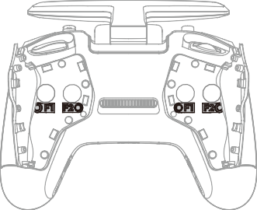

15 16

17 18

1. F1 Right Stick Resistance Adjustment Screw (Vertical)

Tighten the screw clockwise to increase the vertical resistance of the corresponding stick. Loosen the screw

to decrease vertical resistance.

1. F2 Right Stick Recentering Adjustment Screw (Vertical)

Tighten the screw clockwise to disable the vertical recentering of the corresponding stick. Loosen the screw to enable vertical recentering.

1. F1 Left Stick Resistance Adjustment Screw (Vertical)

Tighten the screw clockwise to increase the vertical resistance of the corresponding stick. Loosen the screw

to decrease vertical resistance.

1. F2 Left Stick Recentering Adjustment Screw (Vertical)

Tighten the screw clockwise to disable the vertical recentering of the corresponding stick. Loosen the screw to enable vertical recentering.

Linking

The devices are all linked before shipping. Linking is only required when using a new device for the first time. Follow the steps below to link the aircraft, goggles, and remote controller:

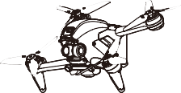

1. Power on the aircraft, goggles, and remote controller.
2. Press the link button on the goggles. The goggles will start to beep continually.
3. Press and hold the power button of the aircraft until the battery level LEDs start to blink in sequence.

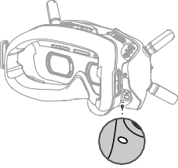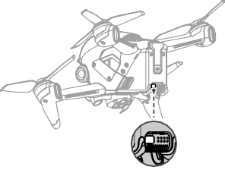

1. The battery level LEDs of the aircraft turn solid and display the battery level. The goggles stop beeping when they are successfully linked and the video display is normal.
2. Press and hold the power button of the aircraft until the battery level LEDs start to blink in sequence.
3. Press and hold the power button of the remote controller until it starts to beep continually and the battery level LEDs blinks in sequence.

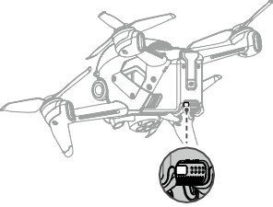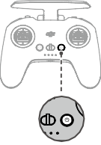

1. Once linking is successful, the remote controller stops beeping and both the battery level LEDs turn solid and display the battery level.

 Make sure the goggles and the remote controller are within 0.5 m of the aircraft during linking.  The aircraft must be linked with the goggles before the remote controller.

Activation

DJI FPV must be activated before using for the first time. Make sure all devices are linked after powering on the aircraft, goggles, and remote controller. Connect the USB-C port of the goggles to the mobile device, run DJI Fly, and follow the prompts to activate. An internet connection is required for activation.

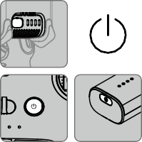

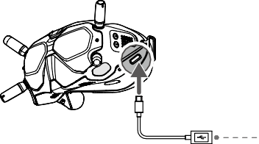

**DJI Fly App**

Press and then press and hold to power devices on or off.

##### Aircraft

DJI FPV contains a flight controller, a gimbal and camera, video downlink system, vision system, propulsion

system, and an Intelligent Flight Battery.

Flight Modes

DJI FPV has three flight modes, plus a fourth flight mode that the aircraft switches to in certain scenarios. Flight modes can be switched via the flight mode switch on the remote controller.

Normal Mode: The aircraft utilizes GPS, the Forward and Downward Vision Systems, and the Infrared Sensing System to locate itself and stabilize. The aircraft will use GPS to locate itself when the GPS signal is strong and use the Downward Vision System to locate and stabilize itself when the lighting conditions are sufficient. When the Downward Vision System is enabled and lighting conditions are sufficient, the maximum flight attitude angle is 25° and the maximum flight speed is 15 m/s.

Sport Mode: The aircraft uses GPS and the Downward Vision System for positioning. In Sport mode, aircraft responses are optimized for agility and speed making it more responsive to control stick movements. The maximum flight speed is 27 m/s, maximum ascent speed is 15 m/s, and maximum descent speed is 10 m/s.

Manual Mode: Classic FPV aircraft control mode with the highest maneuverability, which can be used for racing and freestyle flying. In Manual mode, all flight assistance functions such as automatic stabilization are disabled and proficient control skills are required. The throttle stick can be adjusted in this mode.

In Normal or Sport mode, when the Downward Vision System is unavailable or disabled and when the GPS signal is weak or the compass experiences interference, the aircraft cannot position itself or brake automatically, which increases the risk of potential flight hazards. At this time, the aircraft may be more easily affected by its surroundings. Environmental factors such as wind can result in horizontal shifting, which may present hazards, especially when flying in confined spaces.

 When using Manual mode, move the remote control stick to directly control the throttle and attitude of the aircraft. The aircraft has no flight assistance functions such as automatic stabilization and can reach any attitude. Only experienced pilots should use Manual mode. Failure to operate in this mode properly is a safety risk and may even lead to the aircraft crashing.

Manual mode is disabled by default. Make sure that the switch is set to Manual mode in the goggles before switching to Manual mode. The aircraft will remain in Normal or Sport mode if the switch is not set to Manual mode in the goggles. Go to Settings, Control, Remote Control, and then Button Customization and set the Custom Mode to Manual Mode.

Before using Manual mode, it is recommended to adjust the screw on the rear of the throttle stick so that the stick does not recenter and to practice flying in the mode using DJI Virtual Flight.

When using Manual mode for the first time, the maximum attitude of the aircraft will be limited. After you are familiar with flying in Manual mode, the attitude restriction can be disabled in the goggles. Go to Settings, Control, Remote Control, RC Exp, and then M Mode Attitude Limit.

The maximum speed and braking distance of the aircraft significantly increase in Sport mode. A minimum braking distance of 30 m is required in windless conditions.

Descent speed significantly increases in Sport mode. A minimum braking distance of 10 m is required in windless conditions.

The responsiveness of the aircraft significantly increases in Sport mode, which means a small control stick movement on the remote controller translates into the aircraft moving a large distance. Be vigilant and maintain adequate maneuvering space during flight.

Aircraft Status Indicator

DJI FPV has a front LED, frame arm LED, and aircraft status indicator.

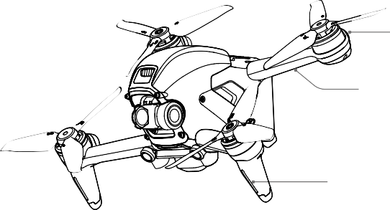Aircraft Status Indicator

Frame Arm LED

Front LED

The front LED shows the orientation of the aircraft and the frame arm LED is for decoration. The LEDs turns solid blue when the aircraft is powered on. The colors and lighting methods of the front LED and frame arm LED can be customized in the goggles.

The aircraft status indicator shows the status of the flight control system of the aircraft. Refer to the table below for more information about the aircraft status indicator.

Aircraft Status Indicator States



Blinks red, yellow, and green alternately Powered on and performing self-diagnostic tests

Blinks green slowly

GPS enabled

Blinks yellow slowly

GPS and Forward and Downward Vision System disabled

Blinks yellow quickly

Remote controller signal lost

Blinks red quickly

Critically low battery

—

Solid red

Critical error

Warning States

Braking

Blinks green quickly

Blinks red and yellow alternately Compass calibration required

Blinks red IMU error

Blinks red slowly Low battery

×2 Blinks green twice repeatedly Forward and Downward Vision Systems enabled

Blinks purple slowly Warming up

Normal States

Return to Home

The Return to Home (RTH) function brings the aircraft back to the last recorded Home Point and lands when the GPS is signal is strong. There are three types of RTH: Smart RTH, Low Battery RTH, and Failsafe RTH. If the aircraft successfully recorded the Home Point and the GPS signal is strong, the RTH will be triggered when either Smart RTH is initiated, the aircraft battery level is low, or the signal between the remote controller and the aircraft is lost. RTH will also be triggered in other abnormal scenarios such as if there is a loss of video transmission.

|  |  |  |
| --- | --- | --- |
|  | GPS | Description |
| Home Point | **20** | The default Home Point is the first location where the aircraft received a strong or moderately strong GPS signal (where the icon shows white). The aircraft status indicator blinks green quickly and a prompt appears in the goggles to confirm the Home Point has been recorded. |

Smart RTH

If the GPS signal is sufficient, Smart RTH can be used to bring the aircraft back to the Home Point. Smart RTH is initiated by pressing and holding the RTH button on the remote controller. Exit Smart RTH by pressing the RTH button.

Low Battery RTH

When the Intelligent Flight Battery level is too low and there is not enough power to return home, land the aircraft as soon as possible. Otherwise, the aircraft will fall when it runs out of power, resulting in the aircraft being damaged and other potential hazards.

To avoid unnecessary danger due to insufficient power, DJI FPV will intelligently determine whether the current battery level is sufficient to return to the Home Point based on the current location. Low Battery RTH is triggered when the Intelligent Flight Battery is depleted to the point that the safe return of the aircraft may be affected.

RTH can be cancelled by pressing the RTH button on the remote controller. If RTH is cancelled following a low battery level warning, the Intelligent Flight Battery may not have enough power for the aircraft to land safely, which may lead to the aircraft crashing or being lost.

The aircraft will land automatically if the current battery level can only support the aircraft long enough to descend from its current altitude. Auto landing cannot be canceled, but the remote controller can be used to alter the direction of the aircraft during the landing process.

 Manual mode does not support Low Battery RTH. If a prompt appears on the goggles that the battery only has enough power to return to the home point, the user must fly the aircraft to the home point manually.

Failsafe RTH

If the Home Point was successfully recorded and the compass is functioning normally, Failsafe RTH automatically activates after the remote controller signal is lost for more than 3.5 seconds.

The aircraft will fly backwards for 50 m on its original flight route and enter Straight Line RTH. The aircraft enters Straight Line RTH if the remote controller signal is restored during Failsafe RTH.

The response of the aircraft when the wireless signal is lost can be changed in the goggles. The aircraft will not execute Failsafe RTH if land or hover has been selected in the settings.

Other RTH Scenarios

A prompt will appear in the goggles and RTH will be initiated if the video download signal is lost during flight while

the remote controller can still be used to control the movements of the aircraft.

RTH (Straight Line)

1. The Home Point is recorded.
2. RTH is triggered.
3. If the aircraft is less than 5 m from the Home Point when RTH begins, it lands immediately.

If the aircraft is more than 5 m and less than 50 m from the Home Point when RTH begins, it will return home at the current altitude with a maximum horizontal speed of 3 m/s.

If the aircraft is further than 50 m from the Home Point when RTH begins, it will ascend to the RTH altitude and return home at a speed of 13.5 m/s. The aircraft flies to the Home Point at the current altitude if the RTH altitude is lower than the current altitude.

1. After reaching the Home Point, the aircraft lands and the motors stop.

Obstacle Avoidance During RTH

1. The aircraft brakes when an obstacle is sensed from in front and ascends to a safe distance. After ascending another 5 m, the aircraft will continue to fly forward.
2. The aircraft brakes when an obstacle is sensed from below and ascends until obstacles are no longer sensed before flying forward.

 During RTH, the aircraft cannot sense obstacles to the side, rear, or from above.

The aircraft cannot avoid obstacles during RTH if the Forward and Downward Vision Systems are unavailable.

The aircraft cannot return to the Home Point if the GPS signal is weak or unavailable. If the GPS signal becomes weak or unavailable after RTH is triggered, the aircraft will hover in place for a while before landing.

Before each flight, it is important to enter Settings and then Safety on the goggles and set a suitable RTH altitude.

During RTH, if the aircraft is flying forward and the remote controller signal is normal, the remote controller can be used to control the speed of the aircraft, but cannot control the orientation or fly left or right. The orientation and horizontal position of the aircraft can be controlled when it is descending. When the aircraft is ascending or flying forward, push the control stick completely in the opposite direction to exit RTH.

GEO zones will affect RTH. The aircraft will hover in place if it flies into a GEO zone during RTH.

The aircraft may not be able to return to a Home Point when the wind speed is too high. Fly with caution.

Landing Protection

Landing Protection will activate during Smart RTH.

1. During Landing Protection, the aircraft will automatically detect and carefully land on suitable ground.
2. If the ground is determined unsuitable for landing, the aircraft will hover and wait for pilot confirmation.
3. If Landing Protection is not operational, the goggles will display a landing prompt when the aircraft descends to 0.3 m. Pull down on the throttle stick to land.

Vision Systems are disabled during landing. Make sure to land the aircraft with caution.

Precision Landing

The aircraft automatically scans and attempts to match the terrain features below during RTH. The aircraft will land when the terrain matches the terrain of the Home Point. A prompt will appear in the goggles if the terrain fails to match.

 Landing Protection is activated during Precision Landing.

The performance of Precision Landing is subject to the following:

* 1. The Home Point must be recorded upon takeoff and must not be changed during flight. Otherwise, the aircraft will have no record of the terrain features of the Home Point.
  2. During takeoff, the aircraft must ascend vertically to at least 7 m before moving horizontally.
  3. The terrain features of the Home Point must remain largely unchanged after it is recorded.
  4. The terrain features of the Home Point must be sufficiently distinctive.
  5. The lighting conditions must not be too light or dark. The following actions are available during Precision Landing:

1. Pull the throttle stick down to accelerate landing.
2. Pull the throttle stick up or move the other control stick to stop Precision Landing. Landing Protection remains active while the aircraft descends vertically.

Vision Systems and Infrared Sensing System

DJI FPV aircraft is equipped with both an Infrared Sensing System and Forward and Downward Vision Systems.

The Forward and Downward Vision Systems consist of two cameras each and the Infrared Sensing System consists of two 3D infrared modules.

The Downward Vision System and Infrared Sensing System help the aircraft maintain its current position, hover in place more precisely, and to fly indoors or in other environments where GPS is unavailable. In addition, the auxiliary bottom light located on the underside of the aircraft improves visibility for the Downward Vision System in weak light conditions.

Forward Vision System

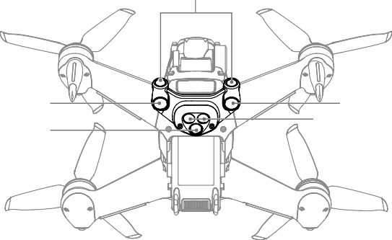Downward Vision System Auxiliary Bottom Light

Downward Vision System Infrared Sensing System

Detection Range

Forward Vision System

The Forward Vision System has a detection range of 0.5 to 18 m, horizontal FOV of 56°, and vertical FOV of 71°.

Downward Vision System

The Downward Vision System works best when the aircraft is at an altitude of 0.5 to 15 m and its operating range is 0.5 to 30 m. The FOV to the front and rear is 106° and 90° to the right and left.

0.5-18 m

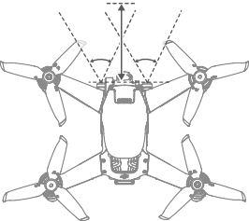

56° 56°

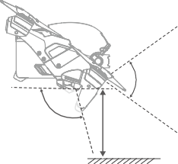

71°

106°

0.5-30 m

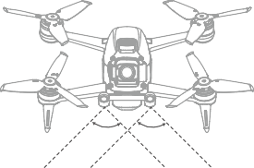

90° 90°

Calibrating Vision System Cameras

Auto Calibration

The Vision System cameras installed on the aircraft are calibrated before shipping. If any abnormality is detected with a Vision System camera, the aircraft will automatically calibrate and a prompt will appear in the goggles. No further action is required to address the issue.

Advanced Calibration

If the abnormality persists after auto calibration, a prompt appears in the goggles that advanced calibration is required. Advanced calibration can only be performed using DJI Assistant 2 (DJI FPV series). Follow the steps below to calibrate the Forward Vision System cameras and repeat the steps to calibrate the other Vision System cameras.

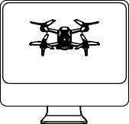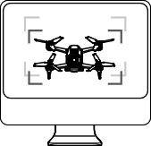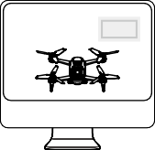

|  |  |  |
| --- | --- | --- |
| 1 | 2 | 3 |
| Point the aircraft toward the screen. | Align the boxes. | Pan and tilt the aircraft. |

Using the Vision Systems

The Downward Vision System is available if the surface has a clear texture and there is sufficient light. The Downward Vision System works best when the aircraft is at an altitude of 0.5 to 15 m. If the altitude of the aircraft is above 15 m, the Vision System may be affected. Extra caution is required.

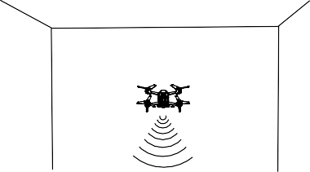

Follow the steps below to use the Downward Vision System.

1. Make sure the aircraft is in Normal mode. Power on the aircraft.
2. The aircraft hovers in place after takeoff. The aircraft status indicator on the rear frame arm blinks green twice to indicate the Downward Vision System is working.

If the aircraft is in Normal mode and Obstacle Slowing is enabled in the goggles, the Forward Vision System will activate automatically when the aircraft is powered on. The Forward Vision System enables the aircraft to actively slow down when an obstacle is detected. The Forward Vision System works best with adequate lighting and clearly marked or textured obstacles. Due to inertia, users need to control the aircraft to brake within a reasonable distance.

 Pay attention to the flight environment. The Forward and Downward Vision Systems and Infrared Sensing System only work in certain scenarios and cannot replace human control and judgment. During flight, pay attention to the surrounding environment and to the warnings on the goggles. Be responsible for and maintain control of the aircraft at all times.

The aircraft has a max hovering altitude of 30 m when using the Vision System in an open and flat environment. The best positioning altitude range of the Vision System is 0.5 to 15 m. The vision positioning performance may decrease when flying beyond this range. Fly with caution.

The Auxiliary Bottom Light can be set on the goggles to on, off, or auto. In Auto, the auxiliary bottom light is automatically enabled when there is insufficient ambient light. The vision positioning performance will be negatively affected during this time. Be careful when flying if the GPS signal is weak.

The Downward Vision System may not function properly when the aircraft is flying over water. Therefore, the aircraft may not be able to actively avoid water below when landing. It is recommended to maintain flight control at all times, make reasonable judgments based on the surrounding environment, and avoid relying on the Downward Vision System.

Note that the Forward and Downward Vision Systems and Infrared Sensing System may not function properly when the aircraft is flying too fast.

The Downward Vision System cannot work properly over surfaces that do not have clear pattern variations or there is weak light. The Downward Vision System cannot work properly in any of the following situations. Operate the aircraft cautiously.

* 1. Flying over monochrome surfaces (e.g., pure black, pure white, pure green).
  2. Flying over highly reflective surfaces.
  3. Flying over water or transparent surfaces.
  4. Flying over moving surfaces or objects.
  5. Flying in an area where the lighting changes frequently or drastically.
  6. Flying over extremely dark (< 10 lux) or bright (> 40,000 lux) surfaces.
  7. Flying over surfaces that strongly reflect or absorb infrared waves (e.g., mirrors).
  8. Flying over surfaces without clear patterns or texture. (e.g., power poles).
  9. Flying over surfaces with repetitive identical patterns or textures (e.g., tiles with the same design).
  10. Flying over obstacles with small surface areas (e.g., tree branches).

Keep the sensors clean at all times. DO NOT tamper with the sensors. DO NOT use the aircraft in environments with significant dust or humidity. DO NOT obstruct the Infrared Sensing System.

The camera must be calibrated if the aircraft is involved in a collision. Calibrate the cameras if prompted

to do so in the goggles.

DO NOT fly when it is rainy, foggy, or if there is no clear sight. Check the following every time before takeoff:

1. Make sure there are no stickers or any other obstructions over the Infrared Sensing System or

Vision Systems.

1. If there is any dirt, dust, or water on the Infrared Sensing System or Vision Systems, clean with a soft cloth. DO NOT use any cleanser that contains alcohol.
2. Contact DJI Support if there is any damage to the glass of the Infrared Sensing System or Vision Systems.

Flight Recorder

Flight data including flight telemetry, aircraft status information, and other parameters are automatically saved to the internal data recorder of the aircraft. The data can be accessed using DJI Assistant 2 (DJI FPV series).

Propellers

There are two types of DJI FPV Quick-Release Propellers, which are designed to spin in different directions. Marks are used to indicate which propellers should be attached to which motors. Make sure to match the propeller and motor following the instructions.

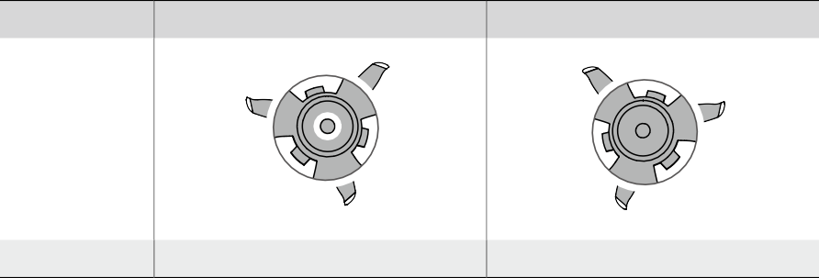

Propellers

With Marks

Without Marks

Illustration

Mounting Position

Attach on motors with marks

Attach on motors without marks

Attaching the Propellers

Attach the propellers with marks to the motors with marks and the unmarked propellers to the motors without marks. Hold the motor, press the propeller down, and rotate in the direction marked on the propeller until it pops up and locks in place.

A B

 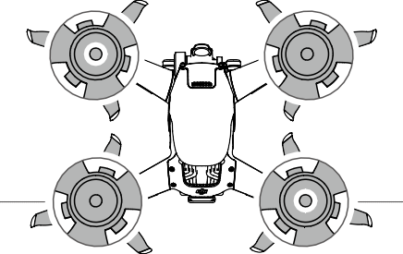 

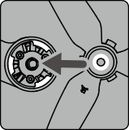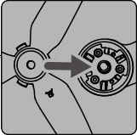B A

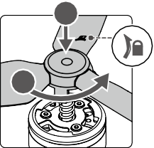

1

2

Detaching the Propellers

Hold the motor, press the propeller down, and rotate in the opposite direction to the one marked on the propeller until it pops out.

 Propeller blades are sharp. Handle with care.

Only use official DJI propellers. DO NOT mix propeller types. Purchase the propellers separately if necessary.

Make sure that the propellers are properly attached before each flight.

Make sure all propellers are in good condition before each flight. DO NOT use aged, chipped, or broken

propellers.

Stay away from the rotating propellers and motors to avoid injuries.

Detach the propellers when storing. DO NOT squeeze or bend the propellers during transportation or

storage.

Make sure the motors are mounted securely and rotating smoothly. Land the aircraft immediately if a motor is stuck and unable to rotate freely.

DO NOT attempt to modify the structure of the motors.

DO NOT touch or let your hands or body come in contact with the motors after flight as they may be hot. DO NOT block any of the ventilation holes on the motors or the body of the aircraft.

Make sure the ESCs sound normal when powered on.

Intelligent Flight Battery

The FPV Intelligent Flight Battery is a 22.2 V, 2000 mAh battery with smart charging and discharging functionality.

Battery Features

1. Battery Level Display: the battery level LEDs display the current battery level.
2. Auto-Discharging Function: to prevent swelling, the battery automatically discharges to approximately 97% of the battery level when it is idle for one day, and automatically discharges to approximately 60% of the battery level when it is idle for five days. It is normal to feel moderate heat being emitted from the battery while it is discharging.
3. Balanced Charging: the voltages of the battery cells are automatically balanced during charging.
4. Overcharge Protection: the battery stops charging automatically once fully charged.
5. Temperature Detection: to prevent damage, the battery only charges when the temperature is between 41° and 104° F (5° and 40° C). Charging stops automatically if the temperature of the battery exceeds 122° F (50° C) during charging.
6. Overcurrent Protection: the battery stops charging if an excess current is detected.
7. Over-discharge Protection: discharging stops automatically to prevent excess discharge when the battery is not in flight use. Over-discharge protection is not enabled when the battery is in flight use.
8. Short Circuit Protection: the power supply is automatically cut if a short circuit is detected.
9. Battery Cell Damage Protection: the goggles display a warning prompt when a damaged battery cell is

detected.

1. Hibernation Mode: the battery switches off after 20 minutes of inactivity to save power. If the battery level is less than 10%, the battery enters Hibernation mode to prevent over-discharge after being idle for six hours. In Hibernation mode, the battery level indicators do not illuminate. Charge the battery to wake it from hibernation.
2. Communication: information about the voltage, capacity, and current of the battery is transmitted to the

aircraft.

 Refer to the DJI FPV Disclaimer and Safety Guidelines and the stickers on the battery before use. Users accept full responsibility for any violations of the safety requirements stated on the label.

Using the Battery

Checking Battery Level

Press the power button once to check the battery level.

Power Button Battery Level LEDs

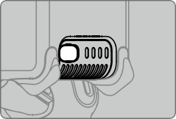

LED1 LED2 LED3 LED4

The battery level LEDs display the power level of the flight battery during charging and discharging. The statuses of the LEDs are defined below:



LED is on.

LED is flashing.

LED is off.



|  |  |  |  |  |
| --- | --- | --- | --- | --- |
| LED1 | LED2 | LED3 | LED4 | Battery Level |
|  |  |  |  | Battery Level > 88% |
|  |  |  |  | 75% < Battery Level ≤ 88% |
|  |  |  |  | 63% < Battery Level ≤ 75% |
|  |  |  |  | 50% < Battery Level ≤ 63% |
|  |  |  |  | 38% < Battery Level ≤ 50% |
|  |  |  |  | 25% < Battery Level ≤ 38% |
|  |  |  |  | 13% < Battery Level ≤ 25% |
|  |  |  |  | 0% < Battery Level ≤ 13% |

Powering On/Off

Press the power button once and then press again and hold for two seconds to power the battery on or off. The battery level LEDs display the battery level when the aircraft is powered on.

Low Temperature Notice

1. Battery capacity is significantly reduced when flying in low-temperature environments of 14° to 41° F (-10° to 5° C). It is recommended to hover the aircraft in place for a while to heat the battery. Make sure to fully charge the battery before takeoff.
2. Batteries cannot be used in extremely low-temperature environments lower than 14° F (-10° C).
3. When in low-temperature environments, end the flight as soon as the goggles display the low battery voltage warning.
4. To ensure optimal performance, keep the battery temperature above 68° F (20° C).
5. The reduced battery capacity in low-temperature environments reduces the wind speed resistance performance of the aircraft. Fly with caution.
6. Exercise extra caution when flying high above sea level.

 In cold environments, insert the battery into the battery compartment and power on the aircraft to warm up before taking off.

Charging the Battery

Use the provided DJI charger to fully charge the Intelligent Flight Battery before every flight.

1. Connect the AC power adapter to an AC power supply (100-240 V, 50/60 Hz).
2. Attach the Intelligent Flight Battery to the AC power adapter using the battery charging cable with the battery powered off.
3. The battery level LEDs display the current battery level during charging.
4. The Intelligent Flight Battery is fully charged when all the battery level LEDs are off. Detach the charger when the battery is fully charged.

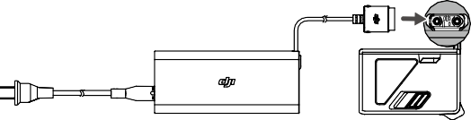

 The charging time is approximately 50 minutes.

It is recommended to discharge the Intelligent Flight Batteries to 30% or lower. This can be done by flying the aircraft outdoors until there is less than 30% charge left.

 DO NOT charge an Intelligent Flight Battery immediately after flight as the temperature may be too high. Wait until it cools down to room temperature before charging again.

The charger stops charging the battery if the battery cell temperature is not within the operating range of 41° to 104° F (5° to 40° C). The ideal charging temperature is 71.6° to 82.4° F (22° to 28° C).

The Battery Charging Hub (not included) can charge up to three batteries. Visit the official DJI online store for more information about the Battery Charging Hub.

Fully charge the battery at least once every three months to maintain battery health. DJI does not take any responsibility for damage caused by third-party chargers.

The table below shows the battery level during charging.



LED1

LED2

LED3

LED4

Battery Level

0% < Battery Level ≤ 50%

50% < Battery Level ≤ 75%

75% < Battery Level < 100% Fully Charged

Battery Protection Mechanisms

The battery level LEDs can display battery protection notifications triggered by abnormal charging conditions.

Battery Protection Mechanisms

LED1 LED2 LED3 LED4 Blinking Pattern Status

LED2 blinks twice per second Overcurrent detected

LED2 blinks three times per second Internal communication abnormal LED3 blinks twice per second Overcharge detected

LED3 blinks three times per second Over-voltage charger detected LED4 blinks twice per second Charging temperature is too low

LED4 blinks three times per second Charging temperature is too high

If any of the battery protection mechanisms are activated, unplug the charger, and plug it in again to resume charging. If the charging temperature is abnormal, wait for the charging temperature to return to normal and the battery will automatically resume charging without the need to unplug and plug the charger again.

Installing/Removing the Battery

Install the Intelligent Flight Battery in the aircraft before use. Insert the Intelligent Flight Battery into the battery compartment of the aircraft. Make sure it is mounted securely and that the battery buckles are clicked into place before connecting it to the power port.

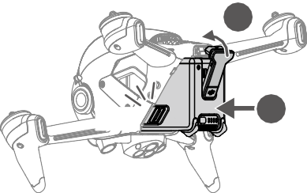

2

Click

1

Disconnect the power port, press the battery buckles on the sides of the Intelligent Flight Battery, and remove it

from the compartment.

 DO NOT detach the battery when the aircraft is powering on.

Make sure that the battery is mounted firmly.

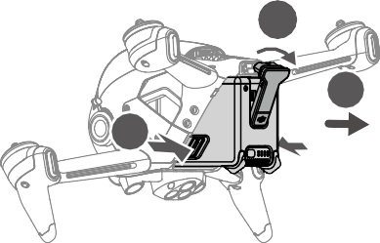

1

3

2

Maintenance

Return to home or land promptly if a prompt appears in the goggles that the Intelligent Flight Battery requires

maintenance.

1. Fully charge the battery.
2. Leave the battery for 24 hours.
3. Insert the battery in the aircraft and hover at an altitude of up to 2 m after takeoff. When the battery reaches 20%, land the aircraft and power off and remove the battery.
4. Leave the battery for 6 hours.
5. Maintenance should now be complete and the battery is ready to use. Repeat the steps above if the maintenance prompt continues to appear in the goggles.

Gimbal and Camera

Gimbal Profile

The gimbal of DJI FPV aircraft stabilizes the camera and users can capture clear and stable images and videos even when the aircraft is flying at high speeds thanks to DJI’s RockSteady electronic stabilization. The control tilt range is -50° to +58°. Use the gimbal dial on the remote controller to control the tilt of the camera.

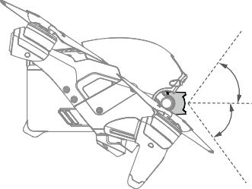58°

0°

-50°

Gimbal Mode

The gimbal mode will automatically switch according to the flight mode.

Normal/Sport mode: the gimbal is in attitude stabilization mode. The tilt angle of the gimbal remains stable relative to the horizontal plane, which is suitable for shooting stable images.

Manual mode: the gimbal is in FPV mode. The tilt angle of the gimbal remains stable relative to the aircraft body, which is suitable for FPV flight experience.

 When the aircraft is powered on, do not tap or knock the gimbal. Take off from open and flat ground to protect the gimbal during takeoff.

Precision elements in the gimbal may be damaged in a collision or impact, which may cause the gimbal to function abnormally.

Avoid getting dust or sand on the gimbal, especially in the gimbal motors.

A gimbal motor error may occur if the aircraft is on uneven ground, the gimbal is obstructed, or if the gimbal experiences excessive external force such as in a collision.

DO NOT apply external force to the gimbal after the gimbal is powered on. DO NOT add any extra payload to the gimbal as this may cause the gimbal to function abnormally or even lead to permanent motor damage.

Make sure to remove the gimbal protector before powering on the aircraft. Also, make sure to mount the gimbal protector when the aircraft is not in use.

Flying in heavy fog or clouds may make the gimbal wet, leading to temporary failure. The gimbal recovers full functionality once it is dry.

Camera Profile

DJI FPV uses a 1/2.3" CMOS sensor camera with a resolution of up to 12 million effective pixels. The aperture of the lens is F2.8, the focus range is 0.6 m to infinity, and the FOV of the lens can reach 150°.

DJI FPV camera can shoot up to 4K 60fps HD video and 4K photos.

 4K video can only be recorded when the transmission quality is set to high quality.

Make sure the temperature and humidity are suitable for the camera during usage and storage.

Use a lens cleanser to clean the lens to avoid damage.

DO NOT block any ventilation holes on the camera as the heat generated may damage the device and injure the user.

Storing Photos and Videos

DJI FPV supports the use of a microSD card to store photos and videos. A UHS-I Speed Grade 3 rating or above microSD card is required due to the fast read and write speeds necessary for high-resolution video data. Refer to the Specifications for more information about recommended microSD cards.

 DO NOT remove the microSD card or the Intelligent Flight Battery from the aircraft while it is powered on. Otherwise, the microSD card may be damaged.

To ensure the stability of the camera system, single video recordings are limited to 30 minutes, after which recording will automatically stop.

Check camera settings before use to make sure the configurations are correct.

Before shooting important photos or videos, shoot a few images to test the camera is operating

correctly.

Photos or videos cannot be transferred from the microSD card in the aircraft using DJI Fly if the aircraft is powered off.

Make sure to power off the aircraft correctly. Otherwise, the camera parameters will not be saved and any recorded videos may be affected. DJI is not responsible for any failure of an image or video to be recorded or having been recorded in a way that is not machine-readable.

##### Goggles

The DJI FPV Goggles V2 give users a first-person view of the aerial camera with real-time video and audio transmission. They can also be used to play videos recorded by the goggles and set transmission, control, and camera parameters.

 The DJI FPV Goggles V2 can also be used with the DJI FPV Air Unit. For more information, refer to the DJI Digital FPV System User Manual at [https://www.dji.com/fpv/info#downloads.](http://www.dji.com/fpv/info#downloads) The DJI FPV Goggles V2 are not compatible with the DJI FPV Air Unit in regions that do not support 5.8 GHz. Observe local laws and regulations.

Power Supply

Use the included goggles power cable (USB-C) to connect the power port of the goggles to the goggles battery.

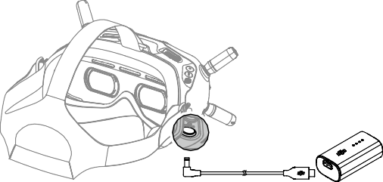

Press the power button once to check the current battery level.

Press once then press again and hold to power the goggles on or off.

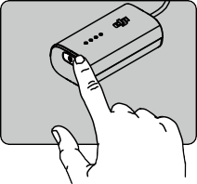

Charge the goggles battery if the battery level is low. It takes approximately 2 hours and 30 minutes to fully charge the battery.

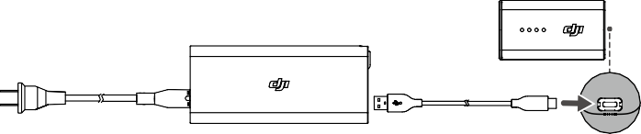

 If you need other batteries, prepare an external power supply with an input voltage of 11.1-25.2 V. The DJI FPV Goggles Power Cable (XT60) (not included) can be used with an external power supply to power the goggles. Visit the official DJI online store for more information about the DJI FPV Goggles Power Cable (XT60).

 Operation

5D Button

Toggle the button to scroll through the menu. Press the button to confirm.

On the home screen, press the button to enter the menu. Toggle left or right to adjust the screen brightness. Toggle up or down to adjust the volume.

Shutter/Record Button



Press once to take photos or start or stop recording. Press and hold to switch between photo and video mode.

Back Button

Press to return to the previous menu or exit the current mode.

Channel Adjustment Buttons Press the up or down button to switch channels (only available

when in manual channel mode).

Channel Display

Displays the current channel of the goggles (will display A when in auto channel mode).

Home Screen

1

2

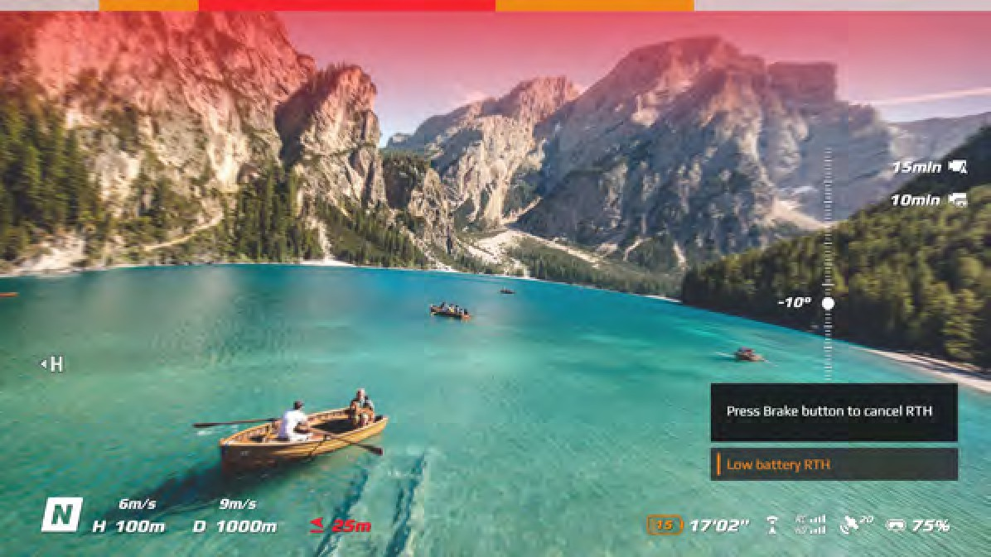

3

14

4

13 12 11

10 9

8 7 6 5

1. Obstacle Detection Status

Indicates the distance between the aircraft and obstacles as well as the general direction of the obstacles. Red, orange, and gray bars indicate the relative distance ranging from near to far. Red bars are displayed when obstacles are close to the aircraft and orange bars are displayed when obstacles are within the detection range. Gray bars indicate there are no obstacles within the detection range.

1. microSD Card Information

Displays whether or not a microSD card is inserted in the aircraft or goggles as well as the remaining capacity. A flashing icon will appear when recording.

1. Gimbal Slider

Displays the gimbal tilt angle when the gimbal dial is toggled.

1. Prompts

Displays information such as when switching modes, when the battery level is low, and other warnings.

1. Goggles Battery Level

Displays the battery level of the goggles. The goggles will beep when the battery level is too low. The voltage will also be displayed if a third-party battery is being used.

1. GPS Status

Displays the current strength of the GPS signal.

1. Remote Controller and Video Downlink Signal Strength

Displays the remote controller signal strength between the aircraft and remote controller and the video downlink signal strength between the aircraft and the goggles.

1. Forward Vision System Status

Displays the status of the Forward Vision System. The icon is white when the Forward Vision System is working normally. Red indicates that the Forward Vision System is not enabled or working abnormally and the aircraft cannot automatically slow down when encountering obstacles.

1. Remaining Flight Time

Displays the remaining flight time of the aircraft after starting the motors.

1. Aircraft Battery Level

Displays the current battery level of the Intelligent Flight Battery on the aircraft.

1. Distance to the Ground

Displays the current altitude information of the aircraft from the ground when the aircraft is less than 10 m above the ground.

1. Flight Telemetry

D 1000 m, H 100 m, 9 m/s, 6 m/s: displays the distance between the aircraft and the Home Point, height from the Home Point, aircraft horizontal speed, and aircraft vertical speed.

1. Flight Modes

Displays the current flight mode.

1. Home Point

Indicates the location of the Home Point.

The goggles will display the screen saver if they are not used for an extended period or disconnected from the aircraft. Press any button of the goggles or relink them to the aircraft to restore the video transmission display.

If the devices are not used for an extended period, it may take longer than usual to search for the GPS signal. If the signal is unobstructed, it takes approximately 20 seconds to search for the GPS signal when powering on and off within a short period.

If you select to record with both the aircraft and the goggles, the microSD card information of both the aircraft and goggles will be displayed on the home screen. If you select to record with only the aircraft or goggles, only the microSD card information of the corresponding device will be displayed.

Menu Bar

Press the 5D button on the goggles to enter the menu bar.

Status

Displays detailed information for current status warning prompts. Calibration is required if there are any IMU or compass abnormalities.

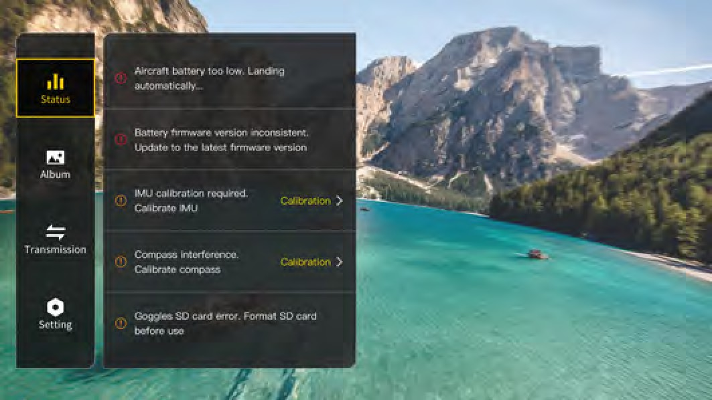

Album

Shows the photos or videos stored on the microSD of the goggles. Select the file and confirm to preview.

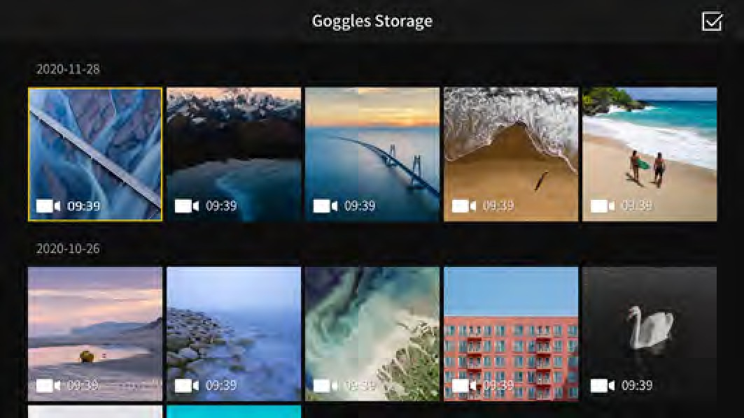

 Photos and videos recorded by the aircraft can be previewed. Insert the microSD card of the aircraft into the microSD card slot of the goggles.

During video playback, press the 5D button to pause or continue, toggle the 5D button left or right to adjust the progress bar, and toggle up or down to adjust the volume.

Transmission

The video transmission of the current device can be set under Pilot settings. Nearby video transmission devices and their signal strength can be viewed in Audience mode. Select a channel to see the camera view.

1

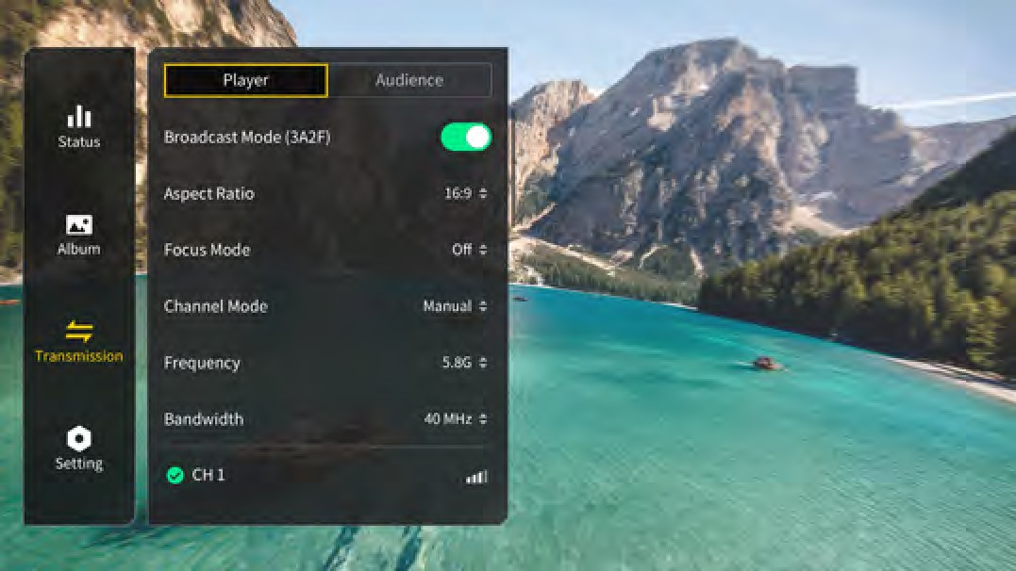

2

3

4

5

6

1. Broadcast Mode

Enable or disable Broadcast mode. The device number will be displayed when Broadcast mode is enabled so that other devices can find the device and enter the channel to watch the camera view.

1. Aspect Ratio

The aspect ratio of the video transmission screen can be adjusted.

1. Focus Mode

Set the Focus mode to on, off, or auto. If Focus mode is turned on, the center of the screen will be clearer and the edges will be blurred.

1. Channel Mode

The channel mode can be set to auto or manual. It is recommended to select auto so that the video transmission will intelligently switch between the 2.4 and 5.8 GHz frequency bands and select the channel with the best signal.

1. Frequency

You can select 2.4 or 5.8 GHz frequency band if the channel mode is manual.

1. Bandwidth

Set the bandwidth of the video transmission. The number of channels available varies according to the bandwidth. The channel with the best signal strength can be manually selected.

The larger the bandwidth, the more spectrum resources it occupies, which can provide a higher video transmission rate and clearer image quality. However, there is a higher chance of wireless interference and the amount of equipment that can be accommodated is more limited. To avoid interference in a multiplayer competition, it is recommended to manually select a fixed bandwidth and channel.

Setting

Safety

Set the safety configurations such as max flight altitude, max flight distance, and RTH altitude. Users can also update the Home Point, enable or disable Obstacle Slowing, and view the status of as well as calibrate the IMU and compass.

Find My Drone helps to find the location of the aircraft on the ground by using the cached video in the goggles.

Advanced Safety Settings include aircraft signal lost action, auxiliary bottom LED Status, and enabling or disabling AirSense and emergency propeller stop. The aircraft can be set to hover, land, or RTH when it loses the signal from the remote controller. If the emergency propeller stop is enabled, the motors can only be stopped by performing a combination stick command (CSC) mid-flight in an emergency situation such as if a collision occurs, a motor stalls, the aircraft rolls in the air, or the aircraft is out of control and is ascending or descending quickly. Stopping the motors mid-flight will cause the aircraft to crash.

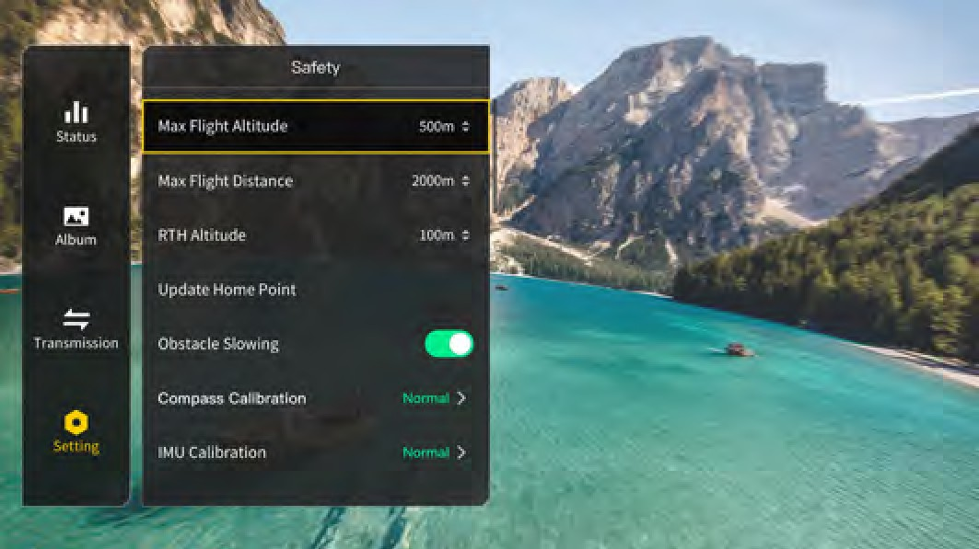

Control

Set aircraft control parameters such as the color and lighting method of the front and frame arm LEDs, the gimbal pitch speed, or the Coordinated Turn (Sport mode). Users can also calibrate the gimbal.

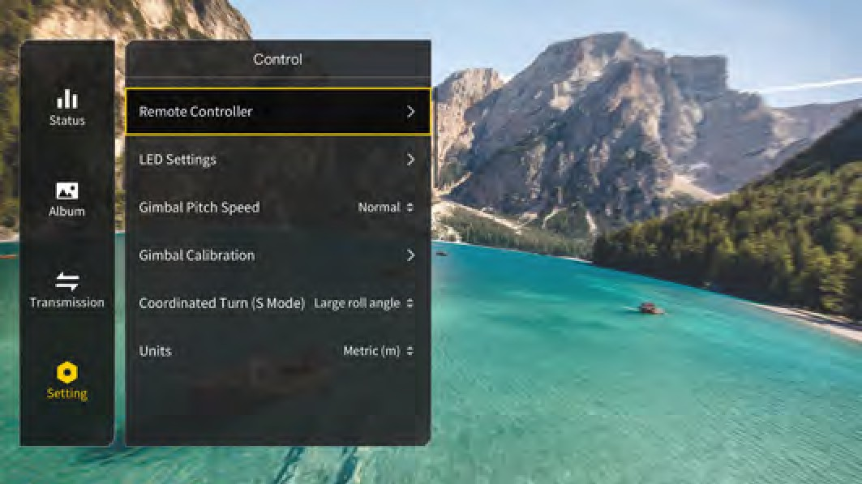

The functions of some of the buttons of the remote controller can be customized in Remote Controller. These include the C1 button, C2 switch, and the custom mode on the flight mode switch. The stick mode can be set and the exponential can be adjusted when using Manual mode. Users can also calibrate the remote controller.

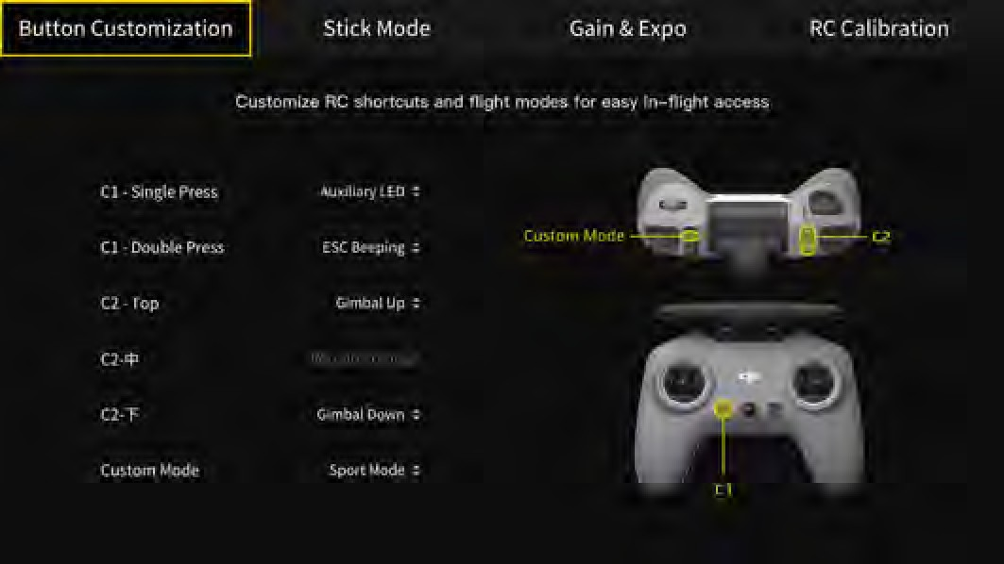

Camera

Camera parameters such as ISO, shutter, EV, saturation, and WB can be adjusted. Also, the camera mode can be set to auto or manual. Shutter and ISO can be set in manual mode while EV can be set in auto mode.

Users can set transmission quality, video quality, video format, gridlines, enable or disable the center point of the screen, and format the microSD card. Note that the data cannot be recovered after formatting. Operate with caution.

In Advanced Camera Settings, users can set the recording device, video coding format, color, and anti-flicker, as well as enable or disable aircraft audio recording, video subtitles, distortion correction, image roll correction, and EIS (electronic image stabilization).

Select Reset Camera Parameters settings to restore all camera settings to default.

 When the frame rate of the video quality is 50/60fps, the audio and video will be stored together in one file. When the frame rate of the video quality is 100/120fps, the audio will be stored separately as an audio file and the video will be four times slower than normal while the audio will be normal.

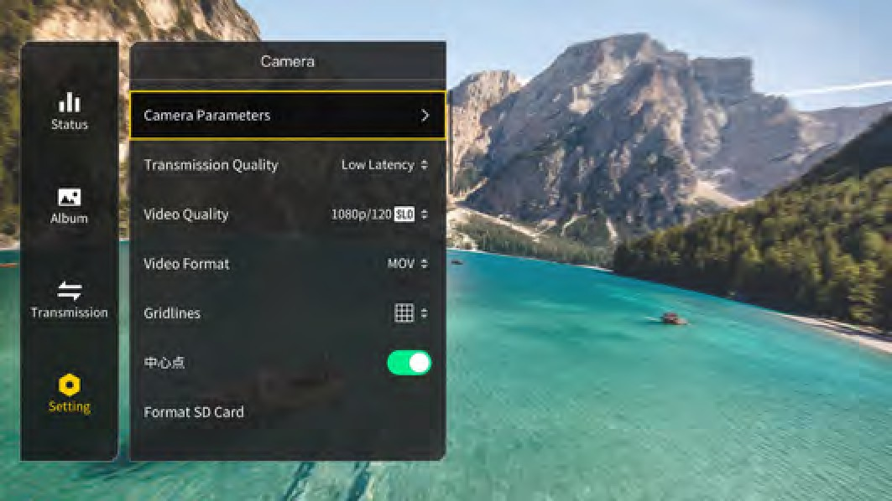

Display

Adjust screen brightness, zoom, and display or hide the Home Point.

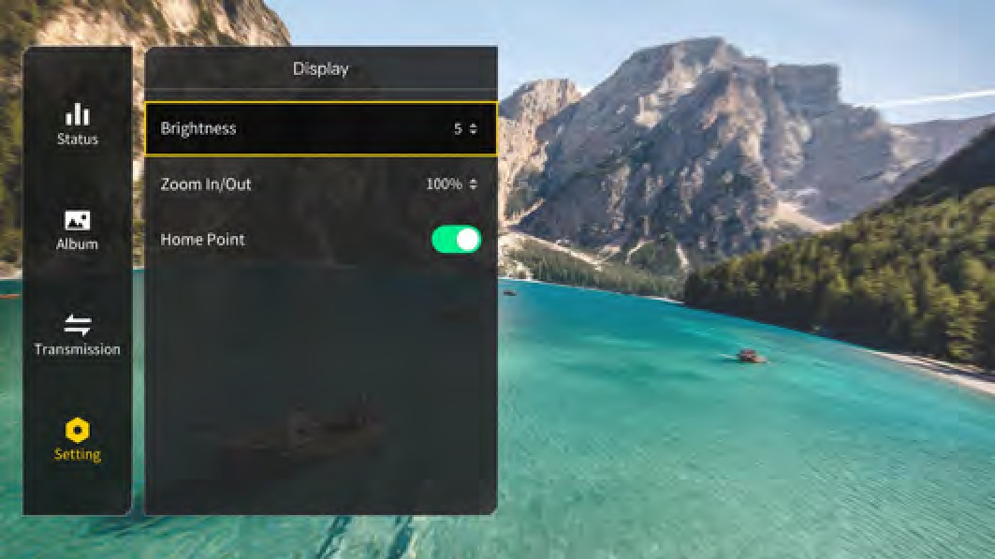

About

View device information such as the serial number and the firmware of the goggles and the linked devices.

Switch to DJI FPV Digital System in the menu to use the DJI FPV Air Unit. Power on the goggles again after switching.

Select Reset All to reset the goggles and the linked devices to their default settings.

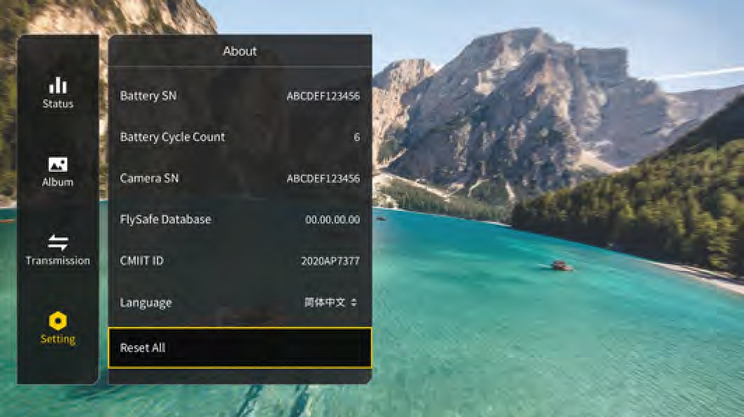

##### Remote Controller

Built into the DJI FPV Remote Controller 2 is DJI's O3 transmission technology, offering a maximum transmission range of 6 mi (10 km). The buttons make control of the aircraft and camera effortless while the detachable control sticks allow for the remote controller to be easily stored.

The built-in battery has a capacity of 5200 mAh and a maximum run time of 9 hours.

Operation

Powering On/Off

Press the power button once to check the current battery level. If the battery level is too low, recharge before use. Press once then press again and hold to power the remote controller on or off.

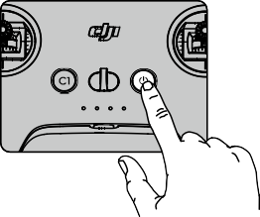

Charging the Battery

Use a USB-C cable to connect an AC power adapter to the USB-C port of the remote controller. It takes approximately 2.5 hours to fully charge the remote controller.

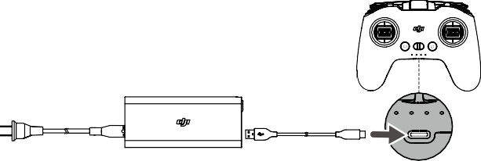

Controlling the Gimbal and Camera

1. Shutter/Record Button: press once to take a photo or to start or stop recording. Press and hold to switch between photo and video mode.
2. Gimbal Dial: use to control the tilt of the gimbal.

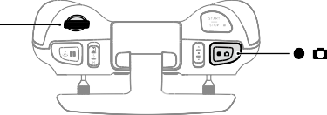Gimbal Dial

Shutter/Record Button

Controlling the Aircraft

The control sticks control the orientation (pan), forward and backward movement (pitch), altitude (throttle), and left and right movement (roll) of the aircraft. The control stick mode determines the function of each control stick movement.

There are three programmed modes including Mode 1, Mode 2, and Mode 3. Mode 2 is selected by default and users can change to Mode 1 or Mode 3 in the goggles setting menu.

Mode 1

Mode 2

Left Stick

Left Stick





Turn Left

Forward

Backward





Turn Right

UP





Down

Right Stick



Right Stick



UP



Down

Forward



Left

Backward



Left





Right

  

Turn Left



Turn Right

Right

Mode 3

Left Stick



Forward

Backward



Left





Right

Right Stick





Turn Left

UP



Down



Turn Right

The figure below uses Mode 2 as an example to explain how to use the control sticks.

Stick Neutral/Center Point: Control sticks are in the center.

Moving the control stick: Push the control stick away from the center or push the throttle stick away from the lowest position when using Manual mode.

|  |  |  |
| --- | --- | --- |
| Remote Controller (Mode 2) | Aircraft ( Indicates nose direction) | Remarks |
|  |  | Throttle Stick: moving the left stick up or down changes the altitude of the aircraft.  Push the stick up to ascend and down to descend. Push the stick gently to prevent sudden and unexpected changes in altitude.  Normal/Sport mode:  The aircraft hovers in place if the stick is in the center. Use the left stick to take off when the motors are spinning at an idle speed. The further the stick is  pushed away from the center, the faster the aircraft  changes elevation.  Manual mode:  The throttle stick has no center. Before flying, adjust the throttle stick to prevent it from returning to the center. |
|  |  | Yaw Stick: moving the left stick to the left or right to  control the orientation of the aircraft.  Push the stick left to rotate the aircraft counterclockwise and right to rotate the aircraft clockwise. The aircraft hovers in place if the stick is in the center.  The farther the stick is pushed away from the center, the faster the aircraft will rotate. |
|  |  | Pitch Stick: moving the right stick up and down  changes the pitch of the aircraft.  Push the stick up to fly forward and down to fly backward. The aircraft hovers in place if the stick is in the center.  The farther the stick is pushed away from the center, the faster the aircraft will move. |
|  |  | Roll Stick: moving the right stick to the left or right  changes the roll of the aircraft.  Push the stick left to fly left and right to fly right. The aircraft hovers in place if the stick is in the center.  The farther the stick is pushed away from the center, the faster the aircraft will move. |

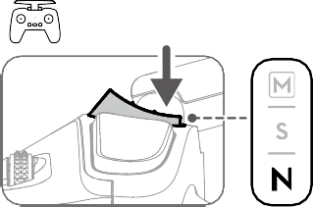Flight Mode Switch

Toggle the switch to select the desired flight mode.



Position Flight Mode

* 1. Manual Mode

S Sport Mode

* 1. Normal Mode

Manual mode is disabled by default. Make sure that the switch is set to Manual mode in the goggles before switching to Manual mode. The aircraft will remain in Normal or Sport mode if the switch is not set to Manual mode in the goggles. Go to Settings, Control, Remote Controller, Button Customization, and set the Custom Mode to Manual mode.

Before using Manual mode, it is recommended to tighten the F2 screw on the rear of the throttle stick so that the stick does not return to the center and adjust the F1 screw to make sure the stick resistance is suitable.



  When using Manual mode, the aircraft has no flight assistance functions such as automatic stabilization. Before using Manual mode, practice flying in Manual mode using DJI Virtual Flight to ensure that you can fly safely.

 Only adjust the throttle stick before the aircraft takes off. DO NOT adjust during flight.



Start/Stop Button

When using Sport mode, press once to enable or disable cruise control. When cruise control is enabled, the aircraft will maintain the current flight speed and fly forward.

When using Manual mode, press twice to start or stop the motor.

When using Normal or Sport mode, press once to cancel Low Battery RTH when the countdown appears in the

goggles.

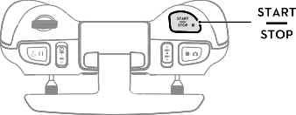

  Cruise control is only available in Sport mode.

 When cruise control is enabled, the aircraft will maintain the current flight speed in the horizontal forward direction. The horizontal speed displayed on the goggles will change accordingly if the control sticks are moved or if the aircraft is flying in a windy environment.

Flight Pause/RTH Button

Press once to make the aircraft brake and hover in place. Make sure that the pitch stick and roll stick return to the center and push the throttle stick to resume control of the flight. If the aircraft is performing RTH or auto landing, press once to exit RTH before braking.

When the aircraft is in Manual mode, press the button to make the aircraft brake and hover in place. The aircraft attitude returns to level and the flight mode automatically switches to Normal mode.

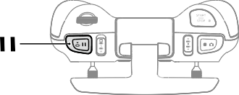Press and hold the RTH button until the remote controller beeps to indicate that RTH has started. Press the button again to cancel RTH and regain control of the aircraft. Refer to the Return to Home section for more information about RTH.

Customizable Button

The functions of the customizable buttons can be set on the remote controller settings in the goggles, including the C1 button, C2 switch, and the custom mode.

The C1 button and C2 switch can be used as shortcuts for functions such as raising, lowering, or recentering the gimbal or enabling or disabling ESC beeping or the auxiliary bottom light.

The custom mode can be set to Manual or Sport mode.

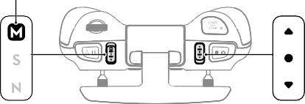Custom Mode

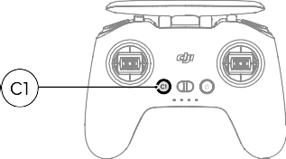

C1 Button

C2 Switch

Remote Controller Alert

The remote controller sounds an alert during RTH. The alert cannot be cancelled. The remote controller sounds an alert when the battery level is 6% to 15%. A low battery level alert can be cancelled by pressing the power button. A critical battery level alert will sound when the battery level is less than 5% and cannot be cancelled.

Optimal Transmission Zone

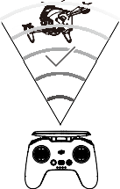The signal between the aircraft and the remote controller is most reliable when the antennas are positioned in relation to the aircraft as shown below.

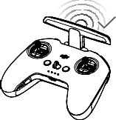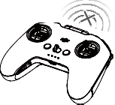Weak Strong

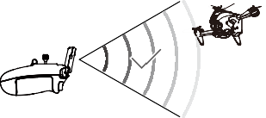

Optimal Transmission Zone



 DO NOT use other wireless devices of the same frequency bands in order to avoid interference to the

remote controller.



Stick Adjustment

When using Manual mode, adjust the throttle stick based on your stick mode for a better user experience.

1. Turn the remote controller over and lift the rear rubber grip from the inside groove.

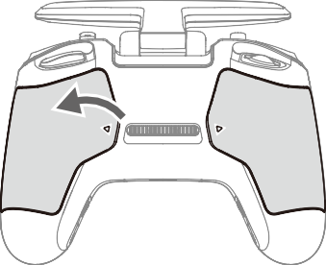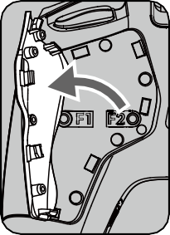

Groove

1. The screws under the grip can adjust the corresponding stick on the front of the remote controller. Use an H1.5 hex key to adjust the resistance of the stick and recenter the stick vertically. The control resistance increases when the F1 screw is tightened, and the control resistance decreases when the F1 screw is loosened. The recentering is disabled when the F2 screw is tightened, and the recentering is enabled when the F2 screw is loosened.

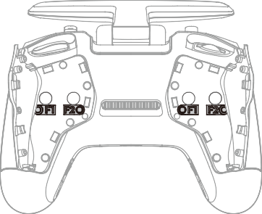

1 2

3 4

F1 Right Stick Resistance Adjustment Screw (Vertical)



1

F2 Right Stick Center Adjustment Screw



2

(Vertical)

F1 Left Stick Resistance Adjustment Screw (Vertical)

F2 Left Stick Center Adjustment Screw



3



4

(Vertical)

1. Reattach the rubber grip once the adjustment is complete.

##### DJI Fly App

Connect the goggles to the mobile device, launch DJI Fly, and enter the home screen. Tap GO FLY to display the video transmission, which allows you to share the FPV camera view.



**Album Skypixel Me**

**GO FLY**

Fly Spots

View or share nearby suitable flight and shooting locations, learn more about GEO zones, and preview aerial photos of different locations taken by other users.

Academy

Tap the icon in the top right corner to enter Academy and view product tutorials, flight tips, flight safety, and manual documents.

SkyPixel

Enter SkyPixel to view videos and photos shared by users.

Profile

View the account information, flight records, DJI forum, online store, Find My Drone, and other settings.

 Some countries and regions require real-time reporting of the location of the aircraft while flying. As a result, it is necessary to connect the goggles to the mobile device and run DJI Fly. Make sure to check and comply with local regulations.

**DJI FPV** User Manual

Fully charge your mobile device before launching DJI Fly.

Mobile cellular data is required when using DJI Fly. Contact your wireless carrier for data charges.

DO NOT accept phone calls or use texting features during flight if you are using a mobile phone as your display device.

Read all safety tips, warning messages, and disclaimers carefully. Familiarize yourself with the related regulations in your area. You are solely responsible for being aware of all relevant regulations and flying in a way that is compliant.

Use the in-app tutorial to practice your flight skills if you have never operated the aircraft or if you do not have sufficient experience to operate the aircraft with confidence.

The app is designed to assist your operation. Use sound discretion and DO NOT rely on the app to control the aircraft. The use of the app is subject to DJI Fly Terms of Use and DJI Privacy Policy. Read them carefully in the app.

##### Flight

Once pre-flight preparation is complete, it is recommended to hone your flight skills and practice flying safely. Make sure that all flights are carried out in an open area. The flight height is limited to 500 m. DO NOT exceed this height. Strictly abide by local laws and regulations when flying. Make sure to read the DJI FPV Disclaimer and Safety Guidelines to understand the safety notices before flying.

Flight Environment Requirements

1. DO NOT use the aircraft in severe weather conditions including wind speeds exceeding 13.8 m/s, snow, rain,

and fog.

1. Only fly in open areas. Tall structures and large metal structures may affect the accuracy of the onboard compass and GPS system. It is recommended to keep the aircraft at least 5 m away from structures.
2. Avoid obstacles, crowds, high voltage power lines, trees, and bodies of water. It is recommended to keep the aircraft at least 3 m above water.
3. Minimize interference by avoiding areas with high levels of electromagnetism such as locations near power lines, base stations, electrical substations, and broadcasting towers.
4. The aircraft and battery performance is subject to environmental factors such as air density and temperature. Be careful when flying 19,685 ft (6,000 m) or more above sea level. Otherwise, the battery and aircraft performance may be reduced.
5. The aircraft cannot use GPS within the polar regions. Use the Downward Vision System when flying in such

locations.

1. Fly with caution when taking off from moving surfaces such as a moving boat or vehicle.

Flight Limits and GEO Zones

Unmanned aerial vehicle (UAV) operators should abide by the regulations from self-regulatory organizations such as the International Civil Aviation Organization, the Federal Aviation Administration, and local aviation authorities. For safety reasons, flight limits are enabled by default to help users operate this aircraft safely and legally. Users can set flight limits on height and distance.

Altitude limits, distance limits, and GEO zones function concurrently to manage flight safety when GPS is available. Only the altitude can be limited when GPS is unavailable.

Flight Altitude and Distance Limits

Users can change the maximum height and radius limits in the goggles. Once completed, the aircraft flight is restricted to a cylindrical area that is determined by these settings. These limits are detailed in the table below.

Max Flight Altitude

Height of aircraft when powered on

Max Radius

Home Point



When GPS is available

|  |  |  |  |
| --- | --- | --- | --- |
|  | Flight Limits | Goggles | Aircraft Status Indicator |
| Max Altitude | Aircraft's altitude cannot exceed the specified value | Warning: Height limit reached | Blinks green and red  alternately |
| Max Radius | Flight distance must be within the max radius | Warning: Distance limit reached |

When GPS is weak

|  |  |  |  |
| --- | --- | --- | --- |
|  | Flight Limits | Goggles | Aircraft Status Indicator |
| Max Altitude | Height is restricted to 98 ft (30 m) when the GPS signal is weak. | Warning: height limit reached. | Blinks red and green  alternately |
| Max Radius | The restrictions on the radius are disabled and warning prompts cannot be received in the goggles. | | |

 There will be no altitude limit if the GPS signal becomes weak during flight as long as the GPS signal display was white or yellow when the aircraft was powered on.

If the aircraft is in a GEO zone and there is a weak or no GPS signal, the aircraft status indicator will glow red for five seconds every twelve seconds.

The aircraft can still be controlled if it reaches an altitude or radius limit, but it cannot fly any farther.

For safety reasons, do not fly close to airports, highways, railway stations, railway lines, city centers, or other sensitive areas. Only fly the aircraft within visual line of sight.

GEO Zones

All GEO zones are listed on the DJI official website at https://[www.dji.com/flysafe.](http://www.dji.com/flysafe) GEO zones are divided into different categories and include locations such as airports, airfields where manned aircraft operate at low altitudes, national borders, and sensitive locations such as power plants.

A prompt will appear in the goggles if the aircraft is approaching a GEO zone and the aircraft will be restricted from flying in the area.

Pre-Flight Checklist

1. Make sure the goggles battery, remote controller, Intelligent Flight Battery, and mobile device are fully charged.
2. Make sure the propellers are mounted correctly and securely.
3. Make sure the Intelligent Flight Battery and goggles battery are properly connected and secure.
4. Make sure the gimbal and camera are functioning normally.
5. Make sure the motors are unobstructed and functioning normally.
6. Make sure that the goggles are functioning normally and display the video transmission.
7. Make sure that the gimbal protector is detached and the camera lens and the Vision System sensors are

clean.

1. Make sure that the goggles antennas are installed securely and the remote controller antenna is lifted.
2. Only use genuine DJI parts or parts certified by DJI. Unauthorized parts or parts from non-DJI certified manufacturers may cause the system to malfunction and compromise safety.

Starting/Stopping the Motors

Starting the Motors

Normal/Sport mode

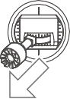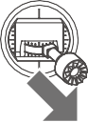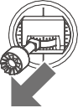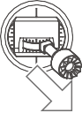A CSC is used to start the motors. Push both sticks to the inner or outer bottom corners to start the motors. Once the motors start spinning, release both sticks simultaneously.

OR

Manual mode

Make sure the throttle stick is in the lowest position and press the start/stop button twice to start the motors.

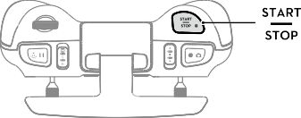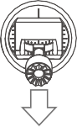+

Throttle Stick

Stopping the Motors

Normal/Sport mode

There are two methods to stop the motors.

Method 1: when the aircraft has landed, push and hold the throttle stick down. The motors will stop after three

seconds.

Method 2: when the aircraft has landed, push the throttle stick down, and perform the same CSC that was used to start the motors. Release both sticks once the motors have stopped.



OR

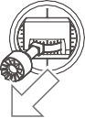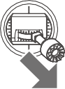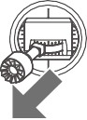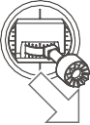Method 1 Method 2

Manual mode

Press the start/stop button twice to stop the motors once the aircraft has landed.

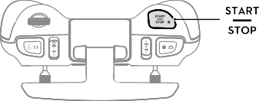

  For flight safety, it is recommended to switch to Normal mode before landing.



Stopping the Motors Mid-Flight

When using Normal or Sport mode, the motors can only be stopped by performing a CSC mid-flight in an emergency situation such as if the aircraft has a stalled motor, is involved in a collision, is rolling in the air, is out of control, or is ascending or descending quickly. The default setting can be changed in goggles.

When using the Manual mode, press the start/stop button twice to stop the motors at any time.



  Stopping motors mid-flight will cause the aircraft to crash.



Flight Test

Takeoff/Landing Procedures

1. Place the aircraft in an open, flat area with the aircraft status indicator facing towards you.
2. Power on the goggles, remote controller, and the aircraft.
3. Wait until the aircraft status indicator blinks green slowly to indicate that the Home Point has been recorded and put on the goggles.
4. Start the motors.
5. Gently push the throttle stick up to take off.
6. Pull the throttle stick down to land the aircraft.
7. Stop the motors after landing.
8. Power off the aircraft, goggles, and remote controller.

Video Suggestions and Tips

1. The pre-flight checklist is designed to help you fly safely and to ensure that you can record video during flight. Go through the full pre-flight checklist before each flight.
2. Select the gimbal operation mode.
3. It is recommended to use Normal mode to take photos or record videos.
4. DO NOT fly in bad weather conditions such as when it is raining or windy.
5. Choose the camera settings that best suit your needs.
6. Perform flight tests to establish flight routes and to preview scenes.
7. Push the control sticks gently to keep the aircraft movement smooth and stable.
8. When using Manual mode, fly in an open, wide, and sparsely populated environment to ensure flight safety.



It is important to understand the basic flight guidelines, both for your protection and for the safety of those around you.

DO NOT forget to read the disclaimer and safety guidelines.



##### Maintenance

Goggles

Cleaning

Make sure to disconnect the goggles from the power outlet before cleaning and make sure that there are no cables connected.

Clean the surface of the goggles with a soft, dry, clean cloth. To clean the foam padding, moisten the cloth with clean water and wipe the foam padding.

Replacing the Foam Padding

The foam padding is attached to the goggles with Velcro. When replacing the foam padding, peel it gradually from the left or right side. Align the new foam padding with the goggles and press the foam padding down so it is securely attached.

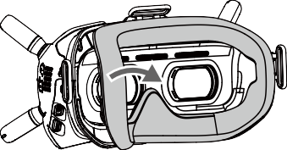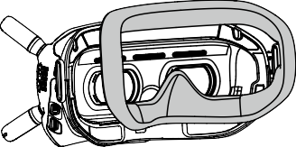

Maintenance of Lenses

Use a cleaning cloth to wipe the lenses gently.

1. Moisten the cleaning cloth with alcohol or a lens cleaner.
2. Wipe in a circular motion from the center to the outer edges of the lenses.

 DO NOT clean the foam padding with alcohol.

The lenses are delicate. Clean them gently. DO NOT scratch them as this will damage the overall viewing experience.

Store the goggles in a dry room at room temperature to avoid damage to the lenses from high temperature and humid environments.

Aircraft

Follow the steps below to replace components of the aircraft such as the top shell, gimbal and camera, or landing

gear.

Gimbal and Camera (Incl. Top Shell)

Detaching

1. Remove the four M1.6 screws on the front and remove the protective shell.

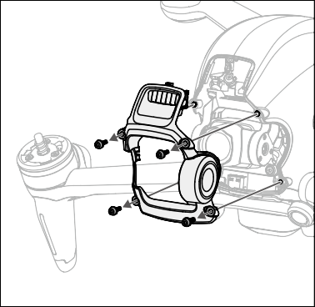

1. Remove the four M2 screws on both sides.

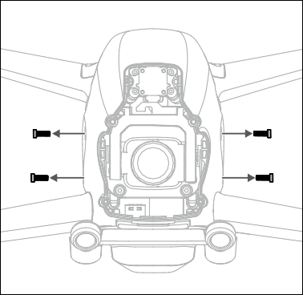

1. Pry a corner of the top shell from the bottom side of the aircraft.

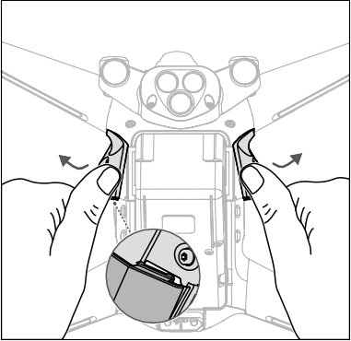

1. Facing the aircraft, hold the front frame arm and push in the direction shown to remove the top shell.

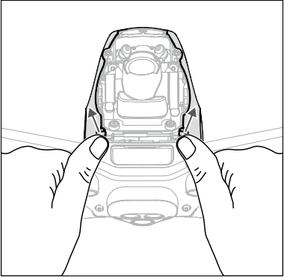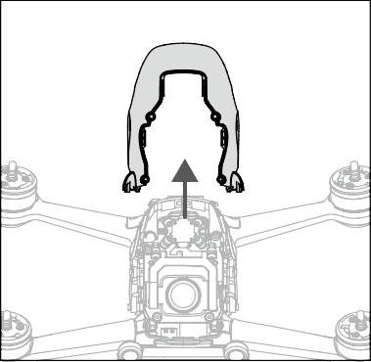

1. Remove the four M2 screws on the front.

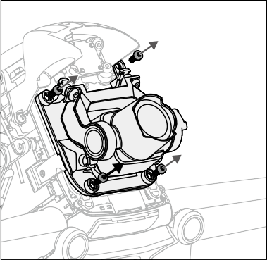

1. Remove the two M1.6 screws on the side before removing the metal piece.

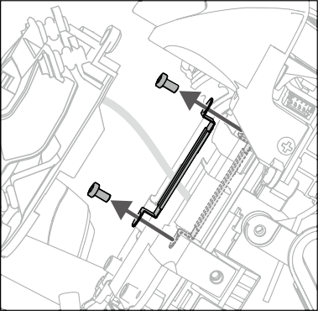

1. Use an appropriate tool to lift and remove the FPC connector on the gimbal and camera.

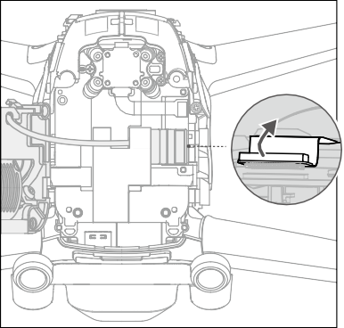

1. Tear off one corner of the fixing tape to remove the gimbal and camera.

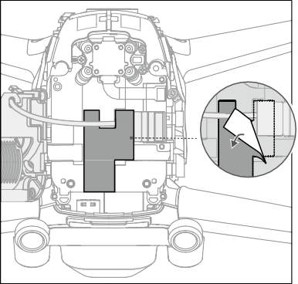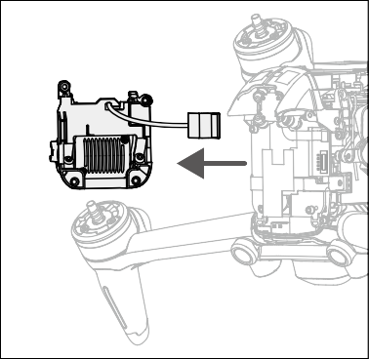

Installation

1. Prepare a new gimbal and camera, align the connector cable to the position, and secure with fixing tape.

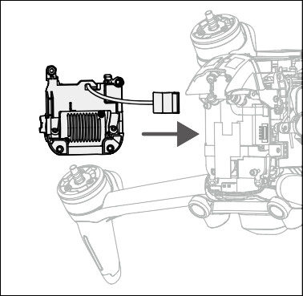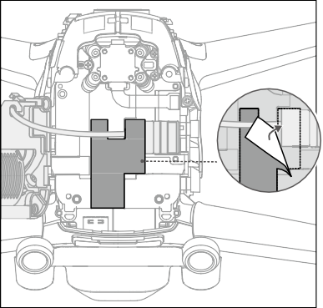

1. Align and press down the FPC connector of the gimbal and camera to make sure they are securely connected.

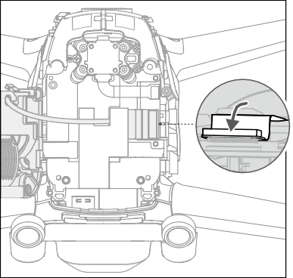

1. Attach the metal plate on the right side and tighten the two M1.6 screws.

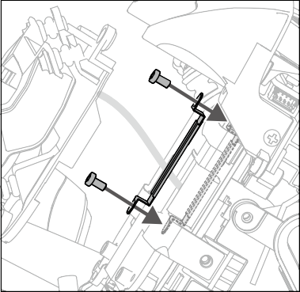

1. Install the gimbal and camera and tighten the four M2 screws.

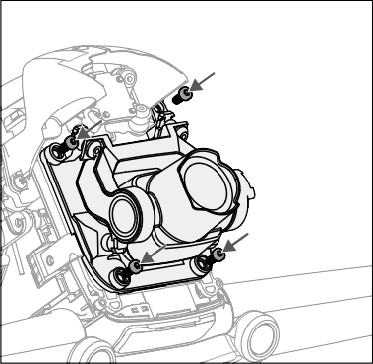

1. Prepare a new top shell to install.

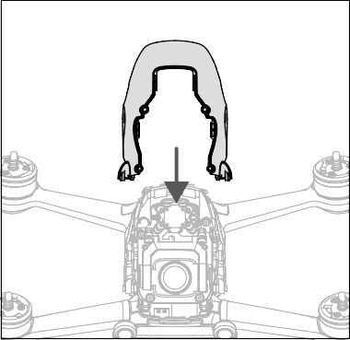

1. Press the following positions in sequence to make sure that the top shell is firmly installed.

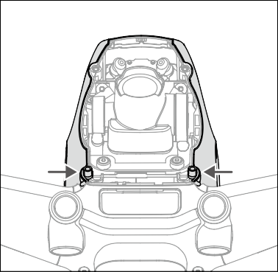

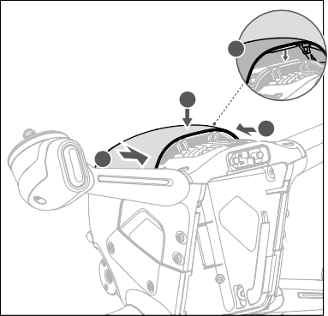

1

1

2

2

1. Slightly bend the side of the top shell to insert the buckle into the aircraft slot and tighten the four M2 screws on both sides.

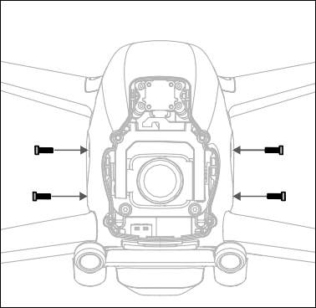

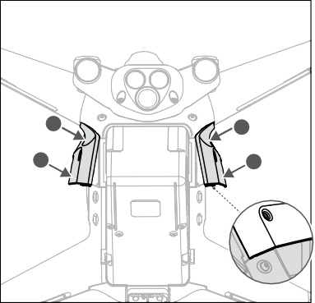

1

1

2

2

1. Install the protective shell from the top and make sure to align the slots. Tighten the four M2 screws on the

front to complete the installation.

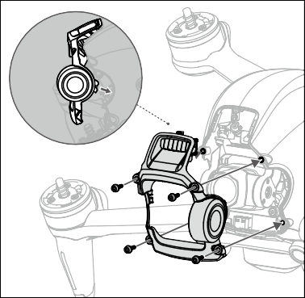

Calibrating the gimbal and camera

After replacing the gimbal and camera, download the calibration file of the camera to calibrate the gimbal and

camera.

1. Power on the aircraft, goggles, and remote controller. Make sure all the devices are linked.
2. Connect the USB-C port of the goggles to the mobile device, run DJI Fly, and follow the on-screen instructions to download the camera calibration file to the aircraft. An internet connection is required for downloading.

Landing Gear

Detaching

1. Remove the two M1.6 screws on the bottom of the left landing gear.

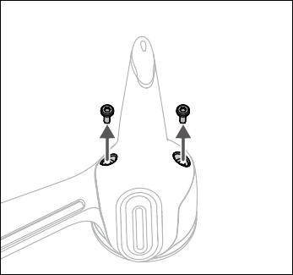

1. Remove the landing gear as shown.

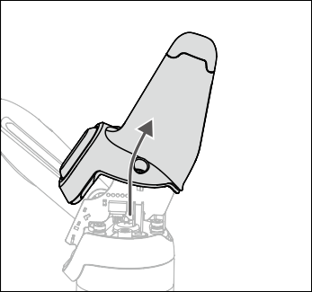

1. Remove the antenna light board of the landing gear.

2

1

1. Remove the antenna connector and 3-pin and 4-pin light wire connectors on both sides of the board.

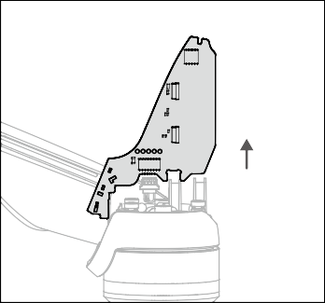

Installation

1. Check the mark inside the landing gear, and remove the antenna light board from the one marked L. Connect the 3-pin and 4-pin light wire connectors and antenna connector on the bottom of the left front motor and make sure they are secure.

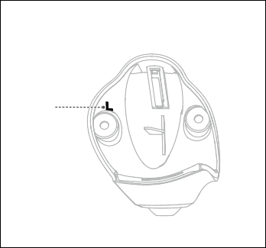

L

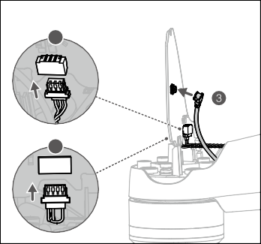

1

2

1. Insert the board between the two clamping positions on the motor base.
2. Make sure the groove of the landing gear is properly inserted into the corresponding position of the motor base.

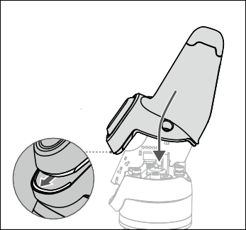

1. Tighten the two M1.6 screws to complete the installation.

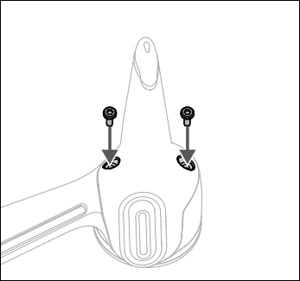

1. Repeat the steps above to install the landing gear on the right side. The landing gear is marked R.

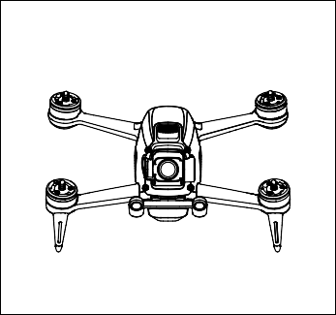

##### Appendix

Dimensions

178×232×127 mm (without propellers) 255×312×127 mm (with propellers)

Max Ascent Speed

8 m/s (Normal mode) 15 m/s (Sport mode) No limit (Manual mode)

Max Service Ceiling Above Sea 6000 m

Level

Transmitter Power (EIRP)

2.4 GHz: ≤31.5 dBm (FCC), ≤20 dBm (CE/SRRC/MIC)

5.8 GHz: ≤31.5 dBm (FCC), ≤25.5 dBm (SRRC), ≤14 dBm (CE)

Specifications

Aircraft

Takeoff Weight Approx. 795 g

Diagonal Distance 245 mm

Max Descent Speed

7 m/s (Normal mode) 10 m/s (Sport mode) No limit (Manual mode)

Max Speed (near sea level, no 15 m/s (Normal mode) wind) 27 m/s (Sport mode)

39 m/s (Manual mode)

Max Horizontal Acceleration (near sea level, no wind)

0-100 kph: 2 s (Manual mode)

Max Flight Time Approx. 20 mins (measured while flying at 40 kph in windless conditions)

Max Hover Time Approx. 16 mins (measured in windless conditions)

Max Flight Distance 16.8 km (measured in windless conditions)

Max Wind Speed Resistance 13.8 m/s

Operating Temperature Range 14° to 104° F (-10° to 40° C)

GNSS GPS+GLONASS+Galileo

Operating Frequency 2.400-2.4835 GHz; 5.725-5.850 GHz

Hovering Accuracy Range Vertical: ±0.1 m (with Vision Positioning), ±0.5 m (with GPS Positioning)

Horizontal: ±0.3 m (with Vision Positioning), ±1.5 m (with GPS Positioning)

Gimbal

Mechanical Range Tilt: -65° to +70°

Controllable Range Tilt: -50° to +58°

Stabilized System Single-axis (tilt), electronic roll axis

Max Control Speed 60°/s

Angular Vibration Range ±0.01° (Normal mode)

Electronic Roll Axis Available (up to an angle of 10°)

Sensing System

Forward

Precision Measurement Range: 0.5-18 m Obstacle Sensing: Only available in Normal mode FOV: 56° (horizontal), 71° (vertical)

Downward

Infrared Sensor Measurement Range: 10 m Hovering Range: 0.5-15 m

Vision Sensor Hovering Range: 0.5-30 m

Auxiliary Bottom Light Single LED

Camera

Non-reflective, discernible surfaces with diffuse reflectivity of >20%; Adequate lighting of lux >15

Operating Environment

Sensor 1/2.3” CMOS, Effective Pixels: 12 MP

Lens

FOV: 150°

35mm Format Equivalent: 14.66 mm Aperture: f/2.8

Focus Mode: Fixed focus Focus range: 0.6 m to ∞

ISO Range 100-12800

Electronic Shutter Speed 1/50-1/8000 s

Still Photography Modes Single shot

Max Image Size 3840×2160

Photo Format JPEG

Video Resolution

4K: 3840×2160 50/60 p

FHD: 1920×1080 50/60/100/120 p

Video Format MP4/MOV (MPEG-4 AVC/H.264, HEVC/H.265)

Max Video Bitrate 120 Mbps

Color Profiles Standard, D-Cinelike

RockSteady EIS Available

Distortion Correction Available

Intelligent Flight Battery

exFAT (recommend) FAT32

Supported File Formats

Capacity 2000 mAh

Voltage 22.2 V (standard)

Charging Voltage Limit 25.2 V

Battery Type LiPo 6S

Energy 44.4 [Wh@0.5C](mailto:Wh@0.5C)

Discharge Rate 10C (typical)

Weight Approx. 295 g

Charging Temperature Range 41° to 104° F (5° to 40° C)

Max Charging Power 90 W

Goggles

Weight Approx. 420 g (incl. headband and antennas)

Dimensions

184×122×110 mm (excl. antennas)

202×126×110 mm (incl. antennas)

Screen Size 2 inch×2

Screen Resolution (Single Screen)

1440×810

Screen Refresh Rate 144 Hz

FOV 30° to 54°; Image size: 50-100%

Interpupillary Distance Range 58-70 mm

Operating Frequency 2.400-2.4835 GHz; 5.725-5.850 GHz

Transmitter Power (EIRP) 2.4 GHz: ≤28.5 dBm (FCC), ≤20 dBm (CE/SRRC/MIC)

5.8 GHz: ≤31.5 dBm (FCC), ≤19 dBm (SRRC), ≤14 dBm (CE)

Communication Bandwidth Max 40 MHz

Live View Mode Low-Latency mode (810p 100fps/120fps), Latency < 28 ms

High-Quality mode (810p 50fps/60fps), Latency < 40 ms

Max Video Bitrate 50 Mbps

Transmission Range 10 km (FCC); 6 km (CE/SRRC/MIC)

Audio Transmission Available

Supported Video Recording

Format

MOV (Video format: H.264)

Supported Video Playback

Format

MP4, MOV, MKV

(Video format: H.264; Audio format: AAC-LC, AAC-HE, AC-3, MP3)

Operating Temperature Range 0° to 40° C (32° to 104° F)

Goggles Battery

Recommended: DJI FPV Goggles Battery Third-party batteries: 11.1-25.2 V

Power Input

Capacity 1800 mAh

Voltage Max 9 V

Battery Type LiPo 2S

Energy 18 Wh

Charging Temperature Range 0° to 45° C (32° to 113° F)

Max Charging Power 10 W

Runtime Approx. 1 hour and 50 minutes (ambient temperature: 25°C, screen brightness: 6)

Remote Controller

Weight 346 g

Dimensions 190×140×51 mm

Operating Frequency 2.400-2.4835 GHz; 5.725-5.850 GHz Max Transmission Distance

(unobstructed, free of

interference)

10 km (FCC); 6 km (CE/SRRC/MIC)

Transmitter Power (EIRP) 2.4 GHz: ≤28.5 dBm (FCC), ≤20 dBm (CE/SRRC/MIC)

5.8 GHz: ≤31.5 dBm (FCC), ≤19 dBm (SRRC), ≤14 dBm (CE)

Battery Charger

Operating Temperature Range -10° to 40° C (14° to 104° F)

Input 100-240 V, 50/60 Hz, 1.8 A

Output

Main: 25.2±0.15 V, 3.57±0.1 A or 1±0.2 A

USB: 5 V/2 A × 2

Rated Power 86 W

Charging Temperature Range 5° to 40° C (41° to 104° F)

Charging Time

Intelligent Flight Battery: approx. 50 minutes Remote Controller: approx. 2 hours 30 minutes Goggles Battery: approx. 2 hours 30 minutes

SD Cards

Supported SD Cards microSD Card

Max 256 GB, UHS-I Speed Grade 3

SanDisk High Endurance U3 V30 64GB microSDXC SanDisk Extreme PRO U3 V30 A2 64GB microSDXC SanDisk Extreme U3 V30 A2 64GB microSDXC SanDisk Extreme U3 V30 A2 128GB microSDXC

Recommended microSD Cards

SanDisk Extreme U3 V30 A2 256GB microSDXC Lexar 667x V30 128GB microSDXC

Lexar High Endurance 128G U3 V30 microSDXC Samsung EVO U3 (Yellow) 64GB microSDXC Samsung EVO Plus U3 (Red) 64GB microSDXC Samsung EVO Plus U3 256GB microSDXC Netac 256GB U3 A1 microSDXC

Aircraft takeoff weight includes battery, propellers, and a microSD card.

The FOV will be 150° when shooting at 50 or 100 fps. For other frame rates, the FOV will be 142°.

Devices will take longer to charge if both the Intelligent Flight Battery and remote controller or goggles battery are being charged simultaneously.

These specifications have been determined through tests conducted with the latest firmware. Firmware updates can enhance performance. It is highly recommended to update to the latest firmware.

Calibrating the Compass

It is recommended to calibrate the compass in the following situations when flying outdoors:

1. Flying at a location farther than 31 miles (50 km) away from the location the aircraft was last flown.
2. The aircraft has not been flown for more than 30 days.
3. A compass interference warning appears in the goggles and/or the aircraft status indicator blinks red and yellow alternatively.

 DO NOT calibrate the compass in locations where magnetic interference may occur such as close to magnetite deposits or large metallic structures such as parking structures, steel-reinforced basements, bridges, cars, or scaffolding.

DO NOT carry objects that contain ferromagnetic materials such as mobile phones near the aircraft during calibration.

It is not necessary to calibrate the compass when flying indoors.

Calibration Procedure

Choose an open area to carry out the following procedure.

1. Select Settings, Safety, and Compass Calibration in the goggles. The aircraft status indicator will be solid yellow to indicate calibration has started.
2. Hold the aircraft horizontally and rotate it 360°. The aircraft status indicator will turn solid green.
3. Hold the aircraft vertically and rotate it 360° around a vertical axis.
4. If the aircraft status indicator blinks red, calibration has failed. Change your location and try to calibrate again.

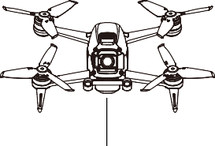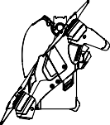

 If the aircraft status indicator blinks red and yellow alternatively after calibration is completed, this indicates that the current location is not suitable for flying the aircraft due to the level of magnetic interference. Choose a new location.

 A prompt will appear in the goggles if compass calibration is required before takeoff.

The aircraft can take off immediately once calibration is complete. If you wait more than three minutes to take off after calibration, you may need to calibrate again.

Updating Firmware

Use DJI Fly or DJI Assistant 2 (DJI FPV series) to update the firmware.

Using DJI Fly

After powering on the aircraft, goggles, and remote controller, make sure that all devices are linked. Connect the USB-C port of the goggles to the mobile device, run DJI Fly, and follow the prompt to update. An internet connection is required.

Using DJI Assistant 2 (DJI FPV series)

Use DJI Assistant 2 (DJI FPV series) to update the aircraft, goggles, or remote controller separately.

1. Power on the device and connect it to a computer with a USB-C cable.
2. Launch DJI Assistant 2 (DJI FPV series) and log in with a DJI account.
3. Select the device and click Firmware Update on the left-hand side.
4. Select the firmware version required.
5. DJI Assistant 2 (DJI FPV series) will download and update the firmware automatically.
6. The device will restart automatically after the firmware update is complete.

 Make sure to follow all the steps to update firmware. Otherwise, the update may fail.

The firmware update will take approximately 11 minutes. When updating the firmware, it is normal for the gimbal to go limp, and the aircraft to reboot. Wait until the update is complete.

Make sure the computer is connected to the internet.

Make sure that the device has sufficient power before updating firmware. Before performing an update, make sure the Intelligent Flight Battery is at least 43% charged and the goggles battery and the remote controller are at least 30% charged.

Do not unplug the USB-C cable during an update.

If there is an additional battery that needs to be updated after the update is complete, insert it into the aircraft and power on the aircraft. A prompt will appear in the goggles to update the battery. Make sure to update the battery before takeoff.

Note that the update may reset various flight parameters such as the RTH altitude and the maximum flight distance. Before updating, take note of your preferred settings and readjust them after the update.

After-Sales Information

Visit [https://www.dji.com/support](http://www.dji.com/support) to learn more about after-sales service policies, repair services, and support.

DJI Support

<http://www.dji.com/support>

This content is subject to change.

Download the latest version from [https://www.dji.com/dji-fpv](http://www.dji.com/dji-fpv)

If you have any questions about this document, please contact DJI by sending a message to [DocSupport@dji.com.](mailto:DocSupport@dji.com)

Copyright © 2021 DJI All Rights Reserved.

Quick Start Guide

快速入门指南

v1.0

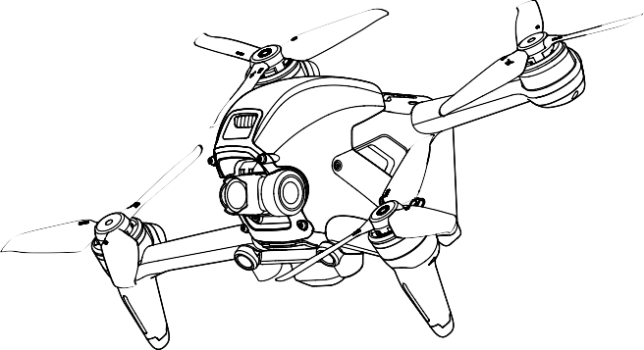

Explorer Combo | 探索套装

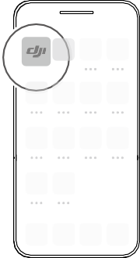

**DJI Fly**



**DJI Fly**

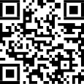

**DJI Fly App**

## 2

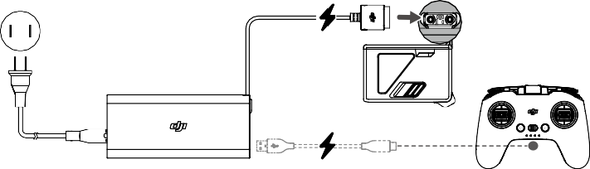

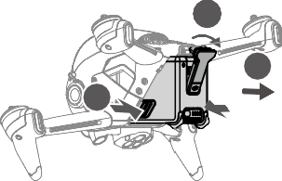

1

3

2

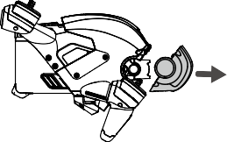

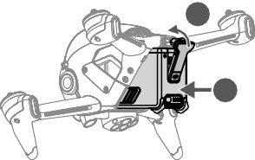

2

1

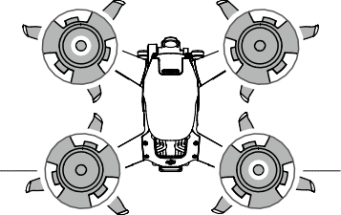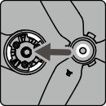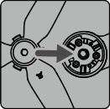A B



|  |  |  |  |  |  |
| --- | --- | --- | --- | --- | --- |
|  | B |  |  | A |  |
| Unmarked |  |  |  |  | Marked |
| 无标记 |  |  |  |  | 红色标记 |
| 無標記 |  |  |  |  | 紅色標記 |
| マークなし |  |  |  |  | マークあり |
| 표시 없음 |  |  |  |  | 표시 있음 |
| Nicht markiert Sin marcas Sans repères  Senza contrassegno |  | 2 | 1 |  | Markiert Con marcas Avec repères  Con contrassegno |
| Ongemarkeerd Não marcado Sin marcas  Без меток |  |  |  |  | Gemarkeerd Marcado Con marcas  С метками |

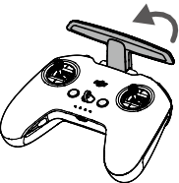

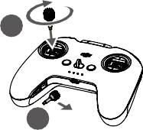

2

1

## 5

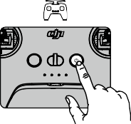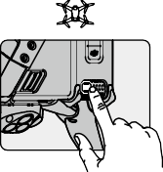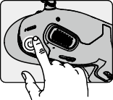Check battery level: press once.



EN

Power on/off: press then press and hold.

检查电量：短按一次。



CHS

开机 / 关机：短按一次，再长按 2 秒。

檢查電量：短按一次。



CHT

開機 / 關機：短按一次，再長按 2 秒。

バッテリー残量確認：1 回押す。



JP

電源をオン／オフ：1 回押して、長押し。

배터리 잔량 확인 : 한 번 누르기



KR

전원 켜기 / 끄기 : 한번 누르고 다시 길게 누르기

Einmal drücken: Akkustand überprüfen.



DE

Ein-/ausschalten: Kurz drücken, dann nochmals drücken und gedrückt halten.

Comprobar nivel de batería: presione una vez.



ES

Encender/apagar: pulse, vuelva a pulsar y mantenga pulsado.

Vérification du niveau de batterie : appuyer une fois



FR

Allumer/Éteindre : appuyez une fois, puis appuyez et maintenez le bouton enfoncé pour allumer/éteindre.

Verificare il livello della batteria: premere una volta.



IT

Accendere/spegnere: premere, quindi premere e tenere premuto.

Controle batterijniveau: één keer drukken.



NL

Aan- en uitzetten: Indrukken en vasthouden.

Verificar o nível da bateria: prima uma vez.



PT

Ligar/desligar: prima, e em seguida prima de forma contínua.

Verificar o nível da bateria: pressione uma vez.



PT-BR

Ligar/desligar: pressione uma vez, então pressione novamente e segure.

Проверить заряд аккумулятора: нажмите один раз. Включение/выключение: нажмите, затем нажмите еще раз и удерживайте кнопку.



RU

## 6

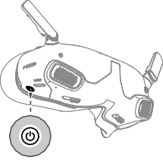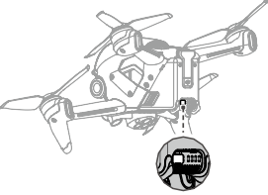a.



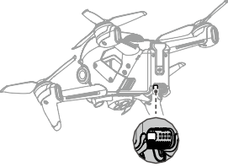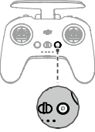b.



Linking



EN

Linking is required if the aircraft status indicator on the rear frame arm blinks yellow quickly after all the devices are powered on.

* 1. Aircraft + Goggles
     1. Press and hold the power button on the goggles. The goggles will beep continually.
     2. Press and hold the power button of the aircraft until the battery level indicator blinks in sequence.
     3. The battery level indicator of the aircraft turns solid and displays the battery level. The goggles stop beeping when they are successfully linked and the video display is normal.
  2. Aircraft + Remote Controller
     1. Press and hold the power button of the aircraft until the battery level indicator blinks in sequence.
     2. Press and hold the power button of the remote controller until it beeps continually and the battery level indicator blinks in sequence.
     3. The remote controller stops beeping when successfully linked and both the battery level indicators turn solid and display the battery level.

 The aircraft must be linked with the goggles before the remote controller.

对频

开启所有设备后，若飞行器后机臂的状态指示灯黄灯快闪，则需要对频。



CHS

1. 飞行器 + 飞行眼镜
   1. 长按飞行眼镜的电源按键直至响起嘀 - 嘀…的提示音。
   2. 长按飞行器的电源按键，电池电量指示灯将循环闪烁。
   3. 对频成功后，飞行器的电池电量指示灯常亮显示电量，飞行眼镜提示音停止并显示图传。
2. 飞行器 + 遥控器
   1. 长按飞行器的电源按键，电池电量指示灯将循环闪烁。
   2. 长按遥控器的电源按键直至响起嘀 - 嘀…的提示音，且电池电量指示灯循环闪烁。
   3. 对频成功后，飞行器及遥控器的电池电量指示灯均常亮显示电量，遥控器提示音停止。

 飞行器需先完成与飞行眼镜的对频，再进行和遥控器的对频。

配對

開啟所有裝置后，若航拍機後機臂的狀態指示燈為黃燈快閃，則需要配對。



CHT

1. 航拍機 + 飛行眼鏡
   1. 長按飛行眼鏡的電源按鍵直至響起嘀 - 嘀…的提示音。
   2. 長按航拍機的電源按鍵，電池電量指示燈將循環閃爍。
   3. 配對成功後，航拍機的電池電量指示燈恆亮顯示電量，飛行眼鏡提示音停止並顯示影像傳輸。
2. 航拍機 + 遙控器
   1. 長按航拍機的電源按鍵，電池電量指示燈將循環閃爍。
   2. 長按遙控器的電源按鍵直至響起嘀 - 嘀…的提示音，且電池電量指示燈循環閃爍。
   3. 配對成功後，航拍機及遙控器的電池電量指示燈均恆亮顯示電量，遙控器提示音停止。

航拍機需先完成與飛行眼鏡的配對，再進行和遙控器的配對。

***リンク***



JP

全てのデバイスの電源を入れた後、後方フレームアームの機体ステータスインジケーターが素早く黄色点滅している場合、リンク接続が必要です。

1. ***機体*** + ***ゴーグル***
   1. ゴーグルの電源ボタンを長押しします。ゴーグルからビープ音が連続して鳴ります。
   2. バッテリー残量インジケーターが順に点滅するまで機体の電源ボタンを長押しします。
   3. 機体のバッテリー残量インジケーターが点灯し、電池残量を表示します。正常に リンクされ、動画ディスプレイが正常になると、ゴーグルのビープ音が止まります。
2. ***機体*** + ***送信機***
   1. バッテリー残量インジケーターが順に点滅するまで機体の電源ボタンを長押しします。
   2. ビープ音が連続して鳴り、バッテリー残量インジケーターが順に点滅するまで、送信機の電源ボタンを長押しします。
   3. リンク作業が正常に終了し、両方のバッテリー残量インジケーターが点灯してバッテリー残量を表示されると、送信機のビープ音は止まります。

 機体は送信機より前にゴーグルとリンクしておく必要があります。

**연동**

만약 모든 기기 전원을 켠 후 후면 프레임 암의 기체 상태 표시등이 노란색으로 빠르게 깜박 인다면 , 연동이 필요합니다 .



KR

1. **기체** + **고글**
   1. 고글의 전원 버튼을 길게 누릅니다 . 고글은 계속 신호음 소리를 냅니다 .
   2. 배터리 잔량 표시기가 순차적으로 깜박일 때까지 기체의 전원 버튼을 길게 누릅니다 .
   3. 기체의 배터리 잔량 표시기가 켜진 상태로 배터리 잔량을 표시합니다 . 성공적으로 연 동되고 동영상 디스플레이가 정상이면 , 고글 신호음이 멈춥니다 .
2. **기체** + **조종기**
   1. 배터리 잔량 표시기가 순차적으로 깜박일 때까지 기체의 전원 버튼을 길게 누릅니다 .
   2. 조종기가 계속해서 신호음을 내고 배터리 잔량 표시기가 순차적으로 깜박일 때까지 조종기의 전원 버튼을 길게 누릅니다 .
   3. 성공적으로 연동되면 조종기가 깜박임을 중단하고 두 배터리 잔량 표시기가 모두 켜 지며 배터리 잔량을 표시합니다 .

 기체를 고글과 먼저 연동한 후 조종기와 연동해야 합니다 .

Koppeln

Eine Kopplung ist erforderlich, wenn die Status-LED des Fluggeräts auf dem hinteren Rahmenausleger schnell gelb blinkt, nachdem alle Geräte eingeschaltet wurden.



DE

1. Fluggerät + Goggles
   1. Halte die Netztaste gedrückt auf den Goggles. Die Goggles piepsen kontinuierlich.
   2. Halt den Einschaltknopf des Fluggeräts gedrückt, bis die Akkustandanzeige blinkt.
   3. Die Akkustandsanzeige auf dem Fluggerät leuchtet ständig und zeigt den

Akkustand an. Die Goggles hören auf zu piepen, sobald sie erfolgreich gekoppelt wurden und die Videowiedergabe normal angezeigt wird.

1. Fluggerät + Fernsteuerung
   1. Halt den Einschaltknopf des Fluggeräts gedrückt, bis die Akkustandanzeige blinkt.
   2. Halt den Einschaltknopf der Fernsteuerung gedrückt, bis diese kontinuierlich piepst und die Akkustandsanzeige blinkt.
   3. Die Fernbedienung hört auf zu piepsen, wenn die Verbindung erfolgreich hergestellt wurde und die beiden Akkustandsanzeigen leuchten ständig und zeigen den Akkustand an.

 Das Fluggerät muss mit den Goggles vor der Fernsteuerung verbunden werden.

Vinculación

Es necesario realizar la vinculación si el indicador de estado de la aeronave situado en el brazo trasero del bastidor parpadea rápidamente en amarillo tras encender todos los dispositivos.



ES

1. Aeronave + Gafas
   1. Mantenga presionado el botón de encendido en las gafas. Las gafas emitirán un pitido continuo.
   2. Mantenga presionado el botón de encendido de la aeronave hasta que el indicador del nivel de batería parpadee en secuencia.
   3. El indicador del nivel de batería de la aeronave se vuelve fijo y muestra el nivel de batería. Las gafas dejarán de pitar cuando se enlacen correctamente y la visualización del vídeo sea normal.
2. Aeronave + Control remoto
   1. Mantenga presionado el botón de encendido de la aeronave hasta que el indicador del nivel de batería parpadee en secuencia.
   2. Mantenga presionado el botón de encendido del control remoto hasta que emita un pitido continuo y el indicador del nivel de batería parpadee en secuencia.
   3. El control remoto deja de pitar cuando se conecta correctamente y ambos indicadores del nivel de batería se vuelven fijos y muestran el nivel de batería.

 La aeronave debe vincularse a las gafas antes que el control remoto.

Appairage

L’appairage est nécessaire si l’indicateur du statut de l’appareil situé sur le bras arrière clignote rapidement en jaune après la mise sous tension de tous les appareils.



FR

1. Appareil + Casque
   1. Maintenez le bouton d'alimentation enfoncé du casque. Le casque émet alors un bip continu.
   2. Maintenez le bouton d'alimentation de l’appareil enfoncé jusqu’à ce que l’indicateur de niveau de batterie clignote en séquence.
   3. L’indicateur de niveau de batterie de l’appareil brille de façon continue et affiche le niveau de batterie. Le casque cessent de biper lorsqu'il est appairé et l'affichage vidéo est normal.
2. Appareil + Radiocommande
   1. Maintenez le bouton d'alimentation de l’appareil enfoncé jusqu’à ce que l’indicateur de niveau de batterie clignote en séquence.
   2. Maintenez le bouton d'alimentation de la radiocommande enfoncé jusqu’à ce qu’elle émette un bip continu et que l’indicateur de niveau de batterie clignote en séquence.
   3. La radiocommande arrête de biper quand elle est correctement appairée et que l’indicateur du niveau de batterie passe au fixe et affiche le niveau de batterie.

 L’appareil doit être appairé au casque avant la radiocommande.

Collegamento

Il collegamento è necessario se l'indicatore di stato del velivolo sul braccio del telaio posteriore lampeggia rapidamente in giallo dopo che tutti i dispositivi sono stati accesi.



IT

1. Aeromobile + visore
   1. Premere e tenere premuto il pulsante di accensione sul visore. Il visore emetterà un bip continuo.
   2. Premere e tenere premuto il pulsante di accensione dell’aeromobile fino a quando l’indicatore del livello della batteria lampeggia in sequenza.
   3. L’indicatore del livello della batteria dell’aeromobile si illumina di luce fissa e visualizza il livello della batteria. Gli occhiali smetteranno di lampeggiare quando collegati correttamente e la visualizzazione delle immagini si stabilizza.
2. Aeromobile + radiocomando
   1. Premere e tenere premuto il pulsante di accensione dell’aeromobile fino a quando l’indicatore del livello della batteria lampeggia in sequenza.
   2. Premere e tenere premuto il pulsante di accensione sul radiocomando fino a quando emette un bip continuo e l’indicatore del livello della batteria lampeggia in sequenza.
   3. Il radiocomando smette di emettere il bip una volta eseguito il collegamento ed entrambi gli indicatori del livello della batteria si illuminano di luce fissa e visualizzano il livello della batteria.

 È necessario collegare l’aeromobile al visore prima del radiocomando.

Koppelen

Koppeling is vereist als de statusindicator van de drone op de achterste frame-arm snel geel knippert nadat alle apparaten zijn ingeschakeld.



NL

1. Drone + bril
   1. Druk en houd de aan-/uitknop op de bril. De bril piept continu.
   2. Druk en houd de aan-/uitknop van de drone ingedrukt totdat de indicator van de accu in volgorde knippert.
   3. De indicator voor het accuniveau van de drone brandt constant en geeft het accuniveau weer. De bril stopt met piepen wanneer deze met succes is gekoppeld en het videoscherm normaal is.
2. Drone + afstandsbediening
   1. Druk en houd de aan-/uitknop van de drone ingedrukt totdat de indicator van de accu in volgorde knippert.
   2. Druk en houd de aan-/uitknop van de afstandsbediening ingedrukt totdat

deze continu piept en de indicator voor het accuniveau op volgorde knippert.

* 1. De afstandsbediening stopt met piepen wanneer deze met succes is gekoppeld. Beide indicatoren voor het accuniveau worden constant en geven het accuniveau weer.

 De drone moet vóór de afstandsbediening met de bril worden gekoppeld.

Ligação

É necessária a ligação se o indicador de estado da aeronave no braço da estrutura traseira piscar rapidamente a amarelo depois de todos os dispositivos serem ligados.



PT

1. Aeronave + Goggles
   1. Prima e mantenha premido o botão de alimentação nos goggles. Os goggles emitirão um sinal sonoro contínuo.
   2. Prima e mantenha premido o botão de alimentação da aeronave até que o indicador de nível de bateria pisque sequencialmente.
   3. O indicador de nível da bateria da aeronave fica sólido e mostra o nível da bateria. Os óculos param de emitir sinais sonoros quando ligados com êxito e o visor de vídeo é normal.
2. Aeronave + Telecomando
   1. Prima e mantenha premido o botão de alimentação da aeronave até que o indicador de nível de bateria pisque sequencialmente.
   2. Prima e mantenha premido o botão do telecomando até emitir um sinal sonoro contínuo e o indicador do nível da bateria piscar em sequência.
   3. O telecomando deixa de emitir um sinal sonoro quando for ligado com êxito e ambos os indicadores do nível de bateria ficarem sólidos e mostrarem o nível da bateria.

 A aeronave tem de ser ligada aos goggles antes do telecomando.

Vinculação

Será necessário realizar a vinculação caso o indicador de status da aeronave no braço traseiro da estrutura piscar rapidamente em amarelo após todos os dispositivos terem sido ligados.



PT-BR

1. Aeronave + óculos
   1. Mantenha pressionado o botão liga/desliga nos óculos. Os óculos emitirão um sinal sonoro contínuo.
   2. Mantenha pressionado o botão liga/desliga da aeronave até que o indicador de nível da bateria pisque em sequência.
   3. O indicador de nível da bateria da aeronave ficará aceso e exibirá o nível da bateria. Os óculos de proteção param de emitir sinal sonoro quando forem vinculados com êxito e a exibição do vídeo for normal.
2. Aeronave + controle remoto
   1. Mantenha pressionado o botão liga/desliga da aeronave até que o indicador de nível da bateria pisque em sequência.
   2. Mantenha pressionado o botão liga/desliga do controle remoto até ouvir um bipe contínuo e o indicador de nível da bateria piscar em sequência.
   3. O controle remoto vai parar de emitir sinal sonoro quando vinculado com êxito e os dois indicadores de nível da bateria ficarem acesos e exibirem o nível da bateria.

A aeronave deve ser vinculada aos óculos antes do controle remoto.

Сопряжение



RU

Требуется сопряжение, если индикатор состояния дрона, расположенный на заднем луче, быстро мигает желтым светом после включения питания всех устройств.

а. Дрон + очки

1. Нажмите и удерживайте кнопку питания на очках. Устройство начнет издавать непрерывный звуковой сигнал.
2. Нажмите и удерживайте кнопку питания дрона до тех пор, пока индикатор уровня заряда аккумулятора не начнет последовательно мигать.
3. Индикатор уровня заряда аккумулятора дрона начнет светиться и отобразит его оставшийся заряд. Очки перестанут издавать звуковой сигнал при успешном сопряжении, а изображение на экране нормализуется.

б. Дрон + пульт управления

1. Нажмите и удерживайте кнопку питания дрона, пока индикатор уровня заряда не начнет последовательно мигать.
2. Нажмите и удерживайте кнопку питания пульта управления, пока устройство не начнет издавать непрерывный звуковой сигнал, а индикатор уровня заряда аккумулятора – последовательно мигать.
3. Звуковой сигнал пульта управления прекратится после успешного сопряжения, индикатор уровня заряда аккумулятора начнет светиться и отобразит оставшийся заряд.

Дрон сначала должен быть сопряжен сначала с очками, а затем с пультом управления.

## 7

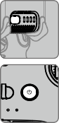Not included in the box

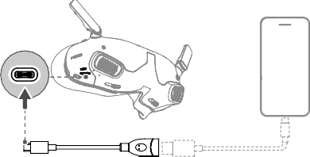

**DJI Fly App**

数据线需自备

Connect the USB-C port of the goggles to the mobile device with the USB-C OTG cable and a suitable data cable. Run DJI Fly on the mobile device and follow the prompts to activate the DJI devices.



EN

使用自备的手机数据线及标配的 USB-C OTG 转接线连接飞行眼镜的 USB-C 接口至手机，运行 DJI Fly App 并根据 App 提示激活设备。



CHS

使用自備的手機傳輸線及標配的 USB-C OTG 轉接線，將飛行眼鏡的 USB-C 接頭連接至手機，執行 DJI Fly 應用程式並根據應用程式提示啟用裝置。



CHT

USB-C OTG ケーブルと適切なデータケーブルを使用して、ゴーグルの USB-C ポートをモバイル端末に接続します。モバイル端末でDJI Fly アプリを起動し、画面の指示に従って DJI デバイスをアクティベーションします。



JP

USB-C OTG 케이블과 적절한 데이터 케이블을 사용하여 고글의 USB-C 포트를 모바일 기기에 연결합니다 . 모바일 기기에서 DJI Fly 를 실행하고 지시에 따라 DJI 기기를 활성화 합니다 .



KR

Verbinde mithilfe des OTG-Kabels (USB-C) und eines geeigneten Datenkabels den USB-C-Anschluss der Goggles mit dem Mobilgerät. Starte die DJI Fly App auf dem Mobilgerät und folge den Anweisungen, um die DJI-Geräte zu aktivieren.



DE

Conecte el puerto USB-C de las gafas al dispositivo móvil con el cable USB-C OTG y un cable de datos adecuado. Inicie la aplicación DJI Fly en el dispositivo móvil y siga las instrucciones para activar los dispositivos DJI.



ES

Connectez le port USB-C du casque à l’appareil mobile avec le câble USB-C OTG et un câble de données adapté. Exécutez DJI Fly sur l’appareil mobile et suivez les instructions pour activer les appareils DJI.



FR

Collegare la porta USB-C del visore al dispositivo mobile per mezzo del cavo USB-C OTG e un cavo dati idoneo. Eseguire DJI Fly sul dispositivo mobile e seguire i prompt per attivare i dispositivi DJI.



IT

Sluit de USB-C-poort van de bril aan op het mobiele apparaat met de USB-C OTG-kabel en een geschikte datakabel. Start DJI Fly op het mobiele apparaat en volg de aanwijzingen om de DJI-apparaten te activeren.



NL

Ligue a porta USB-C dos goggles ao dispositivo móvel com o cabo USB-C OTG e um cabo de dados adequado. Execute o DJI Fly no dispositivo móvel e siga as instruções para ativar os dispositivos DJI.



PT

Conecte a entrada USB-C dos Goggles ao dispositivo móvel com o cabo USB-C OTG e um cabo de dados compatível. Execute o DJI Fly no dispositivo móvel e siga as instruções para ativar os dispositivos DJI.



PT-BR

Подключите порт USB-C на очках к мобильному устройству с помощью кабеля USB-C OTG и соответствующего кабеля для передачи данных. Запустите приложение DJI Fly на мобильном устройстве и следуйте инструкциям, чтобы активировать устройства DJI.



RU

**8**

Normal Mode / 普通挡 / 普通檔 / ノーマルモード / 일반 모드 / Normalmodus / Modo Normal / Mode Normal / Modalità Normal / Normale stand / Modo Normal / Modo Normal / Обычный режим

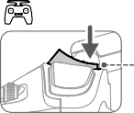

OR Motoren starten oder stoppen Iniciar o detener motores Démarrer ou arrêter les moteurs

Start or stop motors

启动或停止电机啟動或停止馬達

モーターの起動／停止

모터 시작 또는 정지

Avviare o spegnere i motori Start of stop motoren Iniciar ou parar os motores Dá partida ou para motores

Запустить или остановить моторы

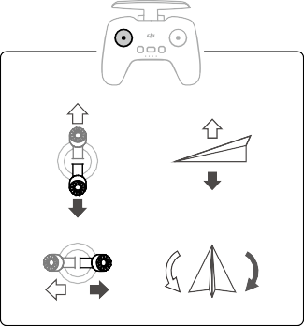 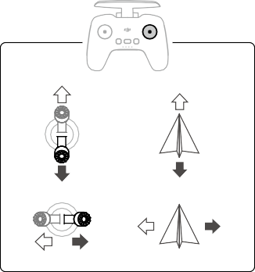

Mode 2 (Normal Mode)

美国手 ( 普通挡 )

美國手 ( 普通檔 )

モード 2 ( ノーマルモード )

모드 2 ( 일반 모드 ) Modus 2 (Normalmodus) Modo 2 (Modo Normal)

Mode 2 (mode Normal) Modalità 2 (Modalità Normal) Stand 2 (normale stand) Modo 2 (Modo Normal) Modo 2 (Modo Normal) Режим 2 (обычный режим)

WE ARE HERE FOR YOU

在线技术支持

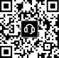 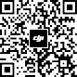

Contact

**DJI SUPPORT**

微信扫一扫获取技术支持

SUBSCRIBE FOR MORE INFORMATION

关注 DJI 大疆创新及时获取最新资讯

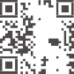





[www.dji.com/dji-fpv/downloads](http://www.dji.com/dji-fpv/downloads)

DJI is a trademark of DJI.

Copyright © 2023 DJI All Rights Reserved.

YCBZSS00255401

### Goggles V2

User Guide

使用说明

使用說明

ユーザーガイド 사용자 가이드 Bedienungsanleitung

Guía de usuario Guide de l'utilisateur Guida dell'utente Gebruiksaanwijzing Manual do utilizador Guia do usuário

Руководство пользователя

2021.03



v1.2

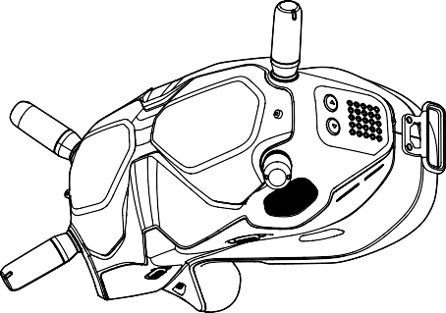

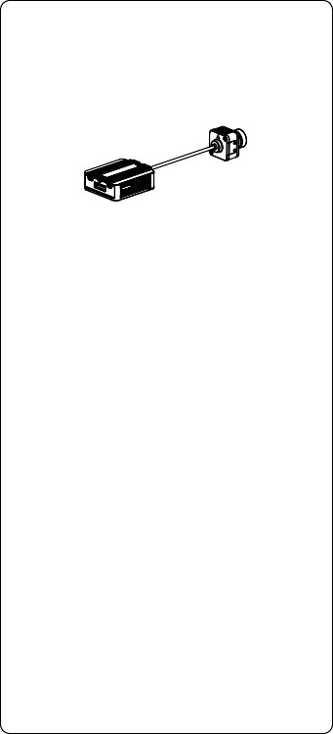

**DJI Digital FPV System**

[www.dji.com/fpv/**video**](http://www.dji.com/fpv/video)

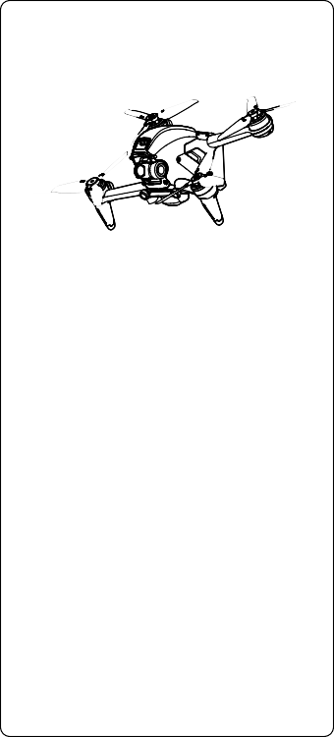

**DJI FPV**

[www.dji.com/dji-fpv/**video**](http://www.dji.com/dji-fpv/video)

## 2

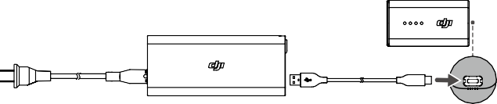

1

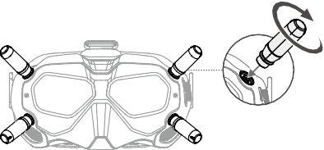

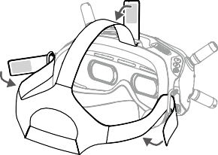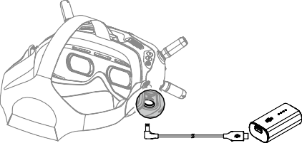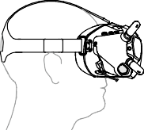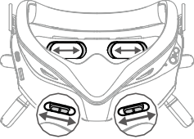

58 – 70 mm

2

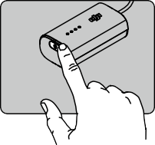

EN Check battery level: press once.

Power on/off: press then press and hold.

CHS 检查电量：短按一次。

开机 / 关机：短按一次，再长按 2 秒。

CHT 檢查電量：短按一次。

開機 / 關機：短按一次，再長按 2 秒。

JP バッテリー残量確認：1 回押す。

電源をオン／オフ：1 回押して、長押し。

KR 배터리 잔량 확인 : 한 번 누르기

전원 켜기 / 끄기 : 한번 누르고 다시 길게 누르기

DE Einmal drücken: Akkustand überprüfen.

Ein-/auszuschalten: Kurz drücken, dann nochmals drücken und gedrückt halten.

ES Comprobar nivel de batería: presione una vez.

Encender/apagar: pulse, vuelva a pulsar y mantenga pulsado.

FR Vérification du niveau de batterie : appuyer une fois

Allumer/Éteindre : appuyez une fois, puis appuyez et maintenez le bouton enfoncé pour allumer/éteindre.

IT Verificare il livello della batteria: premere una volta.

Accendere/spegnere: premere, quindi premere e tenere premuto.

NL Controle batterijniveau: één keer drukken.

Aan- en uitzetten: Indrukken en vasthouden.

PT Verificar o nível da bateria: prima uma vez.

Ligar/desligar: prima, e em seguida prima de forma contínua.

PT-BR Verificar o nível da bateria: pressione uma vez.

Ligar/desligar: pressione uma vez, então pressione novamente e segure.

RU Проверить заряд аккумулятора: нажмите один раз.

Включение/выключение: нажмите, затем нажмите еще раз и удерживайте кнопку.

3

 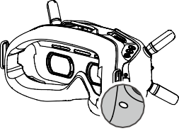



**Linking**

Ensure that all devices are powered on.

1. Press the link button on the air unit. The linking status indicator will turn solid red.
2. Press the link button on the goggles. The goggles will beep continually.
3. The linking status indicator of the air unit turns solid green. The goggles will stop beeping when they are successfully linked and the video display is normal.

If you need to use the Goggles and remote controller together, the air unit must be linked to the goggles before the remote controller.

对 频

对频前请确保所有设备均已开启。

1. 按下天空端的对频按键，对频状态指示灯红灯常亮。
2. 按下飞行眼镜的对频按键，飞行眼镜响起嘀 - 嘀…的提示音。
3. 对频成功后，天空端对频状态指示灯绿灯常亮，飞行眼镜提示音停止并显示图传。

 若同时使用飞行眼镜和遥控器，天空端需先完成与飞行眼镜的对频，再进行和遥控器的对频。

配 對

配對前請確保所有裝置均已開啟。

1. 按下天空端的配對按鈕，配對狀態指示燈將呈現紅燈恆亮。
2. 按下飛行眼鏡的配對按鈕，飛行眼鏡會響起「嘀 - 嘀…」的提示音。
3. 配對成功後，天空端配對狀態指示燈將呈現綠燈恆亮，飛行眼鏡提示音停止，並顯示圖像傳輸。

 若同時使用飛行眼鏡和遙控器，需要先完成天空端與飛行眼鏡的配對，再進行與遙控器的配對。

**リンク**

すべての機器の電源が入っていることを確認します。

1. エアユニットのリンクボタンを押します。リンクステータスインジケーターが赤色に点灯します。
2. ゴーグルのリンクボタンを押します。ゴーグルからビープ音が連続して鳴ります。
3. エアユニットのリンクステータスインジケーターが緑色に点灯します。正常にリンクされ、動画ディスプレイが正常になると、ゴーグルのビープ音が止まります。

 ゴーグルと送信機を一緒に使用する必要がある場合は、エアユニットはゴーグルにリンクしてから、送信機にリンクする必要があります。

4

**연동**

모든 기기의 전원이 켜졌는지 확인합니다 .

1. 에어 유닛의 연동 버튼을 누릅니다 . 연동 상태 표시등이 빨간색을 유지합니다 .
2. 고글의 연동 버튼을 누릅니다 . 고글은 계속 신호음 소리를 냅니다 .
3. 에어 유닛의 연동 상태 표시등이 녹색을 유지합니다 . 성공적으로 연동되고 동영상 디스플레이가 정상이 면 , 고글 신호음이 멈춥니다 .

 고글과 조종기를 함께 사용해야 하는 경우 , 에어 유닛을 고글에 먼저 연동한 후 조종기를 연동해야 합니다 .

**Koppeln**

Stell sicher, dass alle Geräte eingeschaltet sind.

1. Drück die Kopplungstaste an der Lufteinheit. Die Kopplungsstatusanzeige leuchtet permanent rot.
2. Drück die Kopplungstaste auf den Goggles. Die Goggles piepsen kontinuierlich.
3. Die Kopplungsstatusanzeige der Lufteinheit leuchtet permanent grün. Die Goggles hören auf zu piepen, sobald sie erfolgreich gekoppelt wurden und die Videowiedergabe normal angezeigt wird.

Wenn du die Goggles und die Fernsteuerung zusammen verwenden möchtest, muss die Lufteinheit vor der Fernsteuerung mit den Goggles verbunden werden.

**Vinculación**

Asegúrese de que todos los dispositivos estén encendidos.

1. Presione el botón de enlace en la unidad aérea. El indicador de estado de enlace se enciende en

rojo fijo.

1. Presione el botón de enlace en las gafas. Las gafas emitirán un pitido continuo.
2. El indicador de estado de enlace de la unidad aérea se enciende en verde fijo. Las gafas dejan de

pitar cuando se enlazan correctamente y la visualización del vídeo es normal.

 Si necesita usar las gafas y el control remoto a la vez, la unidad aérea debe enlazarse a las gafas antes que al control remoto.

**Appairage**

Assurez-vous que tous les dispositifs sont sous tension.

1. Appuyer sur le bouton d’appairage de l’unité aérienne. Le voyant d’état de l’appairage passe au

rouge fixe.

1. Appuyez sur le bouton d’appairage du casque. Le casque émet alors un bip continu.
2. Le voyant d’état de l’appairage de l’unité aérienne passe au vert fixe. Le casque cesse de biper lorsqu'il est correctement lié et que l'affichage vidéo est normal.

 Si vous devez utiliser le casque et la commande à distance en même temps, l'unité aérienne doit être liée au casque avant la commande à distance.

**Collegamento**

Accertarsi che tutti i dispositivi siano accesi.

1. Premere il pulsante di collegamento sull’aeromobile. L’indicatore di stato del collegamento diventa

rosso e rimane fisso.

1. Premere il pulsante di collegamento sul visore. Il visore emetterà un bip continuo.
2. L’indicatore di stato del collegamento dell’unità aerea diventa verde fisso. Gli occhiali smetteranno

di lampeggiare quando collegati correttamente e la visualizzazione delle immagini si stabilizza.

 Se è necessario utilizzare gli occhiali e il radiocomando insieme, l’unità aerea dev’essere

collegata agli occhiali prima del radiocomando.

5

**Koppelen**

Zorg ervoor dat alle apparaten zijn ingeschakeld.

1. Druk op de verbindingsknop op de luchteenheid. De statusindicator voor koppeling zal continu rood worden.
2. Druk op de verbindingsknop op de bril. De bril piept continu.
3. De statusindicator voor koppeling van de luchteenheid wordt continu groen. De bril zal met piepen stoppen wanneer deze met succes is gekoppeld en het videoscherm normaal is.

Als u de bril en afstandsbediening samen wilt gebruiken, moet de luchteenheid vóór de afstandsbediening aan de bril worden gekoppeld.

**Ligação**

Assegure-se de que todos os dispositivos estão ligados.

1. Pressione o botão de ligação na unidade de ar. O indicador de estado de ligação fica vermelho fixo.
2. Prima o botão de ligação nos goggles. Os goggles emitirão um sinal sonoro contínuo.
3. O indicador de estado de ligação da unidade de ar fica verde fixo. Os goggles param de emitir um sinal sonoro quando ligados com êxito e o visor de vídeo é normal.

 Se precisar de utilizar os Goggles e o telecomando em conjunto, a unidade de ar deve ser ligada aos óculos antes do telecomando.

**Vinculação**

Verifique se todos os dispositivos estão ligados.

1. Pressione o botão de vinculação na unidade aérea. O indicador de status de vinculação ficará

vermelho sólido.

1. Pressione o botão de vinculação nos óculos de proteção. Os óculos de proteção emitirão um sinal sonoro contínuo.
2. O indicador de status de vinculação da unidade aérea ficará verde sólido. Os óculos de proteção param de emitir sinal sonoro quando forem vinculados com êxito e a exibição do vídeo for normal.

Se precisar usar os óculos de proteção e o controle remoto juntos, a unidade aérea deve ser vinculada aos óculos de proteção antes do controle remoto.

**Сопряжение**

Убедитесь, что все устройства включены.

1. Нажмите кнопку сопряжения на дроне. Индикатор состояния сопряжения загорится красным цветом.
2. Нажмите кнопку сопряжения на очках. Очки начнут издавать непрерывный звуковой сигнал.
3. Индикатор состояния сопряжения на дроне должен загореться зеленым цветом. При успешном сопряжении очки перестанут издавать сигнал, а изображение на экране нормализуется.

 В случае необходимости совместного использования очков и пульта дистанционного управления необходимо выполнить сопряжение дрона с очками до сопряжения с пультом

управления.

6

When powered on, connect the goggles to a computer and run DJI ASSISTANTTM 2 for activation.

飞行眼镜需在供电状态下连接至电脑并运行 DJI ASSISTANTTM 2 调参软件激活。飛行眼鏡需在供電狀態下連接至電腦並執行 DJI ASSISTANTTM 2 調參軟體啟動。

電源が入ったら、ゴーグルをパソコンに接続し、DJI ASSISTANTTM 2 を実行して起動します。

전원이 켜진 상태에서 고글을 컴퓨터에 연결한 후 DJI ASSISTANTTM 2 를 작동하십시오 .

Verbinden Sie die Goggles nach dem Einschalten mit einem Computer und starten Sie den DJI ASSISTANTTM 2 zur Aktivierung.

Cuando estén encendidas, conecte las gafas a un ordenador y ejecute DJI ASSISTANTTM 2 para la activación.

Lorsqu’il est allumé, connectez le casque à un ordinateur et exécutez DJI ASSISTANTTM 2 pour l’activation.

Una volta acceso, collegare il visore a un computer ed eseguire DJI ASSISTANTTM 2 per l’attivazione.

Wanneer ingeschakeld, sluit u de bril aan op een computer en draait u DJI ASSISTANTTM 2 voor activering.

Quando ligado, ligue os óculos a um computador e execute o DJI ASSISTANTTM 2 para ativação.

Quando ligado, conecte os Goggles a um computador e execute o DJI ASSISTANTTM 2 para ativação.

Подсоедините включенные очки к компьютеру и запустите DJI ASSISTANTTM 2 для активации.

7

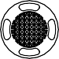



5D Button

Toggle to scroll through the menu.

Press to confirm.

五维按键

拨动以滚动界面菜单，按下确认

五維按鈕

撥動以滾動介面菜單，按下確認

5D ボタン

メニューをスクロールするように切り替えます。

押すと確定されます。

5D 버튼

토글하여 메뉴를 스크롤합니다. 버튼을 눌러서 확인합니다.

5D-Taste

Betätigen, um durch das Menü zu scrollen. Zur Bestätigung drücken.

Botón 5D

Alterne para desplazarse por el menú.

Presione para confirmar.

Bouton 5D

Basculer pour faire défiler le menu. Appuyez pour confirmer.

Pulsante 5D

Attivare per consultare il menu. Premere per confermare.

5D-knop

Wissel om door het menu te bladeren. Druk om te bevestigen.

Botão 5D

Alterne para percorrer o menu.

Prima para confirmar.

Botão 5D

Alterne para percorrer o menu.

Pressione para confirmar.

Кнопка 5D

Коснитесь для просмотра меню. Нажмите для подтверждения.

Record Button

Press to start or stop video recording.

录像按键

按下可开始 / 结束录像

錄影按鈕

按下可開始 / 結束錄影

録画ボタン

押すと録画が開始 / 停止されます。

녹화 버튼

버튼을 누르면 동영상 녹화가 시작되 거나 중단됩니다.

Videoaufnahmetaste

Startet und beendet die Videoaufnahme.

Botón de grabación

Pulse para iniciar o parar la grabación de vídeo.

Bouton d’enregistrement

Appuyez une fois sur cette touche pour démarrer/arrêter l’enregistrement.

Pulsante di registrazione

Premere il pulsante per avviare o interrompere la registrazione video.

Opnameknop

Druk om de video-opname te starten/ stoppen.

Botão de gravação

Prima para iniciar ou parar a gravação de vídeo.

Botão de gravação

Pressione para iniciar ou parar a gravação de vídeo.

Кнопка записи

Нажмите, чтобы начать/остановить запись видео.

8



Back Button

Press to return to the previous menu or exit

the current mode.

返回按键

返回上级菜单或退出当前模式

返回按鈕

返回上層目錄或退出目前模式

戻るボタン

押すと前のメニューに戻るか、現在のモードを終了します。

뒤로 버튼

버튼을 누르면 이전 메뉴로 돌아가거나 현재 모드에서 나갑니다.

Zurück-Taste

Drücken Sie die Taste, um zum vorherigen Menü zurückzukehren oder den aktuellen Modus zu verlassen.

Botón de retroceso

Pulse para volver al menú principal o salir del modo actual.

Bouton de retour

Appuyez pour revenir au menu précédent ou pour quitter le mode actuel.

Pulsante indietro

Premere per tornare al menu precedente o uscire dalla modalità corrente.

Terug-toets

Druk om terug te keren naar het vorige menu of de huidige modus te verlaten.

Botão Voltar

Prima para voltar ao menu anterior ou para sair do modo atual.

Botão voltar

Pressione para retornar ao menu anterior ou sair do modo atual.

Кнопка возврата

Нажмите для возврата в предыдущее меню или выхода из текущего режима.

Channel Adjustment Buttons

Press to switch channels.

Channel Display

Displays the current channel.

频道调节按键 按下可切换频道频道显示屏

显示当前频道

頻道調節按鈕 按下可切換頻道頻道螢幕

顯示目前頻道

チャンネル調整ボタン

押すとチャンネルが切り替わります。

チャンネル表示

現在のチャンネルが表示されます。

채널 조정 버튼

버튼을 눌러서 채널을 전환합니다.

채널 디스플레이

현재 채널을 표시합니다.

Tasten für die Kanaleinstellung Drücken, um den Kanal zu wechseln. Kanalanzeige

Zeigt den aktuellen Kanal an.

Botones de ajuste de canal Presione para cambiar de canal. Visualización del canal

Muestra el canal actual.

Boutons d’ajustement de canal Appuyez pour changer de canal. Affichage du canal

Affiche le canal actuel.

Pulsanti di regolazione del canale

Premere per cambiare canale. Visualizzazione canale Visualizza il canale corrente.

Knoppen voor aanpassing van kanalen

Druk om van kanaal te wisselen.

Kanaalweergave

Geeft het huidige kanaal weer.

Botões de ajuste do canal Prima para mudar de canais. Visor de canal

Apresenta o canal atual.

Botões de ajuste de canal Pressione para alterar os canais. Exibição de canal

Exibe o canal atual.

Кнопки настройки канала

Нажмите для переключения каналов.

Дисплей канала

Отображает текущий канал.

9

EN

**Disclaimer and Warning**

Please read this entire document and all safe and lawful practices DJITM provided carefully before use. Failure to read and follow instructions and warnings may result in serious injury to yourself or others, damage to your DJI product, or damage to other objects in the vicinity. By using this product, you hereby signify that you have read this disclaimer and warning carefully and that you understand and agree to abide by the terms and conditions herein. You agree that you are solely responsible for your own conduct while using this product, and for any consequences thereof. DJI accepts no liability for damage, injury or any legal responsibility incurred directly or indirectly from the use of this product.

DJI is a trademark of SZ DJI TECHNOLOGY CO., LTD. (abbreviated as “DJI”) and its affiliated companies. Names of products, brands, etc., appearing in this document are trademarks or registered trademarks of their respective owner companies. This product and document are copyrighted by DJI with all rights reserved. No part of this product or document shall be reproduced in any form without the prior written consent or authorization of DJI.

This document and all other collateral documents are subject to change at the sole discretion of DJI. For up to date product information, visit [http://www.dji.com](http://www.dji.com/) and click on the product page for this product.

This disclaimer is available in various languages. In the event of divergence among different versions, the English version shall prevail.

**Usage**

Visit <http://www.dji.com/fpv> (User Manual) to learn more about how to use this product with DJI FPV Air Unit.

Visit <http://www.dji.com/dji-fpv> (User Manual) to learn more about how to use this product with DJI FPV Drone.

**Specifications**

Dimensions

184×122×110 mm (excl. antennas) 202×126×110 mm (incl. antennas)

Transmitter Power (EIRP)

2.4 GHz: ≤28.5 dBm (FCC), ≤20 dBm (CE/SRRC/MIC)

5.8 GHz: ≤31.5 dBm (FCC), ≤19 dBm (SRRC), ≤14 dBm (CE)

Weight

Approx. 420 g (incl. headband and antennas)

Screen Size

2-inch × 2

Operating Frequency

2.400-2.4835 GHz; 5.725-5.850 GHz

Screen Resolution (Single Screen) 1440×810

Goggles (Model: FGDB28)

Low Latency Mode (810p 100fps/120fps) High Quality Mode (810p 50fps/60fps)

Video Format MP4 (Video format: H.264)

Supported Video Play Format MP4, MOV, MKV (Video format: H.264; Audio format: AAC-LC,

Live View Mode

AAC-HE, AC-3, MP3)

Operating Temperature 0° to 40° C (32° to 104° F)

Recommend to use DJI FPV goggles battery

Other battery: 11.1-25.2 V

Goggles Battery

Power Input

Capacity 1800 mAh

Voltage 9 V max

Type LiPo 2S

10

Charging Temperature

0° to 45° C (32° to 113° F)

Max Charging Power 10 W

Energy 18 Wh

Please refer to <http://www.dji.com/service> for after-sales service for your product where applicable.

DJI shall mean SZ DJI TECHNOLOGY CO., LTD. and/or its affiliated companies where applicable.

CHS

免责声明和警告

使用本产品之前，请仔细阅读并遵循本文及大疆 TM 创新（DJITM）提供的所有安全指引，否则可能会给您和周围的人带来伤害，损坏本产品或其它周围物品。一旦使用本产品，即视为您已经仔细阅读本文档，理解、认可和接受本声明全部条款和内容。您承诺对使用本产品以及可能带来的后果负全部责任。大疆创新（DJI）对于直接或间接使用本产品而造成的损坏、伤害以及任何法律责任不予负责。

DJI 是深圳市大疆创新科技有限公司及其关联公司的商标。本文出现的产品名称、品牌等，均为其所属公司的商标。本产品及手册为大疆创新版权所有。未经许可，不得以任何形式复制翻印。

本文档及本产品所有相关的文档最终解释权归大疆创新（DJI）所有。如有更新，恕不另行通知。请访问 [www.dji.com](http://www.dji.com/) 官方网站以获取最新的产品信息。

使 用

搭配 DJI FPV 天空端使用时，访问 <http://www.dji.com/fpv>（用户手册）获取详细的产品使用方法。

搭配 DJI FPV 飞行器使用时，访问 <http://www.dji.com/dji-fpv>（用户手册）获取详细的产品使用方法。

规格参数

飞行眼镜（型号：FGDB28）

重量 约 420 g（含头带及天线）

外形尺寸 184×122×110 mm（不含天线）；202×126×110 mm（含天线）

屏幕尺寸 2 inch×2

屏幕分辨率（单屏） 1440×810

工作频率 2.400-2.4835 GHz；5.725-5.850 GHz

发射功率（EIRP）

2.4 GHz: ≤28.5 dBm (FCC), ≤20 dBm (CE/SRRC/MIC)

5.8 GHz: ≤31.5 dBm (FCC), ≤19 dBm (SRRC), ≤14 dBm (CE)

图传模式 低延迟模式 (810p 100fps/120fps)，高画质模式 (810p 50fps/60fps)

录像格式 MP4（视频格式：H.264）

支持播放文件格式 MP4，MOV，MKV

（视频格式：H.264；音频格式：AAC-LC, AAC-HE, AC-3, MP3）

工作环境温度 0℃至 40℃

电源输入 推荐使用 DJI FPV 飞行眼镜电池其他电池：11.1-25.2 V

飞行眼镜电池

容量 1800 mAh

电压 9 V max

类型 LiPo 2S

11

充电环境温度

0℃至 45℃

最大充电功率 10 W

能量 18 Wh

浏览 <http://www.dji.com/service> 以获取产品的售后信息。 “DJI”表示深圳市大疆创新科技有限公司及其关联公司。

CHT

免責聲明和警告

使用本産品之前，請仔細閱讀並遵循本文及大疆 TM 創新（DJITM）提供的所有安全指南，否則可能會給您和周圍的人帶來傷害，損壞本産品或其它周圍物品。一旦使用本產品，即視為您已經仔細閱讀本文件，理解、認可和接受本聲明全部條款和內容。您承諾對使用本產品以及可能帶來的後果負全部責任。大疆創新（DJI）對於直接或間接使用本產品而造成的損壞、傷害及任何法律責任概不負責。

DJI 是深圳市大疆創新科技有限公司及其附屬公司的商標。本文出現的産品名稱、品牌等，均為其所屬公司的商標。本產品及手冊之版權為大疆創新所有。未經許可，不得以任何形式複製翻印。

本文件及本產品所有相關文件的最終解釋權歸大疆創新（DJI）所有。如有更新，恕不另行通知。請前往 [www.dji.com](http://www.dji.com/) 官方網站以取得最新的產品資訊。

使 用

與 DJI FPV 天空端共同搭配使用時，請瀏覽 <http://www.dji.com/fpv>（使用者手冊）以取得詳細的產品使用方法。

與 DJI FPV 航拍機共同搭配使用時，請瀏覽 <http://www.dji.com/dji-fpv>（使用者手冊）以取得詳細的產品使用方法。

規格參數

DJI FPV 飛行眼鏡 V2/DJI FPV Goggles V2（型號：FGDB28）

重量 約 420 g （含頭帶及天線）

外型尺寸 184×122×110 mm（不含天線）；202×126×110 mm（含天線）

螢幕尺寸 2 inch × 2

螢幕解析度（單螢幕） 1440×810

運作頻率 2.400-2.4835 GHz；5.725-5.850 GHz

發射功率（EIRP）

2.4 GHz: ≤28.5 dBm (FCC), ≤20 dBm (CE/SRRC/MIC)

5.8 GHz: ≤31.5 dBm (FCC), ≤19 dBm (SRRC), ≤14 dBm (CE)

影像傳輸模式 低延遲模式 (810p 100fps/120fps)，高畫質模式 (810p 50fps/60fps)

影片格式 MP4（影片格式：H.264）

支援播放檔案格式 MP4，MOV，MKV（影片格式：H.264；音訊格式：AAC-LC, AAC-

HE, AC-3, MP3）

操作環境溫度 0℃ 至 40℃

電源輸入 建議使用 DJI FPV 飛行眼鏡電池其他電池：11.1-25.2 V

|  |  |
| --- | --- |
| 二次鋰電行動電源（飛行眼鏡電池） | |
| 容量 | 1800 mAh |
| 電壓 | 9 V max |
| 類型 | LiPo 2S |
| 能量 | 18 Wh |
| 充電環境溫度 | 0℃ 至 45℃ |
| 最大充電功率 | 10 W |
| 12 |  |

瀏覽 <http://www.dji.com/service> 以取得產品的售後資訊。

「DJI」代表深圳市大疆創新科技有限公司及其附屬公司。

JP

免責事項および警告

ご使用前に、この文書全体に目を通し、DJITM が提供する安全で合法的慣行についての説明を注意深くお読みください。指示と警告に従わなかった場合、ご自身や他の人に重傷を負わせたり、またはお客様の DJI 製品および周辺の他の物の破損につながる恐れがあります。本製品を使用することにより、本書の免責事項および警告をよく読み、記載されている利用規約を理解し、順守することに同意したとみなされます。本製品の使用中の行動とこれに伴う結果には、ユーザーが全面的に責任を負うことに同意するものとします。本製品の使用により直接または間接的に発生する損害、傷害、およびその他法的責任に対して、DJI は一切責任を負いません。

DJI は SZ DJI TECHNOLOGY CO., LTD.（以下「DJI」と省略）およびその関連会社の商標です。本書に記載されている製品、ブランドなどの名称は、その所有者である各社の商標または登録商標です。本製品および本書は、不許複製・禁無断転載を原則とする DJI の著作物のため、 DJI から書面による事前承認または許諾を得ることなく、本製品または文書のいかなる部分も、いかなる方法によっても複製することは固く禁じられています。

本書およびその他すべての付属書は、DJI 独自の裁量で変更されることがあります。最新の製品情報については、[http://www.dji.com](http://www.dji.com/) にアクセスして、本製品に対応する製品ページをクリックしてご覧ください。

この免責条項は複数の言語で提供されています。言語版によって相違がある場合には、英語版が優先されます。

使用方法

本製品を DJI FPV エアユニットと併用するときの使用方法について詳しくは、http://www.dji.

com/fpv（ユーザーマニュアル）をご覧ください。

本製品を DJI FPV ドローンと併用するときの使用方法について詳しくは、<http://www.dji.com/>

dji-fpv（ユーザーマニュアル）をご覧ください。

仕様

サイズ

184 × 122 × 110 mm（アンテナ含まず）

202 × 126 × 110 mm（アンテナ含む）

伝送電力（EIRP）

2.4 GHz: ≤ 28.5 dBm（FCC）、≤ 20 dBm（CE/SRRC/MIC（日本））

5.8 GHz: ≤ 31.5 dBm（FCC）、≤ 19 dBm（SRRC）、≤ 14 dBm（CE）

重量

約 420 g（ヘッドバンドとアンテナ含む）

画面サイズ

2 インチ× 2

動作周波数

2.400 ～ 2.4835 GHz、

5.725 ～ 5.850 GHz（日本では 2.400 ～ 2.4835 GHz のみ）

画面解像度（一画面） 1440 × 810

ゴーグル（モデル：FGDB28）

低遅延モード（810p 100fps/120fps）高画質モード（810p 50fps/60fps）

動画フォーマット MP4（動画フォーマット：H.264）

MP4、MOV、MKV（動画フォーマット：H.264、オーディオフォーマット：

ライブビューモード

対応動画再生フォーマット

AAC-LC、AAC-HE、AC-3、MP3）

動作環境温度 0℃～ 40℃

DJI FPV ゴーグルバッテリーの使用を推奨その他のバッテリー：11.1 ～ 25.2 V

入力電力

13

|  |  |
| --- | --- |
| ゴーグルバッテリー |  |
| 容量 | 1800 mAh |
| 電圧 | 最大 9 V |
| タイプ | LiPo 2S |
| 電力量 | 18 Wh |
| 充電温度 | 0 ～ 45℃ |
| 最大充電電力 | 10 W |

お客様の製品に該当するアフターセールスサービスにつきましては、<http://www.dji.com/service>を参照してください。

DJI は、SZ DJI TECHNOLOGY CO., LTD. および／または該当する場合はその関連会社を表し。

KR

**고지 사항 및 경고**

DJITM 에서 제공해드리는 본 문서 전문과 안전하고 적법한 사용 방법 관련된 모든 내용을 사용 전에 주의 깊게 읽어 주십시오 . 지침 및 경고 사항을 읽고 따르지 않을 경우 사용자 또는 다른 사람이 심각하게 다치거나 DJI 제품 또는 근처에 있는 다른 물체가 손상될 수 있습니다 . 제품을 사용하는 것은 본 고지 사항 및 경고를 주의 깊게 읽었으며 명시된 약관을 이해하고 준수하기로 동의한 것으로 간주합니다 . 본 제품 사용 시 사용자의 행위 와 그에 따른 결과에 대한 책임은 전적으로 본인에게 있다는 것에 동의합니다 . DJI 는 본 제품의 사용으로 인 해 직접 또는 간접적으로 발생한 피해 , 부상 또는 모든 법적 책임에 대해 어떠한 책임도 지지 않습니다 .

DJI 는 SZ DJI TECHNOLOGY CO., LTD.( 약어로 “DJI”) 및 해당 자회사의 상표입니다 . 본 문서에 표시된 제품명 , 브랜드 등은 해당 소유 회사의 상표 또는 등록 상표입니다 . DJI 는 본 제품 및 문서의 저작권과 함께 모든 권리를 보유합니다 . 본 제품 또는 문서의 어떠한 부분도 DJI 의 서면 허가 또는 동의 없이 어떠한 형식으 로 재생산할 수 없습니다 .

이 문서 및 기타 모든 부수적인 문서는 DJI 의 단독 재량에 따라 변경될 수 있습니다 . 최신 제품 정보를 확인하 려면 [http://www.dji.com](http://www.dji.com/) 을 방문하여 본 제품에 대한 제품 페이지를 클릭하십시오 .

이 고지 사항은 다양한 언어로 제공됩니다 . 각 언어 버전 간에 차이가 있을 경우 , 영어 버전이 우선합니다 .

**사용**

이 제품과 DJI FPV 에어 유닛의 사용 방법에 관한 자세한 내용은 <http://www.dji.com/fpv> 사이트 ( 다운로드

- User Manual) 에서 확인하시기 바랍니다 .

이 제품과 DJI FPV 드론의 사용 방법에 관한 자세한 내용은 <http://www.dji.com/dji-fpv> 사이트 ( 다운로드 - User Manual) 에서 확인하시기 바랍니다 .

**사양**

고글 ( 모델명 : FGDB28)

무게 약 420 g ( 헤드밴드 및 안테나 포함 )

크기 184 × 122 × 110 mm ( 안테나 제외 ), 202 × 126 × 110 mm ( 안테나 포함 )

스크린 크기 2 인치 × 2

화면 해상도 ( 단일 화면 ) 1440 × 810

작동 주파수 2.400~2.4835 GHz, 5.725~5.850 GHz

송신기 출력 (EIRP)

2.4 GHz: ≤ 28.5 dBm (FCC), ≤ 20 dBm (CE/SRRC/MIC)

5.8 GHz: ≤ 31.5 dBm (FCC), ≤ 19 dBm (SRRC), ≤ 14 dBm (CE)

라이브 뷰 모드 저지연 모드 (810p 100fps/120fps), 고화질 모드 (810p 50fps/60fps)

동영상 파일 형식 MP4 ( 동영상 파일 형식 : H264)

MP4, MOV, MKV ( 동영상 파일 형식 : H264, 오디오 형식 : AAC-LC, AAC- HE, AC-3, MP3)

작동 온도 0~40 ° C

지원 동영상 재생 형식

14

DJI FPV 고글 배터리 사용을 권장합니다 .

기타 배터리 : 11.1~25.2 V

입력 전력

고글 배터리

용량 1800 mAh

전압 9 V ( 최대 )

유형 LiPo 2S

에너지 18 Wh

충전 온도 0~45 ° C

최대 충전 전력 10 W

해당 제품의 적용 가능한 A/S 서비스는 <http://www.dji.com/service> 를 참조하십시오 . DJI 는 SZ DJI TECHNOLOGY CO., LTD. 및 / 또는 해당 자회사를 의미합니다 .

DE

**Haftungsausschluss und Warnhinweis**

Bitte lesen Sie vor der Verwendung dieses gesamte Dokument und alle von DJITM zur Verfügung gestellten sicheren und rechtmäßigen Praktiken sorgfältig durch. Die Nichtbeachtung der Anweisungen und Warnungen kann zu schweren Verletzungen für Sie oder andere Personen bzw. zu Schäden an Ihrem DJI-Produkt oder anderen Objekten in der näheren Umgebung führen. Mit dem Gebrauch des Produkts bestätigen Sie, dass Sie diesen Haftungsausschluss inkl. Warnungen aufmerksam gelesen und den Inhalt verstanden haben und mit den allgemeinen Geschäftsbedingungen hierin einverstanden sind. Sie stimmen zu, dass Sie beim Gebrauch des Produkts die alleinige Verantwortung für Ihre Handlungen und alle daraus entstehenden Folgen tragen. DJI übernimmt keine Haftung für Sachschäden oder Personenschäden sowie keine juristische Verantwortung für Schäden, die direkt oder indirekt mit dem Gebrauch des Produkts in Zusammenhang stehen.

DJI ist eine Marke von SZ DJI Technology Co., Ltd. (kurz: „DJI“) und seiner verbundenen Unternehmen. Namen von Produkten, Marken usw., die in diesem Dokument enthalten sind, sind Warenzeichen oder eingetragene Warenzeichen der jeweiligen Besitzer (Eigentümergesellschaften). Dieses Produkt und dieses Dokument sind urheberrechtlich geschütztes Eigentum von DJI und alle Rechte sind vorbehalten. Kein Teil dieses Produkts oder dieses Dokuments darf in irgendeiner Form ohne vorherige schriftliche Zustimmung oder Genehmigung von DJI reproduziert werden.

Dieses Dokument und alle zugehörigen Dokumente können nach eigenem Ermessen von DJI jederzeit geändert werden. Aktuelle Produktinformationen finden Sie auf der Produktseite für dieses Produkt unter [http://www.dji.com.](http://www.dji.com/)

Dieser Haftungsausschluss ist in verschiedenen Sprachen verfügbar. Bei Abweichungen zwischen

den verschiedenen Fassungen ist die englische Fassung maßgebend.

**Verwendung**

Besuch [www.dji.com/fpv](http://www.dji.com/fpv) (Benutzerhandbuch), um mehr über den Gebrauch dieses Produkts mit der DJI FPV Lufteinheit zu erfahren.

Besuch [www.dji.com/dji-fpv](http://www.dji.com/dji-fpv) (Benutzerhandbuch), um mehr über den Gebrauch dieses Produkts mit der DJI FPV Drohne zu erfahren.

**Technische Daten**

Abmessungen

184 × 122 × 110 mm (ohne Antennen)

202 × 126 × 110 mm (mit Antennen)

Gewicht

Ca. 420 g (einschließlich Kopfband und Antennen)

Goggles (Modell: FGDB28)

Bildschirmgröße 2 Zoll × 2

15

Strahlungsleistung (EIRP)

2,4 GHz: ≤28,5 dBm (FCC), ≤20 dBm (CE/SRRC/MIC)

5,8 GHz: ≤31,5 dBm (FCC), ≤19 dBm (SRRC), ≤14 dBm (CE)

Betriebsfrequenz

2,400–2,4835 GHz; 5,725–5,850 GHz

Live-Ansicht-Modus

Niedriger Latenz-Modus (810p 100 fps/120 fps) HD-Modus (810p 50 fps/60 fps)

Unterstützte Wiedergabeformate

MP4, MOV, MKV (Videoformat: H.264; Audioformat: AAC-LC, AAC-HE, AC-3, MP3)

Eingangsspannung

Wir empfehlen die DJI FPV Goggle-Akkus zu benutzen.

Anderer Akku: 11,1 – 25,2 V

Speicherkapazität

1.800 mAh

Typ

LiPo 2S

Ladetemperatur

0 °C bis 45 °C

Max. Ladeleistung 10 W

Energie 18 Wh

Spannung 9 V max.

Goggles-Akku

Betriebstemperaturbereich 0 °C bis 40 °C

Videoformat MP4 (Videoformat: H.264)

Bildschirmauflösung (Bildschirm einzeln) 1440×810

Die entsprechenden Informationen zum Kundenservice entnehmen Sie [http://www.dji.com/service.](http://www.dji.com/service) DJI bedeutet SZ DJI TECHNOLOGY CO., LTD. und/oder ihre verbundenen Unternehmen.

ES

**Renuncia de responsabilidad y advertencia**

Lea detenidamente este documento al completo y todas las prácticas de seguridad y legales que DJITM ha facilitado antes de su uso. Si no lee ni sigue correctamente las instrucciones y advertencias, podría sufrir lesiones importantes o provocarlas a otras personas. Asimismo, podría causar daños en su producto DJI u otros objetos en las proximidades. Al usar este producto, manifiesta que ha leído detenidamente esta renuncia de responsabilidad y advertencia, así como que entiende y acepta cumplir los términos y condiciones establecidos en este documento. Acepta que usted es el único responsable de su propia conducta durante el uso de este producto y de cualquier consecuencia derivada de dicho uso. DJI no acepta responsabilidad alguna por daños o lesiones, ni ningún tipo de responsabilidad legal derivada directa o indirectamente del uso de este producto.

DJI es una marca comercial de SZ DJI TECHNOLOGY CO., LTD. (abreviado como “DJI”) y sus filiales. Los nombres de productos, marcas, etc., que aparecen en este documento son marcas comerciales o marcas comerciales registradas de sus respectivas empresas propietarias. Este producto y el documento están protegidos por los derechos de autor de DJI con todos los derechos reservados. No se permite la reproducción total ni parcial de este documento o producto en forma alguna sin el consentimiento previo por escrito o la autorización de DJI.

Este documento y el resto de documentos colaterales están sujetos a cambios a entera discreción de DJI. Para obtener información actualizada sobre el producto, visite [http://www.dji.com](http://www.dji.com/) y haga clic en la página de este producto.

Esta renuncia está disponible en diversos idiomas. En caso de divergencia entre las diferentes versiones, prevalecerá la versión en inglés.

**Uso**

Visite <http://www.dji.com/fpv> (Manual del usuario) para obtener más información sobre el uso de este producto con la Unidad aérea DJI FPV.

Visite <http://www.dji.com/dji-fpv> (Manual del usuario) para obtener más información acerca de cómo usar este producto con el dron DJI FPV.

16

**Especificaciones**

Dimensiones

184 × 122 × 110 mm (sin antenas)

202 × 126 × 110 mm (con antenas)

Resolución de pantalla (pantalla

individual)

1440×810

Transmisor de potencia (PIRE)

2.4 GHz: ≤28.5 dBm (FCC), ≤20 dBm (CE/SRRC/MIC)

5.8 GHz: ≤31.5 dBm (FCC), ≤19 dBm (SRRC), ≤14 dBm (CE)

Peso

Aprox. 420 g (banda de sujeción y antenas incluidas)

Tamaño de pantalla

2 × 2 pulgadas

Frecuencia de funcionamiento

2.400-2.4835 GHz; 5.725-5.850 GHz

Modo de vídeo en directo

Modo de baja latencia (810p 100fps/120fps) Modo de alta calidad (810p 50fps/60fps)

Formatos de reproducción de vídeo compatibles

MP4, MOV, MKV (códec de vídeo: H264; códec de audio: AAC-LC, AAC-HE, AC-3, MP3)

Potencia de entrada

Se recomienda usar la batería de las DJI Goggles FPV

Otra batería: 11.1-25.2 V

Capacidad

1800 mAh

Tipo

LiPo 2S

Temperatura de carga

De 0 a 45 °C (de 32 a 113 °F)

Potencia de carga máx. 10 W

Energía 18 Wh

Voltaje 9 V máx.

Batería de gafas

Temperatura de funcionamiento De 0 a 40 °C (de 32 a 104 °F)

Formato de vídeo MP4 (códec de vídeo: H264)

Gafas (Modelo: FGDB28)

Visite <http://www.dji.com/service> para recibir servicio postventa para su producto según

corresponda.

Por DJI se entiende SZ DJI TECHNOLOGY CO., LTD. y sus filiales, según corresponda.

FR

**Clause d’exclusion de responsabilité et mise en garde**

Veuillez lire attentivement ce document dans son intégralité, ainsi que toutes les pratiques sécuritaires et légales fournies par DJITM avant l’utilisation du produit DJI associé. Si vous ne lisez pas et ne respectez pas les instructions et les mises en garde, vous exposez les autres et vous- même à des blessures graves et risquez d’endommager votre produit DJI ou d’autres objets placés à proximité. En utilisant ce produit, vous confirmez que vous avez lu attentivement la clause d’exclusion de responsabilité et la mise en garde, que vous comprenez les conditions générales qui y sont énoncées, et que vous acceptez de les respecter. Vous déclarez assumer l’entière responsabilité de votre comportement lors de l’utilisation du produit ainsi que toutes les conséquences qui en découlent. DJI décline toute responsabilité quant aux dégâts, aux blessures ou aux problèmes découlant directement ou indirectement de l’utilisation de ce produit.

DJI est une marque commerciale de SZ DJI TECHNOLOGY CO., LTD. (« DJI » en abrégé) et de ses sociétés affiliées. Les noms de produits, de marques, etc., apparaissant dans le présent document sont des marques commerciales ou des marques déposées de leurs détenteurs respectifs. Ce produit et le présent document sont la propriété de DJI, tous droits réservés. Aucune partie de ce produit ou du présent document ne peut être reproduite sous quelque forme que ce soit sans l’autorisation ou le consentement écrit préalable de DJI.

DJI se réserve le droit de modifier, à sa seule discrétion, le présent document et tous les autres

17

documents connexes. Pour connaître les dernières informations sur le produit, rendez-vous sur le site [http://www.dji.com](http://www.dji.com/) et cliquez sur la page produit.

Cette clause de non-responsabilité est disponible en plusieurs langues. En cas de divergence entre

les différentes versions, la version en langue anglaise prévaudra.

**Utilisation**

Rendez-vous sur : <http://www.dji.com/fpv> (guide d’utilisateur) pour en savoir plus sur l’utilisation de

l’Unité Aérienne DJI FPV.

Rendez-vous sur : <http://www.dji.com/dji-fpv> (guide d’utilisateur) pour en savoir plus sur l’utilisation

de ce produit avec le drone DJI FPV.

**Caractéristiques techniques**

Dimensions

184 × 122 × 110 mm (sans antennes)

202 × 126 × 110 mm (avec antennes)

Puissance de l’émetteur (EIRP)

2,4 GHz : ≤28,5 dBm (FCC), ≤20 dBm (CE/SRRC/MIC)

5,8 GHz : ≤31,5 dBm (FCC), ≤19 dBm (SRRC), ≤14 dBm (CE)

Poids

Env. 420 g (bandeau et antennes incluses)

Taille de l'écran

2 pouces × 2

Fréquence de fonctionnement

2,400 à 2,4835 GHz ; 5,725 à 5,850 GHz

Modes d'aperçu en direct (Live View) Mode Latence faible (810p 100 ips/120 ips)

Mode Haute qualité (810p 50 ips/60 ips)

Encodage vidéo pris en charge

MP4, MOV, MKV

(Encodage vidéo : H264 ; Encodage audio : AAC-LC, AAC-HE,

AC-3, MP3)

Puissance d’entrée

Il est recommandé d’utiliser la batterie intégrée au casque DJI FPV.

Autre batterie : 11,1 à 25,2 V

Capacité

1 800 mAh

Type

LiPo 2S

Température de charge

0 à 45 °C

Puissance de charge max. 10 W

Énergie 18 Wh

Tension 9 V max

Batterie du casque

Température de fonctionnement 0 à 40 °C

Format de vidéo MP4 (Encodage vidéo : H264)

Résolution de l'écran (écran unique) 1 440 × 810

Casque (Modèle : FGDB28)

Consultez la page <http://www.dji.com/service> pour bénéﬁcier du service après-vente pour votre

produit, le cas échéant.

DJI signifie SZ DJI TECHNOLOGY CO., LTD. et/ou ses sociétés affiliées le cas échéant.

IT

**Limitazioni di responsabilità e avvertenze**

Si prega di leggere con attenzione l’intero documento e tutte le pratiche sicure e legali DJITM fornite prima dell’uso. La mancata lettura e l’inosservanza delle istruzioni e delle avvertenze ivi riportate potrebbero determinare lesioni gravi all’utente o ad altre persone, nonché danni al prodotto DJI o ad altri oggetti che si trovano nelle vicinanze. Utilizzando il prodotto, l’utente dichiara di aver letto e compreso le limitazioni di responsabilità e le avvertenze e di accettare i termini e le condizioni ivi specificati. L’utente riconosce di essere l’unico responsabile della propria condotta durante l’utilizzo

18

del prodotto e di eventuali relative conseguenze. DJI declina ogni responsabilità per danni, infortuni o altre responsabilità legali direttamente o indirettamente imputabili all’utilizzo del presente prodotto.

DJI è un marchio registrato di SZ DJI TECHNOLOGY CO., LTD. (abbreviato come “DJI”) e delle sue società affiliate. I nomi di prodotti, i marchi e altre informazioni simili menzionati nel presente documento sono marchi o marchi registrati delle rispettive società proprietarie. Il presente prodotto e la relativa documentazione sono protetti da copyright di DJI e tutti i diritti sono riservati. Nessuna parte di questo prodotto o della relativa documentazione potrà essere riprodotta in qualsiasi forma senza previo consenso o autorizzazione scritti da parte di DJI.

Il presente documento e tutti i documenti complementari sono soggetti a modifiche a esclusiva discrezione di DJI. Per informazioni aggiornate su questo prodotto, visitare [http://www.dji.com](http://www.dji.com/) e accedere alla pagina corrispondente.

Le presenti limitazioni di responsabilità sono disponibili in varie lingue. In caso di divergenza tra le diverse versioni, prevarrà la versione in lingua inglese.

**Uso**

Per ulteriori informazioni sull’uso di questo prodotto con l’unità aerea DJI FPV, visitare il sito https:// [www.dji.com/fpv](http://www.dji.com/fpv) (Manuale utente).

Per ulteriori informazioni sull’uso di questo prodotto con il drone DJI FPV, visitare il sito [https://www.](http://www/) dji.com/dji-fpv (Manuale utente).

**Specifiche**

Dimensioni

184×122×110 mm (antenne escluse) 202×126×110 mm (antenne incluse)

Potenza del trasmettitore (EIRP)

2,4 GHz: ≤28,5 dBm (FCC), ≤20 dBm (CE/SRRC/MIC)

5,8 GHz: ≤31,5 dBm (FCC), ≤19 dBm (SRRC), ≤14 dBm (CE)

Peso

Circa. 420 g (fascia e antenne incluse)

Dimensioni schermo

2 pollici × 2

Frequenza operativa

2,400 – 2,4835 GHz; 5,725 – 5,850 GHz

Modalità Live View

Modalità Low Latency (bassa latenza) (810p 100fps/120fps) Modalità High Quality (alta qualità) (810p 50fps/60fps)

Formati di riproduzione supportati

MP4, MOV, MKV (formato video: H.264; formato audio: AAC- LC, AAC-HE, AC-3, MP3)

Potenza in ingresso

Si consiglia di usare la batteria degli occhiali DJI FPV

Altra batteria: 11,1 – 25,2 V

Capacità

1800 mAh

Tipo

LiPo 2S

Temperatura di ricarica

0 °C – 45 °C (32 °F – 113 ° F)

Potenza massima di ricarica 10 W

Energia 18 Wh

Tensione 9 V max

Batteria del visore

Temperatura operativa 0 °C – 40 °C (32 °F – 104 °F)

Formato video MP4 (formato video: H.264)

Risoluzione schermo (display singolo) 1440×810

Visore (modello: FGDB28)

Fare riferimento al sito Web <http://www.dji.com/service> per assistenza post-vendita per il prodotto

acquistato, dove applicabile.

DJI si riferisce a SZ DJI TECHNOLOGY CO., LTD. e/o sue società affiliate, dove applicabile.

19

NL

**Disclaimer en waarschuwing**

Lees dit hele document, evenals alle veilige en wettelijke praktijken die DJITM heeft verstrekt, vóór gebruik zorgvuldig door. Het niet lezen en opvolgen van de instructies en waarschuwingen kan leiden tot ernstig letsel bij uzelf of anderen, schade aan het DJI-product of schade aan andere voorwerpen in de omgeving. Door het gebruik van dit product geeft u te kennen dat u deze disclaimer en waarschuwing zorgvuldig hebt gelezen en dat u begrijpt en ermee akkoord gaat dat u zich dient te houden aan de hierin gestelde algemene voorwaarden. U gaat ermee akkoord dat u tijdens het gebruik van dit product verantwoordelijk bent voor uw eigen gedrag, en voor de mogelijke gevolgen daarvan. DJI aanvaardt geen aansprakelijkheid voor schade, letsel of enige wettelijke verantwoordelijkheid die direct of indirect voortvloeit uit het gebruik van dit product.

DJI is een handelsmerk van SZ DJI TECHNOLOGY CO., LTD. (afgekort als ‘DJI’) en hieraan gelieerde bedrijven. Namen van producten, merken enz. in dit document zijn handelsmerken of gedeponeerde handelsmerken van hun respectieve eigenaren. Het copyright voor dit product en dit document rust bij DJI met alle rechten voorbehouden. Geen enkel onderdeel van dit product of document mag worden gereproduceerd in welke vorm dan ook zonder voorafgaande schriftelijke toestemming van DJI.

Dit document en alle overige documentatie kunnen naar eigen inzicht van DJI gewijzigd worden. Ga voor actuele productinformatie naar [http://www.dji.com](http://www.dji.com/) en klik op de productpagina van dit product.

Deze disclaimer is in verschillende talen beschikbaar. In geval van verschillen tussen verschillende versies, geldt de Engelse versie.

**Gebruik**

Bezoek <http://www.dji.com/fpv> (gebruikershandleiding) voor meer informatie over het gebruik van dit product met de DJI FPV luchteenheid.

Bezoek <http://www.dji.com/dji-fpv> (gebruikershandleiding) voor meer informatie over het gebruik van dit product met de DJI FPV Drone.

**Technische gegevens**

Bril (Model: FGDB28)

Gewicht Circa 420 g (incl. hoofdband en antennes)

Afmetingen 184×122×110 mm (excl. antennes), 202×126×110 mm (incl. antennes)

Schermformaat 2-inch × 2

Schermresolutie (enkel scherm) 1440×810

Bedieningsfrequentie 2,400 - 2,4835 GHz; 5,725 - 5,850 GHz

Zendervermogen (EIRP)

2,4 GHz: ≤28,5 dBm (FCC), ≤20 dBm (CE/SRRC/MIC)

5,8 GHz: ≤31,5 dBm (FCC), ≤19 dBm (SRRC), ≤14 dBm (CE)

Live-weergavemode Modus met lage vertraging (810p 100 fps/120 fps)

Modus met hoge kwaliteit (810p 50 fps/60 fps)

Bestandsindeling video MP4 (videoformaat: H.264)

Ondersteund video- afspeelformaat

MP4, MOV, MKV (videoformaat: H.264; audioformaat: AAC-LC, AAC-HE,

AC-3, MP3)

Bedrijfstemperatuur 0 ° tot 40 °C (32 ° tot 104 °F)

Ingangsvermogen Het wordt aanbevolen om de accu van de DJI FPV-bril te gebruiken

Andere accu: 11,1-25,2 V

Accu voor de bril

Capaciteit 1800 mAh

20

Spanning 9 V max.

Type LiPo 2S

Vermogen 18 Wh

Laadtemperatuur 0° tot 45°C (32° tot 113°F)

Max. laadvermogen 10 W

Raadpleeg indien van toepassing <http://www.dji.com/service> voor after-sales-service voor uw

product.

DJI staat voor SZ DJI TECHNOLOGY CO., LTD. en/of haar dochterondernemingen, indien van

toepassing.

PT

**Declaração de exoneração de responsabilidade e aviso**

Leia cuidadosamente este documento na íntegra e todas as práticas de segurança e legais DJITM fornecidas antes da utilização. A não leitura e o incumprimento das instruções e avisos podem resultar em ferimentos graves para si ou terceiros, em danos ao seu produto da DJI ou em danos noutros objetos que se encontrem nas proximidades. A utilização deste produto significa que o utilizador leu cuidadosamente esta declaração de exoneração de responsabilidade e o aviso e que compreende e aceita cumprir os termos e condições aqui expostos. O utilizador concorda que é o único responsável pela sua conduta durante a utilização deste produto e pelas possíveis consequências daí resultantes. A DJI não assume qualquer responsabilidade pelos danos ou ferimentos ou quaisquer responsabilidades legais decorrentes direta ou indiretamente da utilização deste produto.

A DJI é uma marca comercial da SZ DJI TECHNOLOGY CO., LTD. (abreviada como "DJI") e das respetivas empresas afiliadas. Todos os nomes de produtos, marcas, etc., incluídos no presente documento são marcas comerciais ou marcas comerciais registadas das respetivas empresas detentoras. Este produto e este documento estão protegidos por direitos de autor pela DJI, com todos os direitos reservados. Nenhuma parte deste produto ou documento deverá ser reproduzida, seja de que forma for, sem o consentimento ou autorização prévios, por escrito, da DJI.

Este e todos os outros documentos de garantia estão sujeitos a alteração ao critério exclusivo da DJI. Para obter informações atualizadas sobre o produto, visite [http://www.dji.com](http://www.dji.com/) e clique na página de produto relativa a este produto.

Esta exoneração de responsabilidade está disponível em diversos idiomas. Em caso de divergência

entre as diferentes versões, a versão em Inglês deverá prevalecer.

**Utilização**

Visite <http://www.dji.com/fpv> (Manual do Utilizador) para saber mais sobre como utilizar este

produto com a Unidade de Ar DJI FPV.

Visite <http://www.dji.com/dji-fpv> (Manual do Utilizador) para saber mais sobre como utilizar este

produto com o Drone DJI FPV.

**Especificações**

Dimensões

184×122×110 mm (excl. antenas) 202×126×110 mm (incl. antenas)

Peso

Aprox. 420 g (incl. faixa de cabeça e antenas)

Tamanho do ecrã

2 polegadas × 2

Resolução do ecrã (ecrã único) 1440×810

Goggles (Modelo: FGDB28)

21

Frequência de funcionamento 2,400-2,4835 GHz; 5,725-5,850 GHz

Alimentação do transmissor (EIRP) 2,4 GHz: ≤28,5 dBm (FCC), ≤20 dBm (CE/SRRC/MIC)

5,8 GHz: ≤31,5 dBm (FCC), ≤19 dBm (SRRC), ≤14 dBm (CE)

Modo de vista em tempo real Modo de latência baixa (810p 100 fps/120 fps)

Modo de alta qualidade (810p 50 fps/60 fps)

Formato de vídeo MP4 (formato de vídeo: H.264)

Formatos de reprodução de vídeo suportados

MP4, MOV, MKV (formato de vídeo: H.264; formato de áudio: AAC- LC, AAC-HE, AC-3, MP3)

Temperatura de funcionamento 0 °C a 40 °C (32 °F a 104 °F)

Potência de entrada Recomenda-se a utilização da bateria dos goggles DJI FPV

Outra bateria: 11,1 - 25,2 V

Bateria dos goggles

Capacidade 1800 mAh

Tensão 9 V máx.

Tipo LiPo 2S

Energia 18 Wh

Temperatura de carregamento 0 °C a 45 °C (32 °F a 113 °F)

Potência máx. de carregamento 10 W

Consulte <http://www.dji.com/service> para obter assistência pós-venda para o seu produto,

conforme aplicável.

DJI significa SZ DJI TECHNOLOGY CO., LTD. e/ou as suas empresas afiliadas, conforme aplicável.

PT-BR

**Isenção de Responsabilidade e Advertência**

Leia este documento por inteiro e todas as práticas legais e seguras que a DJITM forneceu cuidadosamente antes de usar seu dispositivo. A não leitura e o não cumprimento das instruções e advertências podem resultar em lesões graves para si ou terceiros, em danos ao produto da DJI ou a outros objetos que se encontrem nas proximidades. O uso deste produto confirma que o usuário leu cuidadosamente a presente Isenção de Responsabilidade e Advertência, e que compreende e aceita obedecer aos termos e as condições aqui expostos. O usuário concorda que é o único responsável por sua conduta ao utilizar este produto e pelas possíveis consequências dele resultantes. A DJI não assume qualquer responsabilidade por danos, ferimentos ou quaisquer responsabilidades legais decorrentes direta ou indiretamente da utilização deste produto.

DJI é uma marca comercial da SZ DJI TECHNOLOGY CO., LTD. (abreviada como “DJI”) e de suas empresas afiliadas. Nomes de produtos, marcas, etc. que aparecem neste documento são marcas comerciais ou marcas registradas de suas respectivas empresas proprietárias. Este produto e documento são protegidos pela DJI com todos os direitos reservados. Nenhuma parte deste produto ou documento deve ser reproduzida de qualquer forma sem o consentimento prévio por escrito ou autorização da DJI.

Este e todos os outros documentos de garantia estão sujeitos à alteração, a critério exclusivo da DJI. Para obter informações atualizadas sobre o produto, acesse [http://www.dji.com](http://www.dji.com/) e clique na página relacionada a este produto.

Esta Isenção de responsabilidade está disponível em vários idiomas. Em caso de divergência entre versões diferentes, a versão em inglês prevalecerá.

**Uso**

Acesse <http://www.dji.com/fpv> (Manual do Usuário) para obter mais informações sobre como utilizar este produto com a Unidade aérea do DJI FPV.

22

Acesse <http://www.dji.com/dji-fpv> (Manual do Usuário) para obter mais informações sobre como utilizar este produto com o drone DJI FPV.

**Especificações**

Dimensões

184×122×110 mm (excluindo antenas) 202×126×110 mm (incluindo antenas)

Potência do transmissor (EIRP)

2,4 GHz: ≤ 28,5 dBm (FCC), ≤ 20 dBm (CE/SRRC/MIC)

5,8 GHz: ≤ 31,5 dBm (FCC), ≤ 19 dBm (SRRC), ≤ 14 dBm (CE)

Peso

Aprox. 420 g (incluindo faixa para a cabeça e antenas)

Tamanho da tela

2 polegadas x 2

Frequência de funcionamento

2,400 a 2,4835 GHz; 5,725 a 5,850 GHz

Modo de visualização ao vivo

Modo de baixa latência (810p 100fps/120fps) Modo de alta qualidade (810p 50fps/60fps)

Formato de reprodução de vídeo suportado

MP4, MOV, MKV (Formatos de vídeo: H.264; Formatos de áudio: AAC-LC, AAC-HE, AC-3, MP3)

Potência de entrada

Recomenda-se usar a bateria dos óculos de proteção DJI FPV

Outra bateria: 11,1 a 25,2 V

Capacidade

1800 mAh

Tipo

LiPo 2S

Temperatura de carregamento

0° a 45 °C (32° a 113 °F)

Potência máx. de carregamento 10 W

Energia 18 Wh

Tensão 9 V máx.

Bateria dos óculos (goggles)

Temperatura de funcionamento 0° a 40 °C (32° a 104 °F)

Formato de vídeo MP4 (Formatos de vídeo: H.264)

Resolução da tela (tela única) 1440×810

Óculos (goggles) (Modelo: FGDB28)

Consulte <http://www.dji.com/service> para informações de atendimento pós-venda de seu produto

onde aplicável.

DJI significa SZ DJI TECHNOLOGY CO., LTD. E/ou suas empresas afiliadas onde aplicável.

RU

**Отказ от ответственности и предупреждение**

Внимательно ознакомьтесь с данным документом и правилами техники безопасности DJITM перед использованием продукта. Пренебрежение содержимым данного документа и несоблюдение мер безопасности может привести к серьезным травмам, повреждению устройства DJI или другого имущества, находящегося поблизости. Используя данный продукт, вы подтверждаете, что внимательно ознакомились с заявлением об отказе от ответственности и предупреждением и соглашаетесь выполнять содержащееся в данном документе пользовательское соглашение. Вы несете полную ответственность за эксплуатацию данного продукта и все возможные последствия его использования. DJI не несет ответственность за повреждения, травмы или любую юридическую ответственность, прямо или косвенно вызванную использованием данного продукта.

DJI – это товарный знак компании SZ DJI TECHNOLOGY CO., LTD. (сокращенно «DJI») и ее дочерних компаний. Названия продуктов, торговых марок и т. д., содержащиеся в данном документе, являются товарными знаками или зарегистрированными товарными знаками

23

соответствующих компаний. Этот продукт и документ DJI охраняются авторским правом. Все права защищены. Никакая часть данного продукта или документа не может быть воспроизведена в какой-либо форме без предварительного письменного согласия или разрешения DJI.

Компания DJI вправе единолично вносить изменения в содержание данного и всех сопутствующих документов. Для получения обновленной информации о продукте посетите сайт [http://www.dji.com](http://www.dji.com/) и выберите страницу, соответствующую данному продукту.

Этот отказ от ответственности доступен на нескольких языках. В случае расхождения между различными версиями, версия на английском языке имеет преимущественную силу.

**Использование**

Посетите сайт <http://www.dji.com/fpv> для получения более подробной информации по использованию продукта с дроном FPV от DJI.

Посетите сайт <http://www.dji.com/dji-fpv> для получения более подробной информации по использованию дрона.

**Технические характеристики**

Очки (модель: FGDB28)

Масса Около 420 г (включая наголовную ленту и антенны)

Размеры 184×122×110 мм (без антенн), 202×126×110 мм (с антеннами)

Размер экрана 2 дюйма × 2

Разрешение экрана (один экран) 1440×810

Диапазон рабочих частот 2,400–2,4835 ГГц

Мощность передатчика (ЭИИМ) ≤ 28,5 дБм (FCC), ≤ 20 дБм (CE/SRRC/MIC)

Режим предпросмотра в реальном Режим низкой задержки сигнала (810p со скоростью

времени

100 кадров/с / 120 кадров/с), режим высокого качества (810p со скоростью 50 кадров/с / 60 кадров/с)

Видеоформат MP4 (видеоформат: H.264)

Совместимые видеоформаты MP4, MOV, MKV (видеоформат: H.264; аудиоформат: AAC-LC,

AAC-HE, AC-3, MP3)

Диапазон рабочих температур 0...+40°C

Рекомендуется использовать аккумулятор очков DJI FPV Другой аккумулятор: 11,1–25,2 В

Аккумулятор очков

Емкость 1800 мАч

Напряжение 9 В макс.

Входная мощность

Тип Литий-полимерный 2S

Энергия 18 Вт·ч

Диапазон температур зарядки 0…+45°C

Макс. мощность зарядки 10 Вт

Посетите страницу <http://www.dji.com/service> для получения информации о послепродажном обслуживании продукта.

Аббревиатура DJI означает SZ DJI TECHNOLOGY CO., LTD. и/или ее дочерние компании.

24

**Compliance Information**

**FCC Compliance Notice**

This device complies with Part 15 of the FCC Rules. Operation is subject to the following two conditions: (1) This device may not cause harmful interference, and (2) This device must accept any interference received, including interference that may cause undesired operation.

Any changes or modifications not expressly approved by the party responsible

for compliance could void the user’s authority to operate the equipment.

This equipment has been tested and found to comply with the limits for a Class B digital device, pursuant to part 15 of the FCC Rules. These limits are designed to provide reasonable protection against harmful interference in a residential installation. This equipment generates, uses and can radiate radio frequency energy and, if not installed and used in accordance with the instructions, may cause harmful interference to radio communications. However, there is no guarantee that interference will not occur in a particular installation. If this equipment does cause harmful interference to radio or television reception, which can be determined by turning the equipment off and on, the user is encouraged to try to correct the interference by one or more of the following measures:

—Reorient or relocate the receiving antenna.

—Increase the separation between the equipment and receiver.

—Connect the equipment into an outlet on a circuit different from that to which

the receiver is connected.

—Consult the dealer or an experienced radio/TV technician for help.

This equipment complies with FCC radiation exposure limits set forth for an uncontrolled environment. End user must follow the specific operating instructions for satisfying RF exposure compliance. This transmitter must not be co-located or operating in conjunction with any other antenna or transmitter.

The portable device is designed to meet the requirements for exposure to radio waves established by the Federal Communications Commission (USA). These requirements set a SAR limit of 1.6 W/kg averaged over one gram of tissue. The highest SAR value reported under this standard during product certification for use when properly worn on the body.

ISED Compliance Notice

This device contains licence-exempt transmitter(s)/receiver(s) that comply with Innovation, Science and Economic Development Canada’s licence-exempt RSS(s). Operation is subject to the following two conditions: (1)This device may not cause interference.(2)This device must accept any interference, including interference that may cause undesired operation of the device.

L’émetteur/récepteur exempt de licence contenu dans le présent appareil est conforme aux CNR d’Innovation, Sciences et Développement économique Canada applicables aux appareils radio exempts de licence. L’exploitation est autorisée aux deux conditions suivantes :(1)L’appareil ne doit pas produire de brouillage; (2)L’appareil doit accepter tout brouillage radioélectrique subi, même si le brouillage est susceptible d’en compromettre le fonctionnement.

This equipment complies with RSS‐102 radiation exposure limits set forth for an uncontrolled environment. This equipment should be installed and operated with minimum distance 20cm between the radiator and your body. This transmitter must not be co-located or operating in conjunction with any other antenna or transmitter.

This equipment complies with ISED radiation exposure limits set forth for an uncontrolled environment. End user must follow the specific operating instructions for satisfying RF exposure compliance. This transmitter must not be co-located or operating in conjunction with any other antenna or transmitter. The portable device is designed to meet the requirements for exposure to radio waves established by the ISED.

These requirements set a SAR limit of 1.6 W/kg averaged over one gram of tissue. The highest SAR value reported under this standard during product certification for use when properly worn on the body.

Cet équipement est conforme aux limites d’exposition aux rayonnements ISED établies pour un environnement non contrôlé. L’utilisateur final doit suivre les instructions spécifiques pour satisfaire les normes. Cet émetteur ne doit pas être co-implanté ou fonctionner en conjonction avec toute autre antenne ou transmetteur. Le dispositif portatif est conçu pour répondre aux exigences d’exposition aux ondes radio établie par le développement énergétique DURABLE.

Ces exigences un SAR limite de 1,6 W/kg en moyenne pour un gramme de tissu. La valeur SAR la plus élevée signalée en vertu de cette norme lors de la certification de produit à utiliser lorsqu’il est correctement porté sur le corps.

|  |  |  |  |  |  |  |
| --- | --- | --- | --- | --- | --- | --- |
| 部件名称 | 有害物质 | | | | | |
| 铅  (Pb) | 汞  (Hg) | 镉  (Cd) | 六价铬  (Cr+6) | 多溴联苯  (PBB) | 多溴二苯醚  (PBDE) |
| 线路板 | × | ○ | ○ | ○ | ○ | ○ |
| 外壳 | × | ○ | ○ | ○ | ○ | ○ |
| 金属部件  （铜合金） | × | ○ | ○ | ○ | ○ | ○ |
| 内部线材 | × | ○ | ○ | ○ | ○ | ○ |
| 其他配件 | × | ○ | ○ | ○ | ○ | ○ |
| 本表格依据 SJ/T 11364 的规定编制。  ○：表示该有害物质在该部件所有均质材料中的含量均在 GB/T 26572 规定的限量要求以下。  ×：表示该有害物质至少在该部件的某一均质材料中的含量超出 GB/T  26572 规定的限量要求。（产品符合欧盟 ROHS 指令环保要求） | | | | | | |



KCC Compliance Notice

“해당무선설비는 운용 중 전파혼신 가능성이 있으므로 인명안전과 관련된 서비스는 할 수 없습니다 .”

“해당 무선설비는 운용 중 전파혼신 가능성이 있음”

NCC Compliance Notice

取得審驗證明之低功率射頻器材，非經核准，公司、商號或使用者均不得擅自變更頻率、加大功率或變更原設計之特性及功能。低功率射頻器材之使用不得影響飛航安全及干擾合法通信；經發現有干擾現象時，應立即停用，並改善至無干擾時方得繼續使用。前述合法通信，指依電信管理法規定作業之無線電通信。低功率射頻器材須忍受合法通信或工業、科學及

醫療用電波輻射性電機設備之干擾。注意：

應避免影響附近雷達系統之操作。

高增益指向性天線只得應用於固定式點對點系統。

供遙控無人機類似器材遙控器之使用，應符合目的的事業主管機關有關遙控無人機之管理規定。

進口商信息

進口商：聯強國際股份有限公司

地址：台北市民生東路三段 75 號 4 樓聯絡電話：02-25063320#2722

使用過度恐傷害視力

注意事項：

1. 使用 30 分鐘請休息 10 分鐘
2. 不滿 2 歲幼兒不看螢幕，2 歲以上每天看螢幕不要超過 1 小時

|  |  |  |  |  |  |  |
| --- | --- | --- | --- | --- | --- | --- |
| 設備名稱：DJI FPV 飛行眼鏡 V2 型號（型式）： FGDB28 DJI FPV Goggles V2 | | | | | | |
| 單元  Unit | 限用物質及其化學符號 | | | | | |
| 鉛 Lead (Pb) | 汞 Mercury (Hg) | 鎘 Cadmium (Cd) | 六價鉻 Hexavalent chromium (Cr+6) | 多溴聯 苯 Polybrominated biphenyls (PBB) | 多溴二苯醚 Polybrominated diphenyl ethers (PBDE) |
| 線路板 | － | ○ | ○ | ○ | ○ | ○ |
| 外殼 | ○ | ○ | ○ | ○ | ○ | ○ |
| 排針 | ○ | ○ | ○ | ○ | ○ | ○ |
| 其他 | － | ○ | ○ | ○ | ○ | ○ |
| 備考 1.〝超出 0.1 wt %〞及〝超出 0.01 wt %〞係指限用物質之百分比含量超出百分比含量基準值。  備考 2.〝○〞係指該項限用物質之百分比含量未超出百分比含量基準值。  備考 3.〝－〞係指該項限用物質為排除項目。 | | | | | | |



EU Compliance Statement: SZ DJI TECHNOLOGY CO., LTD. hereby declares that this device is in compliance with the essential requirements and other relevant provisions of the Directive 2014/53/EU.

A copy of the EU Declaration of Conformity is available online at [www.dji.com/](http://www.dji.com/) euro-compliance

EU contact address: DJI GmbH, Industriestrasse 12, 97618, Niederlauer,

Germany

GB Compliance Statement: SZ DJI TECHNOLOGY CO., LTD. hereby declares that this device is in compliance with the essential requirements and other relevant provisions of Radio Equipment Regulations 2017.

A copy of the GB Declaration of Conformity is available online at [www.dji.com/](http://www.dji.com/) euro-compliance

Declaración de cumplimiento UE: SZ DJI TECHNOLOGY CO., LTD. por la presente declara que este dispositivo cumple los requisitos básicos y el resto de provisiones relevantes de la Directiva 2014/53/EU.

Hay disponible online una copia de la Declaración de conformidad UE en [www.](http://www/)

dji.com/euro-compliance

Dirección de contacto de la UE: DJI GmbH, Industriestrasse 12, 97618,

Niederlauer, Germany

EU-verklaring van overeenstemming: SZ DJI TECHNOLOGY CO., LTD. verklaart hierbij dat dit apparaat voldoet aan de essentiële vereisten en andere relevante bepalingen van Richtlijn 2014/53/EU.

De EU-verklaring van overeenstemming is online beschikbaar op [www.dji.com/](http://www.dji.com/) euro-compliance

Contactadres EU: DJI GmbH, Industriestrasse 12, 97618, Niederlauer,

Germany

Declaração de conformidade da UE: A SZ DJI TECHNOLOGY CO., LTD. declara, através deste documento, que este dispositivo está em conformidade com os requisitos essenciais e outras disposições relevantes da Diretiva 2014/53/EU.

Existe uma cópia da Declaração de conformidade da UE disponível online em

[www.dji.com/euro-compliance](http://www.dji.com/euro-compliance)

Endereço de contacto na UE: DJI GmbH, Industriestrasse 12, 97618,

Niederlauer, Germany

Dichiarazione di conformità UE: SZ DJI TECHNOLOGY CO., LTD. dichiara che il presente dispositivo è conforme ai requisiti essenziali e alle altre disposizioni rilevanti della direttiva 2014/53/EU.

Una copia della dichiarazione di conformità UE è disponibile online all'indirizzo Web [www.dji.com/euro-compliance](http://www.dji.com/euro-compliance)

Indirizzo di contatto UE: DJI GmbH, Industriestrasse 12, 97618, Niederlauer,

Germany

Déclaration de conformité UE : Par la présente, SZ DJI TECHNOLOGY CO., LTD déclare que cet appareil est conforme aux principales exigences et autres clauses pertinentes de la directive européenne 2014/53/EU.

Une copie de la déclaration de conformité UE est disponible sur le site www.dji. com/euro-compliance

Adresse de contact pour l'UE : DJI GmbH, Industriestrasse 12, 97618,

Niederlauer, Germany

PRÉCAUTIONS D'USAGE DE L'APPAREIL

N’utilisez pas l’appareil dans un hôpital, un avion ou un équipement automobile en raison des radiofréquences qui peuvent produire des interférences

25

•Maintenez une distance minimale de 15 cm entre votre appareil et un stimulateur cardiaque pour éviter toute interférence

Eloigner les équipements radioélectriques du ventre des femmes enceintes. Eloigner les équipements radioélectriques du bas-ventre des adolescents.

Le débit d'absorption spécifique (DAS) local quantifie l'exposition de l'utilisateur aux ondes électromagnétiques de l'équipement concerné. Le DAS maximal autorisé est de 2 W/ kg pour la tête et le tronc et de 4 W/ kg pour les membres.

La ou les valeurs du débit d'absorption spécifique des FGDB28: DAS membres: 0.413 W/ kg

EU-Compliance: Hiermit erklärt SZ DJI TECHNOLOGY CO., LTD., dass dieses Gerät den wesentlichen Anforderungen und anderen einschlägigen Bestimmungen der EU-Richtlinie 2014/53/EU entspricht.

Eine Kopie der EU-Konformitätserklärung finden Sie online auf [www.dji.com/](http://www.dji.com/)

euro-compliance.

Kontaktadresse innerhalb der EU: DJI GmbH, Industriestrasse 12, 97618,

Niederlauer, Germany

Декларация за съответствие на ЕС: SZ DJI Technology Co., Ltd. декларира, че това устройство отговаря на основните изисквания и другите приложими разпоредби на Директива 2014/53/ЕС.

Копие от Декларацията за съответствие на ЕС ще намерите онлайн на адрес [www.dji.com/euro-compliance](http://www.dji.com/euro-compliance)

Адрес за контакт за ЕС: DJI GmbH, Industriestrasse 12, 97618, Niederlauer, Германия

Prohlášení o shodě pro EU: Společnost SZ DJI Technology Co., Ltd. tímto prohlašuje, že tohle zařízení vyhovuje základním požadavkům a dalším příslušným ustanovením směrnice 2014/53/EU.

Kopie prohlášení o shodě pro EU je k dispozici on-line na webu [www.dji.com/](http://www.dji.com/)

euro-compliance

Kontaktní adresa v EU: DJI GmbH, Industriestrasse 12, 97618, Niederlauer, Německo

EU-overensstemmelseserklæring: SZ DJI Technology Co., Ltd. erklærer hermed, at denne enhed er i overensstemmelse med de væsentlige krav og andre relevante bestemmelser i direktiv 2014/53/EU.

Der er en kopi af EU-overensstemmelseserklæringen tilgængelig online på [www.dji.com/euro-compliance](http://www.dji.com/euro-compliance)

EU-kontaktadresse: DJI GmbH, Industriestrasse 12, 97618, Niederlauer,

Tyskland

Δήλωση Συμμόρφωσης ΕΕ: Η SZ DJI Technology Co., Ltd. δια του παρόντος δηλώνει ότι η συσκευή αυτή συμμορφώνεται με τις βασικές απαιτήσεις και άλλες σχετικές διατάξεις της Οδηγίας 2014/53/EΕ.

Αντίγραφο της Δήλωσης Συμμόρφωσης ΕΕ διατίθεται ηλεκτρονικά στη διεύθυνση [www.dji.com/euro-compliance](http://www.dji.com/euro-compliance)

Διεύθυνση επικοινωνίας στην ΕΕ: DJI GmbH, Industriestrasse 12, 97618, Niederlauer, Γερμανία

ELi vastavuskinnitus Käesolevaga teatab SZ DJI Technology Co., Ltd., et see seade on kooskõlas direktiivi 2014/53/EL oluliste nõuete ja muude asjakohaste sätetega.

ELi vastavusdeklaratsiooni koopia on kättesaadav veebis aadressil www.dji. com/euro-compliance

Kontaktaadress ELis: DJI GmbH, Industriestrasse 12, 97618, Niederlauer,

Saksamaa

Pranešimas dėl atitikties ES reikalavimams Bendrovė „SZ DJI Technology Co., Ltd.“ tvirtina, kad šis prietaisas atitinka pagrindinius 2014/53/ES direktyvos reikalavimus ir kitas susijusias nuostatas.

ES atitikties deklaracijos kopiją galite rasti adresu [www.dji.com/euro-](http://www.dji.com/euro-)

compliance

ES kontaktinis adresas: „DJI GmbH“, Industriestrasse 12, 97618, Niederlauer, Germany (Vokietija)

ES atbilstības paziņojums: SZ DJI Technology Co., Ltd ar šo apliecina, ka šī ierīce atbilst direktīvas 2014/53/ES pamatprasībām un pārējiem būtiskiem nosacījumiem.

ES atbilstības deklarācijas kopija pieejama tiešsaistē vietnē [www.dji.com/](http://www.dji.com/)

euro-compliance

ES kontaktadrese: DJI GmbH, Industriestrasse 12, 97618, Niederlauer, Vācija

EU:n vaatimustenmukaisuusvakuutus: SZ DJI Technology Co., Ltd. ilmoittaa täten, että tämä laite on direktiivin 2014/53/EU olennaisten vaatimusten ja sen muiden asiaankuuluvien ehtojen mukainen.

Kopio EU:n vaatimustenmukaisuusvakuutuksesta on saatavana verkossa

osoitteessa [www.dji.com/euro-compliance](http://www.dji.com/euro-compliance)

Yhteystiedot EU:ssa: DJI GmbH, Industriestrasse 12, 97618, Niederlauer,

Germany

RÁITEAS Comhlíonta an AE: Dearbhaíonn SZ DJI Technology Co., Ltd. leis seo go bhfuil an gléas seo de réir na gceanglas riachtanach agus na bhforálacha ábhartha eile sa Treoir 2014/53/AE.

Tá coip de Dhearbhú Comhréireachta an AE ar fáil ar líne ag [www.dji.com/](http://www.dji.com/) euro-compliance

Seoladh teagmhála san AE: DJI GmbH, Industriestrasse 12, 97618,

Niederlauer, Germany

Dikjarazzjoni ta’ Konformità tal-UE: SZ DJI Technology Co., Ltd. hawnhekk tiddikjara li dan l-apparat huwa konformi mar-rekwiżiti essenzjali u ma’ dispożizzjonijiet relevanti oħra tad-Direttiva 2014/53/UE.

Kopja tad-Dikjarazzjoni ta’ Konformità tal-UE hija disponibbli onlajn fis-sit [www.dji.com/euro-compliance](http://www.dji.com/euro-compliance)

Indirizz ta’ kuntatt tal-UE: DJI GmbH, Industriestrasse 12, 97618, Niederlauer, il-Ġermanja

Declarația UE de conformitate: Prin prezenta, SZ DJI Technology Co., Ltd. declară faptul că acest dispozitiv este conform cu cerințele esențiale și celelalte prevederi relevante ale Directivei 2014/53/UE.

Un exemplar al Declarației UE de conformitate este disponibil online, la adresa

[www.dji.com/euro-compliance](http://www.dji.com/euro-compliance)

Adresa de contact pentru UE: DJI GmbH, Industriestrasse 12, 97618,

Niederlauer, Germania

Izjava EU o skladnosti: Družba SZ DJI Technology Co., Ltd. izjavlja, da ta naprava ustreza osnovnim zahtevam in drugim ustreznim določbam Direktive 2014/53/EU.

Kopija izjave EU o skladnosti je na voljo na spletu na[www.dji.com/euro-](http://www.dji.com/euro-) compliance

Kontaktni naslov EU: DJI GmbH, Industriestrasse 12, 97618, Niederlauer, Nemčija

EU Izjava o sukladnosti: Tvrtka SZ DJI Technology Co. Ltd. izjavljuje da je ovaj uređaj izrađen u skladu s osnovnim zahtjevima i ostalim relevantnim odredbama Direktive 2014/53/EU.

Kopija EU Izjave o sukladnosti dostupna je na mrežnoj stranici [www.dji.com/](http://www.dji.com/)

euro-compliance

Adresa EU kontakta: DJI GmbH, Industriestrasse 12 97618, Niederlauer, Njemačka

Vyhlásenie o zhode EÚ: SZ DJI Technology Co., Ltd. týmto vyhlasuje, že toto zariadenie je v zhode so základnými požiadavkami a ďalšími relevantnými ustanoveniami smernice 2014/53/EÚ.

Kópia tohto Vyhlásenia o zhode EÚ je k dispozícii online na [www.dji.com/euro-](http://www.dji.com/euro-)

compliance

Kontaktná adresa v EÚ: DJI GmbH, Industriestrasse 12, 97618, Niederlauer,

Nemecko

Deklaracja zgodności UE: Firma SZ DJI Technology Co., Ltd. niniejszym oświadcza, że przedmiotowe urządzenie jest zgodne z zasadniczymi wymogami i innymi stosownymi postanowieniami dyrektywy 2014/53/UE. Kopię deklaracji zgodności UE można znaleźć w Internecie na stronie www.dji. com/euro-compliance

Adres do kontaktu w UE: DJI GmbH, Industriestrasse 12, 97618, Niederlauer,

Niemcy

EU megfelelőségi nyilatkozat: A DJI Technology Co., Ltd. ezúton megerősíti, hogy ez az eszköz megfelel a 2014/53/EU Irányelv alapvető követelményeinek és más vonatkozó rendelkezéseinek.

Az EU megfelelőségi nyilatkozat másolata elérhető a [www.dji.com/euro-](http://www.dji.com/euro-)

compliance oldalon

EU kapcsolati cím: DJI GmbH, Industriestrasse 12, 97618, Niederlauer,

Németország

EU-försäkran om efterlevnad: SZ DJI Technology Co., Ltd. härmed förklarar att denna enhet uppfyller de väsentliga kraven och andra relevanta bestämmelser i direktivet 2014/53/EU.

En kopia av EU-försäkran om efterlevnad finns att tillgå online på adressen

[www.dji.com/euro-compliance](http://www.dji.com/euro-compliance)

Kontaktadress EU: DJI GmbH, Industriestrasse 12, 97618, Niederlauer,

Tyskland

Yfirlýsing um fylgni við reglur ESB: SZ DJI Technology Co., Ltd. lýsir hér með yfir að þetta tæki hlíti mikilvægum kröfum og öðrum viðeigandi ákvæðum tilskipunar 2014/53/ESB.

Nálgast má eintak af ESB-samræmisyfirlýsingunni á netinu á [www.dji.com/](http://www.dji.com/)

euro-compliance

Heimilisfang ESB-tengiliðar: DJI GmbH, Industriestrasse 12, 97618, Niederlauer,

Germany

AB Uygunluk Beyanı: SZ DJI Technology Co., Ltd. bu belge ile bu cihazın temel gerekliliklere ve 2014/53/EU sayılı Direktifin diğer ilgili hükümlerine uygun olduğunu beyan eder.

AB Uygunluk Beyanının bir kopyasına [www.dji.com/euro-compliance](http://www.dji.com/euro-compliance) adresinden çevrim içi olarak ulaşılabilir

AB için iletişim adresi: DJI GmbH, Industriestrasse 12, 97618, Niederlauer,

Almanya

Environmentally friendly disposal

Old electrical appliances must not be disposed of together with the residual waste, but have to be disposed of separately. The disposal at the communal collecting point via private persons is for free. The owner of old appliances is responsible to bring the appliances to these collecting points or to similar collection points. With this little

personal effort, you contribute to recycle valuable raw materials and the

treatment of toxic substances.

Umweltfreundliche Entsorgung

Elektro-Altgeräte dürfen nicht mit gewöhnlichem Abfall entsorgt werden und müssen separat entsorgt werden. Die Entsorgung an kommunalen Sammelstellen ist für Privatpersonen kostenlos. Die Eigentümer der Altgeräte sind für den Transport zu den Sammelstellen verantwortlich. Durch diesen geringen Aufwand können Sie zur Wiederverwertung von wertvollen Rohmaterialien beitragen und dafür sorgen, dass umweltschädliche und giftige Substanzen ordnungsgemäß unschädlich gemacht werden.

Tratamiento de residuos responsable con el medio ambiente

Los aparatos eléctricos viejos no pueden desecharse junto con los residuos orgánicos, sino que deben ser desechados por separado. Existen puntos limpios donde los ciudadanos pueden dejar estos aparatos gratis. El propietario de los aparatos viejos es responsable de llevarlos a estos puntos limpios o similares puntos de recogida. Con este pequeño esfuerzo estás contribuyendo a reciclar valiosas materias primas y al tratamiento de residuos tóxicos.

Mise au rebut écologique

Les appareils électriques usagés ne doivent pas être éliminés avec les déchets résiduels. Ils doivent être éliminés séparément. La mise au rebut au point de collecte municipal par l'intermédiaire de particuliers est gratuite. Il incombe au propriétaire des appareils usagés de les apporter à ces points de collecte ou à des points de collecte similaires. Avec ce petit effort personnel, vous contribuez au recyclage de matières premières précieuses et au traitement des substances toxiques.

Smaltimento ecologico

I vecchi dispositivi elettrici non devono essere smaltiti insieme ai rifiuti residui, ma devono essere smaltiti separatamente. Lo smaltimento da parte di soggetti privati presso i punti di raccolta pubblici è gratis. È responsabilità del proprietario dei vecchi dispositivi portarli presso tali punti di raccolta o punti di raccolta analoghi. Grazie a questo piccolo impegno personale contribuirete al riciclo di materie prime preziose e al corretto trattamento di sostanze tossiche.

26

Milieuvriendelijk afvoeren

Oude elektrische apparaten mogen niet worden weggegooid samen met het restafval, maar moeten afzonderlijk worden afgevoerd. Afvoeren via het gemeentelijke inzamelpunt is gratis voor particulieren. De eigenaar van oude toestellen is verantwoordelijk voor het inleveren van de apparaten op deze of vergelijkbare inzamelpunten. Met deze kleine persoonlijke inspanning lever je een bijdrage aan de recycling van waardevolle grondstoffen en de verwerking van giftige stoffen.

Eliminação ecológica

Os aparelhos elétricos antigos não podem ser eliminados juntamente com os materiais residuais. Têm de ser eliminados separadamente. A eliminação no ponto de recolha público através de entidades particulares é gratuita. É da responsabilidade do proprietário de aparelhos antigos levá-los a estes pontos de recolha ou a pontos de recolha semelhantes. Com este pequeno esforço pessoal, contribui para a reciclagem de matérias-primas úteis e para o tratamento de substâncias tóxicas.

Изхвърляне с оглед опазване на околната среда

Старите електрически уреди не трябва да се изхвърлят заедно с битовите отпадъци, а отделно. Изхвърлянето в общинския пункт за събиране на отпадъци от частни лица е безплатно. Собственикът на старите уреди е отговорен за пренасянето на уредите до тези или до подобни събирателни пунктове. С това малко собствено усилие допринасяте за рециклирането на ценни суровини и за обработката на токсични вещества.

Ekologicky šetrná likvidace

Stará elektrická zařízení nesmějí být likvidována spolu se zbytkovým odpadem, ale musí být likvidována samostatně. Likvidace na komunálních sběrných místech prostřednictvím soukromých osob je bezplatná. Vlastník starých zařízení odpovídá za to, že je donese do těchto sběrných míst nebo na obdobná sběrná místa. Tímto můžete přispět k recyklaci hodnotných surovin a zpracování toxických látek.

Miljøvenlig bortskaffelse

Gamle elektriske apparater må ikke bortskaffes sammen med restaffald, men skal bortskaffes separat. Bortskaffelse på et fælles indsamlingssted er gratis for privatpersoner. Ejere af gamle apparater er ansvarlige for at bringe apparater hen til disse indsamlingssteder eller til lignende indsamlingssteder. Med denne lille personlige indsats bidrager du til genanvendelse af værdifulde råvarer og behandlingen af giftige stoffer.

Απόρριψη φιλική προς το περιβάλλον

Οι παλιές ηλεκτρικές συσκευές δεν πρέπει να απορρίπτονται μαζί με τα υπολειμματικά απόβλητα, αλλά ξεχωριστά. Η απόρριψη στο δημοτικό σημείο συλλογής μέσω ιδιωτών γίνεται χωρίς χρέωση. Ο κάτοχος παλιών συσκευών είναι υπεύθυνος για τη μεταφορά των συσκευών σε αυτά ή παρόμοια σημεία συλλογής. Μέσω της ατομικής σας προσπάθειας, συμβάλλετε στην ανακύκλωση πολύτιμων πρώτων υλών και την επεξεργασία των τοξικών ουσιών.

Keskkonnasäästlik kasutuselt kõrvaldamine

Vanu elektriseadmeid ei tohi ära visata koos olmejäätmetega, vaid tuleb koguda ja kasutuselt kõrvaldada eraldi. Kohaliku omavalitsuse elektroonikaromude kogumispunktis on äraandmine eraisikutele tasuta. Vanade seadmete sellistesse või sarnastesse kogumispunktidesse toimetamise eest vastutavad seadmete omanikud. Selle väikese isikliku panusega aitate kaasa väärtusliku toorme ringlussevõtule ja mürgiste ainete töötlemisele.

Utilizavimas nekenkiant aplinkai

Senų elektrinių prietaisų negalima išmesti kartu su buitinėmis atliekomis; juos būtina utilizuoti atskirai. Tokių prietaisų utilizavimas per komunalinius atliekų surinkimo punktus yra nemokamas. Elektrinių prietaisų savininkai utilizuojamus prietaisus privalo priduoti į atitinkamus arba analogiškus atliekų surinkimo punktus. Tokiu būdu, įdėdami nedaug pastangų, prisidėsite prie vertingų medžiagų perdirbimo ir aplinkos apsaugojimo nuo toksinių medžiagų.

Videi draudzīga atkritumu likvidēšana

Vecas elektriskās ierīces nedrīkst likvidēt kopā ar pārējiem atkritumiem, bet tās jālikvidē atsevišķi. Privātpersonām atkritumu likvidēšana komunālajā savākšanas punktā ir bez maksas. Veco ierīču īpašnieks ir atbildīgs par ierīču nogādāšanu šajos savākšanas punktos vai līdzīgos savākšanas punktos. Ar šīm nelielām personiskajām pūlēm jūs veicināt vērtīgu izejmateriālu pārstrādi un toksisko vielu apstrādi.

Hävittäminen ympäristöystävällisesti

Vanhoja sähkölaitteita ei saa hävittää kaatopaikkajätteen mukana, vaan ne on hävitettävä erikseen. Kunnalliseen keräyspisteeseen vieminen on yksityishenkilölle ilmaista. Vanhojen laitteiden omistaja vastaa laitteiden toimittamisesta kyseisiin keräyspisteisiin tai vastaaviin. Tällä vähäisellä henkilökohtaisella vaivalla edistät omalta osaltasi arvokkaiden raaka-aineiden kierrätystä ja myrkyllisten aineiden käsittelyä.

Diúscairt neamhdhíobhálach don chomhshaol

Níor cheart seanghléasanna leictreacha a dhiúscairt leis an dramhaíl iarmharach, ach caithfear iad a chur de láimh astu féin. Tá an diúscairt ag an ionad bailiúcháin pobail ag daoine príobháideacha saor in aisce. Tá freagracht ar úinéir seanghléasanna na gléasanna a thabhairt chuig na hionaid bhailiúcháin sin nó chuig ionaid bhailiúcháin den chineál céanna. Le hiarracht bheag phearsanta mar sin, cuidíonn tú le hamhábhair luachmhara a athchúrsáil agus le substaintí tocsaineacha a chóireáil

Rimi li jirrispetta l-ambjent

L-apparat elettriku qadim ma għandux jintrema flimkien ma’ skart residwu, iżda għandu jintrema b’mod separat. Ir-rimi fil-post tal-ġbir komunali minn persuni privati huwa b’xejn. Is-sit ta’ apparat qadim huwa responsabbli biex iġib l-apparat f’dawn il-postijiet tal-ġbir jew f’postijiet tal-ġbir simili. B’dan l-isforz personali żgħir, inti tikkontribwixxi għar-riċiklaġġ ta’ materja prima prezzjuża u għat-trattament ta’ sustanzi tossiċi.

Eliminarea ecologică

Aparatele electrice vechi nu trebuie aruncate odată cu deșeurile reziduale, ci trebuie eliminate separat. Eliminarea în cadrul punctului de colectare local de către persoane fizice este gratuită. Proprietarii de aparate vechi

sunt responsabili pentru transportul acestora la respectivele puncte de colectare sau la alte puncte de colectare similare. Prin acest efort personal nesemnificativ, puteți contribui la reciclarea materiilor prime valoroase și la tratarea substanțelor toxice.

Okolju prijazno odlaganje

Starih električnih aparatov ne smete odvreči skupaj z ostanki odpadkov, temveč ločeno. Odlaganje na komunalnem zbirnem mestu je za fizične osebe brezplačno. Lastnik starih naprav je odgovoren, da jih pripelje do teh ali podobnih zbirnih mest. S tako malo osebnega truda prispevate k recikliranju dragocenih surovin in obdelavi strupenih snovi.

Ekološko odlaganje

Stari električni uređaji ne smiju se odlagati zajedno s kućnim otpadom, već ih treba odlagati odvojeno. Odlaganje na komunalnom sabirnom mjestu od strane privatnih osoba je besplatno. Vlasnik starih uređaja dužan je donijeti uređaje do tih sabirnih mjesta ili sličnih sabirnih mjesta. Ovim malim osobnim naporom doprinosite recikliranju vrijednih sirovina i pravilnoj obradi otrovnih tvari.

Ekologická likvidácia

Staré elektrospotrebiče sa nesmú likvidovať spolu so zvyškovým odpadom, ale musia sa zlikvidovať samostatne. Likvidácia v komunálnom zbernom mieste prostredníctvom súkromných osôb je bezplatná. Majiteľ starých spotrebičov je zodpovedný za prinesenie spotrebičov na tieto zberné miesta alebo na podobné zberné miesta. Týmto malým osobným úsilím prispievate k recyklovaniu cenných surovín a spracovaniu toxických látok

Utylizacja przyjazna dla środowiska

Nie można usuwać starych urządzeń elektrycznych wraz z pozostałymi odpadami. Wymagają one oddzielnej utylizacji. Utylizacja przez osoby prywatne w punkcie zbiórki odpadów komunalnych jest darmowa. Właściciel starych urządzeń jest odpowiedzialny za dostarczenie ich do takich lub podobnych punktów zbiórki. Zadając sobie tak niewielki trud, przyczyniasz się do recyklingu cennych surowców i odpowiedniego postępowania z substancjami toksycznymi.

Környezetbarát hulladékkezelés

A régi elektromos készülékeket nem szabad a nem szelektíven gyűjtött hulladékkal együtt kidobni, hanem a hulladékkezelésüket elkülönítve kell végezni A közösségi gyűjtőpontokon a magánszemélyek ingyenesen leadhatják ezeket. A régi készülékek tulajdonosai felelnek azért, hogy e készülékeket ezekre a gyűjtőpontokra, vagy más gyűjtőpontokra elhozzák. Ezzel a kis személyes erőfeszítéssel Ön is hozzájárul az értékes nyersanyagok újrahasznosításához és a mérgező anyagok kezeléséhez.

Miljövänlig hantering av avfall

Gamla elektriska apparater får inte kasseras tillsammans med restavfallet utan måste kasseras separat. Kassering på den lokala insamlingsplatsen för privatpersoner är gratis. Ägaren av gamla apparater ansvarar för att ta apparaterna till dessa insamlingsplatser eller till liknande insamlingsplatser. Med denna lilla personliga insats bidrar du till återvinning av värdefulla råvaror och hantering av giftiga ämnen.

Umhverfisvæn förgun

Ekki má farga gömlum raftækjum með úrgangsleifum, heldur þarf að farga þeim sérstaklega. Förgun á almennum söfnunarstöðum er ókeypis fyrir einstaklinga. Eigandi gamalla tækja ber ábyrgð á að koma með tækin á þessa söfnunarstaði eða á svipaða söfnunarstaði. Með þessu litla persónulega átaki stuðlar þú að endurvinnslu verðmætra hráefna og meðferð eitrurefna.

Çevre dostu bertaraf

Eski elektrikli cihazlar, diğer atıklarla birlikte bertaraf edilmemeli, ayrıca atılmalıdır. Özel kişiler aracılığıyla genel toplama noktasına bertaraf işlemi ücretsiz olarak yapılmaktadır. Eski cihazların sahibi, cihazları bu toplama noktalarına veya benzer toplama noktalarına getirmekten sorumludur. Bu az miktardaki kişisel çabayla, değerli ham maddelerin geri dönüştürülmesine ve toksik maddelerin işleme alınmasına katkıda bulunmuş olursunuz.

Thailand Warning message

เครื่องโทรคมนาคมและอุปกรณ์นี้ มีความสอดคล้องตามข้อกำาหนดของ กทช.

Mexico Warning message

“La operación de este equipo está sujeta a las siguientes dos condiciones: (1) es posible que este equipo o dispositivo no cause interferencia perjudicial y (2) este equipo o dispositivo debe aceptar cualquier interferencia, incluyendo la que pueda causar su operación no deseada.”



27

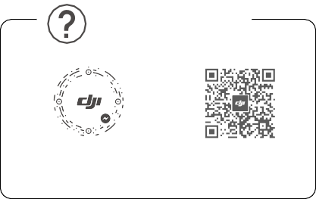

WE ARE HERE FOR YOU

在线技术支持

Contact DJI SUPPORT

via Facebook Messenger

微信扫一扫

获取技术支持

SUBSCRIBE FOR MORE INFORMATION

关注 DJI 大疆创新及时获取最新资讯

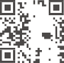





[**www.dji.com/dji-fpv/downloads**](http://www.dji.com/dji-fpv/downloads)

DJI is a trademark of DJI.

Copyright © 2021 DJI All Rights Reserved.

Printed in China.



37QDDJFG03TY

**Remote Controller 2**

User Guide

使用说明

使用說明

ユーザーガイド 사용자 가이드 Bedienungsanleitung

Guía de usuario Guide de l'utilisateur Guida dell'utente Gebruiksaanwijzing Manual do utilizador Guia do usuário

Руководство пользователя

2021.01



v1.0

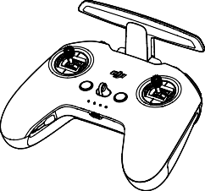

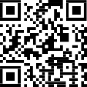

[www.dji.com/dji-fpv/**video**](http://www.dji.com/dji-fpv/video)

###### 2

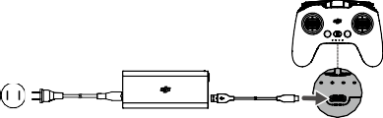

**3**

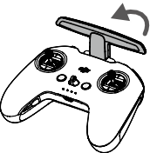

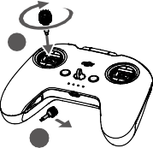

2

1

1

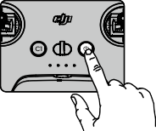

EN Press once to check the battery level.

Press, then press and hold to turn on/off.

CHS 短按一次检查电量。

短按一次，再长按 2 秒可开启、关闭。

CHT 短按一次可檢查電量。

短按一次，再長按 2 秒可開啟、關閉。

JP ボタンを 1 回押すと、バッテリー残量を確認できます。

ボタンを 1 回押した後、長押しすると、電源をオン

／オフにします。

KR 배터리 잔량을 확인하려면 한 번 누릅니다 .

한 번 누른 다음 다시 길게 누르면 켜지거나 꺼집니다 .

DE Drück die Taste einmal, um den Akkustand zu überprüfen.

Drück die Taste einmal, dann noch einmal und halt

diese gedrückt, um ein- oder auszuschalten.

ES Pulse una vez para comprobar el nivel de batería.

Pulse, vuelva a pulsar y mantenga pulsado para encender o apagar.

FR Appuyez une fois pour vérifier le niveau de batterie.

Appuyez une fois, puis une fois de plus et maintenez le bouton enfoncé pour allumer/éteindre.

IT Premere una volta per verificare il livello di carica

della batteria.

2

Premere, quindi premere e tenere premuto per accendere/spegnere.

NL Druk eenmaal om het batterijniveau te controleren. Druk en druk vervolgens en houd vast om aan/uit te zetten.

PT Prima uma vez para verificar o nível da bateria.

Prima e, em seguida, prima de forma contínua para ligar/desligar.

PT-BR Pressione uma vez para verificar o nível da bateria. Pressione uma vez; em seguida, pressione novamente e segure para ligar/desligar.

RU Нажмите один раз для проверки уровня заряда аккумулятора.

Нажмите, затем нажмите и удерживайте для включения/выключения.

###### 5

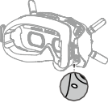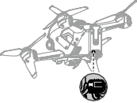**a.**

**b.**

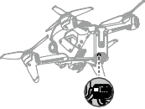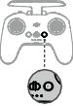

3

**Linking**

Ensure that all devices are powered on.

1. Aircraft + Goggles
   1. Press the link button on the goggles. The goggles will beep continually.
   2. Press and hold the power button of the aircraft until the battery level indicator blinks in sequence.
   3. The battery level indicator of the aircraft turns solid and displays the battery level. The goggles stop beeping when they are successfully linked and the video display is normal.
2. Aircraft + Remote Controller
   1. Press and hold the power button of the aircraft until the battery level indicator blinks in sequence.
   2. Press and hold the power button of the remote controller until it beeps continually and the battery level indicator blinks in sequence.
   3. The remote controller stops beeping when successfully linked and both the battery level indicators turn solid and display the battery level.

The aircraft must be linked with the goggles before the remote controller.

对 频

对频前请确保所有设备均已开启。

1. 飞行器 + 飞行眼镜
   1. 按下飞行眼镜的对频按键，飞行眼镜响起嘀 - 嘀…的提示音。
   2. 长按飞行器的电源按键直至电池电量指示灯循环闪烁。
   3. 对频成功后，飞行器的电池电量指示灯常亮显示电量，飞行眼镜提示音停止并显示图传。
2. 飞行器 + 遥控器
   1. 长按飞行器的电源按键直至电池电量指示灯循环闪烁。
   2. 长按遥控器的电源按键直至响起嘀 - 嘀…的提示音，且电池电量指示灯循环闪烁。
   3. 对频成功后，飞行器及遥控器的电池电量指示灯均常亮显示电量，遥控器提示音停止。

飞行器需先完成与飞行眼镜的对频，再进行和遥控器的对频。

4

配 對

配對前請確保所有裝置均已開啟。

1. 航拍機 + 飛行眼鏡
   1. 按下飛行眼鏡的配對按鍵，飛行眼鏡響起嘀 - 嘀…的提示音。
   2. 長按航拍機的電源按鍵直至電池電量指示燈循環閃爍。
   3. 配對成功後，航拍機的電池電量指示燈恆亮顯示電量，飛行眼鏡提示音停止並顯示影像傳輸。
2. 航拍機 + 遙控器
   1. 長按航拍機的電源按鍵直至電池電量指示燈循環閃爍。
   2. 長按遙控器的電源按鍵直至響起嘀 - 嘀…的提示音，且電池電量指示燈循環閃爍。
   3. 配對成功後，航拍機及遙控器的電池電量指示燈均恆亮顯示電量，遙控器提示音停止。

 航拍機需先完成與飛行眼鏡的配對，再進行和遙控器的配對。

***リンク***

すべての機器の電源が入っていることを確認します。

1. ***機体* + *ゴーグル***
   1. ゴーグルのリンクボタンを押します。ゴーグルからビープ音が連続して鳴ります。
   2. バッテリー残量インジケーターが順に点滅するまで機体の電源ボタンを長押しします。
   3. 機体のバッテリー残量インジケーターが点灯し、電池 残量を表示します。正常にリンクされ、動画ディスプレイが正常になると、ゴーグルのビープ音が止まります。
2. ***機体* + *送信機***
   1. バッテリー残量インジケーターが順に点滅するまで機体の電源ボタンを長押しします。
   2. ビープ音が連続して鳴り、バッテリー残量インジケーターが順に点滅するまで、送信機の電源ボタンを長押しします。
   3. リンク作業が正常に終了し、両方のバッテリー残量インジケーターが点灯してバッテリー残量を表示されると、送信機のビープ音は止まります。

機体は送信機より前にゴーグルとリンクしておく必要があります。

5

**연동**

모든 기기의 전원이 켜졌는지 확인합니다 .

1. **기체 + 고글**
   1. 고글의 연동 버튼을 누릅니다 . 고글은 계속 신호음 소리를 냅 니다 .
   2. 배터리 잔량 표시기가 순차적으로 깜박일 때까지 기체의 전원 버튼을 길게 누릅니다 .
   3. 기체의 배터리 잔량 표시기가 켜진 상태로 배터리 잔량을 표시 합니다 . 성공적으로 연동되고 동영상 디스플레이가 정상이면 , 고글 신호음이 멈춥니다 .
2. **기체 + 조종기**
   1. 배터리 잔량 표시기가 순차적으로 깜박일 때까지 기체의 전원 버튼을 길게 누릅니다 .
   2. 조종기가 계속해서 신호음을 내고 배터리 잔량 표시기가 순차 적으로 깜박일 때까지 조종기의 전원 버튼을 길게 누릅니다 .
   3. 성공적으로 연동되면 조종기가 깜박임을 중단하고 두 배터리 잔량 표시기가 모두 켜지며 배터리 잔량을 표시합니다 .

 기체를 고글과 먼저 연동한 후 조종기와 연동해야 합니다 .

**Koppeln**

Stell sicher, dass alle Geräte eingeschaltet sind.

1. Fluggerät + Goggles
   1. Drück die Kopplungstaste auf den Goggles. Die Goggles piepsen kontinuierlich.
   2. Halt den Einschaltknopf des Fluggeräts gedrückt, bis die Akkustandanzeige blinkt.
   3. Die Akkustandsanzeige auf dem Fluggerät leuchtet ständig und zeigt den Akkustand an. Die Goggles hören auf zu piepen, sobald sie erfolgreich gekoppelt wurden und die Videowiedergabe normal angezeigt wird.
2. Fluggerät + Fernsteuerung
   1. Halt den Einschaltknopf des Fluggeräts gedrückt, bis die Akkustandanzeige blinkt.
   2. Halt den Einschaltknopf der Fernsteuerung gedrückt, bis diese kontinuierlich piepst und die Akkustandsanzeige blinkt.
   3. Die Fernbedienung hört auf zu piepsen, wenn die Verbindung erfolgreich hergestellt wurde und die beiden Akkustandsanzeigen leuchten ständig und

6

zeigen den Akkustand an.

Das Fluggerät muss mit den Goggles vor der Fernsteuerung verbunden werden.

**Vinculación**

Asegúrese de que todos los dispositivos estén encendidos.

1. Aeronave + Gafas
   1. Presione el botón de enlace en las gafas. Las gafas emitirán un pitido continuo.
   2. Mantenga presionado el botón de encendido de la aeronave hasta que el indicador del nivel de batería parpadee en secuencia.
   3. El indicador del nivel de batería de la aeronave se vuelve fijo y muestra el nivel de batería. Las gafas dejarán de pitar cuando se enlacen correctamente y la visualización del vídeo sea normal.
2. Aeronave + Control remoto
   1. Mantenga presionado el botón de encendido de la aeronave hasta que el indicador del nivel de batería parpadee en secuencia.
   2. Mantenga presionado el botón de encendido del control remoto hasta que emita un pitido continuo y el indicador del nivel de batería parpadee en secuencia.
   3. El control remoto deja de pitar cuando se conecta correctamente y ambos indicadores del nivel de batería se vuelven fijos y muestran el nivel de batería.

La aeronave debe vincularse a las gafas antes que el control remoto.

**Appairage**

Assurez-vous que tous les dispositifs sont sous tension.

1. Appareil + Casque
   1. Appuyez sur le bouton d’appairage du casque. Le casque émet alors un bip continu.
   2. Maintenez le bouton d'alimentation de l’appareil enfoncé jusqu’à ce que l’indicateur de niveau de batterie clignote en séquence.
   3. L’indicateur de niveau de batterie de l’appareil brille de façon continue et affiche le niveau de batterie. Le casque cessent de biper lorsqu'il est appairé et

7

l'affichage vidéo est normal.

1. Appareil + Radiocommande
   1. Maintenez le bouton d'alimentation de l’appareil enfoncé jusqu’à ce que l’indicateur de niveau de batterie clignote en séquence.
   2. Maintenez le bouton d'alimentation de la radiocommande enfoncé jusqu’à ce qu’elle émette un bip continu et que l’indicateur de niveau de batterie clignote en séquence.
   3. La radiocommande arrête de biper quand elle est correctement appairée et que l’indicateur du niveau de batterie passe au fixe et affiche le niveau de batterie.

 L’appareil doit être appairé au casque avant la radiocommande.

**Collegamento**

Accertarsi che tutti i dispositivi siano accesi.

1. Aeromobile + visore
   1. Premere il pulsante di collegamento sul visore. Il visore emetterà un bip continuo.
   2. Premere e tenere premuto il pulsante di accensione dell’aeromobile fino a quando l’indicatore del livello della batteria lampeggia in sequenza.
   3. L’indicatore del livello della batteria dell’aeromobile si illumina di luce fissa e visualizza il livello della batteria. Gli occhiali smetteranno di lampeggiare quando collegati correttamente e la visualizzazione delle immagini si stabilizza.
2. Aeromobile + radiocomando
   1. Premere e tenere premuto il pulsante di accensione dell’aeromobile fino a quando l’indicatore del livello della batteria lampeggia in sequenza.
   2. Premere e tenere premuto il pulsante di accensione sul radiocomando fino a quando emette un bip continuo e l’indicatore del livello della batteria lampeggia in sequenza.
   3. Il radiocomando smette di emettere il bip una volta eseguito il collegamento ed entrambi gli indicatori del livello della batteria si illuminano di luce fissa e visualizzano il livello della batteria.

È necessario collegare l’aeromobile al visore prima del

radiocomando.

8

**Koppelen**

Zorg ervoor dat alle apparaten zijn ingeschakeld.

1. Drone + bril
   1. Druk op de verbindingsknop op de bril. De bril piept continu.
   2. Druk en houd de aan-/uitknop van de drone ingedrukt totdat de indicator van de accu in volgorde knippert.
   3. De indicator voor het accuniveau van de drone brandt constant en geeft het accuniveau weer. De bril stopt met piepen wanneer deze met succes is gekoppeld en het videoscherm normaal is.
2. Drone + afstandsbediening
   1. Druk en houd de aan-/uitknop van de drone ingedrukt totdat de indicator van de accu in volgorde knippert.
   2. Druk en houd de aan-/uitknop van de afstandsbediening ingedrukt totdat deze continu piept en de indicator voor het accuniveau op volgorde knippert.
   3. De afstandsbediening stopt met piepen wanneer deze met succes is gekoppeld. Beide indicatoren voor het accuniveau worden constant en geven het accuniveau weer.

 De drone moet vóór de afstandsbediening met de bril worden

gekoppeld.

**Ligação**

Assegure-se de que todos os dispositivos estão ligados.

1. Aeronave + Goggles
   1. Prima o botão de ligação nos goggles. Os goggles

emitirão um sinal sonoro contínuo.

* 1. Prima e mantenha premido o botão de alimentação da aeronave até que o indicador de nível de bateria pisque sequencialmente.
  2. O indicador de nível da bateria da aeronave fica sólido e mostra o nível da bateria. Os óculos param de emitir sinais sonoros quando ligados com êxito e o visor de vídeo é normal.

1. Aeronave + Telecomando
   1. Prima e mantenha premido o botão de alimentação da aeronave até que o indicador de nível de bateria pisque sequencialmente.

9

* 1. Prima e mantenha premido o botão do telecomando até emitir um sinal sonoro contínuo e o indicador do nível da bateria piscar em sequência.
  2. O telecomando deixa de emitir um sinal sonoro quando for ligado com êxito e ambos os indicadores do nível de bateria ficarem sólidos e mostrarem o nível da bateria.

A aeronave tem de ser ligada aos goggles antes do telecomando.

**Vinculação**

Verifique se todos os dispositivos estão ligados.

1. Aeronave + óculos
   1. Pressione o botão de vinculação nos óculos. Os óculos

emitirão um sinal sonoro contínuo.

* 1. Mantenha pressionado o botão liga/desliga da aeronave até que o indicador de nível da bateria pisque em sequência.
  2. O indicador de nível da bateria da aeronave ficará aceso e exibirá o nível da bateria. Os óculos de proteção param de emitir sinal sonoro quando forem vinculados com êxito e a exibição do vídeo for normal.

1. Aeronave + controle remoto
   1. Mantenha pressionado o botão liga/desliga da aeronave até que o indicador de nível da bateria pisque em sequência.
   2. Mantenha pressionado o botão liga/desliga do controle remoto até ouvir um bipe contínuo e o indicador de nível da bateria piscar em sequência.
   3. O controle remoto vai parar de emitir sinal sonoro quando vinculado com êxito e os dois indicadores de nível da bateria ficarem acesos e exibirem o nível da bateria.

A aeronave deve ser vinculada aos óculos antes do controle remoto.

**Сопряжение**

Убедитесь, что все устройства включены.

а. Дрон + очки

1. Нажмите кнопку сопряжения на очках. Устройство начнет издавать непрерывный звуковой сигнал.

10

1. Нажмите и удерживайте кнопку питания дрона до тех пор, пока индикатор уровня заряда аккумулятора не начнет последовательно мигать.
2. Индикатор уровня заряда аккумулятора дрона начнет светиться и отобразит его оставшийся заряд. Очки перестанут издавать звуковой сигнал при успешном сопряжении, а изображение на экране нормализуется.

б. Дрон + пульт управления

1. Нажмите и удерживайте кнопку питания дрона, пока индикатор уровня заряда не начнет последовательно мигать.
2. Нажмите и удерживайте кнопку питания пульта управления, пока устройство не начнет издавать непрерывный звуковой сигнал, а индикатор уровня заряда аккумулятора – последовательно мигать.
3. Звуковой сигнал пульта управления прекратится после успешного сопряжения, индикатор уровня заряда аккумулятора начнет светиться и отобразит оставшийся заряд.

 Дрон сначала должен быть сопряжен сначала с очками, а затем с пультом управления.

###### 6

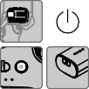

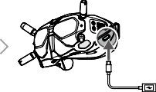

**DJI Fly App**

Connect the USB-C port of the goggles to the mobile device, run DJI Fly, and follow the prompt to activate.

11

连接飞行眼镜的 USB-C 接口至手机，运行 DJI Fly App 并根据

App 提示激活设备。

連接飛行眼鏡的 USB-C 接口至手機，執行 DJI Fly 應用程式並根據應用程式提示啟動裝置。

ゴーグルの USB-C ポートとモバイル端末を接続し、DJI Flyを起動し、プロンプトに従ってアクティベーションを行います。

고글의 USB-C 포트를 모바일 기기에 연결하고 , DJI Fly 를 실행한 다 음 메시지에 따라 활성화합니다 .

Verbinde den USB-C-Anschluss der Goggles mit dem Mobilgerät, starte die DJI Fly App, und folg den Anweisungen zur Aktivierung.

Conecte el puerto USB-C de las gafas al dispositivo móvil, ejecute DJI Fly y siga las instrucciones para la activación.

Connectez le casque à l’appareil mobile à l’aide du câble USB-C, lancez DJI Fly et suivez les instructions à l’écran.

Collegare la porta USB-C del visore al dispositivo mobile, avviare DJI Fly e seguire il prompt per effettuare l’attivazione.

Verbind de USB-C-poort van de bril met het mobiele apparaat, start DJI Fly en volg het bericht om te activeren.

Ligue a porta USB-C dos goggles ao dispositivo móvel, inicie a DJI Fly e siga a mensagem para ativar.

Conecte a entrada USB-C dos óculos ao dispositivo móvel,

execute o DJI Fly e siga as instruções para ativar.

Подключите порт USB-C на очках к мобильному устройству, откройте приложение DJI Fly и следуйте инструкциям по активации.

12



EN

**Disclaimer and Warning**

Please read this entire document and all safe and lawful practices DJITM provided carefully before use. Failure to read and follow instructions and warnings may result in serious injury to yourself or others, damage to your DJI product, or damage to other objects in the vicinity. By using this product, you hereby signify that you have read this disclaimer and warning carefully and that you understand and agree to abide by the terms and conditions herein. You agree that you are solely responsible for your own conduct while using this product, and for any consequences thereof. DJI accepts no liability for damage, injury or any legal responsibility incurred directly or indirectly from the use of this product.

DJI is a trademark of SZ DJI TECHNOLOGY CO., LTD. (abbreviated as “DJI”) and its affiliated companies. Names of products, brands, etc., appearing in this document are trademarks or registered trademarks of their respective owner companies. This product and document are copyrighted by DJI with all rights reserved. No part of this product or document shall be reproduced in any form without the prior written consent or authorization of DJI.

This document and all other collateral documents are subject to change at the sole discretion of DJI. For up to date product information, visit [http://www.dji.com](http://www.dji.com/) and click on the product page for this product.

This disclaimer is available in various languages. In the event of divergence among different versions, the English version shall prevail.

**Usage**

Visit <http://www.dji.com/dji-fpv> (User Manual) to learn more about how to use this product.

**Specifications**

Weight

346 g

Operating Frequency 2.400-2.4835 GHz; 5.725-5.850 GHz

Model FC7BGC

13

Max Transmission

Distance

(unobstructed, free of interference)

10 km (FCC); 6 km (CE/SRRC/MIC)

2.4 GHz: ≤28.5 dBm (FCC), ≤20 dBm

(CE/SRRC/MIC)

Transmitter Power (EIRP)

5.8 GHz: ≤31.5 dBm (FCC), ≤19 dBm

(SRRC), ≤14 dBm (CE)

Operating Temperature -10°to 40°C (14°to 104°F)

Please refer to <http://www.dji.com/service> for after-sales service for your product where applicable.

DJI shall mean SZ DJI TECHNOLOGY CO., LTD. and/or its

affiliated companies where applicable.



CHS

免责声明和警告

使用本产品之前， 请仔细阅读并遵循本文及大疆 TM 创新

（DJITM）提供的所有安全指引，否则可能会给您和周围的人带来伤害，损坏本产品或其它周围物品。一旦使用本产品，即视为您已经仔细阅读本文档，理解、认可和接受本声明全部条款和内容。您承诺对使用本产品以及可能带来的后果负全部责任。大疆创新（DJI）对于直接或间接使用本产品而造成的损坏、伤害以及任何法律责任不予负责。

DJI 是深圳市大疆创新科技有限公司及其关联公司的商标。本文出现的产品名称、品牌等，均为其所属公司的商标。本产品及手册为大疆创新版权所有。未经许可，不得以任何形式复制翻印。

本文档及本产品所有相关的文档最终解释权归大疆创新（DJI）所有。如有更新，恕不另行通知。请访问 [www.dji.com](http://www.dji.com/) 官方网站以获取最新的产品信息。

使 用

访问 <http://www.dji.com/dji-fpv>（用户手册）获取详细的产品使用方法。

规格参数

型号 FC7BGC

14

重量 346 g

工作频率 2.400-2.4835 GHz; 5.725-5.850 GHz

最大信号有效距离

（无干扰、无遮挡） 10 km (FCC); 6 km (CE/SRRC/MIC)

2.4 GHz: ≤28.5 dBm (FCC), ≤20 dBm

发射功率（EIRP）

(CE/SRRC/MIC)

5.8 GHz: ≤31.5 dBm (FCC), ≤19 dBm (SRRC), ≤14 dBm (CE)

工作环境温度 -10℃至 40℃

浏览 <http://www.dji.com/service> 以获取产品的售后信息。 “DJI”表示深圳市大疆创新科技有限公司及其关联公司。



CHT

免責聲明和警告

使用本産品之前，請仔細閱讀並遵循本文及大疆TM 創新（DJITM）提供的所有安全指南，否則可能會給您和周圍的人帶來傷害，損壞本産品或其它周圍物品。一旦使用本產品，即視為您已經仔細閱讀本文件，理解、認可和接受本聲明全部條款和內容。您承諾對使用本產品以及可能帶來的後果負全部責任。大疆創新（DJI）對於直接或間接使用本產品而造成的損壞、傷害及任何法律責任概不負責。

DJI 是深圳市大疆創新科技有限公司及其附屬公司的商標。本文出現的産品名稱、品牌等，均為其所屬公司的商標。本產品及手冊之版權為大疆創新所有。未經許可，不得以任何形式複製翻印。

本文件及本產品所有相關文件的最終解釋權歸大疆創新（DJI）所有。如有更新，恕不另行通知。請前往 [www.dji.com](http://www.dji.com/) 官方網站以取得最新的產品資訊。

使 用

請參閱 <http://www.dji.com/dji-fpv> （使用者手冊）以取得詳細的產品使用方法。

規格參數

型號 FC7BGC

重量 346 g

15

最大訊號有效距離

運作頻率 2.400-2.4835 GHz; 5.725-5.850 GHz

（無干擾、無遮擋）

發射功率（EIRP）

10 km (FCC); 6 km (CE/SRRC/MIC)

2.4 GHz: ≤28.5 dBm (FCC), ≤20 dBm (CE/

SRRC/MIC)

5.8 GHz: ≤31.5 dBm (FCC), ≤19 dBm (SRRC), ≤14 dBm (CE)

運作環境溫度 -10℃ 至 40℃

瀏覽 <http://www.dji.com/service> 以取得產品的售後資訊。

「DJI」代表深圳市大疆創新科技有限公司及其附屬公司。



JP

免責事項および警告

ご使用前に、この文書全体に目を通し、DJITM が提供する安全で合法的慣行についての説明を注意深くお読みください。指示と警告に従わなかった場合、ご自身や他の人に重傷を負わせたり、またはお客様のDJI 製品および周辺の他の物の破損につながる恐れがあります。本製品を使用することにより、本書の免責事項および警告をよく読み、記載されている利用規約を理解し、順守することに同意したとみなされます。本製品の使用中の行動とこれに伴う結果には、ユーザーが全面的に責任を負うことに同意するものとします。本製品の使用により直接または間接的に発生する損害、傷害、およびその他法的責任に対して、DJI は一切責任を負いません。

DJI は SZ DJI TECHNOLOGY CO., LTD.（以下「DJI」と省略）

およびその関連会社の商標です。本書に記載されている製品、ブランドなどの名称は、その所有者である各社の商標または登録商標です。本製品および本書は、不許複製・禁無断転載を原則とする DJI の著作物のため、DJI から書面による事前承認または許諾を得ることなく、本製品または文書のいかなる部分も、いかなる方法によっても複製することは固く禁じられています。

本書およびその他すべての付属書は、DJI 独自の裁量で変更されることがあります。最新の製品情報については、http:// [www.dji.com](http://www.dji.com/) にアクセスして、本製品に対応する製品ページをクリックしてご覧ください。

16

この免責条項は複数の言語で提供されています。言語版によって相違がある場合には、英語版が優先されます。

使用方法

本製品の使用方法について詳しく[は、http://www.dji.com/](http://www.dji.com/) dji-fpv ( ユーザーマニュアル ) をご覧ください。

仕様

動作周波数

2.400 ～ 2.4835 GHz、

5.725 ～ 5.850 GHz ( 日本では

2.400 ～ 2.4835 GHz のみ )

重量

346 g

最大伝送距離

10 km (FCC) 、6 km (CE/SRRC/MIC

( 障害物や干渉がない場合 ) （日本））

伝送電力（EIRP）

2.4 GHz: ≤ 28.5 dBm (FCC)、

≤ 20 dBm（CE/SRRC/MIC（日本）)

5.8 GHz: ≤ 31.5 dBm (FCC)、

≤ 19 dBm (SRRC)、≤ 14 dBm (CE)

モデル FC7BGC

動作環境温度範囲 -10℃～ 40℃

お客様の製品に該当するアフターセールスサービスにつきま[しては、http://www.dji.com/service](http://www.dji.com/service) を参照してください。 DJI は、SZ DJI TECHNOLOGY CO., LTD. および／または該当

する場合はその関連会社を表し。



KR

**고지 사항 및 경고**

DJITM 에서 제공해드리는 본 문서 전문과 안전하고 적법한 사용 방법 관련된 모든 내용을 사용 전에 주의 깊게 읽어 주십시오 . 지침 및 경고 사항을 읽고 따르지 않을 경우 사용자 또는 다른 사람이 심각하게 다 치거나 DJI 제품 또는 근처에 있는 다른 물체가 손상될 수 있습니다 . 제품을 사용하는 것은 본 고지 사항 및 경고를 주의 깊게 읽었으며 명 시된 약관을 이해하고 준수하기로 동의한 것으로 간주합니다 . 본 제품 사용 시 사용자의 행위와 그에 따른 결과에 대한 책임은 전적으로 본 인에게 있다는 것에 동의합니다 . DJI 는 본 제품의 사용으로 인해 직 접 또는 간접적으로 발생한 피해 , 부상 또는 모든 법적 책임에 대해 어 떠한 책임도 지지 않습니다 .

DJI 는 SZ DJI TECHNOLOGY CO., LTD.( 약어로 “DJI”) 및 해당 자회사

17

의 상표입니다 . 본 문서에 표시된 제품명 , 브랜드 등은 해당 소유 회사 의 상표 또는 등록 상표입니다 . DJI 는 본 제품 및 문서의 저작권과 함 께 모든 권리를 보유합니다 . 본 제품 또는 문서의 어떠한 부분도 DJI 의 서면 허가 또는 동의 없이 어떠한 형식으로 재생산할 수 없습니다 .

이 문서 및 기타 모든 부수적인 문서는 DJI 의 단독 재량에 따라 변경 될 수 있습니다 . 최신 제품 정보를 확인하려면 [http://www.dji.com](http://www.dji.com/) 을 방문하여 본 제품에 대한 제품 페이지를 클릭하십시오 .

이 고지 사항은 다양한 언어로 제공됩니다 . 각 언어 버전 간에 차이가 있을 경우 , 영어 버전이 우선합니다 .

**사용**

이 제품의 사용 방법에 관한 자세한 내용은 <http://www.dji.com/dji-> fpv ( 사용 설명 서 ) 에서 확인하십시오 .

**사양**

모델명 FC7BGC

무게 346 g

최대 전송 거리

작동 주파수 2.400~2.4835 GHz, 5.725~5.850 GHz

( 장애물과 간섭이 없는 상태 )

송신기 출력 (EIRP)

10 km (FCC); 6 km (CE/SRRC/MIC)

2.4 GHz: ≤ 28.5 dBm (FCC),

≤ 20 dBm (CE/SRRC/MIC)

5.8 GHz: ≤ 31.5 dBm (FCC),

≤ 19 dBm (SRRC), ≤ 14 dBm (CE)

작동 온도 범위 -10~40 ° C

해당 제품의 적용 가능한 A/S 서비스는 <http://www.dji.com/service> 를 참조하십시오 .

DJI 는 SZ DJI TECHNOLOGY CO., LTD. 및 / 또는 해당 자회사를 의 미합니다 .



DE

**Haftungsausschluss und Warnhinweis**

Bitte lesen Sie vor der Verwendung dieses gesamte Dokument und alle von DJITM zur Verfügung gestellten sicheren und rechtmäßigen Praktiken sorgfältig durch. Die Nichtbeachtung der Anweisungen und Warnungen kann zu schweren Verletzungen für Sie oder andere Personen bzw. zu Schäden an Ihrem DJI-Produkt oder anderen

18

Objekten in der näheren Umgebung führen. Mit dem Gebrauch des Produkts bestätigen Sie, dass Sie diesen Haftungsausschluss inkl. Warnungen aufmerksam gelesen und den Inhalt verstanden haben und mit den allgemeinen Geschäftsbedingungen hierin einverstanden sind. Sie stimmen zu, dass Sie beim Gebrauch des Produkts die alleinige Verantwortung für Ihre Handlungen und alle daraus entstehenden Folgen tragen. DJI übernimmt keine Haftung für Sachschäden oder Personenschäden sowie keine juristische Verantwortung für Schäden, die direkt oder indirekt mit dem Gebrauch des Produkts in Zusammenhang stehen.

DJI ist eine Marke von SZ DJI Technology Co., Ltd. (kurz:

„DJI“) und seiner verbundenen Unternehmen. Namen von Produkten, Marken usw., die in diesem Dokument enthalten sind, sind Warenzeichen oder eingetragene Warenzeichen der jeweiligen Besitzer (Eigentümergesellschaften). Dieses Produkt und dieses Dokument sind urheberrechtlich geschütztes Eigentum von DJI und alle Rechte sind vorbehalten. Kein Teil dieses Produkts oder dieses Dokuments darf in irgendeiner Form ohne vorherige schriftliche Zustimmung oder Genehmigung von DJI reproduziert werden.

Dieses Dokument und alle zugehörigen Dokumente können nach eigenem Ermessen von DJI jederzeit geändert werden. Aktuelle Produktinformationen finden Sie auf der Produktseite für dieses Produkt unter [http://www.dji.com.](http://www.dji.com/)

Dieser Haftungsausschluss ist in verschiedenen Sprachen verfügbar. Bei Abweichungen zwischen den verschiedenen Fassungen ist die englische Fassung maßgebend.

**Verwendung**

Weitere Informationen zur Verwendung dieses Produkts finden Sie im Internet unter <http://www.dji.com/dji-fpv> (Bedienungsanleitung).

**Technische Daten**

Gewicht

346 g

Betriebsfrequenz 2,400–2,4835 GHz; 5,725–5,850 GHz

Modell FC7BGC

19

Max. Übertragungsreichweite (ohne Hindernisse, störungsfrei)

10 km (FCC); 6 km (CE/SRRC/MIC)

2,4 GHz: ≤28,5 dBm (FCC), ≤20 dBm

(CE/SRRC/MIC)

Strahlungsleistung (EIRP)

5,8 GHz: ≤31,5 dBm (FCC), ≤19 dBm

(SRRC), ≤14 dBm (CE)

Betriebstemperatur -10 °C bis 40 °C

Die entsprechenden Informationen zum Kundenservice entnehmen Sie [http://www.dji.com/service.](http://www.dji.com/service)

DJI bedeutet SZ DJI TECHNOLOGY CO., LTD. und/oder ihre verbundenen Unternehmen.



ES

**Renuncia de responsabilidad y advertencia**

Lea detenidamente este documento al completo y todas las prácticas de seguridad y legales que DJITM ha facilitado antes de su uso. Si no lee ni sigue correctamente las instrucciones y advertencias, podría sufrir lesiones importantes o provocarlas a otras personas. Asimismo, podría causar daños en su producto DJI u otros objetos en las proximidades. Al usar este producto, manifiesta que ha leído detenidamente esta renuncia de responsabilidad y advertencia, así como que entiende y acepta cumplir los términos y condiciones establecidos en este documento. Acepta que usted es el único responsable de su propia conducta durante el uso de este producto y de cualquier consecuencia derivada de dicho uso. DJI no acepta responsabilidad alguna por daños o lesiones, ni ningún tipo de responsabilidad legal derivada directa o indirectamente del uso de este producto.

DJI es una marca comercial de SZ DJI TECHNOLOGY CO., LTD. (abreviado como “DJI”) y sus filiales. Los nombres de productos, marcas, etc., que aparecen en este documento son marcas comerciales o marcas comerciales registradas de sus respectivas empresas propietarias. Este producto y el documento están protegidos por los derechos de autor de DJI con todos los derechos reservados. No se permite la reproducción total ni parcial de este documento o producto en forma alguna sin el consentimiento previo por escrito o la autorización de DJI.

20

Este documento y el resto de documentos colaterales están sujetos a cambios a entera discreción de DJI. Para obtener información actualizada sobre el producto, visite [http://www.dji.com](http://www.dji.com/) y haga clic en la página de este producto.

Esta renuncia está disponible en diversos idiomas. En caso de divergencia entre las diferentes versiones, prevalecerá la versión en inglés.

**Uso**

Visite <http://www.dji.com/dji-fpv> (Manual del usuario) para obtener más información sobre el uso de este producto.

**Especificaciones**

Frecuencia de

funcionamiento

2.400-2.4835 GHz; 5.725-5.850 GHz

Peso

346 g

Distancia máx. de

transmisión (sinobstáculos, 10 km (FCC); 6 km (CE/SRRC/MIC) libre de interferencias)

2.4 GHz: ≤28.5 dBm (FCC),

Transmisor de potencia ≤20 dBm (CE/SRRC/MIC)

(PIRE) 5.8 GHz: ≤31.5 dBm (FCC),

≤19 dBm (SRRC), ≤14 dBm (CE)

Modelo FC7BGC

Rango de temperatura de

funcionamiento

De -10 a 40 °C (de 14 a 104 °F)

Visite <http://www.dji.com/service> para recibir servicio postventa para su producto según corresponda.

Por DJI se entiende SZ DJI TECHNOLOGY CO., LTD. y sus

filiales, según corresponda.



FR

**Clause d’exclusion de responsabilité et mise en**

**garde**

Veuillez lire attentivement ce document dans son intégralité, ainsi que toutes les pratiques sécuritaires et légales fournies par DJITM avant l’utilisation du produit DJI associé. Si vous ne lisez pas et ne respectez pas les instructions et les mises en garde, vous exposez les autres et vous-même à des blessures graves et risquez d’endommager votre produit DJI ou d’autres objets placés à proximité. En utilisant ce produit, vous

21

confirmez que vous avez lu attentivement la clause d’exclusion de responsabilité et la mise en garde, que vous comprenez les conditions générales qui y sont énoncées, et que vous acceptez de les respecter. Vous déclarez assumer l’entière responsabilité de votre comportement lors de l’utilisation du produit ainsi que toutes les conséquences qui en découlent. DJI décline toute responsabilité quant aux dégâts, aux blessures ou aux problèmes découlant directement ou indirectement de l’utilisation de ce produit.

DJI est une marque commerciale de SZ DJI TECHNOLOGY CO., LTD. (« DJI » en abrégé) et de ses sociétés affiliées. Les noms de produits, de marques, etc., apparaissant dans le présent document sont des marques commerciales ou des marques déposées de leurs détenteurs respectifs. Ce produit et le présent document sont la propriété de DJI, tous droits réservés. Aucune partie de ce produit ou du présent document ne peut être reproduite sous quelque forme que ce soit sans l’autorisation ou le consentement écrit préalable de DJI.

DJI se réserve le droit de modifier, à sa seule discrétion, le présent document et tous les autres documents connexes. Pour connaître les dernières informations sur le produit, rendez-vous sur le site [http://www.dji.com](http://www.dji.com/) et cliquez sur la page produit.

Cette clause de non-responsabilité est disponible en plusieurs langues. En cas de divergence entre les différentes versions, la version en langue anglaise prévaudra.

**Utilisation**

Rendez-vous sur le site <http://www.dji.com/dji-fpv> (Manuel de l'utilisateur) pour en savoir plus sur l'utilisation de ce produit.

**Caractéristiques techniques**

Fréquence de

fonctionnement

2,400 à 2,4835 GHz ;

5,725 à 5,850 GHz

Poids

346 g

Modèle FC7BGC

Distance de transmission

max.(espace dégagé, sans

interférences)

22

10 km (FCC); 6 km (CE/SRRC/MIC)

Puissance de l’émetteur (EIRP)

Plage de températures de fonctionnement

2,4 GHz : ≤28,5 dBm (FCC),

≤20 dBm (CE/SRRC/MIC) 5,8 GHz : ≤31,5 dBm (FCC),

≤19 dBm (SRRC), ≤14 dBm (CE)

-10 à 40 °C

Consultez la page <http://www.dji.com/service> pour bénéficier du service après-vente pour votre produit, le cas échéant.

DJI signifie SZ DJI TECHNOLOGY CO., LTD. et/ou ses

sociétés affiliées le cas échéant.



IT

**Limitazioni di responsabilità e avvertenze**

Si prega di leggere con attenzione l’intero documento e tutte le pratiche sicure e legali DJITM fornite prima dell’uso. La mancata lettura e l’inosservanza delle istruzioni e delle avvertenze ivi riportate potrebbero determinare lesioni gravi all’utente o ad altre persone, nonché danni al prodotto DJI o ad altri oggetti che si trovano nelle vicinanze. Utilizzando il prodotto, l’utente dichiara di aver letto e compreso le limitazioni di responsabilità e le avvertenze e di accettare i termini e le condizioni ivi specificati. L’utente riconosce di essere l’unico responsabile della propria condotta durante l’utilizzo del prodotto e di eventuali relative conseguenze. DJI declina ogni responsabilità per danni, infortuni o altre responsabilità legali direttamente o indirettamente imputabili all’utilizzo del presente prodotto.

DJI è un marchio registrato di SZ DJI TECHNOLOGY CO., LTD. (abbreviato come “DJI”) e delle sue società affiliate. I nomi di prodotti, i marchi e altre informazioni simili menzionati nel presente documento sono marchi o marchi registrati delle rispettive società proprietarie. Il presente prodotto e la relativa documentazione sono protetti da copyright di DJI e tutti i diritti sono riservati. Nessuna parte di questo prodotto o della relativa documentazione potrà essere riprodotta in qualsiasi forma senza previo consenso o autorizzazione scritti da parte di DJI.

Il presente documento e tutti i documenti complementari sono soggetti a modifiche a esclusiva discrezione di DJI. Per informazioni aggiornate su questo prodotto, visitare

23

[http://www.dji.com](http://www.dji.com/) e accedere alla pagina corrispondente.

Le presenti limitazioni di responsabilità sono disponibili in varie lingue. In caso di divergenza tra le diverse versioni, prevarrà la versione in lingua inglese.

**Uso**

Per ulteriori informazioni sull'uso di questo prodotto, visitare il sito Web <http://www.dji.com/dji-fpv> (Manuale utente).

**Specifiche**

Frequenza operativa

2,400 – 2,4835 GHz,

5,725 – 5,850 GHz

Peso

346 g

Rmodello FC7BGC

Massima distanza di

trasmissione (senza ostacoli né interferenze)

10 km (FCC);

6 km (CE/SRRC/MIC)

2,4 GHz: ≤28,5 dBm (FCC),

Potenza del trasmettitore ≤20 dBm (CE/SRRC/MIC)

(EIRP) 5,8 GHz: ≤31,5 dBm (FCC),

≤19 dBm (SRRC), ≤14 dBm (CE)

Intervallo di temperatura operativa

-10 °C – 40 °C (14 °F – 104 °F)

Fare riferimento al sito Web <http://www.dji.com/service> per assistenza post-vendita per il prodotto acquistato, dove applicabile.

DJI si riferisce a SZ DJI TECHNOLOGY CO., LTD. e/o sue

società affiliate, dove applicabile.



NL

**Disclaimer en waarschuwing**

Lees dit hele document, evenals alle veilige en wettelijke praktijken die DJITM heeft verstrekt, vóór gebruik zorgvuldig door. Het niet lezen en opvolgen van de instructies en waarschuwingen kan leiden tot ernstig letsel bij uzelf of anderen, schade aan het DJI-product of schade aan andere voorwerpen in de omgeving. Door het gebruik van dit product geeft u te kennen dat u deze disclaimer en waarschuwing zorgvuldig hebt gelezen en dat u begrijpt en ermee akkoord gaat dat u zich dient te houden aan de hierin

24

gestelde algemene voorwaarden. U gaat ermee akkoord dat u tijdens het gebruik van dit product verantwoordelijk bent voor uw eigen gedrag, en voor de mogelijke gevolgen daarvan. DJI aanvaardt geen aansprakelijkheid voor schade, letsel of enige wettelijke verantwoordelijkheid die direct of indirect voortvloeit uit het gebruik van dit product.

DJI is een handelsmerk van SZ DJI TECHNOLOGY CO., LTD. (afgekort als ‘DJI’) en hieraan gelieerde bedrijven. Namen van producten, merken enz. in dit document zijn handelsmerken of gedeponeerde handelsmerken van hun respectieve eigenaren. Het copyright voor dit product en dit document rust bij DJI met alle rechten voorbehouden. Geen enkel onderdeel van dit product of document mag worden gereproduceerd in welke vorm dan ook zonder voorafgaande schriftelijke toestemming van DJI.

Dit document en alle overige documentatie kunnen naar eigen inzicht van DJI gewijzigd worden. Ga voor actuele productinformatie naar [http://www.dji.com](http://www.dji.com/) en klik op de productpagina van dit product.

Deze disclaimer is in verschillende talen beschikbaar. In geval van verschillen tussen verschillende versies, geldt de Engelse versie.

**Gebruik**

Bezoek <http://www.dji.com/dji-fpv> (Gebruikershandleiding) voor meer informatie over het gebruik van dit product.

**Technische gegevens**

Gewicht 346 g

Gebruiksfrequentie

2,400 - 2,4835 GHz;

5,725 - 5,850 GHz

Model FC7BGC

Max. zendbereik

(vrij van obstakels en interferentie)

Zendervermogen (EIRP)

10 km (FCC); 6 km (CE/SRRC/MIC)

2,4 GHz: ≤28,5 dBm (FCC),

≤20 dBm (CE/SRRC/MIC) 5,8 GHz: ≤31,5 dBm (FCC),

≤19 dBm (SRRC), ≤14 dBm (CE)

Bedrijfstemperatuurbereik -10 ° tot 40 °C (14 ° tot 104 °F)

25

Raadpleeg indien van toepassing <http://www.dji.com/service> voor after-sales-service voor uw product.

DJI staat voor SZ DJI TECHNOLOGY CO., LTD. en/of haar dochterondernemingen, indien van toepassing.



PT

**Declaração de exoneração de responsabilidade**

**e aviso**

Leia cuidadosamente este documento na íntegra e todas as práticas de segurança e legais DJITM fornecidas antes da utilização. A não leitura e o incumprimento das instruções e avisos podem resultar em ferimentos graves para si ou terceiros, em danos ao seu produto da DJI ou em danos noutros objetos que se encontrem nas proximidades. A utilização deste produto significa que o utilizador leu cuidadosamente esta declaração de exoneração de responsabilidade e o aviso e que compreende e aceita cumprir os termos e condições aqui expostos. O utilizador concorda que é o único responsável pela sua conduta durante a utilização deste produto e pelas possíveis consequências daí resultantes. A DJI não assume qualquer responsabilidade pelos danos ou ferimentos ou quaisquer responsabilidades legais decorrentes direta ou indiretamente da utilização deste produto.

A DJI é uma marca comercial da SZ DJI TECHNOLOGY CO., LTD. (abreviada como "DJI") e das respetivas empresas afiliadas. Todos os nomes de produtos, marcas, etc., incluídos no presente documento são marcas comerciais ou marcas comerciais registadas das respetivas empresas detentoras. Este produto e este documento estão protegidos por direitos de autor pela DJI, com todos os direitos reservados. Nenhuma parte deste produto ou documento deverá ser reproduzida, seja de que forma for, sem o consentimento ou autorização prévios, por escrito, da DJI.

Este e todos os outros documentos de garantia estão sujeitos a alteração ao critério exclusivo da DJI. Para obter informações atualizadas sobre o produto, visite http://www.dji. com e clique na página de produto relativa a este produto.

Esta exoneração de responsabilidade está disponível em diversos idiomas. Em caso de divergência entre as diferentes versões, a versão em Inglês deverá prevalecer.

26

**Utilização**

Para obter informações adicionais sobre como utilizar este

produto, visite <http://www.dji.com/dji-fpv> (Manual do utilizador).

**Especificações**

Frequência de

funcionamento

2,400-2,4835 GHz; 5,725-5,850 GHz

Peso

346 g

Distância máxima de

transmissão (desobstruída, 10 km (FCC); 6 km (CE/SRRC/MIC) sem interferências)

2,4 GHz: ≤28,5 dBm (FCC), ≤20 dBm

Alimentação do (CE/SRRC/MIC)

transmissor (EIRP) 5,8 GHz: ≤31,5 dBm (FCC), ≤19 dBm

(SRRC), ≤14 dBm (CE)

Modelo FC7BGC

Intervalo de temperaturas

de funcionamento

-10 °C a 40 °C (14 °F a 104 °F)

Consulte <http://www.dji.com/service> para obter assistência pós-venda para o seu produto, conforme aplicável.

DJI significa SZ DJI TECHNOLOGY CO., LTD. e/ou as suas empresas afiliadas, conforme aplicável.



PT-BR

**Isenção de Responsabilidade e Advertência** Leia este documento por inteiro e todas as práticas legais e seguras que a DJITM forneceu cuidadosamente antes de usar seu dispositivo. A não leitura e o não cumprimento das

instruções e advertências podem resultar em lesões graves para si ou terceiros, em danos ao produto da DJI ou a outros objetos que se encontrem nas proximidades. O uso deste produto confirma que o usuário leu cuidadosamente a presente Isenção de Responsabilidade e Advertência, e que compreende e aceita obedecer aos termos e as condições aqui expostos. O usuário concorda que é o único responsável por sua conduta ao utilizar este produto e pelas possíveis consequências dele resultantes. A DJI não assume qualquer responsabilidade por danos, ferimentos ou quaisquer responsabilidades legais decorrentes direta ou indiretamente da utilização deste produto.

27

DJI é uma marca comercial da SZ DJI TECHNOLOGY CO., LTD. (abreviada como “DJI”) e de suas empresas afiliadas. Nomes de produtos, marcas, etc. que aparecem neste documento são marcas comerciais ou marcas registradas de suas respectivas empresas proprietárias. Este produto e documento são protegidos pela DJI com todos os direitos reservados. Nenhuma parte deste produto ou documento deve ser reproduzida de qualquer forma sem o consentimento prévio por escrito ou autorização da DJI.

Este e todos os outros documentos de garantia estão sujeitos à alteração, a critério exclusivo da DJI. Para obter informações atualizadas sobre o produto, acesse [http://www.dji.com](http://www.dji.com/) e clique na página relacionada a este produto.

Esta Isenção de responsabilidade está disponível em vários idiomas. Em caso de divergência entre versões diferentes, a versão em inglês prevalecerá.

**Uso**

Acesse <http://www.dji.com/dji-fpv> (Manual do usuário) para

mais informações sobre como utilizar este produto.

**Especificações**

Frequência de

funcionamento

2,400 a 2,4835 GHz;

5,725 a 5,850 GHz

2,4 GHz: ≤ 28,5 dBm (FCC),

Potência do transmissor (EIRP) ≤ 20 dBm (CE/SRRC/MIC)

5,8 GHz: ≤ 31,5 dBm (FCC),

≤ 19 dBm (SRRC), ≤ 14 dBm (CE)

Peso

346 g

Distância máx. de transmissão 10 km (FCC);

(sem obstruções, livre de

interferências)

6 km (CE/SRRC/MIC)

Modelo FC7BGC

Alcance da temperatura de

funcionamento

-10° a 40 °C (14° a 104 °F)

Consulte <http://www.dji.com/service> para informações de

atendimento pós-venda de seu produto onde aplicável.

DJI significa SZ DJI TECHNOLOGY CO., LTD. E/ou suas

empresas afiliadas onde aplicável.

28



RU

**Отказ от ответственности и предупреждение** Внимательно ознакомьтесь с данным документом и правилами техники безопасности DJITM перед использованием продукта. Пренебрежение содержимым данного документа и несоблюдение мер безопасности может привести к серьезным травмам, повреждению устройства DJI или другого имущества, находящегося поблизости. Используя данный продукт, вы подтверждаете, что внимательно ознакомились с заявлением об отказе от ответственности и предупреждением и соглашаетесь выполнять содержащееся в данном документе пользовательское соглашение. Вы несете полную ответственность за эксплуатацию данного продукта и все возможные последствия его использования. DJI не несет ответственность за повреждения, травмы или любую юридическую ответственность, прямо или косвенно вызванную использованием данного продукта.

DJI – это товарный знак компании SZ DJI TECHNOLOGY CO., LTD. (сокращенно «DJI») и ее дочерних компаний. Названия продуктов, торговых марок и т. д., содержащиеся в данном документе, являются товарными знаками или зарегистрированными товарными знаками соответствующих компаний. Этот продукт и документ DJI охраняются авторским правом. Все права защищены. Никакая часть данного продукта или документа не может быть воспроизведена в какой-либо форме без предварительного письменного согласия или разрешения DJI.

Компания DJI вправе единолично вносить изменения в содержание данного и всех сопутствующих документов. Для получения обновленной информации о продукте посетите сайт [http://www.dji.com](http://www.dji.com/) и выберите страницу, соответствующую данному продукту.

Этот отказ от ответственности доступен на нескольких языках. В случае расхождения между различными версиями, версия на английском языке имеет преимущественную силу.

**Использование**

Посетите сайт <http://www.dji.com/dji-fpv> (Руководство

29

пользователя) для получения более подробной информации по применению данного продукта.

**Технические характеристики**

модель FC7BGC

Масса 346 g

Диапазон рабочих частот 2,400–2,4835 ГГц

Макс. дальность передачи сигнала (при отсутствии препятствий и помех)

10 км (FCC);

6 км (CE/SRRC/MIC)

Мощность передатчика (ЭИИМ)

≤28,5 дБм (FCC),

≤20 дБм (CE/SRRC/MIC)

Диапазон рабочих температур -10°...+40°C

Посетите страницу <http://www.dji.com/service> для получения информации о послепродажном обслуживании продукта. Аббревиатура DJI означает SZ DJI TECHNOLOGY CO., LTD. и/или ее дочерние компании.

30

**Compliance Information**

**FCC Compliance Notice**

This device complies with Part 15 of the FCC Rules. Operation is subject to the following two conditions: (1) This device may not cause harmful interference, and (2) This device must accept any interference received, including interference that may cause undesired operation.

Any changes or modifications not expressly approved by the party responsible for compliance could void the user’s authority to operate the equipment.

This equipment has been tested and found to comply with the limits for a Class B digital device, pursuant to part 15 of the FCC Rules. These limits are designed to provide reasonable protection against harmful interference in a residential installation. This equipment generates, uses and can radiate radio frequency energy and, if not installed and used in accordance with the instructions, may cause harmful interference to radio communications. However, there is no guarantee that interference will not occur in a particular installation. If this equipment does cause harmful interference to radio or television reception, which can be determined by turning the equipment off and on, the user is encouraged to try to correct the interference by one or more of the following measures:

—Reorient or relocate the receiving antenna.

—Increase the separation between the equipment and receiver.

—Connect the equipment into an outlet on a circuit different from that to which the receiver is connected.

—Consult the dealer or an experienced radio/TV technician for help.

This equipment complies with FCC radiation exposure limits set forth for an uncontrolled environment. End user must follow the specific operating instructions for satisfying RF exposure compliance. This transmitter must not be co-located or operating in conjunction with any other antenna or transmitter.

The portable device is designed to meet the requirements for exposure to radio waves established by the Federal Communications Commission (USA). These requirements set a SAR limit of 1.6 W/kg averaged over one gram of tissue. The highest SAR value reported under this standard during product certification for use when properly worn on the body.

ISED Compliance Notice

This device contains licence-exempt transmitter(s)/receiver(s) that comply with Innovation, Science and Economic Development Canada’s licence-exempt RSS(s). Operation is subject to the following two conditions: (1)This device may not cause interference.(2)This device must accept any interference, including interference that may cause undesired operation of the device.

L’émetteur/récepteur exempt de licence contenu dans le présent appareil est conforme aux CNR d’Innovation, Sciences et Développement économique Canada applicables aux appareils radio exempts de licence. L’exploitation est autorisée aux deux conditions suivantes :(1)L’appareil ne doit pas produire de brouillage; (2)L’appareil doit accepter tout brouillage radioélectrique subi, même si le brouillage est susceptible d’en compromettre le fonctionnement.

This equipment complies with RSS‐102 radiation exposure limits set forth for an uncontrolled environment. This equipment should be installed and operated with minimum distance 20cm between the radiator and your body. This transmitter must not be co- located or operating in conjunction with any other antenna or transmitter.

This equipment complies with ISED radiation exposure limits set forth for an uncontrolled environment. End user must follow the specific operating instructions for satisfying RF exposure compliance. This transmitter must not be co-located or operating in conjunction with any other antenna or transmitter.The portable device is designed to meet the requirements for exposure to radio waves established by the ISED.

These requirements set a SAR limit of 1.6 W/kg averaged over one gram of tissue. The highest SAR value reported under this standard during product certification for use when properly worn on the body.

Cet équipement est conforme aux limites d’exposition aux rayonnements ISED établies pour un environnement non contrôlé. L’utilisateur final doit suivre les instructions spécifiques pour satisfaire les normes. Cet émetteur ne doit pas être co-implanté ou fonctionner en conjonction avec toute autre antenne ou transmetteur. Le dispositif portatif est conçu pour répondre aux exigences d’exposition aux ondes radio établie par le

31

développement énergétique DURABLE.

Ces exigences un SAR limite de 1,6 W/kg en moyenne pour un gramme de tissu. La valeur SAR la plus élevée signalée en vertu de cette norme lors de la certification de produit à utiliser lorsqu’il est correctement porté sur le corps.

|  |  |  |  |  |  |  |
| --- | --- | --- | --- | --- | --- | --- |
| 部件名称 | 有害物质 | | | | | |
| 铅  (Pb) | 汞  (Hg) | 镉  (Cd) | 六价铬  (Cr+6) | 多溴联苯  (PBB) | 多溴二苯醚  (PBDE) |
| 线路板 | × | ○ | ○ | ○ | ○ | ○ |
| 外壳 | × | ○ | ○ | ○ | ○ | ○ |
| 金属部件（铜合金） | × | ○ | ○ | ○ | ○ | ○ |
| 内部线材 | × | ○ | ○ | ○ | ○ | ○ |
| 其他配件 | × | ○ | ○ | ○ | ○ | ○ |
| 本表格依据 SJ/T 11364 的规定编制。  ○：表示该有害物质在该部件所有均质材料中的含量均在 GB/T 26572 规定的限量要求以下。  ×：表示该有害物质至少在该部件的某一均质材料中的含量超出 GB/T 26572 规定的限量要求。（产品符合欧盟 ROHS 指令环保要求） | | | | | | |



KCC Compliance Notice “해당무선설비는 운용 중 전파혼신 가능성이 있으므로 인명안전과 관련된 서비스는 할 수 없습니다 .” “해당 무선설비는 운용 중 전파혼신 가능성이 있음”

NCC Compliance Notice

取得審驗證明之低功率射頻器材，非經核准，公司、商號或使用者均不得擅自變更頻率、加大功率或變更原設計之特性及功能。低功率射頻器材之使用不得影響飛航安全及干擾合法通信；經發現有干擾現象時，應立即停用，並改善至無干擾時方得繼續使用。 前述合法通信，指依電信管理法規定作業之無線電通信。低功率射頻器材須忍受合法通信或工業、科學及

醫療用電波輻射性電機設備之干擾。注意：

應避免影響附近雷達系統之操作。

高增益指向性天線只得應用於固定式點對點系統。

|  |  |  |  |  |  |  |
| --- | --- | --- | --- | --- | --- | --- |
| 設備名稱：DJI FPV Remote Controller 2，型號（型式）：FC7BGC | | | | | | |
| 單元  Unit | 限用物質及其化學符號 | | | | | |
| 鉛 Lead (Pb) | 汞 Mercury (Hg) | 鎘 Cadmium (Cd) | 六價鉻 Hexavalent chromium (Cr+6) | 多溴聯苯 Polybrominated biphenyls (PBB) | 多溴二苯醚 Polybrominated diphenyl ethers (PBDE) |
| 線路板 | － | ○ | ○ | ○ | ○ | ○ |
| 外殼 | ○ | ○ | ○ | ○ | ○ | ○ |
| 排針 | ○ | ○ | ○ | ○ | ○ | ○ |
| 其他 | － | ○ | ○ | ○ | ○ | ○ |
| 備考 1.〝超出 0.1 wt %〞及〝超出 0.01 wt %〞係指限用物質之百分比含量超出百分比含量基準值。  備考 2.〝○〞係指該項限用物質之百分比含量未超出百分比含量基準值。  備考 3.〝－〞係指該項限用物質為排除項目。 | | | | | | |



EU Compliance Statement: SZ DJI TECHNOLOGY CO., LTD. hereby declares that this

32

device is in compliance with the essential requirements and other relevant provisions of the Directive 2014/53/EU.

A copy of the EU Declaration of Conformity is available online at [www.dji.com/euro-](http://www.dji.com/euro-) compliance

GB Compliance Statement: SZ DJI TECHNOLOGY CO., LTD. hereby declares that this device is in compliance with the essential requirements and other relevant provisions of Radio Equipment Regulations 2017.

A copy of the GB Declaration of Conformity is available online at [www.dji.com/euro-](http://www.dji.com/euro-) compliance

EU contact address: DJI GmbH, Industriestrasse 12, 97618, Niederlauer, Germany Declaración de cumplimiento UE: SZ DJI TECHNOLOGY CO., LTD. por la presente declara que este dispositivo cumple los requisitos básicos y el resto de provisiones relevantes de la Directiva 2014/53/EU.

Hay disponible online una copia de la Declaración de conformidad UE en [www.dji.com/](http://www.dji.com/) euro-compliance

Dirección de contacto de la UE: DJI GmbH, Industriestrasse 12, 97618, Niederlauer,

Germany

EU-verklaring van overeenstemming: SZ DJI TECHNOLOGY CO., LTD. verklaart hierbij dat dit apparaat voldoet aan de essentiële vereisten en andere relevante bepalingen van Richtlijn 2014/53/EU.

De EU-verklaring van overeenstemming is online beschikbaar op [www.dji.com/euro-](http://www.dji.com/euro-) compliance

Contactadres EU: DJI GmbH, Industriestrasse 12, 97618, Niederlauer, Germany

Declaração de conformidade da UE: A SZ DJI TECHNOLOGY CO., LTD. declara, através deste documento, que este dispositivo está em conformidade com os requisitos essenciais e outras disposições relevantes da Diretiva 2014/53/EU.

Existe uma cópia da Declaração de conformidade da UE disponível online em www.dji. com/euro-compliance

Endereço de contacto na UE: DJI GmbH, Industriestrasse 12, 97618, Niederlauer,

Germany

Dichiarazione di conformità UE: SZ DJI TECHNOLOGY CO., LTD. dichiara che il presente dispositivo è conforme ai requisiti essenziali e alle altre disposizioni rilevanti della direttiva 2014/53/EU.

Una copia della dichiarazione di conformità UE è disponibile online all'indirizzo Web [www.](http://www/) dji.com/euro-compliance

Indirizzo di contatto UE: DJI GmbH, Industriestrasse 12, 97618, Niederlauer, Germany

Déclaration de conformité UE : Par la présente, SZ DJI TECHNOLOGY CO., LTD déclare que cet appareil est conforme aux principales exigences et autres clauses pertinentes de la directive européenne 2014/53/EU.

Une copie de la déclaration de conformité UE est disponible sur le site [www.dji.com/euro-](http://www.dji.com/euro-) compliance

Adresse de contact pour l'UE : DJI GmbH, Industriestrasse 12, 97618, Niederlauer,

Germany

PRÉCAUTIONS D'USAGE DE L'APPAREIL

N’utilisez pas l’appareil dans un hôpital, un avion ou un équipement automobile en raison

des radiofréquences qui peuvent produire des interférences

* Maintenez une distance minimale de 15 cm entre votre appareil et un stimulateur cardiaque pour éviter toute interférence

Eloigner les équipements radioélectriques du ventre des femmes enceintes. Eloigner les équipements radioélectriques du bas-ventre des adolescents.

Le débit d'absorption spécifique (DAS) local quantifie l'exposition de l'utilisateur aux ondes électromagnétiques de l'équipement concerné. Le DAS maximal autorisé est de 2 W/ kg pour la tête et le tronc et de 4 W/ kg pour les membres.

La ou les valeurs du débit d'absorption spécifique des FC7BGC：

DAS tronc: 0.505 W/ kg DAS membres: 0.505 W/ kg

EU-Compliance: Hiermit erklärt SZ DJI TECHNOLOGY CO., LTD., dass dieses Gerät den wesentlichen Anforderungen und anderen einschlägigen Bestimmungen der EU-Richtlinie 2014/53/EU entspricht.

Eine Kopie der EU-Konformitätserklärung finden Sie online auf [www.dji.com/euro-](http://www.dji.com/euro-) compliance.

33

Kontaktadresse innerhalb der EU: DJI GmbH, Industriestrasse 12, 97618, Niederlauer,

Germany

Декларация за съответствие на ЕС: SZ DJI Technology Co., Ltd. декларира, че това устройство отговаря на основните изисквания и другите приложими разпоредби на Директива 2014/53/ЕС.

Копие от Декларацията за съответствие на ЕС ще намерите онлайн на адрес [www.](http://www/)

dji.com/euro-compliance

Адрес за контакт за ЕС: DJI GmbH, Industriestrasse 12, 97618, Niederlauer, Германия

Prohlášení o shodě pro EU: Společnost SZ DJI Technology Co., Ltd. tímto prohlašuje, že tohle zařízení vyhovuje základním požadavkům a dalším příslušným ustanovením směrnice 2014/53/EU.

Kopie prohlášení o shodě pro EU je k dispozici on-line na webu [www.dji.com/euro-](http://www.dji.com/euro-)

compliance

Kontaktní adresa v EU: DJI GmbH, Industriestrasse 12, 97618, Niederlauer, Německo

EU-overensstemmelseserklæring: SZ DJI Technology Co., Ltd. erklærer hermed, at denne enhed er i overensstemmelse med de væsentlige krav og andre relevante bestemmelser i direktiv 2014/53/EU.

Der er en kopi af EU-overensstemmelseserklæringen tilgængelig online på [www.dji.com/](http://www.dji.com/)

euro-compliance

EU-kontaktadresse: DJI GmbH, Industriestrasse 12, 97618, Niederlauer, Tyskland

Δήλωση Συμμόρφωσης ΕΕ: Η SZ DJI Technology Co., Ltd. δια του παρόντος δηλώνει ότι η συσκευή αυτή συμμορφώνεται με τις βασικές απαιτήσεις και άλλες σχετικές διατάξεις της Οδηγίας 2014/53/EΕ.

Αντίγραφο της Δήλωσης Συμμόρφωσης ΕΕ διατίθεται ηλεκτρονικά στη διεύθυνση [www.](http://www/)

dji.com/euro-compliance

Διεύθυνση επικοινωνίας στην ΕΕ: DJI GmbH, Industriestrasse 12, 97618, Niederlauer, Γερμανία

ELi vastavuskinnitus Käesolevaga teatab SZ DJI Technology Co., Ltd., et see seade on kooskõlas direktiivi 2014/53/EL oluliste nõuete ja muude asjakohaste sätetega.

ELi vastavusdeklaratsiooni koopia on kättesaadav veebis aadressil [www.dji.com/euro-](http://www.dji.com/euro-)

compliance

Kontaktaadress ELis: DJI GmbH, Industriestrasse 12, 97618, Niederlauer, Saksamaa

Pranešimas dėl atitikties ES reikalavimams Bendrovė „SZ DJI Technology Co., Ltd.“ tvirtina, kad šis prietaisas atitinka pagrindinius 2014/53/ES direktyvos reikalavimus ir kitas susijusias nuostatas.

ES atitikties deklaracijos kopiją galite rasti adresu [www.dji.com/euro-compliance](http://www.dji.com/euro-compliance)

ES kontaktinis adresas: „DJI GmbH“, Industriestrasse 12, 97618, Niederlauer, Germany

(Vokietija)

ES atbilstības paziņojums: SZ DJI Technology Co., Ltd ar šo apliecina, ka šī ierīce atbilst direktīvas 2014/53/ES pamatprasībām un pārējiem būtiskiem nosacījumiem.

ES atbilstības deklarācijas kopija pieejama tiešsaistē vietnē [www.dji.com/euro-compliance](http://www.dji.com/euro-compliance) ES kontaktadrese: DJI GmbH, Industriestrasse 12, 97618, Niederlauer, Vācija

EU:n vaatimustenmukaisuusvakuutus: SZ DJI Technology Co., Ltd. ilmoittaa täten, että tämä laite on direktiivin 2014/53/EU olennaisten vaatimusten ja sen muiden asiaankuuluvien ehtojen mukainen.

Kopio EU:n vaatimustenmukaisuusvakuutuksesta on saatavana verkossa osoitteessa [www.dji.com/euro-compliance](http://www.dji.com/euro-compliance)

Yhteystiedot EU:ssa: DJI GmbH, Industriestrasse 12, 97618, Niederlauer, Germany

RÁITEAS Comhlíonta an AE: Dearbhaíonn SZ DJI Technology Co., Ltd. leis seo go bhfuil an gléas seo de réir na gceanglas riachtanach agus na bhforálacha ábhartha eile sa Treoir 2014/53/AE.

Tá coip de Dhearbhú Comhréireachta an AE ar fáil ar líne ag [www.dji.com/euro-](http://www.dji.com/euro-) compliance

Seoladh teagmhála san AE: DJI GmbH, Industriestrasse 12, 97618, Niederlauer, Germany

Dikjarazzjoni ta’ Konformità tal-UE: SZ DJI Technology Co., Ltd. hawnhekk tiddikjara li dan l-apparat huwa konformi mar-rekwiżiti essenzjali u ma’ dispożizzjonijiet relevanti oħra tad-Direttiva 2014/53/UE.

Kopja tad-Dikjarazzjoni ta’ Konformità tal-UE hija disponibbli onlajn fis-sit [www.dji.com/](http://www.dji.com/)

euro-compliance

Indirizz ta’ kuntatt tal-UE: DJI GmbH, Industriestrasse 12, 97618, Niederlauer, il-Ġermanja

34

Declarația UE de conformitate: Prin prezenta, SZ DJI Technology Co., Ltd. declară faptul că acest dispozitiv este conform cu cerințele esențiale și celelalte prevederi relevante ale Directivei 2014/53/UE.

Un exemplar al Declarației UE de conformitate este disponibil online, la adresa www.dji.

com/euro-compliance

Adresa de contact pentru UE: DJI GmbH, Industriestrasse 12, 97618, Niederlauer, Germania

Izjava EU o skladnosti: Družba SZ DJI Technology Co., Ltd. izjavlja, da ta naprava ustreza osnovnim zahtevam in drugim ustreznim določbam Direktive 2014/53/EU.

Kopija izjave EU o skladnosti je na voljo na spletu [nawww.dji.com/euro-compliance](http://www.dji.com/euro-compliance)

Kontaktni naslov EU: DJI GmbH, Industriestrasse 12, 97618, Niederlauer, Nemčija

EU Izjava o sukladnosti: Tvrtka SZ DJI Technology Co. Ltd. izjavljuje da je ovaj uređaj izrađen u skladu s osnovnim zahtjevima i ostalim relevantnim odredbama Direktive 2014/53/EU.

Kopija EU Izjave o sukladnosti dostupna je na mrežnoj stranici [www.dji.com/euro-](http://www.dji.com/euro-)

compliance

Adresa EU kontakta: DJI GmbH, Industriestrasse 12 97618, Niederlauer, Njemačka

Vyhlásenie o zhode EÚ: SZ DJI Technology Co., Ltd. týmto vyhlasuje, že toto zariadenie je v zhode so základnými požiadavkami a ďalšími relevantnými ustanoveniami smernice 2014/53/EÚ.

Kópia tohto Vyhlásenia o zhode EÚ je k dispozícii online na [www.dji.com/euro-compliance](http://www.dji.com/euro-compliance)

Kontaktná adresa v EÚ: DJI GmbH, Industriestrasse 12, 97618, Niederlauer, Nemecko

Deklaracja zgodności UE: Firma SZ DJI Technology Co., Ltd. niniejszym oświadcza, że przedmiotowe urządzenie jest zgodne z zasadniczymi wymogami i innymi stosownymi postanowieniami dyrektywy 2014/53/UE.

Kopię deklaracji zgodności UE można znaleźć w Internecie na stronie [www.dji.com/euro-](http://www.dji.com/euro-)

compliance

Adres do kontaktu w UE: DJI GmbH, Industriestrasse 12, 97618, Niederlauer, Niemcy

EU megfelelőségi nyilatkozat: A DJI Technology Co., Ltd. ezúton megerősíti, hogy ez az eszköz megfelel a 2014/53/EU Irányelv alapvető követelményeinek és más vonatkozó rendelkezéseinek.

Az EU megfelelőségi nyilatkozat másolata elérhető a [www.dji.com/euro-compliance](http://www.dji.com/euro-compliance)

oldalon

EU kapcsolati cím: DJI GmbH, Industriestrasse 12, 97618, Niederlauer, Németország

EU-försäkran om efterlevnad: SZ DJI Technology Co., Ltd. härmed förklarar att denna enhet uppfyller de väsentliga kraven och andra relevanta bestämmelser i direktivet 2014/53/EU.

En kopia av EU-försäkran om efterlevnad finns att tillgå online på adressen [www.dji.com/](http://www.dji.com/)

euro-compliance

Kontaktadress EU: DJI GmbH, Industriestrasse 12, 97618, Niederlauer, Tyskland

Yfirlýsing um fylgni við reglur ESB: SZ DJI Technology Co., Ltd. lýsir hér með yfir að þetta tæki hlíti mikilvægum kröfum og öðrum viðeigandi ákvæðum tilskipunar 2014/53/ESB. Nálgast má eintak af ESB-samræmisyfirlýsingunni á netinu á [www.dji.com/euro-](http://www.dji.com/euro-) compliance

Heimilisfang ESB-tengiliðar: DJI GmbH, Industriestrasse 12, 97618, Niederlauer, Germany

AB Uygunluk Beyanı: SZ DJI Technology Co., Ltd. bu belge ile bu cihazın temel gerekliliklere ve 2014/53/EU sayılı Direktifin diğer ilgili hükümlerine uygun olduğunu beyan eder.

AB Uygunluk Beyanının bir kopyasına [www.dji.com/euro-compliance](http://www.dji.com/euro-compliance) adresinden çevrim içi olarak ulaşılabilir

AB için iletişim adresi: DJI GmbH, Industriestrasse 12, 97618, Niederlauer, Almanya

Environmentally friendly disposal

Old electrical appliances must not be disposed of together with the residual waste, but have to be disposed of separately. The disposal at the communal collecting point via private persons is for free. The owner of old appliances is responsible to bring the appliances to these collecting points or to similar collection points. With this little personal effort, you contribute to recycle

valuable raw materials and the treatment of toxic substances.

Umweltfreundliche Entsorgung

Elektro-Altgeräte dürfen nicht mit gewöhnlichem Abfall entsorgt werden und müssen

35

separat entsorgt werden. Die Entsorgung an kommunalen Sammelstellen ist für Privatpersonen kostenlos. Die Eigentümer der Altgeräte sind für den Transport zu den Sammelstellen verantwortlich. Durch diesen geringen Aufwand können Sie zur Wiederverwertung von wertvollen Rohmaterialien beitragen und dafür sorgen, dass umweltschädliche und giftige Substanzen ordnungsgemäß unschädlich gemacht werden.

Tratamiento de residuos responsable con el medio ambiente

Los aparatos eléctricos viejos no pueden desecharse junto con los residuos orgánicos, sino que deben ser desechados por separado. Existen puntos limpios donde los ciudadanos pueden dejar estos aparatos gratis. El propietario de los aparatos viejos es responsable de llevarlos a estos puntos limpios o similares puntos de recogida. Con este pequeño esfuerzo estás contribuyendo a reciclar valiosas materias primas y al tratamiento de residuos tóxicos.

Mise au rebut écologique

Les appareils électriques usagés ne doivent pas être éliminés avec les déchets résiduels. Ils doivent être éliminés séparément. La mise au rebut au point de collecte municipal par l'intermédiaire de particuliers est gratuite. Il incombe au propriétaire des appareils usagés de les apporter à ces points de collecte ou à des points de collecte similaires. Avec ce petit effort personnel, vous contribuez au recyclage de matières premières précieuses et au traitement des substances toxiques.

Smaltimento ecologico

I vecchi dispositivi elettrici non devono essere smaltiti insieme ai rifiuti residui, ma devono essere smaltiti separatamente. Lo smaltimento da parte di soggetti privati presso i punti di raccolta pubblici è gratis. È responsabilità del proprietario dei vecchi dispositivi portarli presso tali punti di raccolta o punti di raccolta analoghi. Grazie a questo piccolo impegno personale contribuirete al riciclo di materie prime preziose e al corretto trattamento di sostanze tossiche.

Milieuvriendelijk afvoeren

Oude elektrische apparaten mogen niet worden weggegooid samen met het restafval, maar moeten afzonderlijk worden afgevoerd. Afvoeren via het gemeentelijke inzamelpunt is gratis voor particulieren. De eigenaar van oude toestellen is verantwoordelijk voor het inleveren van de apparaten op deze of vergelijkbare inzamelpunten. Met deze kleine persoonlijke inspanning lever je een bijdrage aan de recycling van waardevolle grondstoffen en de verwerking van giftige stoffen.

Eliminação ecológica

Os aparelhos elétricos antigos não podem ser eliminados juntamente com os materiais residuais. Têm de ser eliminados separadamente. A eliminação no ponto de recolha público através de entidades particulares é gratuita. É da responsabilidade do proprietário de aparelhos antigos levá-los a estes pontos de recolha ou a pontos de recolha semelhantes. Com este pequeno esforço pessoal, contribui para a reciclagem de matérias-primas úteis e para o tratamento de substâncias tóxicas.

Изхвърляне с оглед опазване на околната среда

Старите електрически уреди не трябва да се изхвърлят заедно с битовите отпадъци, а отделно. Изхвърлянето в общинския пункт за събиране на отпадъци от частни лица е безплатно. Собственикът на старите уреди е отговорен за пренасянето на уредите до тези или до подобни събирателни пунктове. С това малко собствено усилие допринасяте за рециклирането на ценни суровини и за обработката на токсични вещества.

Ekologicky šetrná likvidace

Stará elektrická zařízení nesmějí být likvidována spolu se zbytkovým odpadem, ale musí být likvidována samostatně. Likvidace na komunálních sběrných místech prostřednictvím soukromých osob je bezplatná. Vlastník starých zařízení odpovídá za to, že je donese do těchto sběrných míst nebo na obdobná sběrná místa. Tímto můžete přispět k recyklaci hodnotných surovin a zpracování toxických látek.

Miljøvenlig bortskaffelse

Gamle elektriske apparater må ikke bortskaffes sammen med restaffald, men skal bortskaffes separat. Bortskaffelse på et fælles indsamlingssted er gratis for privatpersoner. Ejere af gamle apparater er ansvarlige for at bringe apparater hen til disse indsamlingssteder eller til lignende indsamlingssteder. Med denne lille personlige indsats bidrager du til genanvendelse af værdifulde råvarer og behandlingen af giftige stoffer.

36

Απόρριψη φιλική προς το περιβάλλον

Οι παλιές ηλεκτρικές συσκευές δεν πρέπει να απορρίπτονται μαζί με τα υπολειμματικά απόβλητα, αλλά ξεχωριστά. Η απόρριψη στο δημοτικό σημείο συλλογής μέσω ιδιωτών γίνεται χωρίς χρέωση. Ο κάτοχος παλιών συσκευών είναι υπεύθυνος για τη μεταφορά των συσκευών σε αυτά ή παρόμοια σημεία συλλογής. Μέσω της ατομικής σας προσπάθειας, συμβάλλετε στην ανακύκλωση πολύτιμων πρώτων υλών και την επεξεργασία των τοξικών ουσιών.

Keskkonnasäästlik kasutuselt kõrvaldamine

Vanu elektriseadmeid ei tohi ära visata koos olmejäätmetega, vaid tuleb koguda ja kasutuselt kõrvaldada eraldi. Kohaliku omavalitsuse elektroonikaromude kogumispunktis on äraandmine eraisikutele tasuta. Vanade seadmete sellistesse või sarnastesse kogumispunktidesse toimetamise eest vastutavad seadmete omanikud. Selle väikese isikliku panusega aitate kaasa väärtusliku toorme ringlussevõtule ja mürgiste ainete töötlemisele.

Utilizavimas nekenkiant aplinkai

Senų elektrinių prietaisų negalima išmesti kartu su buitinėmis atliekomis; juos būtina utilizuoti atskirai. Tokių prietaisų utilizavimas per komunalinius atliekų surinkimo punktus yra nemokamas. Elektrinių prietaisų savininkai utilizuojamus prietaisus privalo priduoti į atitinkamus arba analogiškus atliekų surinkimo punktus. Tokiu būdu, įdėdami nedaug pastangų, prisidėsite prie vertingų medžiagų perdirbimo ir aplinkos apsaugojimo nuo toksinių medžiagų.

Videi draudzīga atkritumu likvidēšana

Vecas elektriskās ierīces nedrīkst likvidēt kopā ar pārējiem atkritumiem, bet tās jālikvidē atsevišķi. Privātpersonām atkritumu likvidēšana komunālajā savākšanas punktā ir bez maksas. Veco ierīču īpašnieks ir atbildīgs par ierīču nogādāšanu šajos savākšanas punktos vai līdzīgos savākšanas punktos. Ar šīm nelielām personiskajām pūlēm jūs veicināt vērtīgu izejmateriālu pārstrādi un toksisko vielu apstrādi.

Hävittäminen ympäristöystävällisesti

Vanhoja sähkölaitteita ei saa hävittää kaatopaikkajätteen mukana, vaan ne on hävitettävä erikseen. Kunnalliseen keräyspisteeseen vieminen on yksityishenkilölle ilmaista. Vanhojen laitteiden omistaja vastaa laitteiden toimittamisesta kyseisiin keräyspisteisiin tai vastaaviin. Tällä vähäisellä henkilökohtaisella vaivalla edistät omalta osaltasi arvokkaiden raaka-aineiden kierrätystä ja myrkyllisten aineiden käsittelyä.

Diúscairt neamhdhíobhálach don chomhshaol

Níor cheart seanghléasanna leictreacha a dhiúscairt leis an dramhaíl iarmharach, ach caithfear iad a chur de láimh astu féin. Tá an diúscairt ag an ionad bailiúcháin pobail ag daoine príobháideacha saor in aisce. Tá freagracht ar úinéir seanghléasanna na gléasanna a thabhairt chuig na hionaid bhailiúcháin sin nó chuig ionaid bhailiúcháin den chineál céanna. Le hiarracht bheag phearsanta mar sin, cuidíonn tú le hamhábhair luachmhara a athchúrsáil agus le substaintí tocsaineacha a chóireáil

Rimi li jirrispetta l-ambjent

L-apparat elettriku qadim ma għandux jintrema flimkien ma’ skart residwu, iżda għandu jintrema b’mod separat. Ir-rimi fil-post tal-ġbir komunali minn persuni privati huwa b’xejn. Is-sit ta’ apparat qadim huwa responsabbli biex iġib l-apparat f’dawn il-postijiet tal-ġbir jew f’postijiet tal-ġbir simili. B’dan l-isforz personali żgħir, inti tikkontribwixxi għar-riċiklaġġ ta’ materja prima prezzjuża u għat-trattament ta’ sustanzi tossiċi.

Eliminarea ecologică

Aparatele electrice vechi nu trebuie aruncate odată cu deșeurile reziduale, ci trebuie eliminate separat. Eliminarea în cadrul punctului de colectare local de către persoane fizice este gratuită. Proprietarii de aparate vechi sunt responsabili pentru transportul acestora la respectivele puncte de colectare sau la alte puncte de colectare similare. Prin acest efort personal nesemnificativ, puteți contribui la reciclarea materiilor prime valoroase și la tratarea substanțelor toxice.

Okolju prijazno odlaganje

Starih električnih aparatov ne smete odvreči skupaj z ostanki odpadkov, temveč ločeno. Odlaganje na komunalnem zbirnem mestu je za fizične osebe brezplačno. Lastnik starih naprav je odgovoren, da jih pripelje do teh ali podobnih zbirnih mest. S tako malo osebnega truda prispevate k recikliranju dragocenih surovin in obdelavi strupenih snovi.

Ekološko odlaganje

Stari električni uređaji ne smiju se odlagati zajedno s kućnim otpadom, već ih treba odlagati odvojeno. Odlaganje na komunalnom sabirnom mjestu od strane privatnih

37

osoba je besplatno. Vlasnik starih uređaja dužan je donijeti uređaje do tih sabirnih mjesta ili sličnih sabirnih mjesta. Ovim malim osobnim naporom doprinosite recikliranju vrijednih sirovina i pravilnoj obradi otrovnih tvari.

Ekologická likvidácia

Staré elektrospotrebiče sa nesmú likvidovať spolu so zvyškovým odpadom, ale musia sa zlikvidovať samostatne. Likvidácia v komunálnom zbernom mieste prostredníctvom súkromných osôb je bezplatná. Majiteľ starých spotrebičov je zodpovedný za prinesenie spotrebičov na tieto zberné miesta alebo na podobné zberné miesta. Týmto malým osobným úsilím prispievate k recyklovaniu cenných surovín a spracovaniu toxických látok

Utylizacja przyjazna dla środowiska

Nie można usuwać starych urządzeń elektrycznych wraz z pozostałymi odpadami. Wymagają one oddzielnej utylizacji. Utylizacja przez osoby prywatne w punkcie zbiórki odpadów komunalnych jest darmowa. Właściciel starych urządzeń jest odpowiedzialny za dostarczenie ich do takich lub podobnych punktów zbiórki. Zadając sobie tak niewielki trud, przyczyniasz się do recyklingu cennych surowców i odpowiedniego postępowania z substancjami toksycznymi.

Környezetbarát hulladékkezelés

A régi elektromos készülékeket nem szabad a nem szelektíven gyűjtött hulladékkal együtt kidobni, hanem a hulladékkezelésüket elkülönítve kell végezni A közösségi gyűjtőpontokon a magánszemélyek ingyenesen leadhatják ezeket. A régi készülékek tulajdonosai felelnek azért, hogy e készülékeket ezekre a gyűjtőpontokra, vagy más gyűjtőpontokra elhozzák. Ezzel a kis személyes erőfeszítéssel Ön is hozzájárul az értékes nyersanyagok újrahasznosításához és a mérgező anyagok kezeléséhez.

Miljövänlig hantering av avfall

Gamla elektriska apparater får inte kasseras tillsammans med restavfallet utan måste kasseras separat. Kassering på den lokala insamlingsplatsen för privatpersoner är gratis. Ägaren av gamla apparater ansvarar för att ta apparaterna till dessa insamlingsplatser eller till liknande insamlingsplatser. Med denna lilla personliga insats bidrar du till återvinning av värdefulla råvaror och hantering av giftiga ämnen.

Umhverfisvæn förgun

Ekki má farga gömlum raftækjum með úrgangsleifum, heldur þarf að farga þeim sérstaklega. Förgun á almennum söfnunarstöðum er ókeypis fyrir einstaklinga. Eigandi gamalla tækja ber ábyrgð á að koma með tækin á þessa söfnunarstaði eða á svipaða söfnunarstaði. Með þessu litla persónulega átaki stuðlar þú að endurvinnslu verðmætra hráefna og meðferð eitrurefna.

Çevre dostu bertaraf

Eski elektrikli cihazlar, diğer atıklarla birlikte bertaraf edilmemeli, ayrıca atılmalıdır. Özel kişiler aracılığıyla genel toplama noktasına bertaraf işlemi ücretsiz olarak yapılmaktadır. Eski cihazların sahibi, cihazları bu toplama noktalarına veya benzer toplama noktalarına getirmekten sorumludur. Bu az miktardaki kişisel çabayla, değerli ham maddelerin geri dönüştürülmesine ve toksik maddelerin işleme alınmasına katkıda bulunmuş olursunuz.

Thailand Warning message

เครื่องโทรคมนาคมและอุปกรณ์นี้ มีความสอดคล้องตามข้อกำาหนดของ กทช.

Mexico Warning message

“La operación de este equipo está sujeta a las siguientes dos condiciones: (1) es posible que este equipo o dispositivo no cause interferencia perjudicial y (2) este equipo o dispositivo debe aceptar cualquier interferencia, incluyendo la que pueda causar su operación no deseada.”



DJI is a trademark of DJI.

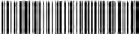Copyright © 2021 DJI All Rights Reserved.

Printed in China. 37RDDJRC02TY

Date: 2024.09.05

DJI FPV Remote Controller 3 Firmware: v01.00.0300

What’s New

* Added support to use with DJI Neo.
* Fixed some known issues.

Notes:

* Restart the aircraft, remote control device, and goggles after the firmware update is complete.
* Note that the firmware update may reset various flight parameters such as RTH Altitude and Maximum Flight Distance. Before updating, take note of your preferred settings and readjust them after the firmware update is complete.
* Note that the firmware update may reset the customizable button settings. Before updating, take note of your preferred settings and readjust them after the firmware update is complete.
* If the update fails, restart the aircraft, remote control device, goggles, and the DJI Fly app or DJI Assistant 2 (Consumer Drone Series), and try again.

Date: 2024.07.25

DJI FPV Remote Controller 3 Firmware: v01.00.0200

What’s New

* Added support to use with DJI O3 Air Unit.
* Fixed some known issues.

Notes:

* Restart the aircraft, remote control device, and goggles after the firmware update is complete.
* Note that the firmware update may reset various flight parameters such as RTH Altitude and Maximum Flight Distance. Before updating, take note of your preferred settings and readjust them after the firmware update is complete.
* Note that the firmware update may reset the customizable button settings. Before updating, take note of your preferred settings and readjust them after the firmware update is complete.
* If the update fails, restart the aircraft, remote control device, goggles, and the DJI Fly app or DJI Assistant 2 (Consumer Drone Series), and try again.

Date: 2024.04.11

DJI FPV Remote Controller 3 Firmware: v01.00.0100 DJI Fly App iOS: v1.13.0

DJI Fly App Android: v1.13.0

What’s New

* Optimized communication stability between the goggles and remote control device.
* Fixed some known issues.

Notes:

* Restart the aircraft, remote control device, and goggles after the firmware update is complete.
* Note that the firmware update may reset various flight parameters such as RTH Altitude and Maximum Flight Distance. Before updating, take note of your preferred settings and readjust them after the firmware update is complete.
* If the update fails, restart the aircraft, remote control device, goggles, and the DJI Fly app or DJI Assistant 2 (Consumer Drone Series), and try again.

# Motion Controller

User Manual

2021.03

v1.0

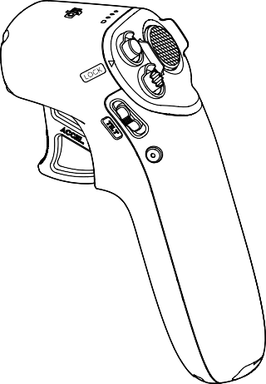



**Searching for Keywords**

Search for keywords such as “battery” and “install” to find a topic. If you are using Adobe Acrobat Reader to read this document, press Ctrl+F on Windows or Command+F on Mac to begin a search.

**Navigating to a Topic**

View a complete list of topics in the table of contents. Click on a topic to navigate to that section.

**Printing this Document**

This document supports high resolution printing.

#### Using this Manual

Legend

 Warning  Important  Hints and Tips  Reference

Read Before the First Flight

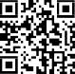Visit the address below or scan the QR code to watch the tutorial videos, which demonstrate how to use the DJI Motion Controller safely:

[https://www.dji.com/dji-fpv/video](http://www.dji.com/dji-fpv/video)

Download the DJI Fly App

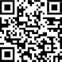Scan the QR code on the right to download DJI Fly.

The Android version of DJI Fly is compatible with Android v6.0 and later. The iOS version of DJI Fly is compatible with iOS v11.0 and later.

Download the DJI Virtual Flight App

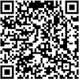Scan the QR code on the right to download DJI Virtual Flight.

The iOS version of DJI Virtual Flight is compatible with iOS v11.0 and later.

Download DJI Assistant 2 (DJI FPV series)

Download DJI ASSISTANTTM 2 (DJI FPV Series) at [https://www.dji.com/dji-fpv/downloads.](http://www.dji.com/dji-fpv/downloads)

Warnings

1. Use this product within the operating temperature range. Avoid any sudden or large movements when handling the product.
2. Fly in an environment away from electromagnetic interference such as power lines and metal structures.

**Contents**

Using this Manual 3

Legend 3

Read Before the First Flight 3

Download the DJI Fly App 3

Download the DJI Virtual Flight App 3

Download DJI Assistant 2 (DJI FPV series) 3

Warnings 3

Product Profile 5

Introduction 5

Diagram 5

Operation 7

Powering On/Off 7

Charging 7

Linking 8

Activation 8

Controlling the Aircraft 8

Controlling the Camera 11

Optimal Transmission Zone 11

Goggles Screen 12

Appendix 14

Specifications 14

Motion Controller Calibration 14

Firmware Update 14

After-Sales Information 15

#### Product Profile

Introduction

When used with the DJI FPV Goggles V2, the DJI Motion Controller provides an immersive and intuitive flying experience that allows users to easily control the aircraft using hand movements. Built into the DJI Motion Controller is DJI's O3 transmission technology, offering a maximum transmission range of 6 mi (10 km). The motion controller works at both 2.4 and 5.8 GHz and is capable of selecting the best transmission channel automatically. The maximum runtime of the motion controller is approximately 5 hours.

 The motion controller reaches its maximum transmission distance (FCC) in a wide-open area with no electromagnetic interference when the aircraft is at an altitude of approximately 400 ft (120 m). The maximum transmission distance refers to the maximum distance that the aircraft can still send and receive transmissions. It does not refer to the maximum distance the aircraft can fly in a single flight.

5.8 GHz is not supported in certain regions. Observe local laws and regulations.

Diagram

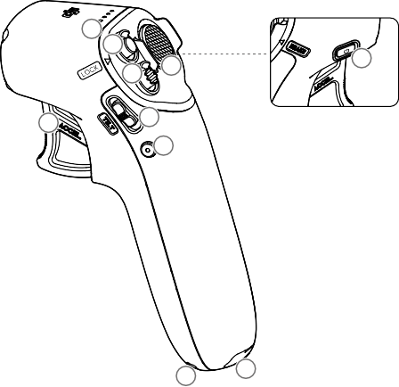

1

2

10

3

4

7

5

6

8

9

1. Battery Level LEDs

Indicates the battery level of the motion controller.

1. Lock Button

Press twice to start the motors of the aircraft.

Press and hold to make the aircraft automatically take off, ascend to approximately 1 m, and hover. Press and hold again to make the aircraft automatically land and the motors stop.

Press once to cancel Low Battery RTH when the countdown appears in the goggles.

1. Mode Button

Press once to switch between Normal and Sport mode.

**DJI Motion Controller** User Manual

1. Brake Button

Press once to make the aircraft brake and hover in place (only when GPS or Downward Vision System is available). Press again to unlock the attitude and record the current position as zero attitude.

Press and hold to initiate RTH. Press again to cancel RTH.

1. Gimbal Tilt Slider

Push up and down to adjust the tilt of the gimbal (only available before takeoff).

1. Shutter/Record Button

Press once to take photos or start or stop recording. Press and hold to switch between photo and video

mode.

1. Accelerator

Press to fly the aircraft in the direction of the circle in the goggles. Apply more pressure to accelerate. Release to stop and hover.

1. Lanyard Hole
2. USB-C Port

For charging or connecting the motion controller to a computer to update firmware.

1. Power Button

Press once to check the current battery level. Press once then again and hold to power the motion controller on or off.

#### Operation

Powering On/Of f

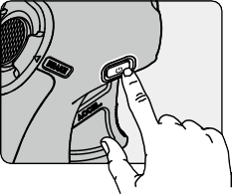Press the power button once to check the current battery level. Recharge before using if the battery level is too low. Press once then press again and hold to power the motion controller on or off.



The battery level LEDs display the power level of the battery during

charging and discharging. The statuses of the LEDs are defined below:

 LED is on.

 LED is flashing.



LED is off.

|  |  |  |  |  |
| --- | --- | --- | --- | --- |
| LED1 | LED2 | LED3 | LED4 | Battery Level |
|  |  |  |  | Battery Level > 80% |
|  |  |  |  | 75% < Battery Level ≤ 80% |
|  |  |  |  | 63% < Battery Level ≤ 75% |
|  |  |  |  | 50% < Battery Level ≤ 63% |
|  |  |  |  | 38% < Battery Level ≤ 50% |
|  |  |  |  | 15% < Battery Level ≤ 38% |
|  |  |  |  | 8% < Battery Level ≤ 15% |
|  |  |  |  | 0% < Battery Level ≤ 8% |

Charging

Use a USB-C cable to connect a charger to the USB-C port of the motion controller. It takes approximately 2.5 hours to fully charge the motion controller.

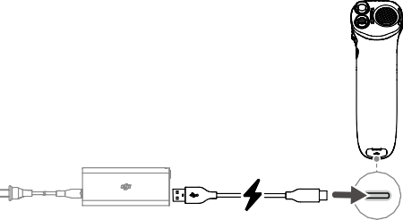

**5V, 1A**

The table below shows the battery level during charging.

|  |  |  |  |  |
| --- | --- | --- | --- | --- |
| LED1 | LED2 | LED3 | LED4 | Battery Level |
|  |  |  |  | 0% < Battery Level ≤ 50% |
|  |  |  |  | 50% < Battery Level ≤ 75% |
|  |  |  |  | 75% < Battery Level < 100% |
|  |  |  |  | Fully charged |

Linking

Follow the steps below to link the motion controller and the aircraft.

The aircraft must be linked with the goggles before the motion controller.

Make sure that all devices are powered on before linking.

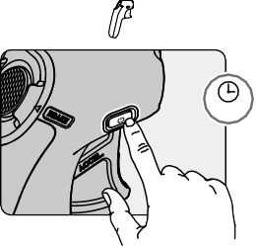

2s

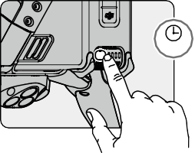

2s

1. Press and hold the power button of the aircraft until the battery level LEDs start to blink in sequence.
2. Press and hold the power button of the motion controller until it beeps continually and the battery level

indicators blink in sequence.

1. The motion controller stops beeping when linking is successful and both the battery level indicators turn

solid and display the battery level.

Activation

The DJI Motion Controller must be activated before using for the first time. Make sure all devices are linked after powering on the aircraft, goggles, and motion controller. Connect the USB-C port of the goggles to the mobile device, run DJI Fly, and follow the prompts to activate. An internet connection is required for activation.

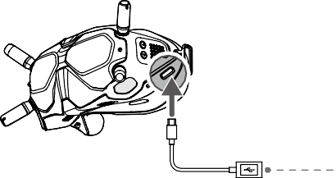

**DJI Fly App**

Controlling the Aircraft

The motion controller has two modes: Normal mode and Sport mode. Normal mode is selected by default.

 Zero attitude: the initial position of the motion controller that is used as a reference point when any movements are made with the motion controller.

Before using for the first time, practice flying with the motion controller using DJI Virtual Flight.

|  |  |  |
| --- | --- | --- |
| Motion Controller | Aircraft & Goggles Screen ( Indicates nose direction) | Remarks |
|  |  | Rotate the motion controller to control the orientation of the aircraft.  The orientation of the aircraft changes with the rotation of the motion controller accordingly and is always consistent with the orientation of the motion controller.  The circle in the goggles will move left and right and the video transmission will change accordingly. |
|  | The orientation of the aircraft can also be controlled by tilting the motion controller left and right.  Tilt left to rotate the aircraft counterclockwise and tilt right to rotate clockwise. The aircraft hovers in place if the motion controller is at zero attitude.  The tilt angle corresponds to the angular velocity of the rotation of the aircraft. The greater the tilt angle of the motion controller, the faster the aircraft will rotate.  The circle in the goggles will move left and right and the video transmission will change accordingly.  It is recommended to use this movement to control the orientation of the aircraft. |
|  |  | Tilt the motion controller up and down to control the tilt of the gimbal.  The tilt of the gimbal changes with the tilt of the motion controller accordingly and is always consistent with the orientation of the motion controller.  The circle in the goggles will move up and down and the video transmission will change accordingly. |
|  | To control the ascent or descent of the aircraft, first tilt the motion controller 90° up or down. Once complete, press the accelerator to make the aircraft ascend or descend. |
|  |  | Press the accelerator to fly in the direction of the circle  in the goggles.  Apply more pressure to accelerate. Release to stop and hover. |

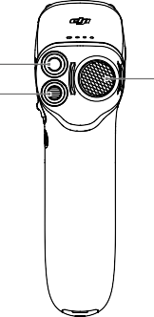Lock Button

Mode Button

Brake Button

Lock Button

Press twice to start the motors of the aircraft.

Press and hold to make the aircraft automatically take off, ascend to approximately 1 m, and hover. Press and hold while hovering to make the aircraft automatically land and the motors to stop.

Press once to cancel Low Battery RTH when the countdown appears in the goggles.

Critical Low Battery landing cannot be canceled.

Brake Button

Press once to make the aircraft brake and hover in place. The goggles will show . Press again to unlock the attitude and record the current position as zero attitude. To record the zero attitude, the motion controller must

be held upright and the white dot must be inside the box of the motion controller movement display. The box turns to  when the white dot is inside.

If the aircraft is performing RTH or auto landing, press once to exit RTH.

Press and hold the brake button until the motion controller beeps to indicate that RTH has started. Press the

button again to cancel RTH and regain control of the aircraft.

 If the aircraft brakes and hovers, the zero attitude may need to be reset before the flight can resume.

Mode Button

Press once to switch between Normal and Sport mode. The current mode is displayed in the goggles.

Motion Controller Alert

The motion controller sounds an alert during RTH. The alert cannot be cancelled.

The motion controller sounds an alert when the battery level is 6% to 15%. A low battery level alert can be cancelled by pressing the power button. A critical battery level alert will sound when the battery level is less than 5% and cannot be cancelled.

Controlling the Camera

1. Shutter/Record Button: press once to take a photo or to start or stop recording. Press and hold to switch

between photo and video mode.

1. Gimbal Tilt Slider: push up and down to adjust the tilt of the gimbal (only available before takeoff).

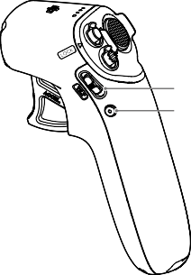Gimbal Tilt Slider Shutter/Record Button

Optimal Transmission Zone

The signal between the aircraft and the motion controller is most reliable when the motion controller is positioned in relation to the aircraft as shown below.

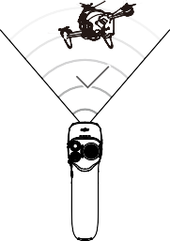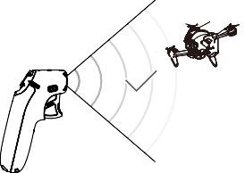

Optimal Transmission Zone

 In order to avoid interference, DO NOT use other wireless devices on the same frequency as the

motion controller.

#### Goggles Screen

The motion controller should be used with the DJI FPV Goggles V2, which give users a first-person view from

the aerial camera with real-time video and audio transmission.

1

2



***15min***

***10min***

***20.5km/h 1.8km/h***

***H 500m D 1024.4m***

***15 12'59''***

***20***

***75%***

Low battery RTH

Press Brake button to cancel RTH

13

3

12 11 10 9 8 7 6 5 4

1. Flight Direction Indicator

When the motion controller is stationary, it indicates the midpoint of the screen. When the motion controller is moved, it indicates the change of the aircraft orientation or gimbal pitch.

1. microSD Card Information

Displays whether or not a microSD card is inserted in the aircraft or goggles as well as the remaining

capacity. A flashing icon will appear when recording.

1. Prompts

Displays information such as when switching modes and when the battery level is low.

1. Goggles Battery Level

Displays the battery level of the goggles. The goggles will beep when the battery level is too low. The voltage will also be displayed if a third-party battery is being used.

1. GPS Status

Displays the current strength of the GPS signal.

1. Remote Control and Video Downlink Signal Strength

Displays the remote control signal strength between the aircraft and motion controller and the video

downlink signal strength between the aircraft and the goggles.

1. Forward Vision System Status

Displays the status of the Forward Vision System. The icon is white when the Forward Vision System is working normally. Red indicates that the Forward Vision System is not enabled or working abnormally and the aircraft cannot automatically slow down when encountering obstacles.

1. Remaining Flight Time

Displays the remaining flight time of the aircraft after starting the motors.

**DJI Motion Controller** User Manual

1. Aircraft Battery Level

Displays the current battery level of the Intelligent Flight Battery on the aircraft.

1. Motion Controller Movement Display

Displays the attitude information of the motion controller such as when it tilts left and right, up and down,

and whether the attitude is fixed when the aircraft brakes and hovers.

1. Flight Telemetry

D 1024.4 m, H 500 m, 9 m/s, 6 m/s: displays the distance between the aircraft and the Home Point, height

from the Home Point, aircraft horizontal speed, and aircraft vertical speed.

1. Flight Modes

Displays the current flight mode.

1. Home Point

Indicates the location of the Home Point.

It is recommended to watch the tutorial video in the goggles before using for the first time. Go to

Settings, Control, Motion Controller, Flight Control, and then First Flight Tutorial.

Using the goggles does not satisfy the requirement of visual line of sight (VLOS). Some countries or regions require a visual observer to assist during flight. Make sure to comply with local regulations when using the goggles.

#### Appendix

Specifications

Model FC7BMC

Weight 167 g

Operating Frequency 2.400-2.4835 GHz; 5.725-5.850 GHz

Max Transmission Distance (unobstructed, free of interference)

Transmitter Power (EIRP)

10 km (FCC); 6 km (CE/SRRC/MIC)

2.4 GHz: ≤28.5 dBm (FCC), ≤20 dBm (CE/SRRC/MIC)

5.8 GHz: ≤31.5 dBm (FCC), ≤19 dBm (SRRC), ≤14 dBm (CE)

Operating Temperature Range -10° to 40° C (14° to 104° F)

Max Runtime 5 hours

Motion Controller Calibration

The compass, IMU, and accelerator of the motion controller can be calibrated. Immediately calibrate any of the modules when prompted to do so.

On the goggles, go to Settings, Control, Motion Controller, and then Motion Controller Calibration. Select the module and follow the prompts to complete calibration.

 DO NOT calibrate the compass in locations where magnetic interference may occur such as close to magnetite deposits or large metallic structures such as parking structures, steel-reinforced basements, bridges, cars, or scaffolding.

DO NOT carry objects that contain ferromagnetic materials such as mobile phones near the aircraft during calibration.

Firmware Update

Use DJI Fly or DJI Assistant 2 (DJI FPV series) to update the motion controller firmware.

Using DJI Fly

Power on the aircraft, goggles, and motion controller. Make sure all the devices are linked. Connect the USB-C port of the goggles to the mobile device, run DJI Fly, and follow the prompt to update. An internet connection is required.

Using DJI Assistant 2 (DJI FPV Series)

Use DJI Assistant 2 (DJI FPV series) to update the motion controller separately.

1. Power on the device and connect it to a computer with a USB-C cable.
2. Launch DJI Assistant 2 (DJI FPV series) and log in with a DJI account.
3. Select the device and click Firmware Update on the left.
4. Select the firmware version required.
5. DJI Assistant 2 (DJI FPV series) will download and update the firmware automatically.
6. The device will restart automatically after the firmware update is complete.

**DJI Motion Controller** User Manual

 Before performing an update, make sure the motion controller has a battery level of at least 30%.

Do not unplug the USB-C cable during an update.

The firmware update will take approximately 5 minutes. Make sure the mobile device or the

computer is connected to the internet.

After-Sales Information

Visit [https://www.dji.com/support](http://www.dji.com/support) to learn more about after-sales service policies, repair services, and support.

DJI Support

<http://www.dji.com/support>

This content is subject to change.

Download the latest version from [https://www.dji.com/dji-fpv](http://www.dji.com/dji-fpv)

If you have any questions about this document, please contact

DJI by sending a message to [DocSupport@dji.com.](mailto:DocSupport@dji.com)

Copyright © 2021 DJI All Rights Reserved.

Battery Charging Hub

User Guide使用说明 使用說明

ユーザーガイド

사용자 가이드

Bedienungsanleitung Guía del usuario Guide de l'utilisateur Guida dell'utente Gebruiksaanwijzing Manual do utilizador Guia do usuário

Руководство пользователя

2021.01



v1.0

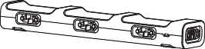

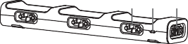

3 2 1

|  |  |  |
| --- | --- | --- |
| 1 | 2 | 3 |
| Power Port | Status LED Indicator | Battery Port |
| 电源接口 | 状态指示灯 | 电池接口 |
| 電源連接埠 | 狀態指示燈 | 電池連接埠 |
| 電源ポート | ステータス LED インジケーター | バッテリーポート |
| 전원 포트 | LED 상태 표시등 | 배터리 포트 |
| Netzanschluss | LED-Statusanzeige | Akkuschacht |
| Puerto de alimentación | Indicador led de estado | Puerto para baterías |
| Port d’alimentation | Indicateur LED d’état | Port de la batterie |
| Porta di alimentazione | Indicatore LED di stato | Vano batteria |
| Voedingspoort | Status LED–indicator | Batterijpoort |
| Porta de alimentação | Indicador de Estado LED | Porta da bateria |
| Entrada de alimentação | Indicador LED de status | Entrada da bateria |
| Порт питания | Светодиодный индикатор состояния | Порт для аккумулятора |

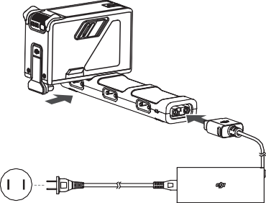

1



EN

**Disclaimer**

Please read this entire document and all safe and lawful practices DJITM provided carefully before use. Failure to read and follow instructions and warnings may result in serious injury to yourself or others, damage to your DJI product, or damage to other objects in the vicinity. By using this product, you hereby signify that you have read this disclaimer and warning carefully and that you understand and agree to abide by the terms and conditions herein. You agree that you are solely responsible for your own conduct while using this product, and for any consequences thereof. DJI accepts no liability for damage, injury or any legal responsibility incurred directly or indirectly from the use of this product.

DJI is a trademark of SZ DJI TECHNOLOGY CO., LTD. (abbreviated as “DJI”) and its affiliated companies. Names of products, brands, etc., appearing in this document are trademarks or registered trademarks of their respective owner companies. This product and document are copyrighted by DJI with all rights reserved. No part of this product or document shall be reproduced in any form without the prior written consent or authorization of DJI.

This document and all other collateral documents are subject to change at the sole discretion of DJI. For up to date product information, visit [http://www.](http://www/) dji.com and click on the product page for this product.

This disclaimer is available in various languages. In the event of divergence among different versions, the English version shall prevail.

**Warnings**

1. The Charging Hub is only compatible with the DJI FPV AC Power Adapter. DO NOT attempt to use the Charging Hub with any other battery charger.
2. The Charging Hub is only compatible with BWX170-2000-22.2 Intelligent Flight Batteries. DO NOT attempt to use the Charging Hub with other battery models.
3. Place the Charging Hub on a flat and stable surface when in use. Make sure the device is properly insulated to prevent fire hazards.
4. DO NOT attempt to touch the metal terminals on the Charging Hub.
5. Clean the metal terminals with a clean, dry cloth if there is any noticeable buildup.

**Introduction**

The DJI FPV Battery Charging Hub is designed for use with the DJI FPV Intelligent Flight Battery. When used with the DJI FPV AC Power Adapter, it can charge up to three Intelligent Flight Batteries in sequence according to their power levels, from high to low. The charging time for one battery is approximately 55 minutes.

**Usage**

1. Connect the DJI FPV AC Power Adapter to a power outlet (100-240 V, 50/60 Hz) and connect the Charging Hub to the DJI FPV Battery Charger.
2. Insert the Intelligent Flight Battery into the battery port to begin charging. The Intelligent Flight Battery with the highest power level will be charged first and the rest in sequence according to their power levels. Refer to the Status LED Indicator Descriptions section for more information about the blinking patterns of Status LED indicator. The Intelligent Flight Battery can be disconnected from the Charging Hub when charging is complete.

**Status LED Indicator Descriptions**

Blinks yellow

Temperature of batteries too low or too high (no

further operation needed)

Solid yellow

No battery attached

Solid green

All batteries fully charged

Pulses green Charging

Blinking Pattern Descriptions

2

Solid red

Power supply or battery error (unplug and plug the batteries or charger to resume charging)

**Specifications**

Product Model CHX170-90

Compatible Power Adapter CDX170-90

Compatible Battery Model BWX170-2000-22.2

Operating Temperature 5° to 40° C (41° to 104° F)

Input 25.2 V, 3.4 A

Charging Time Approx. 55 minutes (single battery)



CHS

免责声明和警告

使用本产品之前，请仔细阅读并遵循本文及大疆 TM 创新（DJITM）提供的所有安全指引，否则可能会给您和周围的人带来伤害，损坏本产品或其它周围物品。一旦使用本产品，即视为您已经仔细阅读本文档，理解、认可和接受本声明全部条款和内容。您承诺对使用本产品以及可能带来的后果负全部责任。大疆创新（DJI）对于直接或间接使用本产品而造成的损坏、伤害以及任何法律责任不予负责。

DJI 是深圳市大疆创新科技有限公司及其关联公司的商标。本文出现的产品名称、品牌等，均为其所属公司的商标。本产品及手册为大疆创新版权所有。未经许可，不得以任何形式复制翻印。

本文档及本产品所有相关的文档最终解释权归大疆创新（DJI）所有。如有更新，恕不另行通知。请访问[www.dji.com 官方网站以获取最新的产品信息。](http://www.dji.com官方网站以获取最新的产品信息/)

注意事项

1. 充电管家仅适用于扩展充电接口，请配合使用 DJI FPV 电源适配器为充电管家供电。
2. 充电管家仅适用于 BWX170-2000-22.2 智能飞行电池充电。请勿使用充电管家为其他型号电池充电。
3. 使用时请将充电管家平稳放置，并注意绝缘及防火。
4. 请勿用手或其他物体触碰金属端子。
5. 若金属端子附着异物，请用干布擦拭干净。

简 介

DJI FPV 充电管家配合标配电源适配器使用，可连接三块 DJI FPV 智能飞行电池，并根据电池的剩余电量高低依次为电池充电。充满单块电池的时间大约为 55 分钟。

使 用

1. 按图示方向将电池插入充电管家的电池接口，使用标配电源适配器连接电源接口至交流电源（100-240 V，50/60 Hz）。
2. 充电管家将根据电池的电量高低轮流为电池充电。充电过程中，充电管家状态指示灯显示当前状态（参照下表了解详情），电池电量指示灯显示电量信息。充电完成后，请取下电池并断开电源连接。

状态指示灯描述

黄灯闪烁

电池温度过高或过低（无须用户操作，等待电池温度恢

复至正常范围时可继续充电）

黄灯常亮

无电池在位

绿灯常亮

所有电池电量充满

绿灯呼吸 正在充电

闪灯方式 描述

3

红灯常亮 充电过流、输入电压异常或其它错误（需要重新插拔电池或充电器以恢复充电）

规格参数

产品型号 CHX170-90

适用电源适配器型号 CDX170-90

适用电池型号 BWX170-2000-22.2

工作环境温度 5℃至 40℃

输入 25.2 V, 3.4 A

充电时间 约 55 分钟（单块电池）



CHT

免責聲明和警告

使用本産品之前，請仔細閱讀並遵循本文及大疆 TM 創新（DJITM）提供的所有安全指南，否則可能會為您和周圍的人帶來傷害，損壞本産品或其它周圍物品。一旦使用本產品，即視為您已經仔細閱讀本文件，瞭解、認可和接受本聲明全部條款和內容。您承諾對使用本產品及其可能帶來的後果負全部責任。大疆創新（DJI）對於直接或間接使用本產品而造成的損壞、傷害及其任何法律責任概不負責。

DJI 是深圳市大疆創新科技有限公司及其附屬公司的商標。本文出現的産品名稱、品牌等，均為其所屬公司的商標。本產品及手冊之版權為大疆創新所有。未經許可，不得以任何形式複製翻印。

本文件及本產品所有相關文件的最終解釋權歸大疆創新（DJI）所有。如有更新，恕不另行通知。請前往 [www.dji.com](http://www.dji.com/) 官方網站以取得最新的產品資訊。

注意事項

1. 充電管家僅適用於擴充充電連接埠，請配合使用 DJI FPV 電源轉接器為充電管家供電。
2. 充電管家僅適用於 BWX170-2000-22.2 智能飛行電池充電。請勿使用充電管家為其他型號的電池充電。
3. 使用時，請將充電管家平穩放置，並注意絕緣及防火。
4. 請勿用手或其他物體觸碰金屬端點。
5. 若金屬端點上附著異物，請用乾布擦拭乾淨。

簡 介

DJI FPV 充電管家配合標配電源轉接器使用，可連接三顆 DJI FPV 智能飛行電池，並根據電池的剩餘電量高低依次為電池充電。充滿單顆電池的時間大約為 55 分鐘。

使 用

1. 按圖示方向將電池插入充電管家的電池連接埠，使用標配電源轉接器連接電源連接埠至交流電源（100-240 V，50/60 Hz）。
2. 充電管家將根據電池的電量高低輪流為電池充電。充電過程中，充電管家狀態指示燈顯示為當前狀態（請參閱下表了解詳情），電池電量指示燈顯示電量資訊。充電完成後，請取下電池並斷開電源連接。

狀態指示燈說明

黃色閃爍

電池溫度過高或過低（無需使用者操作，等待

電池溫度恢復至正常範圍即可繼續充電）

黃燈恆亮

無內置電池

綠燈恆亮

所有電池電量充滿

綠燈呼吸 正在充電

閃燈方式 描述

4

（需要重新插拔電池或充電器以恢復充電）

規格參數

產品型號 CHX170-90

適用電源轉接器型號 CDX170-90

適用電池型號 BWX170-2000-22.2

運作環境溫度 5℃ 至 40℃

輸入 25.2 V, 3.4 A

充電時間 約 55 分鐘（單顆電池）



JP

**免責事項**

ご使用前に、この文書全体に目を通し、DJITM が提供する安全で合法的慣行についての説明を注意深くお読みください。指示と警告に従わなかった場合、ご自身や他の人に重傷を負わせたり、またはお客様の DJI 製品および周辺の他の物の破損につながる恐れがあります。本製品を使用することにより、本書の免責事項および警告をよく読み、記載されている利用規約を理解し、順守することに同意したとみなされます。本製品の使用中の行動とこれに伴う結果には、ユーザーが全面的に責任を負うことに同意するものとします。本製品の使用により直接または間接的に発生する損害、傷害、およびその他法的責任に対して、DJI は一切責任を負いません。

DJI は、SZ DJI TECHNOLOGY CO., LTD.（以下「DJI」と省略）およびその関連会社の商標です。本書に記載されている製品、ブランドなどの名称は、その所有者である各社の商標または登録商標です。本製品および本書は、不許複製 • 禁無断転載を原則とする DJI の著作物のため、DJI から書面による事前承認または許諾を得ることなく、本製品または文書のいかなる部分も、いかなる方法によっても複製することは固く禁じられています。

本書およびその他すべての付属書は、DJI 独自の裁量で変更されることがあります。最新の製品情報については、[http://www.dji.com にアクセスして、](http://www.dji.comにアクセスして/)本製品に対応する製品ページをクリックしてご覧ください。

この免責事項は複数の言語で提供されています。言語版によって相違がある場合には、英語版が優先されます。

**警告**

1. 充電ハブは、DJI FPV AC 電源アダプターとのみ互換性があります。それ以外のバッテリー充電器と一緒に充電ハブを使用しないでください。
2. 充電ハブは、BWX170-2000-22.2 インテリジェント フライトバッテリーにのみ互換性があります。それ以外のバッテリーモデルと一緒に充電ハブを使用しないでください。
3. 充電ハブを使用する際は、平らで安定した面に置いてください。火災の危険を防ぐために、本機器が適切に絶縁されていることを確認してください。
4. 充電ハブの金属端子に触れないでください。
5. 金属端子の汚れが目立つ場合は、きれいな乾いた布で拭いてください。

**はじめに**

DJI FPV バッテリー充電ハブは、DJI FPV インテリジェント フライトバッテリーで使用するために設計されています。DJI FPV AC 電源アダプターと一緒に使用すると、3 個のインテリジェント フライトバッテリーを充電でき、バッテリー残量にあわせてバッテリー残量の多いものから少ないものへと順次充電します。バッテリー 1 個の充電時間は、約 55 分です。

**使用方法**

1. DJI FPV AC 電源アダプターを電源コンセント (100 ～ 240 V、50/60 Hz)

に接続し、充電ハブを DJI FPV バッテリー充電器に接続します。

5

1. インテリジェント フライトバッテリーをバッテリーポートに挿入して充電を開始します。バッテリー残量の一番多いインテリジェントフライトバッテリーが最初に充電され完了すると、他のバッテリーも残量が多いものから順に充電されます。ステータス LED インジケーターの点滅パターンの詳細については、「ステータス LED インジケーターの説明」のセクションを参照してください。充電が完了したら、インテリジェントフライトバッテリーを充電ハブから取り外すことができます。

**ステータス** LED **インジケーターの説明**

黄色点滅

バッテリーの温度が低すぎるか高すぎる（それ以上の操作は不要）

黄色点灯

バッテリーが取り付けられていません

緑色点灯

全バッテリーが充電完了

緑色のパルス点滅 充電中

点滅パターン 説明

赤色点灯 電源またはバッテリーエラー（バッテリーまたは

充電器を抜き差しして充電を再開してください）

**仕様**

製品モデル CHX170-90

対応している電源アダプター CDX170-90

対応しているバッテリーモデル BWX170-2000-22.2

動作環境温度 5℃ ～ 40℃

入力 25.2 V、3.4 A

充電時間 約 55 分（バッテリー 1 個）



KR

**고지 사항**

DJITM 에서 제공해드리는 본 문서 전문과 안전하고 적법한 사용 방법 관련된 모든 내용 을 사용 전에 주의 깊게 읽어 주십시오 . 지침 및 경고 사항을 읽고 따르지 않을 경우 사 용자 또는 다른 사람이 심각하게 다치거나 DJI 제품 또는 근처에 있는 다른 물체가 손 상될 수 있습니다 . 제품을 사용하는 것은 본 고지 사항 및 경고를 주의 깊게 읽었으며 명시된 약관을 이해하고 준수하기로 동의한 것으로 간주합니다 . 귀하는 본 제품의 사 용과 관련한 귀하의 행위 및 그로 인한 모든 결과에 대해 독자적으로 책임진다는 데 동 의합니다 . DJI 는 본 제품의 사용으로 인해 직접 또는 간접적으로 발생한 피해 , 부상 또는 모든 법적 책임에 대해 어떠한 책임도 지지 않습니다 .

DJI 는 SZ DJI TECHNOLOGY CO., LTD.( 약어로 “DJI”) 및 해당 자회사의 상표입

니다 . 본 문서에 나타나는 제품 , 브랜드 등의 이름은 각각 그것을 소유하는 회사의 상 표이거나 등록 상표입니다 . DJI 는 본 제품 및 문서의 저작권과 함께 모든 권리를 보유 합니다 . 본 제품 또는 문서의 어떠한 부분도 DJI 의 사전 서면 허가 또는 동의 없이 어 떠한 형식으로 재생산할 수 없습니다 .

이 문서 및 기타 모든 부수적인 문서는 DJI 의 단독 재량에 따라 변경될 수 있습니다 . 최신 제품 정보는 [http://www.dji.com](http://www.dji.com/) 을 방문하여 본 제품에 대한 제품 페이지를 클 릭하여 확인하실 수 있습니다 .

이 고지 사항은 다양한 언어로 제공됩니다 . 언어 사이의 차이점이 있을 경우 , 영어 버 전이 우선합니다 .

**경고**

1. 충전 허브는 DJI FPV AC 전원 어댑터와만 호환됩니다 . 이 충전 허브를 다른 배터 리 충전기에 사용하려고 하지 마십시오 .
2. 충전 허브는 BWX170-2000-22.2 인텔리전트 플라이트 배터리와만 호환됩니다 .

이 충전 허브를 다른 배터리 모델에 사용하려고 하지 마십시오 .

1. 충전 허브를 사용할 때는 평평하고 안정된 바닥에 놓으십시오 . 화재가 발생하지 않 도록 기기가 올바르게 절연되어 있는지 확인하십시오 .
2. 충전 허브의 금속 단자를 만지려고 시도하지 마십시오 .
3. 눈에 띄는 이물질이 있으면 깨끗하고 마른 천으로 금속 단자를 닦으십시오 .

6

**소개**

DJI FPV 배터리 충전 허브는 DJI FPV 인텔리전트 플라이트 배터리와 함께 사용하도 록 설계된 제품입니다 . DJI FPV AC 전원 어댑터와 함께 사용하면 최대 3 개의 인텔 리전트 플라이트 배터리를 충전할 수 있으며 , 배터리 잔량에 따라 높은 순서부터 차례 대로 충전합니다 . 배터리 하나의 충전 시간은 약 55 분입니다 .

**사용 방법**

1. DJI FPV AC 전원 어댑터를 전원 콘센트 (100~240V, 50/60Hz) 에 연결하고 충전 허브를 DJI FPV 배터리 충전기에 연결합니다 .
2. 충전을 시작하려면 인텔리전트 플라이트 배터리를 배터리 포트에 삽입합니다 . 배 터리 잔량이 가장 높은 인텔리전트 플라이트 배터리부터 먼저 충전되고 잔량 정도 에 따라 나머지도 순서대로 충전됩니다 . LED 상태 표시등의 깜박임 패턴에 대한 자세한 내용은 LED 상태 표시등 설명을 참조하십시오 . 충전이 완료되면 충전 허브 에서 인텔리전트 플라이트 배터리를 분리할 수 있습니다 .

**LED 상태 표시등 설명**

노란색으로 깜박임

배터리 온도가 너무 낮거나 너무 높음 ( 추가적인 작업 불필요 )

노란색 유지

배터리가 연결되어 있지 않음

녹색 유지

배터리가 완전히 충전됨

녹색이 느리게 깜박임 충전

깜박임 패턴 설명

빨간색 유지 전력 공급 장치 또는 배터리 오류 ( 배터리나 충전기를 뽑았다가 다시 꽂아서 충전 재개 )

|  |  |
| --- | --- |
| **사양** |  |
| 제품 모델명 | CHX170-90 |
| 호환 전원 어댑터 | CDX170-90 |
| 호환 배터리 모델명 | BWX170-2000-22.2 |
| 작동 온도 | 5~40° C |
| 입력 | 25.2 V, 3.4 A |
| 충전 시간 | 약 55 분 ( 배터리 1 개 ) |



DE

**Haftungsausschluss**

Bitte lies vor dem ersten Gebrauch dieses Dokument sowie alle von DJITM zur Verfügung gestellten sicherheitsrelevanten und rechtlichen Bestimmungen sorgfältig durch. Bei Nichtbeachtung der Anweisungen und Warnungen kann es zu schweren Verletzungen an dir selbst oder anderen Personen bzw. zu Schäden am DJI-Produkt oder anderen Objekten in der näheren Umgebung führen. Mit dem Gebrauch des Produkts bestätigst du, dass du diesen Haftungsausschluss einschließlich der Warnungen aufmerksam gelesen, den Inhalt verstanden hast und mit den Allgemeinen Geschäftsbedingungen einverstanden bist. Du stimmst zu, dass du beim Gebrauch des Produkts die alleinige Verantwortung für deine Handlungen und alle daraus entstehenden Folgen trägst. DJI übernimmt keine Haftung für Sachschäden oder Personenschäden sowie keine juristische Verantwortung für Schäden, die direkt oder indirekt mit dem Gebrauch des Produkts in Zusammenhang stehen.

DJI ist eine Marke von SZ DJI TECHNOLOGY CO., LTD. (kurz: „DJI“) und seiner verbundenen Unternehmen. Namen von Produkten, Marken usw., die in diesem Dokument enthalten sind, sind Warenzeichen oder eingetragene Warenzeichen der jeweiligen Besitzer (Eigentümergesellschaften). Dieses Produkt und dieses Dokument sind urheberrechtlich geschütztes Eigentum von DJI und alle Rechte sind vorbehalten. Kein Teil dieses Produkts oder dieses Dokuments darf in irgendeiner Form ohne vorherige schriftliche Zustimmung oder Genehmigung von DJI reproduziert werden.

7

Dieses Dokument und alle zugehörigen Dokumente können nach eigenem Ermessen von DJI jederzeit geändert werden. Aktuelle Produktinformationen findest du auf [www.dji.com.](http://www.dji.com/)

Dieser Haftungsausschluss ist in verschiedenen Sprachen verfügbar. Bei Abweichungen zwischen den verschiedenen Fassungen ist die englische Fassung maßgebend.

**Warnhinweise**

1. Die Akkuladestation ist nur mit dem Wechselstrom-Netzteil der DJI FPV kompatibel. Versuche NICHT, die Akkuladestation mit einem anderen Akkuladegerät zu verwenden.
2. Die Akkuladestation ist nur mit den BWX170-2000-22.2 Intelligent Flight Batteries kompatibel. Versuche NICHT, die Akkuladestation mit anderen Akkumodellen zu verwenden.
3. Verwende die Akkuladestation nur auf ebenen und stabilen Flächen. Sorge außerdem dafür, dass das Gerät ordnungsgemäß elektrisch isoliert ist, um kein Brandrisiko einzugehen.
4. Versuche NICHT, die Metallklemmen an der Akkuladestation zu berühren.
5. Reinige erkennbare Verschmutzungen mit einem sauberen und trockenen Tuch.

**Einführung**

Die Akkuladestation der DJI FPV wurde für die Verwendung mit der DJI FPV Intelligent Flight Battery entwickelt. In Kombination mit dem Wechselstrom-Netzteil der DJI FPV lassen sich bis zu drei Intelligent Flight Batteries nacheinander aufladen, wobei der Akku mit dem jeweils höchsten Ladestand zuerst aufgeladen wird. Die Ladezeit für einen Akku beträgt etwa 55 Minuten.

**Verwendung**

1. Schließe das Wechselstrom-Netzteil der DJI FPV an eine Steckdose (100-240 V, 50/60 Hz) an und verbinde die Akkuladestation mit dem Akkuladegerät der DJI FPV.
2. Setze die Intelligent Flight Battery in den Akkuschacht ein, um den Ladevorgang zu beginnen. Die Intelligent Flight Battery mit dem höchsten Ladezustand wird zuerst geladen, die anderen werden anschließend in der Reihenfolge ihres jeweiligen Ladezustands geladen. Unter „Beschreibung der Status-LED“ findest du weitere Informationen zu den Blinkmustern der Status-LED-Blinkfolgen. Die Intelligent Flight Battery kann von der Akkuladestation getrennt werden, wenn der Ladevorgang abgeschlossen ist.

**Beschreibung der Status-LED-Anzeigen**

Blinkfolge Beschreibung

Leuchtet durchgehend gelb

Pulsiert grün Ladevorgang aktiv

Kein Akku eingesetzt

Leuchtet kontinuierlich grün

Alle Akkus vollständig geladen

Blinkt gelb

Die Temperatur der Akkus ist zu niedrig oder

zu hoch (keine Benutzereingabe erforderlich)

Leuchtet kontinuierlich rot

Stromversorgungs- oder Akkufehler (Stecker erst von der Steckdose abziehen und dann die Akkus oder das Ladegerät wieder anschließen, um den Ladevorgang fortzusetzen)

**Technische Daten**

Modell

CHX170-90

Kompatibles Akkumodell

BWX170-2000-22.2

Betriebstemperatur 5 °C bis 40 °C

Kompatibles Netzteil CDX170-90

8

Eingang 25,2 V, 3,4 A

Ladezeit Ca. 55 Minuten (einzelner Akku)



ES

**Descargo de responsabilidad**

Lea detenidamente este documento al completo y todas las prácticas de seguridad y legales que DJITM ha facilitado antes de su uso. Si no lee ni sigue correctamente las instrucciones y advertencias, podría sufrir lesiones graves u ocasionárselas a otras personas. Asimismo, podría causar daños en su producto DJI u otros objetos próximos. Al usar este producto, manifiesta que ha leído detenidamente esta renuncia de responsabilidad y advertencia, así como que entiende y acepta cumplir los términos y condiciones establecidos en este documento. Acepta que usted es el único responsable de su propia conducta durante el uso de este producto y de cualquier consecuencia derivada de dicho uso. DJI no acepta responsabilidad alguna por daños o lesiones, ni ningún tipo de responsabilidad legal derivada directa o indirectamente del uso de este producto.

DJI es una marca comercial de SZ DJI TECHNOLOGY CO., LTD. (abreviado como “DJI”) y sus empresas vinculadas. Los nombres de productos, marcas, etc., que aparecen en este documento son marcas comerciales o marcas comerciales registradas de sus respectivas empresas propietarias. Este producto y el documento están sujetos a derechos de autor de titularidad de DJI, que se reserva todos los derechos. No se permite la reproducción total ni parcial de este documento o producto en forma alguna sin el consentimiento previo por escrito o la autorización de DJI.

Este documento y el resto de documentos suplementarios están sujetos a cambios a criterio exclusivo de DJI. Para obtener información actualizada sobre el producto, visite [http://www.dji.com](http://www.dji.com/) y haga clic en la página de este producto.

Esta renuncia de responsabilidad está disponible en diversos idiomas. En caso de divergencia entre las diferentes versiones, prevalecerá la versión en inglés.

**Advertencias**

1. El Centro de carga solo es compatible con el adaptador de corriente de CA DJI FPV. NO intente usar el Centro de carga con ningún otro cargador de batería.
2. El Centro de carga solo es compatible con las Baterías de Vuelo Inteligente BWX170-2000-22.2. NO intente usar el Centro de carga con otros modelos de batería.
3. Coloque el Centro de carga sobre una superficie lisa y estable cuando esté en uso. Asegúrese de que el dispositivo está debidamente aislado para evitar el riesgo de incendio.
4. NO intente tocar los terminales metálicos del Centro de carga.
5. Limpie los terminales metálicos con un paño limpio y seco si presentan acumulación de residuos.

**Introducción**

El Centro de carga de baterías DJI FPV está diseñado para usarse con la Batería de Vuelo Inteligente del sistema DJI FPV. Si se utiliza con el adaptador de corriente de CA DJI FPV, puede cargar hasta tres Baterías de Vuelo Inteligente sucesivamente en función de sus niveles de carga, desde la más cargada hasta la menos cargada. El tiempo de carga por cada batería es de aproximadamente 55 minutos.

**Uso**

1. Enchufe el adaptador de corriente de CA DJI FPV a una toma de corriente (100-240 V, 50/60 Hz) y conecte el Centro de carga al cargador de batería DJI FPV.
2. Inserte la Batería de Vuelo Inteligente en el puerto para baterías para comenzar la carga. La Batería de Vuelo Inteligente con el mayor nivel de

9

carga se cargará primero, y las demás se cargarán secuencialmente de acuerdo con sus niveles de carga. Consulte la sección Descripciones del indicador led de estado para obtener más información sobre los patrones de parpadeo del indicador led de estado. La Batería de Vuelo Inteligente se puede desconectar del puerto de carga cuando se completa la carga.

**Descripciones del indicador led de estado**

Patrón de parpadeo Descripción

Amarillo fijo No hay ninguna batería conectada.

Parpadea en verde Carga.

Verde fijo

Todas las baterías están completamente cargadas.

La temperatura de las baterías es demasiado Parpadea en amarillo baja o demasiado alta (no es necesario realizar

ninguna otra acción).

Rojo fijo

Error de fuente de alimentación o batería (desenchufe y enchufe las baterías o el cargador para reanudar la carga).

**Especificaciones**

Modelo de producto CHX170-90

Adaptador de corriente compatible CDX170-90

Modelo de batería compatible BWX170-2000-22.2

Temperatura de funcionamiento De 5 a 40 °C (de 41 a 104 °F)

Entrada 25.2 V, 3.4 A

Tiempo de carga Aprox. 55 min minutos (por batería)



FR

**Clause d’exclusion de responsabilité**

Veuillez lire attentivement ce document dans son intégralité, ainsi que toutes les pratiques sécuritaires et légales fournies par DJITM avant l’utilisation du produit DJI associé. Si vous ne lisez pas et ne respectez pas les instructions et les mises en garde, vous exposez les autres et vous-même à des blessures graves et risquez d’endommager votre produit DJI ou d’autres objets placés à proximité. En utilisant ce produit, vous confirmez que vous avez lu attentivement la clause d’exclusion de responsabilité et la mise en garde, que vous comprenez les conditions générales qui y sont énoncées, et que vous acceptez de les respecter. Vous déclarez assumer l’entière responsabilité de votre comportement lors de l’utilisation du produit ainsi que toutes les conséquences qui en découlent. DJI décline toute responsabilité quant aux dégâts, aux blessures ou aux problèmes découlant directement ou indirectement de l’utilisation de ce produit.

DJI est une marque commerciale de SZ DJI TECHNOLOGY CO., LTD. (« DJI » en abrégé) et de ses sociétés affiliées. Les noms de produits, de marques, etc., apparaissant dans le présent document sont des marques commerciales ou des marques déposées de leurs détenteurs respectifs. Ce produit et le présent document sont la propriété de DJI, tous droits réservés. Aucune partie de ce produit ou du présent document ne peut être reproduite sous quelque forme que ce soit sans l’autorisation ou le consentement écrit préalable de DJI.

DJI se réserve le droit de modifier, à sa seule discrétion, le présent document et tous les autres documents connexes. Pour connaître les dernières informations sur le produit, rendez-vous sur le site [http://www.dji.com](http://www.dji.com/) et cliquez sur la page produit correspondante.

Cette clause de non-responsabilité est disponible en plusieurs langues. En cas de divergence entre les différentes versions, la version en langue anglaise prévaudra.

10

**Avertissements**

1. La station de recharge est uniquement compatible avec l’adaptateur secteur CA pour DJI FPV. N’essayez PAS d’utiliser la station de recharge avec un autre chargeur de batterie.
2. La station de recharge est uniquement compatible avec les batteries de vol intelligentes BWX170-2000-22.2. N’essayez PAS d’utiliser la station de recharge avec d’autres modèles de batterie.
3. Placez la station de recharge sur une surface plane et stable pour l’utiliser. Assurez-vous que l’appareil est correctement isolé pour éviter les risques d’incendie.
4. N’essayez PAS de toucher les bornes métalliques de la station de recharge.
5. Nettoyez les bornes métalliques à l’aide d’un chiffon sec et propre si vous voyez apparaître des dépôts.

**Introduction**

La station de recharge de batterie pour DJI FPV est conçue pour être utilisée avec la Batterie de Vol Intelligente pour DJI FPV. Lorsqu’elle est utilisée avec l’adaptateur secteur CA pour DJI FPV, elle peut charger jusqu’à trois Batteries de vol intelligentes en séquence selon leur niveau de charge, de la plus chargée à la moins chargée. Le temps de charge d’une batterie est d’environ 55 minutes.

**Utilisation**

1. Branchez l’adaptateur secteur CA pour DJI FPV sur une prise courant (100-240 V, 50/60 Hz) et connectez la station de recharge au chargeur de batterie pour DJI FPV.
2. Insérez la Batterie de vol intelligente dans le port de la batterie pour commencer la recharge. La Batterie de Vol Intelligente ayant le niveau de puissance le plus élevé sera chargée en premier et les autres en séquence en fonction de leur niveau de puissance. Reportez-vous à la section Description des indicateurs LED d’état pour plus d’informations sur les modèles de clignotement des indicateurs LED d’état. La Batterie de Vol Intelligente peut être déconnectée de la station de recharge lorsque la charge est terminée.

**Description des indicateurs LED d’état**

Clignotement Descriptions

Jaune fixe Pas de batterie

Clignote lentement en Chargement vert

Vert fixe

Clignote en jaune

Rouge fixe

Toutes les batteries sont complètement rechargées

La température des batteries est trop basse ou trop élevée (aucune autre opération n’est nécessaire)

Erreur d’alimentation électrique ou de batterie (débrancher et brancher les batteries ou le chargeur pour reprendre la charge)

**Caractéristiques techniques**

Modèle du produit CHX170-90

Adaptateur secteur compatible CDX170-90

Modèle de batterie compatible BWX170-2000-22.2

Température de fonctionnement De 5° à 40° C

Entrée 25,2 V, 3,4 A

Temps de charge Environ 55 minutes (batterie unique)

11



IT

**Limitazioni di responsabilità**

Si prega di leggere con attenzione l’intero documento e tutte le pratiche sicure e legali DJITM fornite prima dell’uso. La mancata lettura e l’inosservanza delle istruzioni e delle avvertenze ivi riportate potrebbero determinare lesioni gravi all’utente o ad altre persone, nonché danni al prodotto DJI o ad altri oggetti che si trovano nelle vicinanze. Utilizzando il prodotto, l’utente dichiara di aver letto e compreso le limitazioni di responsabilità e le avvertenze e di accettare i termini e le condizioni ivi specificati. L’utente riconosce di essere l’unico responsabile della propria condotta durante l’utilizzo del prodotto e di eventuali relative conseguenze. DJI declina ogni responsabilità per danni, infortuni o altre responsabilità legali direttamente o indirettamente imputabili all’utilizzo del presente prodotto.

DJI è un marchio registrato di SZ DJI TECHNOLOGY CO., LTD. (abbreviato come “DJI”) e delle sue società affiliate. I nomi di prodotti, i marchi e altre informazioni simili menzionati nel presente documento sono marchi o marchi registrati delle rispettive società proprietarie. Il presente prodotto e la relativa documentazione sono protetti da copyright di DJI e tutti i diritti sono riservati. Nessuna parte di questo prodotto o della relativa documentazione potrà essere riprodotta in qualsiasi forma senza previo consenso o autorizzazione scritti da parte di DJI.

Il presente documento e tutti i documenti complementari sono soggetti a modifiche a esclusiva discrezione di DJI. Per informazioni aggiornate su questo prodotto, visitare https:/[/www.dji.com](http://www.dji.com/) e accedere alla pagina corrispondente.

Le presenti limitazioni di responsabilità sono disponibili in varie lingue. In caso di divergenza tra le diverse versioni, prevarrà la versione in lingua inglese.

**Avvertenze**

1. La Stazione di ricarica è compatibile esclusivamente con l’Adattatore di alimentazione CA DJI FPV. NON usare la stazione di ricarica con altri caricabatterie.
2. La Stazione di ricarica è compatibile solo con Batterie di volo intelligente BWX170-2000-22.2. NON utilizzare la stazione di ricarica con altri modelli di batteria.
3. Durante l’uso, posizionare la stazione di ricarica su una superficie piana e stabile. Assicurarsi che il dispositivo sia adeguatamente isolato per prevenire i rischi di incendio.
4. NON toccare i terminali in metallo presenti sulla stazione di ricarica.
5. Se si notano accumuli di sporcizia, pulire i terminali con un panno asciutto e pulito.

**Presentazione**

La Stazione di ricarica per batteria DJI FPV è progettata per l’uso con la Batteria di volo intelligente DJI FPV. Se utilizzata con l’Adattatore di alimentazione CA DJI FPV, è in grado di ricaricare fino a tre Batterie di volo intelligenti in sequenza in base al loro livello di energia, da quella con la carica maggiore fino a quella con la minore. Il tempo di ricarica di una batteria è di circa 55 minuti.

**Utilizzo**

1. Collegare l’Adattatore di alimentazione CA DJI FPV a una presa di alimentazione (100-240 V, 50/60 Hz), quindi collegare la Stazione di ricarica al Caricabatterie DJI FPV.
2. Inserire la batteria di volo intelligente nel vano batteria per avviare la ricarica. La batteria di volo intelligente con il livello di carica maggiore verrà ricaricata per prima, quindi in sequenza le batterie con livelli di carica a decrescere. Per ulteriori informazioni sugli schemi di lampeggiamento dei LED di stato fare riferimento alla sezione ‘Indicatori LED di stato’. Una volta terminata la ricarica è possibile scollegare la batteria di volo intelligente dalla stazione di ricarica.

12

**Indicatori LED di stato**

Schema di

lampeggiamento

Descrizione

Giallo fisso Nessuna batteria inserita

Luce verde lampeggiante Batteria in carica

Verde fisso Tutte le batterie sono completamente cariche La temperatura delle batterie è troppo bassa

Giallo lampeggiante

Rosso fisso

o troppo alta (non sono necessarie ulteriori

operazioni)

Errore di alimentazione o della batteria (scollegare e collegare le batterie o il caricabatterie e riavviare la ricarica)

**Specifiche tecniche**

Modello CHX170-90

Adattatore di alimentazione

compatibile

CDX170-90

Modello di batteria compatibile BWX170-2000-22.2

Temperatura operativa Tra 5 °C e 40 °C

Ingresso 25,2 V, 3,4 A

Tempo di ricarica Circa 55 minuti (batteria singola)



NL

**Disclaimer**

Lees dit hele document, evenals alle veilige en wettelijke praktijken die DJITM heeft verstrekt, vóór gebruik zorgvuldig door. Het niet lezen en opvolgen van de instructies en waarschuwingen kan leiden tot ernstig letsel bij uzelf of anderen, tot schade aan het DJI-product of tot schade aan andere voorwerpen in de omgeving. Door het gebruik van dit product geeft u te kennen dat u deze disclaimer en waarschuwing zorgvuldig hebt gelezen en dat u begrijpt en ermee akkoord gaat dat u zich dient te houden aan de hierin gestelde algemene voorwaarden. U gaat ermee akkoord dat u tijdens het gebruik van dit product zelf verantwoordelijk bent voor uw eigen gedrag en voor de mogelijke gevolgen daarvan. DJI aanvaardt geen aansprakelijkheid voor schade, letsel of enige wettelijke verantwoordelijkheid die direct of indirect voortvloeit uit het gebruik van dit product.

DJI is een handelsmerk van SZ DJI TECHNOLOGY CO., LTD. (afgekort ‘DJI’) en aan hieraan gelieerde bedrijven. Namen van producten, merken enz. in dit document zijn handelsmerken of gedeponeerde handelsmerken van hun respectieve eigenaren. Het copyright voor dit product en dit document rust bij DJI met alle rechten voorbehouden. Geen enkel onderdeel van dit product of document mag worden gereproduceerd in welke vorm dan ook zonder voorafgaande schriftelijke toestemming van DJI.

Dit document en alle overige documentatie kunnen naar eigen inzicht van DJI gewijzigd worden. Ga voor actuele productinformatie naar [http://www.dji.com](http://www.dji.com/) en klik op de productpagina van dit product.

Deze disclaimer is in verschillende talen beschikbaar. In geval van verschillen tussen verschillende versies, geldt de Engelse versie.

**Waarschuwingen**

1. De lader is alleen compatibel met de DJI FPV-voedingsadapter. Probeer de oplaadhub NIET te gebruiken met een andere batterijlader.
2. De oplaadhub is alleen compatibel met de BWX170-2000-22.2 Intelligent Flight-batterijen. Probeer de oplaadhub NIET met andere batterijmodellen te gebruiken.
3. Plaats de oplaadhub voor gebruik op een vlakke en stabiele ondergrond. Zorg ervoor dat het apparaat goed geïsoleerd is, om brandgevaar te voorkomen.

13

1. Raak de metalen klemmen van de oplaadhub NIET aan.
2. Reinig de metalen klemmen met een schone, droge doek als vuil zichtbaar is.

**Inleiding**

De DJI FPV-voedingsadapter is ontworpen voor gebruik met de DJI FPV Intelligent Flight-batterij. Bij gebruik met de DJI FPV-voedingsadapter kan het tot drie Intelligent Flight-batterijen in serie opladen, afhankelijk van hun vermogensniveau, van hoog naar laag. De oplaadtijd voor een batterij is ongeveer 55 minuten.

**Gebruik**

1. Sluit de DJI FPV-voedingsadapter aan op een stopcontact (100-240 V, 50/60 Hz) en sluit de lader aan op de DJI FPV-batterijlader.
2. Plaats de Intelligent Flight-batterij in de batterijpoort om te beginnen met opladen. De Intelligent Flight-batterij met het hoogste vermogen wordt als eerste opgeladen en de rest op volgorde van hun vermogensniveau. Raadpleeg het gedeelte Beschrijvingen van status LED-indicatoren voor meer informatie over de knipperpatronen van de status LED- indicator. De Intelligent Flight-batterij kan worden losgekoppeld van de oplaadhub wanneer het opladen is voltooid.

**Beschrijving van status LED-indicator**

Knippert geel

De temperatuur van de batterijen is te laag of

te hoog (geen verdere actie nodig)

Continu geel

Geen batterij aangesloten

Continu groen

Alle batterijen zijn volledig opgeladen

Knippert groen Opladen

Knipperpatroon Beschrijvingen

Continu rood

Voedings- of batterijfout (koppel de batterijen

of oplader los en sluit ze opnieuw aan om het opladen te hervatten)

**Technische gegevens**

Productmodel CHX170-90

Compatibele voedingsadapter CDX170-90

Compatibel batterijmodel BWX170-2000-22.2

Bedrijfstemperatuur 5 °C tot 40 °C

Input 25,2 V, 3,4 A

Oplaadtijd Ca. 55 minuten (enkele batterij)



PT

**Exoneração de responsabilidade**

Leia cuidadosamente este documento na íntegra e todas as práticas de segurança e legais DJITM fornecidas antes da utilização. A não-leitura e o incumprimento das instruções e avisos podem resultar em ferimentos graves para si ou terceiros, em danos ao seu produto da DJI ou em danos noutros objetos que se encontrem nas proximidades. A utilização deste produto significa que o utilizador leu cuidadosamente esta declaração de exoneração de responsabilidade e o aviso e que compreende e aceita cumprir os termos e condições aqui expostos. O utilizador concorda que é o único responsável pela sua conduta durante a utilização deste produto e pelas possíveis consequências daí resultantes. A DJI não assume qualquer responsabilidade pelos danos ou ferimentos ou quaisquer responsabilidades legais decorrentes direta ou indiretamente da utilização deste produto.

A DJI é uma marca comercial da SZ DJI TECHNOLOGY CO., LTD. (abreviada como “DJI”) e das respetivas empresas afiliadas. Todos os

14

nomes de produtos, marcas, etc., incluídos no presente documento são marcas comerciais ou marcas comerciais registadas das respetivas empresas detentoras. Este produto e este documento estão protegidos com direitos de autor pela DJI, com todos os direitos reservados. Nenhuma parte deste produto ou documento deverá ser reproduzida, seja de que forma for, sem o consentimento ou autorização prévios, por escrito, da DJI.

Este e todos os outros documentos de garantia estão sujeitos a alteração ao critério exclusivo da DJI. Para obter informações atualizadas sobre o produto, visite [http://www.dji.com](http://www.dji.com/) e clique na página relativa a este produto.

Esta isenção de responsabilidade está disponível em diversos idiomas. Em caso de divergência entre as diferentes versões, a versão em inglês deverá prevalecer.

**Avisos**

1. O terminal de carregamento é compatível apenas com o transformador CA DJI FPV. NÃO tente usar o terminal de carregamento com qualquer outro carregador de bateria.
2. O terminal de carregamento é compatível apenas com baterias de voo inteligentes BWX170-2000-22.2. NÃO tente utilizar o terminal de carregamento com outros modelos de bateria.
3. Coloque o terminal de carregamento sobre uma superfície plana e estável quando estiver a ser utilizado. Certifique-se de que o dispositivo está devidamente isolado para evitar riscos de incêndio.
4. NÃO tente tocar nos terminais de metal do terminal de carregamento.
5. Se existir qualquer acumulação visível de sujidade, limpe os terminais de metal com um pano limpo e seco.

**Introdução**

O terminal de carregamento de bateria DJI FPV foi concebido para utilizar com a bateria de voo inteligente DJI FPV. Ao ser usado com o transformador CA DJI FPV, pode carregar até três baterias de voo inteligentes em sequência, de acordo com os seus níveis de energia, do mais elevado para o mais baixo. O tempo de carregamento de uma bateria é de aproximadamente 55 minutos.

**Utilização**

1. Ligue o transformador CA DJI FPV a uma tomada elétrica (100-240 V, 50/60 Hz) e ligue o terminal de carregamento ao carregador da bateria DJI FPV.
2. Insira a bateria de voo inteligente na porta da bateria, para começar a carregar. A bateria de voo inteligente com o nível de potência mais elevado será carregada primeiro e as restantes serão carregadas em sequência, de acordo com os respetivos níveis de carga. Consulte a secção Descrições do estado do indicador LED, para obter mais informações sobre os padrões de intermitência do indicador de estado LED. A bateria de voo inteligente pode ser desligada do terminal de carregamento quando o carregamento estiver concluído.

**Descrições do estado do indicador LED**

Padrão de intermitência Descrições

Luz amarela continuamente acesa

Impulsos verdes Carregar

Nenhuma bateria colocada

Luz verde continuamente acesa

Todas as baterias totalmente carregadas

A temperatura das baterias demasiado baixa Luz amarela a piscar ou demasiado elevada (não são necessárias

outras operações)

Luz vermelha continuamente acesa

Erro da fonte de alimentação ou da bateria (desligue e volte a ligar as baterias ou o carregador para retomar o carregamento)

15

**Especificações**

Modelo do produto CHX170-90

Transformador compatível CDX170-90

Modelo de bateria compatível BWX170-2000-22.2

Temperatura de funcionamento 5 °C a 40 °C (41 °F a 104 °F)

Entrada 25,2 V, 3,4 A

Tempo de carregamento Aprox. 55 minutos (bateria única)

PT-BR

**Isenção de Responsabilidade**

Leia este documento por inteiro e todas as práticas legais e seguras que a DJITM forneceu cuidadosamente antes de usar seu dispositivo. A não leitura e o não cumprimento das instruções e advertências podem resultar em lesões graves para si ou terceiros, em danos no produto da DJI ou a outros objetos que se encontrem nas proximidades. A utilização deste produto significa que o usuário leu cuidadosamente esta declaração de isenção de responsabilidade e o aviso e que compreende e aceita cumprir os termos e condições aqui expostos. Você concorda que é o único responsável pela sua conduta durante a utilização deste produto e pelas possíveis consequências daí resultantes. A DJI não assume qualquer responsabilidade por danos, ferimentos ou quaisquer responsabilidades legais decorrentes direta ou indiretamente da utilização deste produto.

DJI é uma marca comercial da SZ DJI TECHNOLOGY CO., LTD. (abreviada como “DJI”) e das respectivas empresas afiliadas. Nomes de produtos, marcas etc., que aparecem neste documento são marcas comerciais ou marcas registradas de suas respectivas empresas proprietárias. Este produto e documento são protegidos pela DJI com todos os direitos reservados. Nenhuma parte deste produto ou documento deve ser reproduzida de qualquer forma sem o consentimento prévio por escrito ou autorização da DJI.

Este e todos os outros documentos de garantia estão sujeitos à alteração a critério exclusivo da DJI. Para obter informações atualizadas sobre o produto, visite [http://www.dji.com](http://www.dji.com/) e clique na página de produto relacionada a este produto.

Esta Isenção de Responsabilidade está disponível em vários idiomas. Em caso de divergência entre versões diferentes, a versão em inglês prevalecerá.

**Avisos**

1. O carregador com múltiplas entradas só é compatível com o adaptador de alimentação CA DJI FPV. NÃO tente utilizar o carregador com múltiplas entradas com qualquer outro carregador da bateria.
2. O carregador com múltiplas entradas só é compatível com baterias de voo inteligente BWX170-2000-22.2. NÃO utilize o carregador com múltiplas entradas com outros modelos de bateria.
3. Coloque o carregador com múltiplas entradas em uma superfície plana e estável quando estiver em uso. Certifique-se de que o dispositivo esteja devidamente isolado para evitar riscos de incêndio.
4. NÃO toque nos terminais metálicos do carregador com múltiplas entradas.
5. Se houver acúmulo de sujeira nos terminais metálicos, limpe-os com um pano limpo e seco.

**Introdução**

O carregador com múltiplas entradas da bateria do DJI FPV foi projetado para uso com a bateria de voo inteligente do DJI FPV. Quando utilizado com o adaptador de alimentação CA do DJI FPV, é capaz de carregar até três baterias de voo inteligente em sequência, de acordo com seus níveis de energia, do mais alto ao mais baixo. O tempo de carregamento de uma única bateria é de aproximadamente 55 minutos.

16

**Uso**

1. Conecte o adaptador de alimentação CA DJI FPV a uma tomada elétrica (100 a 240 V, 50/60 Hz) e conecte o carregador com múltiplas entradas ao carregador da bateria do DJI FPV.
2. Insira a bateria de voo inteligente na entrada da bateria para iniciar o carregamento. A bateria de voo inteligente com o maior nível de energia será carregada primeiro; as outras serão carregadas em sequência, de acordo com seus níveis de energia. Consulte a seção Descrições dos indicadores LED de status para obter mais informações sobre os padrões de luzes intermitentes dos indicadores LED de status. A bateria de voo inteligente pode ser desconectada do carregador com múltiplas entradas quando o carregamento for concluído.

**Descrições dos indicadores LED de status**

Padrão de luzes

intermitentes

Descrições

Aceso em amarelo Sem bateria conectada

Pulsa em verde Como carregar

Aceso em verde Todas as baterias estão totalmente carregadas

A temperatura das baterias está muito baixa

Pisca em amarelo

Aceso em vermelho

ou muito alta (nenhuma operação adicional é necessária)

Erro na fonte de alimentação ou na bateria (desconecte e conecte as baterias ou o carregador para retomar o carregamento)

**Especificações**

Modelo do produto CHX170-90

Adaptador de alimentação

compatível

CDX170-90

Modelo de bateria compatível BWX170-2000-22.2

Temperatura de funcionamento 5° a 40 °C

Entrada 25,2 V, 3,4 A

Tempo de carregamento

Aproximadamente 55 minutos

(uma bateria)



RU

**Отказ от ответственности**

Внимательно ознакомьтесь с данным документом и правилами техники безопасности DJI™ перед использованием продукта. Пренебрежение содержимым данного документа и несоблюдение мер безопасности может привести к серьезным травмам, повреждению устройства DJI или другого имущества, находящегося поблизости. Используя данный продукт, вы подтверждаете, что внимательно ознакомились с заявлением об отказе от ответственности и предупреждением и соглашаетесь выполнять содержащееся в данном документе пользовательское соглашение. Вы несете полную ответственность за эксплуатацию данного продукта и за все возможные последствия его использования. DJI не несет ответственности за повреждения или травмы, а также любой юридической ответственности, прямо или косвенно вызванной использованием данного продукта.

DJI — это товарный знак компании SZ DJI TECHNOLOGY CO., LTD. (сокращенно «DJI») и ее дочерних компаний. Названия продуктов, торговых марок и т. д., содержащиеся в данном документе, являются товарными знаками или зарегистрированными товарными знаками соответствующих компаний. Этот продукт и документ DJI охраняются авторским правом. Все права защищены. Никакая часть данного продукта или документа не может быть воспроизведена в какой-либо форме без предварительного письменного согласия или разрешения DJI.

17

Компания DJI вправе единолично вносить изменения в содержание данного и всех сопутствующих документов. Для получения обновленной информации о продукте посетите сайт [http://www.dji.com](http://www.dji.com/) и выберите страницу, соответствующую данному продукту.

Этот отказ от ответственности доступен на нескольких языках. В случае расхождения между различными версиями, версия на английском языке имеет преимущественную силу.

**Предупреждения**

1. Зарядный концентратор совместим только с адаптером питания переменного тока FPV DJI. НЕ ПЫТАЙТЕСЬ использовать зарядный концентратор с другим зарядным устройством.
2. Зарядный концентратор совместим только с аккумуляторами Intelligent Flight Battery BWX170-2000-22.2. НЕ пытайтесь использовать зарядный концентратор с другими моделями аккумуляторов.
3. Во время использования поместите зарядный концентратор на ровную и устойчивую поверхность. Убедитесь, что устройство изолировано для предотвращения опасности возгорания.
4. НЕ касайтесь металлических контактов на зарядном концентраторе.
5. При наличии налета очистите металлические контакты чистой сухой тканью.

**Введение**

Аккумуляторный зарядный концентратор FPV DJI предназначен для использования с интеллектуальным аккумулятором Intelligent Flight Battery FPV DJI. Концентратор заряжает до трех аккумуляторов Intelligent Flight Battery при использовании с адаптером питания переменного тока FPV DJI. Аккумуляторы заряжаются поочередно в зависимости от уровня заряда каждой батареи — от самого высокого до самого низкого. Время зарядки одного аккумулятора составляет примерно 55 минут.

**Использование**

1. Подключите адаптер питания переменного тока FPV DJI к розетке (100–240 В, 50/60 Гц) и подключите зарядный концентратор к зарядному устройству FPV DJI.
2. Вставьте аккумулятор Intelligent Flight Battery в порт аккумулятора, чтобы начать зарядку. Первым будет заряжаться аккумулятор Intelligent Flight Battery с наибольшим уровнем заряда, а затем остальные в соответствии с их уровнями заряда. См. раздел

«Описание светодиодных индикаторов состояния» для получения дополнительной информации о характере их мигания. После завершения зарядки аккумулятор Intelligent Flight Battery можно отсоединить от зарядного концентратора.

**Описание сигналов светодиодных индикаторов состояния**

Характер мигания Описание

Желтый индикатор горит непрерывно

Аккумулятор не установлен

Пульсирует зеленым Зарядка

Непрерывный зеленый Все аккумуляторы полностью заряжены

Температура аккумуляторов слишком низкая

Мигание желтым

Красный индикатор горит непрерывно

или слишком высокая (совершение действия не требуется)

Ошибка питания или аккумулятора (отсоедините и подключите аккумуляторы или зарядное устройство для возобновления зарядки)

18

**Технические характеристики**

Модель продукта CHX170-90

Совместимый адаптер питания CDX170-90

Совместимая модель аккумулятора

BWX170-2000-22.2

Диапазон рабочих температур 5...40 °C

Вход 25,2 В, 3,4 A

Время зарядки Около 55 минут (один аккумулятор)

**Compliance Information**

FCC Compliance Statement: Supplier’s Declaration of Conformity

Product name: DJI FPV Battery Charging Hub

Model Number: CHX170-90

Responsible Party: DJI Technology, Inc.

Responsible Party Address: 201 S. Victory Blvd., Burbank, CA 91502

Website: [www.dji.com](http://www.dji.com/)

We, DJI Technology, Inc., being the responsible party, declares that the above mentioned model was tested to demonstrate complying with all applicable FCC rules and regulations. This device complies with part 15 of the FCC Rules. Operation is subject to the following two conditions: (1) This device may not cause harmful interference, and (2) this device must accept any interference received, including interference that may cause undesired operation.

Any changes or modifications not expressly approved by the party responsible for compliance could void the user’s authority to operate the equipment.

ISED Compliance

CAN ICES-3 (B)/NMB-3(B)



EU Compliance Statement: SZ DJI TECHNOLOGY CO., LTD. hereby declares that this device is in compliance with the essential requirements and other relevant provisions of the Directive 2014/30/EU.

A copy of the EU Declaration of Conformity is available online at [www.dji.com/euro-](http://www.dji.com/euro-) compliance

EU contact address: DJI GmbH, Industriestrasse 12, 97618, Niederlauer, Germany

GB Compliance Statement: SZ DJI TECHNOLOGY CO., LTD. hereby declares that this device is in compliance with the essential requirements and other relevant provisions of Electromagnetic Compatibility Regulations 2016.

A copy of the GB Declaration of Conformity is available online at [www.dji.com/euro-](http://www.dji.com/euro-) compliance

Declaración de cumplimiento UE: SZ DJI TECHNOLOGY CO., LTD. por la presente declara que este dispositivo cumple los requisitos básicos y el resto de provisiones relevantes de la Directive 2014/30/EU.

Hay disponible online una copia de la Declaración de conformidad UE en www.dji. com/euro-compliance

Dirección de contacto de la UE: DJI GmbH, Industriestrasse 12, 97618, Niederlauer, Germany

EU-verklaring van overeenstemming: SZ DJI TECHNOLOGY CO., LTD. verklaart hierbij dat dit apparaat voldoet aan de essentiële vereisten en andere relevante bepalingen van Richtlijn 2014/30/EU.

De EU-verklaring van overeenstemming is online beschikbaar op [www.dji.com/euro-](http://www.dji.com/euro-) compliance

Contactadres EU: DJI GmbH, Industriestrasse 12, 97618, Niederlauer, Germany

Declaração de conformidade da UE: A SZ DJI TECHNOLOGY CO., LTD. declara, através deste documento, que este dispositivo está em conformidade com os requisitos essenciais e outras disposições relevantes da Diretiva 2014/30/EU.

Existe uma cópia da Declaração de conformidade da UE disponível online em [www.](http://www/) dji.com/euro-compliance

Endereço de contacto na UE: DJI GmbH, Industriestrasse 12, 97618, Niederlauer, Germany

Dichiarazione di conformità UE: SZ DJI TECHNOLOGY CO., LTD. dichiara che il presente dispositivo è conforme ai requisiti essenziali e alle altre disposizioni rilevanti della direttiva 2014/30/EU.

Una copia della dichiarazione di conformità UE è disponibile online all'indirizzo Web [www.dji.com/euro-compliance](http://www.dji.com/euro-compliance)

Indirizzo di contatto UE: DJI GmbH, Industriestrasse 12, 97618, Niederlauer, Germany

19

Déclaration de conformité UE: Par la présente, SZ DJI TECHNOLOGY CO., LTD. déclare que cet appareil est conforme aux principales exigences et autres clauses pertinentes de la directive européenne 2014/30/EU.

Une copie de la déclaration de conformité UE est disponible sur le site [www.dji.com/](http://www.dji.com/) euro-compliance

Adresse de contact pour l'UE : DJI GmbH, Industriestrasse 12, 97618, Niederlauer, Germany

EU-Compliance: Hiermit erklärt SZ DJI TECHNOLOGY CO., LTD., dass dieses Gerät den wesentlichen Anforderungen und anderen einschlägigen Bestimmungen der EU- Richtlinie 2014/30/EU entspricht.

Eine Kopie der EU-Konformitätserklärung finden Sie online auf [www.dji.com/euro-](http://www.dji.com/euro-) compliance

Kontaktadresse innerhalb der EU: DJI GmbH, Industriestrasse 12, 97618, Niederlauer, Germany

Декларация за съответствие на ЕС: SZ DJI TECHNOLOGY CO., LTD. декларира, че това устройство отговаря на основните изисквания и другите приложими разпоредби на Директива 2014/30/ЕС.

Копие от Декларацията за съответствие на ЕС ще намерите онлайн на адрес [www.](http://www/) dji.com/euro-compliance

Адрес за контакт за ЕС: DJI GmbH, Industriestrasse 12, 97618, Niederlauer, Германия

Prohlášení o shodě pro EU: Společnost SZ DJI TECHNOLOGY CO., LTD. tímto prohlašuje, že tohle zařízení vyhovuje základním požadavkům a dalším příslušným ustanovením směrnice 2014/30/EU.

Kopie prohlášení o shodě pro EU je k dispozici on-line na webu [www.dji.com/euro-](http://www.dji.com/euro-) compliance

Kontaktní adresa v EU: DJI GmbH, Industriestrasse 12, 97618, Niederlauer, Německo

EU-overensstemmelseserklæring: SZ DJI TECHNOLOGY CO., LTD. erklærer hermed, at denne enhed er i overensstemmelse med de væsentlige krav og andre relevante bestemmelser i direktiv 2014/30/EU.

Der er en kopi af EU-overensstemmelseserklæringen tilgængelig online på www.dji. com/euro-compliance

EU-kontaktadresse: DJI GmbH, Industriestrasse 12, 97618, Niederlauer, Tyskland

Δήλωση Συμμόρφωσης ΕΕ: Η SZ DJI TECHNOLOGY CO., LTD. δια του παρόντος δηλώνει ότι η συσκευή αυτή συμμορφώνεται με τις βασικές απαιτήσεις και άλλες σχετικές διατάξεις της Οδηγίας 2014/30/EΕ.

Αντίγραφο της Δήλωσης Συμμόρφωσης ΕΕ διατίθεται ηλεκτρονικά στη διεύθυνση [www.](http://www/) dji.com/euro-compliance

Διεύθυνση επικοινωνίας στην ΕΕ: DJI GmbH, Industriestrasse 12, 97618, Niederlauer, Γερμανία

ELi vastavuskinnitus Käesolevaga teatab SZ DJI TECHNOLOGY CO., LTD., et see seade on kooskõlas direktiivi 2014/30/EL oluliste nõuete ja muude asjakohaste sätetega.

ELi vastavusdeklaratsiooni koopia on kättesaadav veebis aadressil [www.dji.com/euro-](http://www.dji.com/euro-) compliance

Kontaktaadress ELis: DJI GmbH, Industriestrasse 12, 97618, Niederlauer, Saksamaa

Pranešimas dėl atitikties ES reikalavimams Bendrovė „SZ DJI TECHNOLOGY CO., LTD.“ tvirtina, kad šis prietaisas atitinka pagrindinius 2014/30/ES direktyvos reikalavimus ir kitas susijusias nuostatas.

ES atitikties deklaracijos kopiją galite rasti adresu [www.dji.com/euro-compliance](http://www.dji.com/euro-compliance)

ES kontaktinis adresas: „DJI GmbH“, Industriestrasse 12, 97618, Niederlauer, Germany (Vokietija)

ES atbilstības paziņojums: SZ DJI TECHNOLOGY CO., LTD. ar šo apliecina, ka šī ierīce atbilst direktīvas 2014/30/ES pamatprasībām un pārējiem būtiskiem nosacījumiem.

ES atbilstības deklarācijas kopija pieejama tiešsaistē vietnē [www.dji.com/euro-](http://www.dji.com/euro-) compliance

ES kontaktadrese: DJI GmbH, Industriestrasse 12, 97618, Niederlauer, Vācija

EU:n vaatimustenmukaisuusvakuutus: SZ DJI TECHNOLOGY CO., LTD. ilmoittaa täten, että tämä laite on direktiivin 2014/30/EU olennaisten vaatimusten ja sen muiden asiaankuuluvien ehtojen mukainen.

Kopio EU:n vaatimustenmukaisuusvakuutuksesta on saatavana verkossa osoitteessa [www.dji.com/euro-compliance](http://www.dji.com/euro-compliance)

Yhteystiedot EU:ssa: DJI GmbH, Industriestrasse 12, 97618, Niederlauer, Germany

RÁITEAS Comhlíonta an AE: Dearbhaíonn SZ DJI TECHNOLOGY CO., LTD. leis seo go bhfuil an gléas seo de réir na gceanglas riachtanach agus na bhforálacha ábhartha eile sa Treoir 2014/30/AE.

Tá coip de Dhearbhú Comhréireachta an AE ar fáil ar líne ag [www.dji.com/euro-compliance](http://www.dji.com/euro-compliance)

Seoladh teagmhála san AE: DJI GmbH, Industriestrasse 12, 97618, Niederlauer, Germany

Dikjarazzjoni ta’ Konformità tal-UE: SZ DJI TECHNOLOGY CO., LTD. hawnhekk

20

tiddikjara li dan l-apparat huwa konformi mar-rekwiżiti essenzjali u ma’ dispożizzjonijiet relevanti oħra tad-Direttiva 2014/30/UE.

Kopja tad-Dikjarazzjoni ta’ Konformità tal-UE hija disponibbli onlajn fis-sit [www.dji.com/](http://www.dji.com/) euro-compliance

Indirizz ta’ kuntatt tal-UE: DJI GmbH, Industriestrasse 12, 97618, Niederlauer, il-Ġermanja

Declarația UE de conformitate: Prin prezenta, SZ DJI TECHNOLOGY CO., LTD. declară faptul că acest dispozitiv este conform cu cerințele esențiale și celelalte prevederi relevante ale Directivei 2014/30/UE.

Un exemplar al Declarației UE de conformitate este disponibil online, la adresa [www.](http://www/) dji.com/euro-compliance

Adresa de contact pentru UE: DJI GmbH, Industriestrasse 12, 97618, Niederlauer, Germania

Izjava EU o skladnosti: Družba SZ DJI TECHNOLOGY CO., LTD. izjavlja, da ta naprava ustreza osnovnim zahtevam in drugim ustreznim določbam Direktive 2014/30/EU. Kopija izjave EU o skladnosti je na voljo na spletu na [www.dji.com/euro-compliance](http://www.dji.com/euro-compliance)

Kontaktni naslov EU: DJI GmbH, Industriestrasse 12, 97618, Niederlauer, Nemčija

EU Izjava o sukladnosti: Tvrtka SZ DJI TECHNOLOGY CO., LTD. izjavljuje da je ovaj uređaj izrađen u skladu s osnovnim zahtjevima i ostalim relevantnim odredbama Direktive 2014/30/EU.

Kopija EU Izjave o sukladnosti dostupna je na mrežnoj stranici [www.dji.com/euro-](http://www.dji.com/euro-) compliance

Adresa EU kontakta: DJI GmbH, Industriestrasse 12 97618, Niederlauer, Njemačka

Vyhlásenie o zhode EÚ: SZ DJI TECHNOLOGY CO., LTD. týmto vyhlasuje, že toto zariadenie je v zhode so základnými požiadavkami a ďalšími relevantnými ustanoveniami smernice 2014/30/EÚ.

Kópia tohto Vyhlásenia o zhode EÚ je k dispozícii online na [www.dji.com/euro-](http://www.dji.com/euro-) compliance

Kontaktná adresa v EÚ: DJI GmbH, Industriestrasse 12, 97618, Niederlauer, Nemecko

Deklaracja zgodności UE: Firma SZ DJI TECHNOLOGY CO., LTD. niniejszym oświadcza, że przedmiotowe urządzenie jest zgodne z zasadniczymi wymogami i innymi stosownymi postanowieniami dyrektywy 2014/30/UE.

Kopię deklaracji zgodności UE można znaleźć w Internecie na stronie [www.dji.com/](http://www.dji.com/) euro-compliance

Adres do kontaktu w UE: DJI GmbH, Industriestrasse 12, 97618, Niederlauer, Niemcy

EU megfelelőségi nyilatkozat: A SZ DJI TECHNOLOGY CO., LTD. ezúton megerősíti, hogy ez az eszköz megfelel a 2014/30/EU Irányelv alapvető követelményeinek és más vonatkozó rendelkezéseinek.

Az EU megfelelőségi nyilatkozat másolata elérhető a [www.dji.com/euro-compliance](http://www.dji.com/euro-compliance) oldalon

EU kapcsolati cím: DJI GmbH, Industriestrasse 12, 97618, Niederlauer, Németország

EU-försäkran om efterlevnad: SZ DJI TECHNOLOGY CO., LTD. härmed förklarar att denna enhet uppfyller de väsentliga kraven och andra relevanta bestämmelser i direktivet 2014/30/EU

En kopia av EU-försäkran om efterlevnad finns att tillgå online på adressen www.dji. com/euro-compliance

Kontaktadress EU: DJI GmbH, Industriestrasse 12, 97618, Niederlauer, Tyskland

Yfirlýsing um fylgni við reglur ESB: SZ DJI TECHNOLOGY CO., LTD. lýsir hér með yfir að þetta tæki hlíti mikilvægum kröfum og öðrum viðeigandi ákvæðum tilskipunar 2014/30/ESB.

Nálgast má eintak af ESB-samræmisyfirlýsingunni á netinu á [www.dji.com/euro-](http://www.dji.com/euro-) compliance

Heimilisfang ESB-tengiliðar: DJI GmbH, Industriestrasse 12, 97618, Niederlauer, Germany

AB Uygunluk Beyanı: SZ DJI TECHNOLOGY CO., LTD. bu belge ile bu cihazın temel gerekliliklere ve 2014/30/EU sayılı Direktifin diğer ilgili hükümlerine uygun olduğunu beyan eder.

AB Uygunluk Beyanının bir kopyasına [www.dji.com/euro-compliance.](http://www.dji.com/euro-compliance) adresinden çevrim içi olarak ulaşılabilir

AB için iletişim adresi: DJI GmbH, Industriestrasse 12, 97618, Niederlauer, Almanya

Environmentally friendly disposal

Old electrical appliances must not be disposed of together with the residual waste, but have to be disposed of separately. The disposal at the communal collecting point via private persons is for free. The owner of old appliances is responsible to bring

the appliances to these collecting points or to similar collection points. With this little personal effort, you contribute to recycle valuable raw materials and the treatment of toxic substances.

21

Umweltfreundliche Entsorgung

Elektro-Altgeräte dürfen nicht mit gewöhnlichem Abfall entsorgt werden und müssen separatentsorgt werden. Die Entsorgung an kommunalen Sammelstellen ist für Privatpersonen kostenlos. Die Eigentümer der Altgeräte sind für den Transport zu den Sammelstellen verantwortlich. Durch diesen geringen Aufwand können Sie zur Wiederverwertung von wertvollen Rohmaterialien beitragen und dafür sorgen, dass

umweltschädliche und giftige Substanzen ordnungsgemäß unschädlich gemacht werden.

Tratamiento de residuos responsable con el medio ambiente

Los aparatos eléctricos viejos no pueden desecharse junto con los residuos orgánicos, sino que deben ser desechados por separado. Existen puntos limpios donde los ciudadanos pueden dejar estos aparatos gratis. El propietario de los aparatos viejos es responsable de llevarlos a estos puntos limpios o similares puntos de recogida.

Con este pequeño esfuerzo estás contribuyendo a reciclar valiosas materias primas y al tratamiento de residuos tóxicos.

Mise au rebut écologique

Les appareils électriques usagés ne doivent pas être éliminés avec les déchets résiduels. Ils doivent être éliminés séparément. La mise au rebut au point de collecte municipal par l'intermédiaire de particuliers est gratuite. Il incombe au propriétaire des appareils usagés de les apporter à ces points de collecte ou à des points de collecte similaires. Avec ce petit effort personnel, vous contribuez au recyclage de matières premières précieuses et au traitement des substances toxiques.

Smaltimento ecologico

I vecchi dispositivi elettrici non devono essere smaltiti insieme ai rifiuti residui, ma devono essere smaltiti separatamente. Lo smaltimento da parte di soggetti privati presso i punti di raccolta pubblici è gratis. È responsabilità del proprietario dei vecchi dispositivi portarli presso tali punti di raccolta o punti di raccolta analoghi. Grazie a questo piccolo impegno personale contribuirete al riciclo di materie prime preziose e al corretto trattamento di sostanze tossiche.

Milieuvriendelijk afvoeren

Oude elektrische apparaten mogen niet worden weggegooid samen met het restafval, maar moeten afzonderlijk worden afgevoerd. Afvoeren via het gemeentelijke inzamelpunt is gratis voor particulieren. De eigenaar van oude toestellen is verantwoordelijk voor het inleveren van de apparaten op deze of vergelijkbare inzamelpunten. Met deze kleine persoonlijke inspanning lever je een bijdrage aan de recycling van waardevolle grondstoffen en de verwerking van giftige stoffen.

Eliminação ecológica

Os aparelhos elétricos antigos não podem ser eliminados juntamente com os materiais residuais. Têm de ser eliminados separadamente. A eliminação no ponto de recolha público através de entidades particulares é gratuita. É da responsabilidade do proprietário de aparelhos antigos levá-los a estes pontos de recolha ou a pontos de recolha semelhantes. Com este pequeno esforço pessoal, contribui para a reciclagem de matérias-primas úteis e para o tratamento de substâncias tóxicas.

Изхвърляне с оглед опазване на околната среда

Старите електрически уреди не трябва да се изхвърлят заедно с битовите отпадъци, а отделно. Изхвърлянето в общинския пункт за събиране на отпадъци от частни лица е безплатно. Собственикът на старите уреди е отговорен за пренасянето на уредите до тези или до подобни събирателни пунктове. С това малко собствено усилие допринасяте за рециклирането на ценни суровини и за обработката на токсични вещества.

Ekologicky šetrná likvidace

Stará elektrická zařízení nesmějí být likvidována spolu se zbytkovým odpadem, ale musí být likvidována samostatně. Likvidace na komunálních sběrných místech prostřednictvím soukromých osob je bezplatná. Vlastník starých zařízení odpovídá za to, že je donese do těchto sběrných míst nebo na obdobná sběrná místa. Tímto můžete přispět k recyklaci hodnotných surovin a zpracování toxických látek.

Miljøvenlig bortskaffelse

Gamle elektriske apparater må ikke bortskaffes sammen med restaffald, men skal bortskaffes separat. Bortskaffelse på et fælles indsamlingssted er gratis for privatpersoner. Ejere af gamle apparater er ansvarlige for at bringe apparater hen til disse indsamlingssteder eller til lignende indsamlingssteder. Med denne lille personlige indsats bidrager du til genanvendelse af værdifulde råvarer og behandlingen af giftige stoffer.

Απόρριψη φιλική προς το περιβάλλον

Οι παλιές ηλεκτρικές συσκευές δεν πρέπει να απορρίπτονται μαζί με τα υπολειμματικά απόβλητα, αλλά ξεχωριστά. Η απόρριψη στο δημοτικό σημείο συλλογής μέσω ιδιωτών γίνεται χωρίς χρέωση. Ο κάτοχος παλιών συσκευών είναι υπεύθυνος για τη μεταφορά των συσκευών σε αυτά ή παρόμοια σημεία συλλογής. Μέσω της ατομικής σας προσπάθειας, συμβάλλετε στην ανακύκλωση πολύτιμων πρώτων υλών και την επεξεργασία των τοξικών ουσιών.

Keskkonnasäästlik kasutuselt kõrvaldamine

Vanu elektriseadmeid ei tohi ära visata koos olmejäätmetega, vaid tuleb koguda ja kasutuselt kõrvaldada eraldi. Kohaliku omavalitsuse elektroonikaromude

kogumispunktis on äraandmine eraisikutele tasuta. Vanade seadmete sellistesse või sarnastesse kogumispunktidesse toimetamise eest vastutavad seadmete omanikud. Selle väikese isikliku panusega aitate kaasa väärtusliku toorme ringlussevõtule ja mürgiste ainete töötlemisele.

22

Utilizavimas nekenkiant aplinkai

Senų elektrinių prietaisų negalima išmesti kartu su buitinėmis atliekomis; juos būtina utilizuoti atskirai. Tokių prietaisų utilizavimas per komunalinius atliekų surinkimo punktus yra nemokamas. Elektrinių prietaisų savininkai utilizuojamus prietaisus privalo priduoti

į atitinkamus arba analogiškus atliekų surinkimo punktus. Tokiu būdu, įdėdami nedaug pastangų, prisidėsite prie vertingų medžiagų perdirbimo ir aplinkos apsaugojimo nuo toksinių medžiagų.

Videi draudzīga atkritumu likvidēšana

Vecas elektriskās ierīces nedrīkst likvidēt kopā ar pārējiem atkritumiem, bet tās jālikvidē atsevišķi. Privātpersonām atkritumu likvidēšana komunālajā savākšanas punktā ir bez maksas. Veco ierīču īpašnieks ir atbildīgs par ierīču nogādāšanu šajos savākšanas punktos vai līdzīgos savākšanas punktos. Ar šīm nelielām personiskajām pūlēm jūs veicināt vērtīgu izejmateriālu pārstrādi un toksisko vielu apstrādi.

Hävittäminen ympäristöystävällisesti

Vanhoja sähkölaitteita ei saa hävittää kaatopaikkajätteen mukana, vaan ne on hävitettävä erikseen. Kunnalliseen keräyspisteeseen vieminen on yksityishenkilölle ilmaista. Vanhojen laitteiden omistaja vastaa laitteiden toimittamisesta kyseisiin keräyspisteisiin tai vastaaviin. Tällä vähäisellä henkilökohtaisella vaivalla edistät omalta osaltasi arvokkaiden raaka-aineiden kierrätystä ja myrkyllisten aineiden käsittelyä.

Diúscairt neamhdhíobhálach don chomhshaol

Níor cheart seanghléasanna leictreacha a dhiúscairt leis an dramhaíl iarmharach, ach caithfear iad a chur de láimh astu féin. Tá an diúscairt ag an ionad bailiúcháin pobail ag daoine príobháideacha saor in aisce. Tá freagracht ar úinéir seanghléasanna na gléasanna a thabhairt chuig na hionaid bhailiúcháin sin nó chuig ionaid bhailiúcháin den chineál céanna. Le hiarracht bheag phearsanta mar sin, cuidíonn tú le hamhábhair luachmhara a athchúrsáil agus le substaintí tocsaineacha a chóireáil.

Rimi li jirrispetta l-ambjent

L-apparat elettriku qadim ma għandux jintrema flimkien ma’ skart residwu, iżda għandu jintrema b’mod separat. Ir-rimi fil-post tal-ġbir komunali minn persuni privati huwa b’xejn. Is-sit ta’ apparat qadim huwa responsabbli biex iġib l-apparat f’dawn il-postijiet tal-ġbir jew f’postijiet tal-ġbir simili. B’dan l-isforz personali żgħir, inti tikkontribwixxi għar-riċiklaġġ ta’ materja prima prezzjuża u għat-trattament ta’ sustanzi tossiċi.

Eliminarea ecologică

Aparatele electrice vechi nu trebuie aruncate odată cu deșeurile reziduale, ci trebuie eliminate separat. Eliminarea în cadrul punctului de colectare local de către persoane fizice este gratuită. Proprietarii de aparate vechi sunt responsabili pentru transportul acestora la respectivele puncte de colectare sau la alte puncte de colectare similare. Prin acest efort personal nesemnificativ, puteți contribui la reciclarea materiilor prime valoroase și la tratarea substanțelor toxice.

Okolju prijazno odlaganje

Starih električnih aparatov ne smete odvreči skupaj z ostanki odpadkov, temveč ločeno. Odlaganje na komunalnem zbirnem mestu je za fizične osebe brezplačno. Lastnik starih naprav je odgovoren, da jih pripelje do teh ali podobnih zbirnih mest. S tako malo osebnega truda prispevate k recikliranju dragocenih surovin in obdelavi strupenih snovi.

Ekološko odlaganje

Stari električni uređaji ne smiju se odlagati zajedno s kućnim otpadom, već ih treba odlagati odvojeno. Odlaganje na komunalnom sabirnom mjestu od strane privatnih osoba je besplatno. Vlasnik starih uređaja dužan je donijeti uređaje do tih sabirnih mjesta ili sličnih sabirnih mjesta. Ovim malim osobnim naporom doprinosite recikliranju vrijednih sirovina i pravilnoj obradi otrovnih tvari.

Ekologická likvidácia

Staré elektrospotrebiče sa nesmú likvidovať spolu so zvyškovým odpadom, ale musia sa zlikvidovať samostatne. Likvidácia v komunálnom zbernom mieste prostredníctvom súkromných osôb je bezplatná. Majiteľ starých spotrebičov je zodpovedný za prinesenie spotrebičov na tieto zberné miesta alebo na podobné zberné miesta. Týmto malým osobným úsilím prispievate k recyklovaniu cenných surovín a spracovaniu toxických látok.

Utylizacja przyjazna dla środowiska

Nie można usuwać starych urządzeń elektrycznych wraz z pozostałymi odpadami. Wymagają one oddzielnej utylizacji. Utylizacja przez osoby prywatne w punkcie zbiórki odpadów komunalnych jest darmowa. Właściciel starych urządzeń jest odpowiedzialny za dostarczenie ich do takich lub podobnych punktów zbiórki. Zadając sobie tak niewielki trud, przyczyniasz się do recyklingu cennych surowców i odpowiedniego postępowania z substancjami toksycznymi.

Környezetbarát hulladékkezelés

A régi elektromos készülékeket nem szabad a nem szelektíven gyűjtött hulladékkal együtt kidobni, hanem a hulladékkezelésüket elkülönítve kell végezni A közösségi gyűjtőpontokon a magánszemélyek ingyenesen leadhatják ezeket. A régi készülékek tulajdonosai felelnek azért, hogy e készülékeket ezekre a gyűjtőpontokra, vagy más gyűjtőpontokra elhozzák. Ezzel a kis személyes erőfeszítéssel Ön is hozzájárul az értékes nyersanyagok újrahasznosításához és a mérgező anyagok kezeléséhez.

23

Miljövänlig hantering av avfall

Gamla elektriska apparater får inte kasseras tillsammans med restavfallet utan måste kasseras separat. Kassering på den lokala insamlingsplatsen för privatpersoner

är gratis. Ägaren av gamla apparater ansvarar för att ta apparaterna till dessa insamlingsplatser eller till liknande insamlingsplatser. Med denna lilla personliga insats bidrar du till återvinning av värdefulla råvaror och hantering av giftiga ämnen.

Umhverfisvæn förgun

Ekki má farga gömlum raftækjum með úrgangsleifum, heldur þarf að farga þeim sérstaklega. Förgun á almennum söfnunarstöðum er ókeypis fyrir einstaklinga. Eigandi gamalla tækja ber ábyrgð á að koma með tækin á þessa söfnunarstaði eða á svipaða söfnunarstaði. Með þessu litla persónulega átaki stuðlar þú að endurvinnslu verðmætra hráefna og meðferð eitrurefna.

Çevre dostu bertaraf

Eski elektrikli cihazlar, diğer atıklarla birlikte bertaraf edilmemeli, ayrıca atılmalıdır. Özel kişiler aracılığıyla genel toplama noktasına bertaraf işlemi ücretsiz olarak yapılmaktadır. Eski cihazların sahibi, cihazları bu toplama noktalarına veya benzer toplama noktalarına getirmekten sorumludur. Bu az miktardaki kişisel çabayla, değerli ham maddelerin geri dönüştürülmesine ve toksik maddelerin işleme alınmasına katkıda bulunmuş olursunuz.

|  |  |  |  |  |  |  |
| --- | --- | --- | --- | --- | --- | --- |
| 部件名称 | 有害物质 | | | | | |
| 铅(Pb) | 汞  (Hg) | 镉  (Cd) | 六价铬 (Cr+6) | 多溴联苯  (PBB) | 多溴二苯醚  (PBDE) |
| 线路板 | × | ○ | ○ | ○ | ○ | ○ |
| 外壳 | × | ○ | ○ | ○ | ○ | ○ |
| 金属部件  （铜合金） | × | ○ | ○ | ○ | ○ | ○ |
| 内部线材 | × | ○ | ○ | ○ | ○ | ○ |
| 其他配件 | × | ○ | ○ | ○ | ○ | ○ |
| 本表格依据 SJ/T 11364 的规定编制。  ○：表示该有害物质在该部件所有均质材料中的含量均在 GB/T 26572 规定的限量要求以下。  ×：表示该有害物质至少在该部件的某一均质材料中的含量超出 GB/T 26572 规定的  限量要求。（产品符合欧盟 ROHS 指令环保要求） | | | | | | |



24

DJI Support DJI 技术支持 DJI 技術支援

DJI サポート DJI 고객지원

DJI Support

Asistencia técnica de DJI Service client DJI Assistenza DJI

DJI Support Suporte DJI Suporte DJI

Техническая поддержка DJI

[**http://www.dji.com/support**](http://www.dji.com/support)

This content is subject to change.

Download the latest version from [https://www.dji.com/dji-fpv](http://www.dji.com/dji-fpv)

DJI is a trademark of DJI.

Copyright © 2021 DJI All Rights Reserved.



37QDDJCB01TY

Printed in China.